DSWD DROMIC Report #5 on the Armed Conflict
in San Jose de Buan, Western Samar
as of 27 March 2019, 4PM

SUMMARY

On 08 March 2019 at about 8PM, an armed conflict transpired in Brgy. Hagbay, San Jose de Buan, Western Samar which resulted to displacement of families and individuals in the area.

Source: DSWD-FO VIII

- Status of Affected Families / Persons
A total of 247 families or 988 persons were affected by the armed conflict in San Jose de Buan, Western Samar (see Table 1).

Table 1. Number of Affected Families / Persons
REGION / PROVINCE / MUNICIPALITY |  | NUMBER OF AFFECTED
 |  | Barangays | Families | Persons
GRAND TOTAL |  | 3 | 247 | 988
Region VIII |  | 3 | 247 | 988
Western Samar |  | 3 | 247 | 988
 | San Jose de Buan | 3 | 247 | 988
Note: Ongoing assessment and validation.
Source: DSWD-FO VIII

- Status of Displaced Families/ Persons
  - There are 242 families or 968 persons who are currently staying at the Poblacion Covered Court and Poblacion Market Site (see Table 2).

Table 2. Number of Displaced Families / Persons Inside Evacuation Center
REGION / PROVINCE / MUNICIPALITY |  | NO. OF EVACUATION CENTER |  | INSIDE ECs
 |  |  |  | Families |  | Persons
 |  | CUM | NOW | CUM | NOW | CUM | NOW
GRAND TOTAL |  | 2 | 2 | 245 | 242 | 980 | 968
Region VIII |  | 2 | 2 | 245 | 242 | 980 | 968
Western Samar |  | 2 | 2 | 245 | 242 | 980 | 968
 | San Jose de Buan | 2 | 2 | 245 | 242 | 980 | 968
Note: Ongoing assessment and validation.
Source: DSWD-FO VIII

  - 2 families or 8 persons are temporarily staying with relatives (see Table 3).

Table 3. Number of Displaced Families / Persons Outside Evacuation Center
REGION / PROVINCE / MUNICIPALITY |  | OUTSIDE ECs
 |  | Families |  | Persons
 |  | CUM | NOW | CUM | NOW
GRAND TOTAL |  | 2 | 2 | 8 | 8
Region VIII |  | 2 | 2 | 8 | 8
Western Samar |  | 2 | 2 | 8 | 8
 | San Jose de Buan | 2 | 2 | 8 | 8
Note: Ongoing assessment and validation.
Source: DSWD-FO VIII

- Assistance Provided
A total of ₱288,575.10 worth of assistance was provided by DSWD to the affected families (see Table 4).

Table 4. Cost of Assistance Provided to Affected Families / Persons
REGION / PROVINCE / MUNICIPALITY |  | TOTAL COST OF ASSISTANCE
 |  | DSWD | LGU | NGOs | OTHERS | GRAND TOTAL
GRAND TOTAL |  | 288,575.10 | - | - | - | 288,575.10
Region VIII |  | 288,575.10 | - | - | - | 288,575.10
Western Samar |  | 288,575.10 | - | - | - | 288,575.10
 | San Jose de Buan | 288,575.10 | - | - | - | 288,575.10

Source: DSWD-FO VIII

SITUATIONAL REPORT

DSWD-DRMB
DATE | SITUATIONS / ACTIONS UNDERTAKEN
27 March 2019 | - The Disaster Response Operations Monitoring and Information Center (DROMIC) of the DSWD-DRMB continues to closely coordinate with DSWD-FO VIII for significant reports on the status of affected families, assistance, and relief efforts.

DSWD-FO VIII
DATE | SITUATIONS / ACTIONS UNDERTAKEN
27 March 2019 | - DSWD-FO VIII through its Disaster Response Management Division provided augmentation assistance to the displaced families consisting of family food packs and blankets.  - The Regional Resource Operation Section (RROS) dispatched food and non-food items to the affected families in San Jose de Buan.  - The Local Government of San Jose de Buan conducted relief operation to the affected families.  - The DSWD Field Office VIII through the Disaster Response Management Division had provided additional augmentation assistance for the displaced families consisting 255 Family Food Packs, 150 pcs. of Blankets and 6 sacks of Used Clothing. This used clothing was delivered at the RROC from VDRC wherein cost per sack aren’t specified.  - DROMIC Focal Person is continuously coordinating updates of this incident with the SWADT and MDRRMC.  - DROMIC Focal Person gather data and in coordination with MSWDO of San Jose de Buan.  - Regional Resource Operation Section (RROS) dispatched the F/NFI’s for San Jose de Buan this morning.  - DSWD-FO VIII through its Disaster Response Management Division is continuously coordinating with the concerned LGU for possible request of augmentation assistance.

*****
The Disaster Response Operations Monitoring and Information Center (DROMIC) of the DSWD-DRMB continues to closely coordinate with DSWD-FO VIII for significant disaster response updates and assistance provided.

JOANNA CAMILLE R. JACINTO
Releasing Officer
PHOTO DOCUMENTATION

- Displaced families at the Poblacion Covered Court
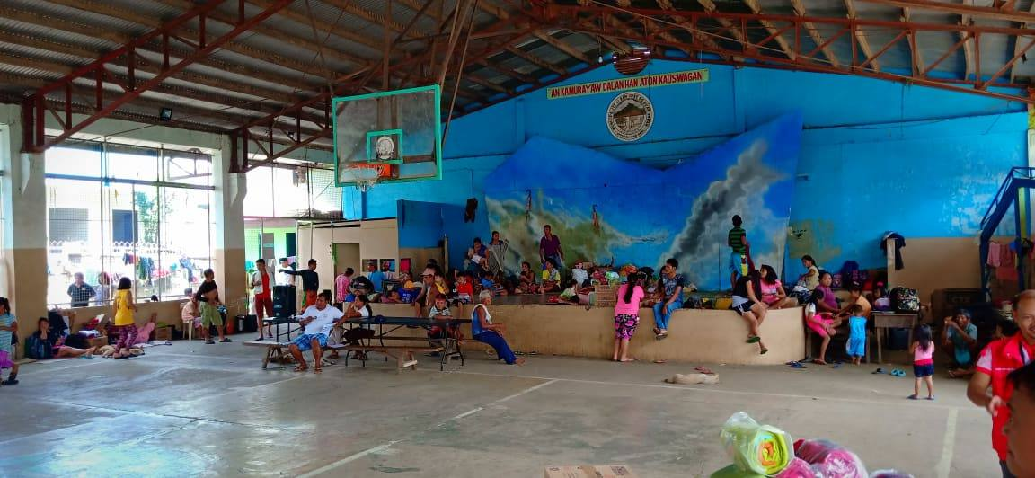
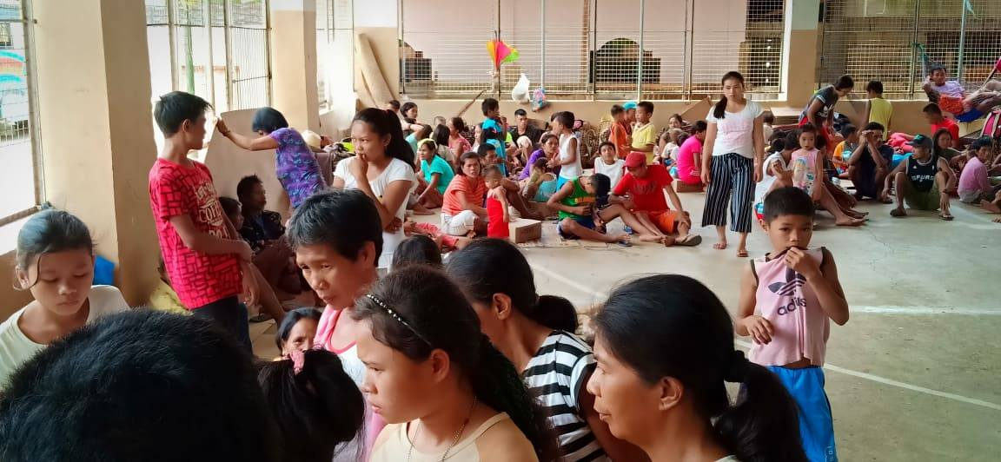
- Distribution of Family Food Packs (FFPs) and blanket last 21 March 2019
