DSWD DROMIC Report #5
on the Earthquake Incident in San Julian, Eastern Samar
as of 25 April 2019, 4PM

Situation Overview

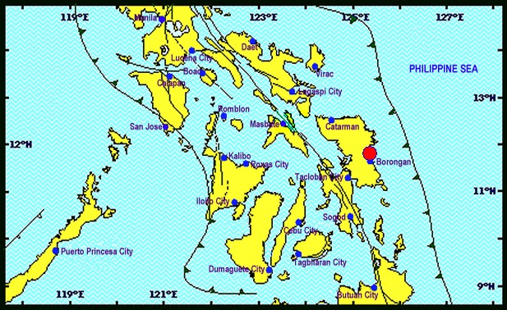

On April 23, 2019 at exactly 1:37 PM, a Magnitude 6.5 earthquake shook San Julian, Eastern Samar. The epicenter of the earthquake was located 11.79°N, 125.38°E - 009 km N 66° W of San Julian (Eastern Samar) with a depth focus of 063 km and with a Tectonic origin

Reported Intensities (02:28 PM): | Intensity VI - San Julian, Eastern Samar;  Intensity V - Tacloban City; Catbalogan City, Samar; Gen. Mc Arthur, Salcedo and  Guiuan Eastern Samar; Naval, Biliran; Catarman, Northern Samar; Palo and Pastrana, Leyte;  Intensity IV - Abuyog, Hilongos, Javier, Capoocan, Julieta, Baybay, Barogo, Jaro, MacArthur,  Matalum, Villaba, Leyte; San Francisco, Southern Leyte; Bislig City, Surigao Del Sur; Iloilo City;  Naga City; Sorsogon City; Panganiban, Catanduanes;  Intensity III - Binalbagan, Negros Occidental; Cabalian, Southern Leyte; Dimasalang, Masbate;  Butuan City; Cabadbaran City;  Intensity II - Bago City; Bacolod City;  Instrumental Intensities:  Intensity VI - Catbalogan, Samar;  Intensity IV - Masbate City, Masbate;  Intensity III - Legazpi City; Iriga City, Camarines Sur; Ormoc City; Argao City, Cebu; Bogo City,  Cebu; Surigao City;  Intensity II - Passi City, Iloilo; Malinao, Aklan; Jamindan, Capiz; Roxas City; Talibon, Bohol; San  Francisco, Cebu; Gingoog City; Mulanay, Quezon; Bago City, Negros Occidental; Daet,  Camarines Norte  Intensity I - Tapaz, Capiz; Sipocot, Camarines Sur; Lapu-lapu City; La Carlota City;
Expecting Damage: | YES
Expecting Aftershocks: | YES
Source: DOST-PHIVOLCS Earthquake Bulletin

- Status of Affected Families / Persons
93 families or 372 persons are affected in 18 barangays (see Table 1).

Table 1. Affected Families / Persons
REGION / PROVINCE / MUNICIPALITY |  | NUMBER OF AFFECTED
 |  | Barangays | Families | Persons
GRAND TOTAL |  | 18 | 93 | 372
REGION VIII |  | 18 | 93 | 372
Eastern Samar |  | 7 | 28 | 112
 | Can-Avid | 6 | 26 | 104
 | San Julian | 1 | 2 | 8
Western Samar |  | 11 | 65 | 260
 | Gandara | 2 | 2 | 8
 | Matuguinao | 2 | 6 | 24
 | Pagsanghan | 1 | 2 | 8
 | Santa Margarita | 5 | 53 | 212
 | Pinabacdao | 1 | 2 | 8
Note: Ongoing assessment and validation
Source: DSWD-FO VIII

- Damaged Houses

There are 92 damaged houses; 4 of which are totally damaged and 88 are partially damaged (see Table 2).

Table 2. Damaged Houses
REGION / PROVINCE / MUNICIPALITY |  | NO. OF DAMAGED HOUSES
 |  | Total | Totally | Partially
GRAND TOTAL |  | 92 | 4 | 88
REGION VIII |  | 92 | 4 | 88
Eastern Samar |  | 28 | - | 28
 | Can-Avid | 26 | - | 26
 | San Julian | 2 | - | 2
Western Samar |  | 64 | 4 | 60
 | Gandara | 2 | 1 | 1
 | Matuguinao | 5 | 3 | 2
 | Pagsanghan | 2 | - | 2
 | Santa Margarita | 53 | - | 53
 | Pinabacdao | 2 | - | 2
Note: Ongoing assessment and validation
Source: DSWD-FO VIII

Status of Prepositioned Resources: Stockpiles and Standby Funds

The DSWD Central Office (CO), Field Offices (FOs), and National Resource Operations Center (NROC) have stockpiles and standby funds amounting to ₱2,234,150,833.96 with breakdown as follows:

- Stockpiles
A total of 348,925 Family Food Packs (FFPs) amounting to ₱133,782,569.36 and available Food and Non-food Items (FNIs) amounting to ₱762,853,229.19.
- Standby Funds
A total of ₱1,337,515,035.41 standby funds in the CO and FOs. Of the said amount, ₱1,292,291,840.16 is the available Quick Response Fund in the CO.

Standby Funds and Stockpile
FIELD OFFICE | STANDBY FUNDS | STOCKPILES |  |  |  |  | Total STANDBY FUNDS & STOCKPILE
 |  | Family Food Packs |  | Other Food Items | Non Food Items | SUB-TOTAL (Food and NFIs)
 |  | Quantity | Total Cost | Total Cost | Total Cost
TOTAL | 1,337,515,035.41 | 348,925 | 133,782,569.36 | 169,858,084.57 | 592,995,144.62 | 762,853,229.19 | 2,234,150,833.96
Central Office | 1,292,291,840.16 |  |  |  |  |  | 1,292,291,840.16
NRLMB - NROC | 0.00 | 107,317 | 44,472,697.90 | 85,406,485.55 | 346,094,741.32 | 431,501,226.87 | 475,973,924.77
NRLMB - VDRC | 0.00 | 10,100 | 3,636,000.00 | 18,463,035.38 | 8,382,582.50 | 26,845,617.88 | 30,481,617.88
I | 3,000,752.75 | 7,354 | 2,713,497.56 | 2,725,567.60 | 42,345,070.52 | 45,070,638.12 | 50,784,888.43
II | 2,477,816.92 | 12,046 | 3,904,435.44 | 3,657,302.00 | 349,519.59 | 4,006,821.59 | 10,389,073.95
III | 2,484,557.00 | 23,363 | 9,056,855.66 | 1,123,719.70 | 259,588.00 | 1,383,307.70 | 12,924,720.36
CALABARZON | 3,000,000.00 | 3,083 | 1,126,109.36 | 4,756,639.32 | 2,299,264.59 | 7,055,903.91 | 11,182,013.27
MIMAROPA | 2,754,714.78 | 18,771 | 7,846,278.00 | 3,729,151.72 | 859,605.00 | 4,588,756.72 | 15,189,749.50
V | 3,000,000.00 | 27,781 | 10,687,021.50 | 5,657,748.72 | 40,981,437.47 | 46,639,186.19 | 60,326,207.69
VI | 1,400,400.00 | 5,935 | 2,141,536.32 | 10,541,995.50 | 6,453,779.20 | 16,995,774.70 | 20,537,711.02
VII | 3,000,000.00 | 11,825 | 4,257,000.00 | 8,794,751.40 | 17,487,147.07 | 26,281,898.47 | 33,538,898.47
VIII | 3,001,960.00 | 29,507 | 10,664,419.94 | 1,331,639.16 | 1,210,683.00 | 2,542,322.16 | 16,208,702.10
IX | 2,780,581.35 | 17,851 | 6,426,360.00 | 2,425,410.00 | 3,793,242.65 | 6,218,652.65 | 15,425,594.00
X | 3,000,000.00 | 19,912 | 7,304,085.94 | 5,893,823.00 | 98,529,822.16 | 104,423,645.16 | 114,727,731.10
XI | 3,028,750.00 | 22,249 | 7,482,338.70 | 2,032,400.00 | 10,770,129.49 | 12,802,529.49 | 23,313,618.19
XII | 3,000,433.00 | 3,254 | 1,304,854.00 | 2,103,532.67 | 912,957.26 | 3,016,489.93 | 7,321,776.93
CARAGA | 3,000,000.00 | 11,585 | 4,224,707.70 | 2,664,901.30 | 6,355,495.95 | 9,020,397.25 | 16,245,104.95
NCR | 3,292,543.50 | 1,720 | 647,080.24 | 1,621,524.15 | 928,770.00 | 2,550,294.15 | 6,489,917.89
CAR | 3,000,685.95 | 15,272 | 5,887,291.10 | 6,928,457.40 | 4,981,308.85 | 11,909,766.25 | 20,797,743.30
* Quick Response Fund (QRF) as of 25 April 2019
Sources: DSWD-Central Office, DSWD-Field Offices, and NROC

Situational Reports

DSWD-DRMB
DATE | SITUATIONS / ACTIONS UNDERTAKEN
25 April 2018 | - The Disaster Response Operations Monitoring and Information Center (DROMIC) of the DSWD-DRMB continues to closely coordinate with DSWD-FO VIII for significant reports on the status of affected families, assistance, and relief efforts.  - DSWD-RETT is on Standby and ready for deployment, with Emergency Communications Equipment  - DSWD-CO QRT members is on standby and ready for deployment.

DSWD-FO V
DATE | ACTION(S) TAKEN
23 April 2018 | - Coordinated with POOs responsible effects of the earthquake  - Conducted the SOP on Earthquake Situation.  - Alerted and advised to be prepared for augmentation support needed from the field and/or 24/7 duty at the DRMD Operation Center.  - PAT and MAT members in the 6 provinces are on standby and were instructed to coordinate with P/MDRRMOs for status reports and updates  - Continuous monitoring of the situation

DSWD-FO VI
DATE | ACTION(S) TAKEN
23 April 2018 | - Suspension of work at Iloilo City Hall following the magnitude 6.5 earthquake. Employees evacuated the building after the tremor.  - The earthquake was felt in entire Western Visayas as per report of QRTs stationed in the following provinces:  - Aklan  - Antique  - Capiz  - Guimaras  - Iloilo  - Negros Occidental  - Government Offices including DSWD evacuated their respective offices as preventive measure after the shake.  - DROMIC FO VI is in close coordination to warning agencies as to possible aftershocks and tsunami alert.  - No reported casualties and damages as of reporting time.  - Quick Response Team are on call and ready for activation during emergency situation.

DSWD-FO VII
DATE | ACTION(S) TAKEN
23 April 2018 | - DSWD-FO VII will continue to coordinate with Cebu Province through its PDRRMO for any updates.  - PDRRMO will closely coordinate with municipal and city DRRMOs to determine if there were any damages from the aftershocks expected.

DSWD-FO VIII
DATE | SITUATIONS / ACTIONS UNDERTAKEN
25 April 2018 | - The DSWD-FO VIII is still in close coordination with SWADTs and PDOs for any additional update.  - All Quick Response Team (QRT) members and Disaster Response Management Division (DRMD) are alerted in case augmentation of the workforce is needed to those affected areas.  - SWAD Teams and DRMD-PDOs assigned at the provinces are still in close coordination with P/C/MSWDOs and/or P/C/MDRRMOs for any additional updates based on the results of RDANA.  - Regional Resource Operation Section (RROS) are also alerted to ensure the readiness of dispatching the Food and Non-Food commodities whenever needed.

DSWD-FO CARAGA
DATE | ACTION(S) TAKEN
23 April 2018 | - Through the Disaster Response and Management Division (DRMD) in close coordination with the SWADTL, LSWDOs and LDRRMOs will continue to monitor the situation in order to provide the Central Office with more updates.

***
The Disaster Response Operations Monitoring and Information Center (DROMIC) of the DSWD-DRMB continues to closely coordinate with the concerned DSWD Field Offices for updating of regional situation and any significant disaster response updates.

JAN ERWIN ANDREW I. ONTANILLAS
Releasing Officer

PHOTO DOCUMENTATION

DSWD-FO VII
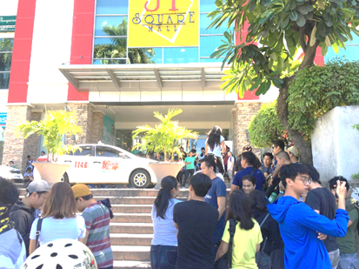
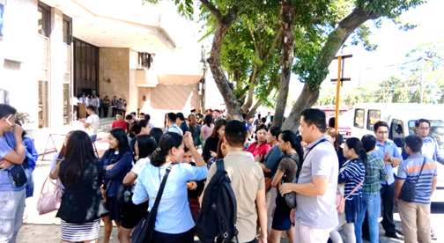

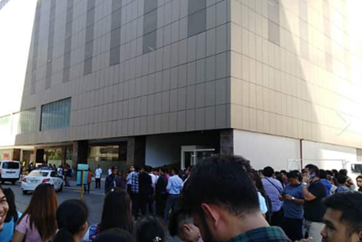

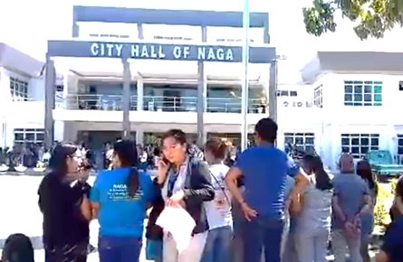

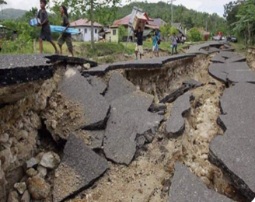
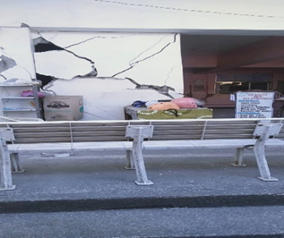
DSWD-FO VIII
