DSWD DROMIC Terminal Report on the Armed Conflict
in Bindoy, Negros Oriental
19 April 2019, 3PM

SUMMARY

This is the final report on the armed conflict transpired between the 94th Infantry (MANDIRIGMA) Battalion (IB) of the Philippine Army and New People’s Army (NPA) in Brgy. Cabcaban, Bindoy, Negros Oriental on 14 April 2019.
Source: DSWD-FO VII

- Status of Affected Families / Persons
A total of 411 families or 1,094 persons were affected by the armed conflict in Bindoy, Negros Oriental (see Table 1).

Table 1. Number of Affected Families / Persons
REGION / PROVINCE / MUNICIPALITY | NUMBER OF AFFECTED
 | Barangays | Families | Persons
GRAND TOTAL | 1 | 411 | 1,094
REGION VII | 1 | 411 | 1,094
Negros Oriental | 1 | 411 | 1,094
Bindoy (Payabon) | 1 | 411 | 1,094
Note: Decrease in the number of affected persons is based on the validation conducted.
Source: DSWD-FO VII

- Status of Displaced Families / Persons
A total of 411 families or 1,094 persons took temporary shelter in Cabcaban Elementary School, barangay gym and in a church. Evacuation centers are already closed and families returned to their homes (see Table 2).

Table 2. Number of Displaced Families / Persons Inside Evacuation Center
REGION / PROVINCE / MUNICIPALITY | NUMBER OF EVACUATION CENTERS (ECs) |  | INSIDE ECs
 |  |  | Families |  | Persons
 | CUM | NOW | CUM | NOW | CUM | NOW
GRAND TOTAL | 3 | - | 411 | - | 1,094 | -
REGION VII | 3 | - | 411 | - | 1,094 | -
Negros Oriental | 3 | - | 411 | - | 1,094 | -
Bindoy (Payabon) | 3 | - | 411 | - | 1,094 | -
Source: DSWD-FO VII

- Cost of Assistance
A total of ₱634,637.50 worth of assistance was provided by the DSWD to the affected families (see Table 3).

Table 3. Cost of Assistance Provided to Affected Families / Persons
REGION / PROVINCE / MUNICIPALITY | TOTAL COST OF ASSISTANCE
 | DSWD | LGU | NGOs | OTHERS | GRAND TOTAL
GRAND TOTAL | 634,637.50 | - | - | - | 634,637.50
REGION VII | 634,637.50 | - | - | - | 634,637.50
Negros Oriental | 634,637.50 | - | - | - | 634,637.50
Bindoy (Payabon) | 634,637.50 | - | - | - | 634,637.50
Source: DSWD-FO VII

SITUATIONAL REPORT

DSWD-FO VII
DATE | SITUATIONS / ACTIONS UNDERTAKEN
19 April 2019 | - DSWD-FO VII submitted their terminal report.  - DSWD-FO VII through Bindoy MAT members provided and distributed Family Food Packs (FFPs) and family kits to the affected families. The LGU of Bindoy also provided sacks of rice and boxes of sardines.

*****
The Disaster Response Operations Monitoring and Information Center (DROMIC) of the DSWD continues to closely coordinate with DSWD-FO VII for any request of Technical Assistance and Resource Augmentation (TARA).

KIM ASUTIN A. ASPILLAGA
Releasing Officer

PHOTO DOCUMENTATION

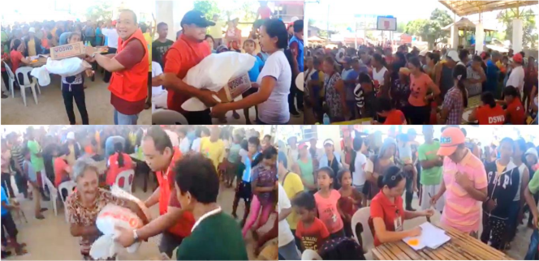

Distribution of relief assistance to the affected families.

