DSWD DROMIC Terminal Report
on the Earthquake Incident in Castillejos, Zambales
21 May 2019, 4PM

This is the final report on the magnitude 6.1 earthquake incident that shook Castillejos, Zambales on April 22, 2019 at exactly 5:11 PM. The epicenter of the earthquake was located 15.02°N, 120.34°E - 018 km N 58° E of Castillejos (Zambales) with a depth focus of 10 km and with a Tectonic origin.

SUMMARY

- Status of Affected Families / Persons

A total of 5,122 families or 25,860 persons were affected in 114 barangays in Region III (see Table 1).

Table 1. Number of Affected Families / Persons
REGION / PROVINCE / MUNICIPALITY |  | NUMBER OF AFFECTED
 |  | Barangays | Families | Persons
GRAND TOTAL |  | 114 | 5,122 | 25,860
REGION III |  | 114 | 5,122 | 25,860
Bataan |  | 4 | 114 | 562
 | Abucay | 1 | 4 | 13
 | Bagac | 1 | 1 | 4
 | Hermosa | 1 | 107 | 535
 | Orani | 1 | 2 | 10
Pampanga |  | 106 | 4,616 | 23,310
 | Angeles City | 1 | 1 | 6
 | Bacolor | 3 | 39 | 149
 | Floridablanca | 32 | 1,867 | 9,335
 | Guagua | 4 | 85 | 332
 | Lubao | 22 | 320 | 1,600
 | Mexico | 1 | 1 | 6
 | Porac | 24 | 2,034 | 10,170
 | City of San Fernando (capital) | 6 | 18 | 86
 | Santa Rita | 1 | 1 | 4
 | Sasmuan (Sexmoan) | 12 | 250 | 1,622
Zambales |  | 4 | 392 | 1,988
 | San Marcelino | 3 | 288 | 1,468
 | Subic | 1 | 104 | 520
Source: DSWD-FO III

- Status of Displaced Families / Persons
- There are 692 families or 2,962 persons who are currently staying inside 3 evacuation centers (see Table 2). The current situation in the affected areas is now stabilized and manageable by the LGUs.

Table 2. Number of Displaced Families / Persons Inside Evacuation Centers
REGION / PROVINCE / MUNICIPALITY |  | NUMBER OF EVACUATION CENTERS (ECs) |  | INSIDE ECs
 |  |  |  | Families |  | Persons
 |  | CUM | NOW | CUM | NOW | CUM | NOW
GRAND TOTAL |  | 8 | 3 | 1,048 | 692 | 4,800 | 2,962
REGION III |  | 8 | 3 | 1,048 | 692 | 4,800 | 2,962
Pampanga |  | 5 | 3 | 760 | 692 | 3,332 | 2,962
 | Bacolor | 2 | 1 | 18 | 6 | 81 | 29
 | Floridablanca | 2 | 2 | 686 | 686 | 2,933 | 2,933
 | Guagua | 1 | - | 56 | - | 318 | -
Zambales |  | 3 | - | 288 | - | 1,468 | -
 | San Marcelino | 3 | - | 288 | - | 1,468 | -
Source: DSWD-FO III

- There are 951 families or 4,756 persons who are currently staying with their relatives and/or friends (see Table 3).

Table 3. Number of Displaced Families Outside Evacuation Centers
REGION / PROVINCE / MUNICIPALITY |  | OUTSIDE ECs
 |  | Families |  | Persons
 |  | CUM | NOW | CUM | NOW
GRAND TOTAL |  | 951 | 951 | 4,756 | 4,756
REGION III |  | 951 | 951 | 4,756 | 4,756
Pampanga |  | 951 | 951 | 4,756 | 4,756
 | Porac | 951 | 951 | 4,756 | 4,756
Source: DSWD-FO III

- Damaged Houses

There were 3,235 damaged houses; of which 1,005 houses were totally damaged and 2,230 houses were partially damaged (see Table 4).

Table 4. Number of Damaged Houses
REGION / PROVINCE / MUNICIPALITY |  | NO. OF DAMAGED HOUSES
 |  | Total | Totally | Partially
GRAND TOTAL |  | 3,235 | 1,005 | 2,230
REGION III |  | 3,235 | 1,005 | 2,230
Bataan |  | 64 | 1 | 63
 | Abucay | 4 | - | 4
 | Hermosa | 58 | 1 | 57
 | Orani | 2 | - | 2
Pampanga |  | 3,086 | 1,002 | 2,084
 | Bacolor | 38 | 15 | 23
 | Floridablanca | 433 | 189 | 244
 | Guagua | 85 | 17 | 68
 | Lubao | 320 | 11 | 309
 | Porac | 2,012 | 753 | 1,259
 | City of San Fernando (capital) | 13 | 6 | 7
 | Santa Rita | 1 | 1 | -
 | Sasmuan (Sexmoan) | 184 | 10 | 174
Zambales |  | 85 | 2 | 83
 | Subic | 85 | 2 | 83
Source: DSWD-FO III

- Assistance Provided
A total of ₱2,806,497.50 worth of assistance was provided to the affected families; of which, ₱2,451,423.50 from DSWD, ₱242,574.00 from LGUs, and ₱112,500.00 from NGOs respectively (see Table 5).
Table 5. Cost of Assistance Provided to Affected Families / Persons
REGION / PROVINCE / MUNICIPALITY |  | TOTAL COST OF ASSISTANCE
 |  | DSWD | LGUs | NGOs | OTHERS | GRAND TOTAL
GRAND TOTAL |  | 2,451,423.50 | 242,574.00 | 112,500.00 | - | 2,806,497.50
REGION III |  | 2,451,423.50 | 242,574.00 | 112,500.00 | - | 2,806,497.50
Pampanga |  | 2,352,138.50 | 242,574.00 | 112,500.00 | - | 2,707,212.50
 | Angeles City | 5,000.00 | - | - | - | 5,000.00
 | Floridablanca | 761,298.62 | - | - | - | 761,298.62
 | Guagua | 20,742.70 | - | - | - | 20,742.70
 | Lubao | 145,000.00 | - | - | - | 145,000.00
 | Mexico | 20,000.00 | - | - | - | 20,000.00
 | Porac | 1,400,097.18 | 242,574.00 | 112,500.00 | - | 1,755,171.18
Zambales |  | 99,285.00 | - | - | - | 99,285.00
 | San Marcelino | 99,285.00 | - | - | - | 99,285.00

Source: DSWD-FO III

Situational Reports

DSWD-FO NCR
DATE | SITUATIONS / ACTIONS UNDERTAKEN
21 May 2019 | - DSWD-FO NCR submitted their terminal report stating that no families were reported to be affected and no pre-emptive evacuation centers were established.

DSWD-FO I
DATE | SITUATIONS / ACTIONS UNDERTAKEN
- May 2019 | - DSWD-FO I submitted their terminal report. There were no affected population or damaged properties reported during the 6.1 magnitude earthquake as per Social Welfare and Development (SWAD) Team Leaders, the Provincial/City/Municipal Disaster Risk Reduction and Management Councils (P/C/MDRRMCs), and the Provincial/City/Municipal Social Welfare and Development Offices (P/C/MSWDOs) of FO I.

DSWD-FO III
DATE | SITUATIONS / ACTIONS UNDERTAKEN
21 May 2019 | - DSWD-FO III submitted their terminal report. Based on the assessment of the Regional Office, the current situation in the affected areas is now stabilized. As per agreement of DSWD and LGU, the affected families currently staying inside the 3 evacuation centers shall be managed by LGUs.

DSWD-FO CALABARZON
DATE | SITUATIONS / ACTIONS UNDERTAKEN
- May 2019 | - DSWD-FO CALABARZON submitted their terminal report. Based on the reports from the Local Government Units (LGUs) of CALABARZON, the earthquake did not cause any damage in their respective areas.

*****
The Disaster Response Operations Monitoring and Information Center (DROMIC) of the DSWD-DRMB continues to closely coordinate with DSWD Field Offices for any request of Technical Assistance and Resource Augmentation (TARA).

RODEL V. CABADDU
Releasing Officer
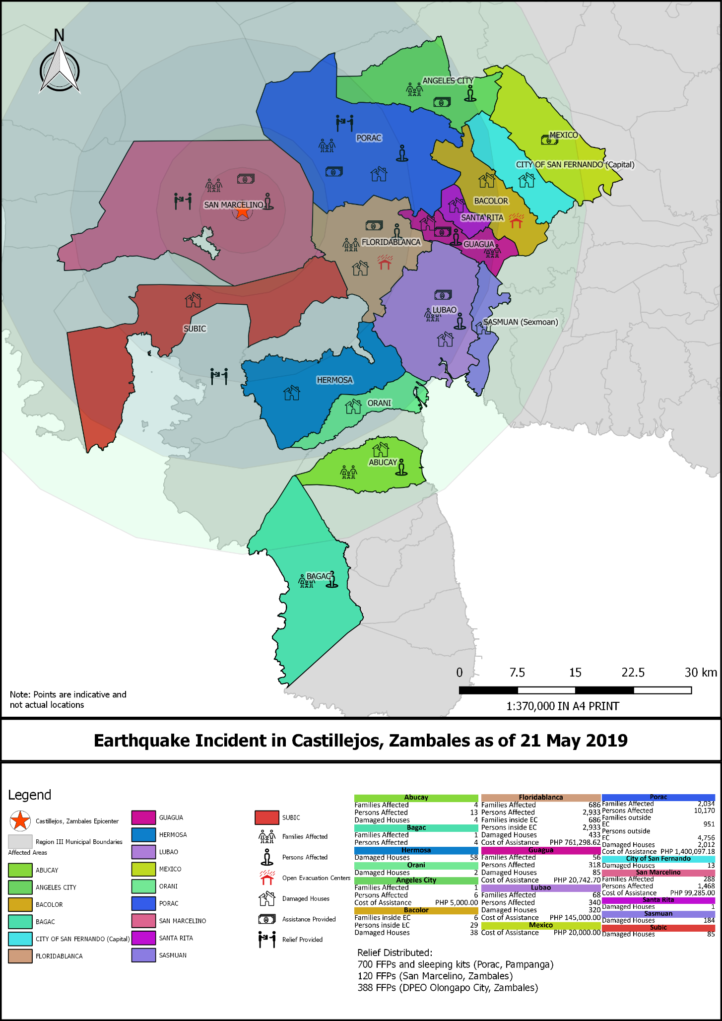
EARTHQUAKE INCIDENT MAP
PHOTO DOCUMENTATION

DSWD-FO III

