DSWD DROMIC Terminal Report
on the Earthquake Incident in San Julian, Eastern Samar
26 April 2019, 4PM

Situation Overview

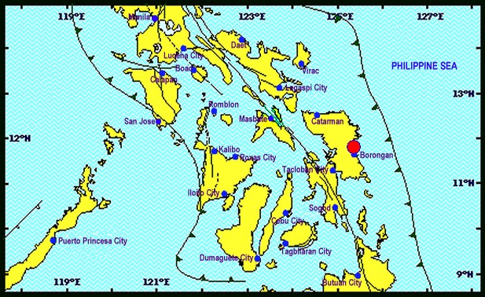

This is the final report on the a Magnitude 6.5 earthquake shook San Julian, Eastern Samar on April 23, 2019 at exactly 1:37 PM,. The epicenter of the earthquake was located 11.79°N, 125.38°E - 009 km N 66° W of San Julian (Eastern Samar) with a depth focus of 063 km and with a Tectonic origin

Reported Intensities (02:28 PM): | Intensity VI - San Julian, Eastern Samar;  Intensity V - Tacloban City; Catbalogan City, Samar; Gen. Mc Arthur, Salcedo and  Guiuan Eastern Samar; Naval, Biliran; Catarman, Northern Samar; Palo and Pastrana, Leyte;  Intensity IV - Abuyog, Hilongos, Javier, Capoocan, Julieta, Baybay, Barogo, Jaro, MacArthur,  Matalum, Villaba, Leyte; San Francisco, Southern Leyte; Bislig City, Surigao Del Sur; Iloilo City;  Naga City; Sorsogon City; Panganiban, Catanduanes;  Intensity III - Binalbagan, Negros Occidental; Cabalian, Southern Leyte; Dimasalang, Masbate;  Butuan City; Cabadbaran City;  Intensity II - Bago City; Bacolod City;  Instrumental Intensities:  Intensity VI - Catbalogan, Samar;  Intensity IV - Masbate City, Masbate;  Intensity III - Legazpi City; Iriga City, Camarines Sur; Ormoc City; Argao City, Cebu; Bogo City,  Cebu; Surigao City;  Intensity II - Passi City, Iloilo; Malinao, Aklan; Jamindan, Capiz; Roxas City; Talibon, Bohol; San  Francisco, Cebu; Gingoog City; Mulanay, Quezon; Bago City, Negros Occidental; Daet,  Camarines Norte  Intensity I - Tapaz, Capiz; Sipocot, Camarines Sur; Lapu-lapu City; La Carlota City;
Expecting Damage: | YES
Expecting Aftershocks: | YES
Source: DOST-PHIVOLCS Earthquake Bulletin

- Status of Affected Families / Persons
252 families or 1,008 persons were affected in 33 barangays (see Table 1).

Table 1. Affected Families / Persons
REGION / PROVINCE / MUNICIPALITY |  | NUMBER OF AFFECTED
 |  | Barangays | Families | Persons
GRAND TOTAL |  | 33 | 252 | 1,008
REGION VIII |  | 33 | 252 | 1,008
Eastern Samar |  | 10 | 33 | 132
 | Can-Avid | 8 | 28 | 112
 | San Julian | 2 | 5 | 20
Western Samar |  | 23 | 219 | 876
 | Gandara | 4 | 26 | 104
 | Matuguinao | 2 | 6 | 24
 | Pagsanghan | 1 | 2 | 8
 | San Jorge | 7 | 119 | 476
 | Santa Margarita | 8 | 64 | 256
 | Pinabacdao | 1 | 2 | 8
Source: DSWD-FO VIII

- Damaged Houses

There were 245 damaged houses; 1 of which are totally damaged and 244 are partially damaged (see Table 2).

Table 2. Damaged Houses
REGION / PROVINCE / MUNICIPALITY |  | NO. OF DAMAGED HOUSES
 |  | Total | Totally | Partially
GRAND TOTAL |  | 245 | 1 | 244
REGION VIII |  | 245 | 1 | 244
Eastern Samar |  | 33 | - | 33
 | Can-Avid | 28 | - | 28
 | San Julian | 5 | - | 5
Western Samar |  | 212 | 1 | 211
 | Gandara | 26 | 1 | 25
 | Matuguinao | 6 | - | 6
 | Pagsanghan | 2 | - | 2
 | San Jorge | 112 | - | 112
 | Santa Margarita | 64 | - | 64
 | Pinabacdao | 2 | - | 2
Source: DSWD-FO VIII

Status of Prepositioned Resources: Stockpiles and Standby Funds

The DSWD Central Office (CO), Field Offices (FOs), and National Resource Operations Center (NROC) have stockpiles and standby funds amounting to ₱2,234,150,833.96 with breakdown as follows:

- Stockpiles
A total of 348,925 Family Food Packs (FFPs) amounting to ₱133,782,569.36 and available Food and Non-food Items (FNIs) amounting to ₱762,853,229.19.
- Standby Funds
A total of ₱1,337,515,035.41 standby funds in the CO and FOs. Of the said amount, ₱1,292,291,840.16 is the available Quick Response Fund in the CO.

Standby Funds and Stockpile
FIELD OFFICE | STANDBY FUNDS | STOCKPILES |  |  |  |  | Total STANDBY FUNDS & STOCKPILE
 |  | Family Food Packs |  | Other Food Items | Non Food Items | SUB-TOTAL (Food and NFIs)
 |  | Quantity | Total Cost | Total Cost | Total Cost
TOTAL | 1,337,515,035.41 | 348,925 | 133,782,569.36 | 169,858,084.57 | 592,995,144.62 | 762,853,229.19 | 2,234,150,833.96
Central Office | 1,292,291,840.16 |  |  |  |  |  | 1,292,291,840.16
NRLMB - NROC | 0.00 | 107,317 | 44,472,697.90 | 85,406,485.55 | 346,094,741.32 | 431,501,226.87 | 475,973,924.77
NRLMB - VDRC | 0.00 | 10,100 | 3,636,000.00 | 18,463,035.38 | 8,382,582.50 | 26,845,617.88 | 30,481,617.88
I | 3,000,752.75 | 7,354 | 2,713,497.56 | 2,725,567.60 | 42,345,070.52 | 45,070,638.12 | 50,784,888.43
II | 2,477,816.92 | 12,046 | 3,904,435.44 | 3,657,302.00 | 349,519.59 | 4,006,821.59 | 10,389,073.95
III | 2,484,557.00 | 23,363 | 9,056,855.66 | 1,123,719.70 | 259,588.00 | 1,383,307.70 | 12,924,720.36
CALABARZON | 3,000,000.00 | 3,083 | 1,126,109.36 | 4,756,639.32 | 2,299,264.59 | 7,055,903.91 | 11,182,013.27
MIMAROPA | 2,754,714.78 | 18,771 | 7,846,278.00 | 3,729,151.72 | 859,605.00 | 4,588,756.72 | 15,189,749.50
V | 3,000,000.00 | 27,781 | 10,687,021.50 | 5,657,748.72 | 40,981,437.47 | 46,639,186.19 | 60,326,207.69
VI | 1,400,400.00 | 5,935 | 2,141,536.32 | 10,541,995.50 | 6,453,779.20 | 16,995,774.70 | 20,537,711.02
VII | 3,000,000.00 | 11,825 | 4,257,000.00 | 8,794,751.40 | 17,487,147.07 | 26,281,898.47 | 33,538,898.47
VIII | 3,001,960.00 | 29,507 | 10,664,419.94 | 1,331,639.16 | 1,210,683.00 | 2,542,322.16 | 16,208,702.10
IX | 2,780,581.35 | 17,851 | 6,426,360.00 | 2,425,410.00 | 3,793,242.65 | 6,218,652.65 | 15,425,594.00
X | 3,000,000.00 | 19,912 | 7,304,085.94 | 5,893,823.00 | 98,529,822.16 | 104,423,645.16 | 114,727,731.10
XI | 3,028,750.00 | 22,249 | 7,482,338.70 | 2,032,400.00 | 10,770,129.49 | 12,802,529.49 | 23,313,618.19
XII | 3,000,433.00 | 3,254 | 1,304,854.00 | 2,103,532.67 | 912,957.26 | 3,016,489.93 | 7,321,776.93
CARAGA | 3,000,000.00 | 11,585 | 4,224,707.70 | 2,664,901.30 | 6,355,495.95 | 9,020,397.25 | 16,245,104.95
NCR | 3,292,543.50 | 1,720 | 647,080.24 | 1,621,524.15 | 928,770.00 | 2,550,294.15 | 6,489,917.89
CAR | 3,000,685.95 | 15,272 | 5,887,291.10 | 6,928,457.40 | 4,981,308.85 | 11,909,766.25 | 20,797,743.30
* Quick Response Fund (QRF) as of 25 April 2019
Sources: DSWD-Central Office, DSWD-Field Offices, and NROC

Situational Reports

DSWD-DRMB
DATE | SITUATIONS / ACTIONS UNDERTAKEN
26 April 2018 | - The Disaster Response Operations Monitoring and Information Center (DROMIC) of the DSWD-DRMB continues to closely coordinate with the concerned DSWD Field Offices for updating of regional situation and any significant disaster response updates.

DSWD-FO VIII
DATE | SITUATIONS / ACTIONS UNDERTAKEN
26 April 2018 | - FO VIII Submitted Terminal Report  - SWAD Teams and DRMD-PDOs assigned at the provinces had coordinated with P/C/MSWDOs and P/C/MDRRMOs to get data on the extent of damage caused by the 6.5 earthquake based on the results of PDANA.  - The Department of Social Welfare and Development (DSWD) Field Office VIII thru the Disaster Response Management Division (DRMD) had coordinated to all SWAD Teams on the results of their data collections under their areas of responsibilities. The results has recorded the Province of Western and Eastern Samar with the most number of partially damaged houses.  - Furthermore, the department is not implementing early recovery and rehabilitation activities in areas which have recorded with totally and partially damaged houses as this could already be managed by the concerned Local Government Units. Instead, Technical Assistance should be provided to them once the early recovery/rehabilitation projects would start.

***
The Disaster Response Operations Monitoring and Information Center (DROMIC) of the DSWD-DRMB continues to closely coordinate with the concerned DSWD Field Offices for updating of regional situation and any significant disaster response updates.

JAN ERWIN ANDREW I. ONTANILLAS
Releasing Officer

PHOTO DOCUMENTATION

DSWD-FO VII
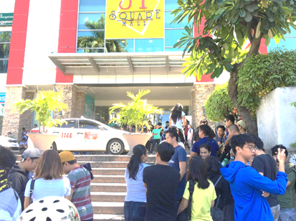
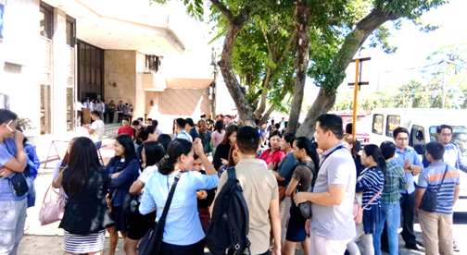

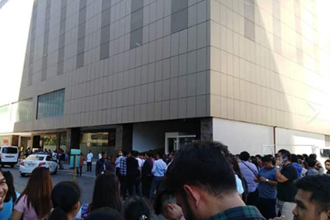

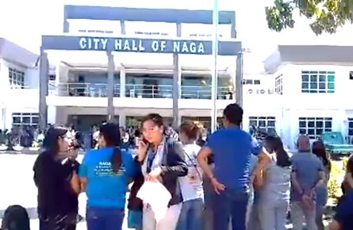

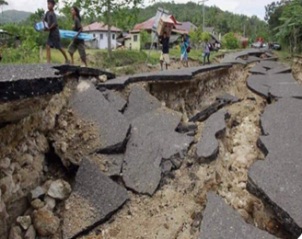
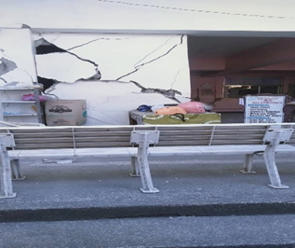
DSWD-FO VIII
