DSWD DROMIC Terminal Report on the Social Disorganization (Human Induced Incident)
in San Jose, Occidental Mindoro
23 April 2019, 6AM

SUMMARY

This is the final report on the social disorganization (human induced incident) that took place in Brgy. Naibuan, San Jose, Occidental Mindoro on 16 April 2019. This incident has resulted to a distraught in the nearby community especially to the Indigenous People.

Source: DSWD-FO MIMAROPA

- Status of Affected Families / Persons
A total of 49 families or 277 persons were affected by the social disorganization in Brgy. Naibuan, San Jose, Occidental Mindoro (see Table 1).

Table 1. Number of Affected Families / Persons
REGION / PROVINCE / MUNICIPALITY | NUMBER OF AFFECTED
 | Barangays | Families | Persons
GRAND TOTAL | 1 | 49 | 277
REGION MIMAROPA | 1 | 49 | 277
Occidental Mindoro | 1 | 49 | 277
San Jose | 1 | 49 | 277

Source: DSWD-FO MIMAROPA

- Status of Displaced Families/ Persons

  - The 50 household heads who stayed at the Bravo Company TCP have already returned to their respective houses (see Table 2).

Table 2. Number of Displaced Families / Persons Inside Evacuation Center
REGION / PROVINCE / MUNICIPALITY | NUMBER OF EVACUATION CENTERS (ECs) |  | INSIDE ECs
 |  |  | Families |  | Persons
 | CUM | NOW | CUM | NOW | CUM | NOW
GRAND TOTAL | 1 | 0 | - | - | 50 | 0
REGION MIMAROPA | 1 | 0 | - | - | 50 | 0
Occidental Mindoro | 1 | 0 | - | - | 50 | 0
San Jose | 1 | 0 | - | - | 50 | 0

Source: DSWD-FO MIMAROPA

  - As per coordination with the Armed Forces of the Philippines through the SWADT Occidental Mindoro, it has been confirmed that the area of Brgy. Naibuan is already safe for the people in the community (see Table 3).

Table 3. Number of Displaced Families / Persons Outside Evacuation Center
 | OUTSIDE ECs
 | Families |  | Persons
 | CUM | NOW | CUM | NOW
GRAND TOTAL | 49 | 0 | 227 | 0
REGION MIMAROPA | 49 | 0 | 227 | 0
Occidental Mindoro | 49 | 0 | 227 | 0
San Jose | 49 | 0 | 227 | 0

Source: DSWD-FO MIMAROPA

- Assistance Provided
A total of ₱42,592.00 worth of assistance was provided by the DSWD and LGU to the affected families (see Table 4).

Table 4. Cost of Assistance Provided to Affected Families / Persons
REGION / PROVINCE / MUNICIPALITY | TOTAL COST OF ASSISTANCE
 | DSWD | LGU | GRAND TOTAL
GRAND TOTAL | 36,802.00 | 5,790.00 | 42,592.00
REGION MIMAROPA | 36,802.00 | 5,790.00 | 42,592.00
Occidental Mindoro | 36,802.00 | 5,790.00 | 42,592.00
San Jose | 36,802.00 | 5,790.00 | 42,592.00

Source: DSWD-FO MIMAROPA

SITUATIONAL REPORT

DSWD-FO MIMAROPA
DATE | SITUATIONS / ACTIONS UNDERTAKEN
22 April 2019 | - The DSWD-FO MIMAROPA submitted their Terminal Report.

*****
The Disaster Response Operations Monitoring and Information Center (DROMIC) of the DSWD continues to closely coordinate with DSWD-FO MIMAROPA for any request of Technical Assistance and Resource Augmentation (TARA).

KIM AUSTIN A. ASPILLAGA
Releasing Officer

PHOTO DOCUMENTATION

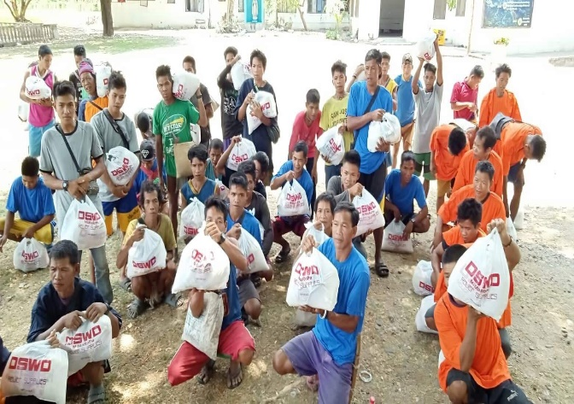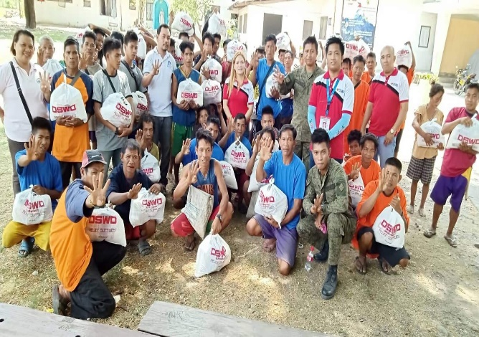
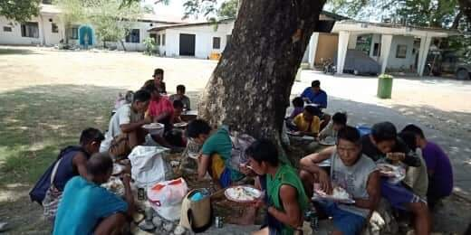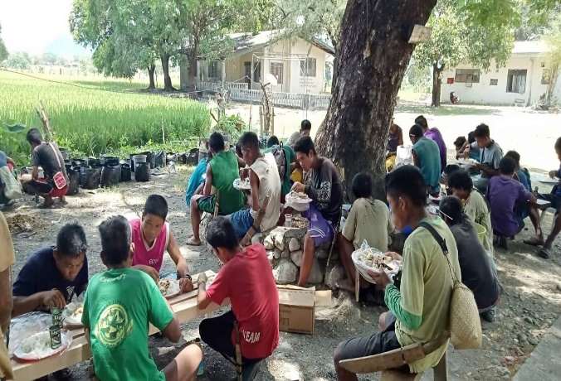
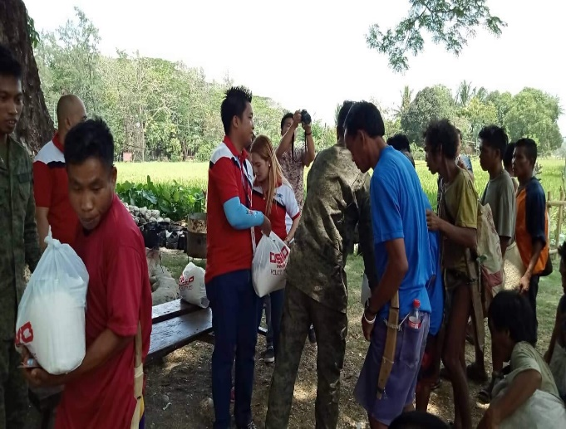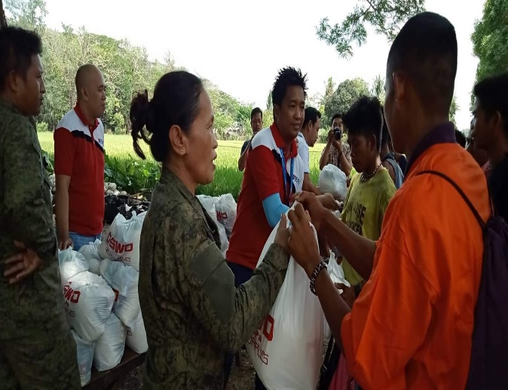
Relief distribution to the household heads of Brgy. Naibuan, San Jose, Occidental Mindoro.

