DSWD DROMIC Report #2 on the Flooding Incident
in Midsayap, North Cotabato
as of 17 June 2019, 6PM

SUMMARY

Due to the continuous heavy rainfall that started on June 3, 2019, this weather disturbance has affected families in Midsayap, North Cotabato.
Source: DSWD-FO XII

- Status of Affected Families / Persons
A total of 200 families or 1,000 persons were affected by the flooding incident in Midsayap, North Cotabato (see Table 1).

Table 1. Number of Affected Families / Persons
REGION / PROVINCE / MUNICIPALITY |  | NUMBER OF AFFECTED
 |  | Barangays | Families | Persons
GRAND TOTAL |  | 1 | 200 | 1,000
REGION XII |  | 1 | 200 | 1,000
North Cotabato |  | 1 | 200 | 1,000
 | Midsayap | 1 | 200 | 1,000
Note: Ongoing assessment and validation
Source: DSWD-FO XII

- Status of Displaced Families / Persons
200 families or 1,000 persons are taking temporary shelter at the Barangay Salunayan Covered Court (see Table 2).

Table 2. Number of Displaced Families Inside Evacuation Center
REGION / PROVINCE / MUNICIPALITY |  | NUMBER OF EVACUATION CENTERS (ECs) |  | INSIDE ECs
 |  |  |  | Families |  | Persons
 |  | CUM | NOW | CUM | NOW | CUM | NOW
GRAND TOTAL |  | 1 | 1 | 200 | 200 | 1,000 | 1,000
REGION XII |  | 1 | 1 | 200 | 200 | 1,000 | 1,000
North Cotabato |  | 1 | 1 | 200 | 200 | 1,000 | 1,000
 | Midsayap | 1 | 1 | 200 | 200 | 1,000 | 1,000
Note: Ongoing assessment and validation
Source: DSWD-FO XII

- Damaged Houses
A total of 8 houses were totally damaged (see table 3)

Table 3. Number of Damaged Houses
REGION / PROVINCE / MUNICIPALITY |  | NO. OF DAMAGED HOUSES
 |  | Total | Totally | Partially
GRAND TOTAL |  | 8 | 8 | -
REGION XII |  | 8 | 8 | -
North Cotabato |  | 8 | 8 | -
 | Midsayap | 8 | 8 | -
Note: Ongoing assessment and validation
Source: DSWD-FO XII

- Cost of Assistance Provided
A total of ₱127,800.00 worth of assistance was provided to the affected families, of which, ₱80,200.00 was provided by DSWD and ₱47,600.00 was provided by LGU (see Table 4).

Table 4. Cost of Assistance Provided
REGION / PROVINCE / MUNICIPALITY |  | TOTAL COST OF ASSISTANCE
 |  | DSWD | LGU | NGOs | OTHERS | GRAND TOTAL
GRAND TOTAL |  | 80,200.00 | 47,600.00 | - | - | 127,800.00
REGION XII |  | 80,200.00 | 47,600.00 | - | - | 127,800.00
North Cotabato |  | 80,200.00 | 47,600.00 | - | - | 127,800.00
 | Midsayap | 80,200.00 | 47,600.00 | - | - | 127,800.00
Note: Ongoing assessment and validation
Source: DSWD-FO XII

SITUATIONAL REPORT

DSWD-DRMB
DATE | SITUATIONS / ACTIONS UNDERTAKEN
13 June 2019 | - The Disaster Response Operations Monitoring and Information Center (DROMIC) of the DSWD-DRMB continues to closely coordinate with DSWD-FO XII for significant reports on the status of affected families, assistance, and relief efforts.

DSWD-FO XII
DATE | SITUATIONS / ACTIONS UNDERTAKEN
13 June 2019 | - DSWD FO XII provided 200 Family Food Packs (FFPs) to the affected families.
11 June 2019 | - LGU Midsayap has provided relief goods to affected families.  - DSWD-FO XII is continuously coordinating with the MSWDO for any technical assistance and resource augmentation.

*****
The Disaster Response Operations Monitoring and Information Center (DROMIC) of the DSWD-DRMB is closely coordinating with DSWD-FO XII for any significant disaster response updates.

JAN ERWIN ANDREW I. ONTANILLAS
Releasing Officer

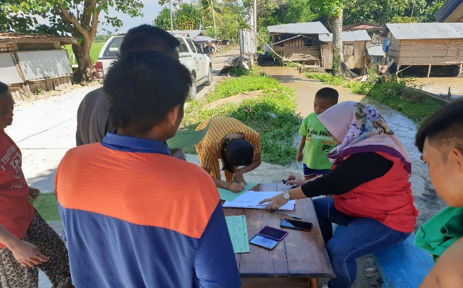
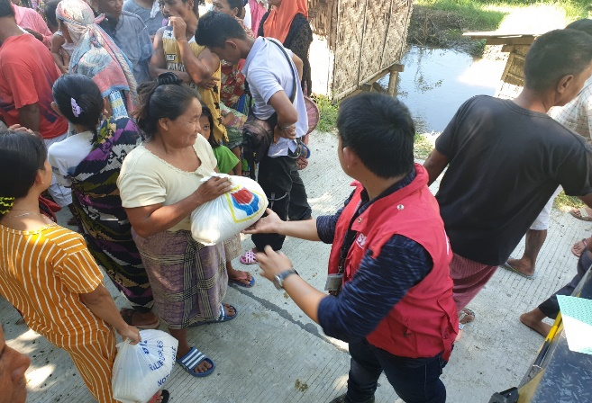
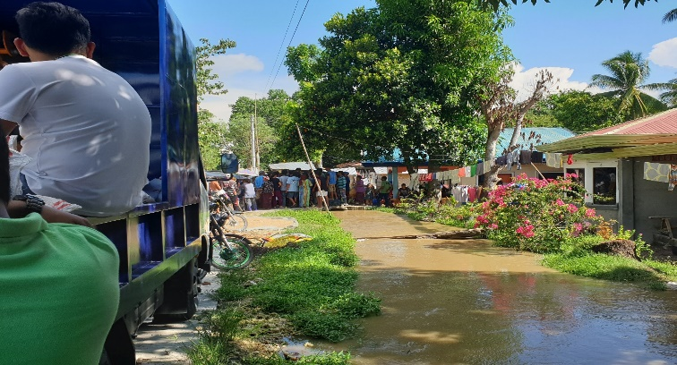
PHOTO DOCUMENTATION
