DSWD DROMIC Terminal Report on the Flooding Incident
in Midsayap, North Cotabato
25 June 2019, 12NN

SUMMARY

This is the final report on the flooding incidents that were experienced over portions of Midsayap, North Cotabato on 2 June 2019.
Source: DSWD-FO XII

- Status of Affected Families / Persons
A total of 200 families or 1,000 persons were affected by the flooding incident in Midsayap, North Cotabato (see Table 1).

Table 1. Number of Affected Families / Persons
REGION / PROVINCE / MUNICIPALITY |  | NUMBER OF AFFECTED
 |  | Barangays | Families | Persons
GRAND TOTAL |  | 1 | 200 | 1,000
REGION XII |  | 1 | 200 | 1,000
North Cotabato |  | 1 | 200 | 1,000
 | Midsayap | 1 | 200 | 1,000
Note: Ongoing assessment and validation
Source: DSWD-FO XII

- Status of Displaced Families / Persons
A total of 200 families or 1,000 persons took temporary shelter at the Barangay Salunayan Covered Court (see Table 2).

Table 2. Number of Displaced Families Inside Evacuation Center
REGION / PROVINCE / MUNICIPALITY |  | NUMBER OF EVACUATION CENTERS (ECs) |  | INSIDE ECs
 |  |  |  | Families |  | Persons
 |  | CUM | NOW | CUM | NOW | CUM | NOW
GRAND TOTAL |  | 1 | 0 | 200 | 0 | 1,000 | 0
REGION XII |  | 1 | 0 | 200 | 0 | 1,000 | 0
North Cotabato |  | 1 | 0 | 200 | 0 | 1,000 | 0
 | Midsayap | 1 | 0 | 200 | 0 | 1,000 | 0
Note: Ongoing assessment and validation
Source: DSWD-FO XII

- Damaged Houses
A total of 8 houses were totally damaged (see table 3)

Table 3. Number of Damaged Houses
REGION / PROVINCE / MUNICIPALITY |  | NO. OF DAMAGED HOUSES
 |  | Total | Totally | Partially
GRAND TOTAL |  | 8 | 8 | -
REGION XII |  | 8 | 8 | -
North Cotabato |  | 8 | 8 | -
 | Midsayap | 8 | 8 | -
Note: Ongoing assessment and validation
Source: DSWD-FO XII

- Cost of Assistance Provided
A total of ₱127,800.00 worth of assistance was provided to the affected families, of which, ₱80,200.00 was provided by DSWD and ₱47,600.00 was provided by LGU (see Table 4).

Table 4. Cost of Assistance Provided
REGION / PROVINCE / MUNICIPALITY |  | TOTAL COST OF ASSISTANCE
 |  | DSWD | LGU | NGOs | OTHERS | GRAND TOTAL
GRAND TOTAL |  | 80,200.00 | 47,600.00 | - | - | 127,800.00
REGION XII |  | 80,200.00 | 47,600.00 | - | - | 127,800.00
North Cotabato |  | 80,200.00 | 47,600.00 | - | - | 127,800.00
 | Midsayap | 80,200.00 | 47,600.00 | - | - | 127,800.00
Note: Ongoing assessment and validation
Source: DSWD-FO XII

SITUATIONAL REPORT

DSWD-FO XII
DATE | SITUATIONS / ACTIONS UNDERTAKEN
25 June 2019 | - DSWD-FO XII submitted their terminal report.  - All affected families returned to their respective place of origin.

*****
The Disaster Response Operations Monitoring and Information Center (DROMIC) of the DSWD-DRMB continues to closely coordinate with DSWD-FO XII for any request of technical assistance and resource augmentation.

JAN ERWIN ANDREW I. ONTANILLAS
Releasing Officer

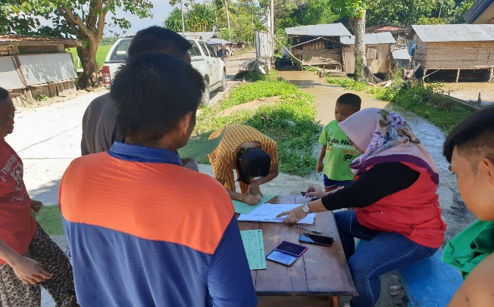
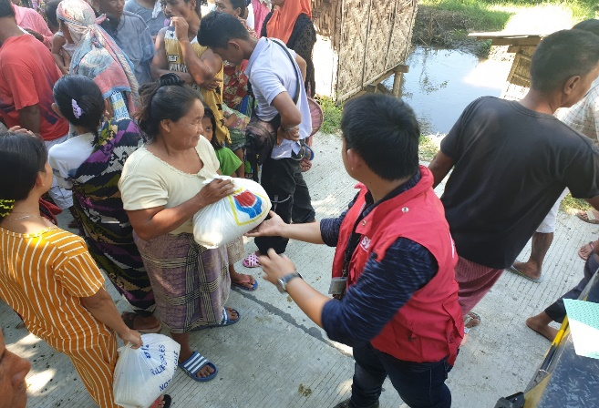
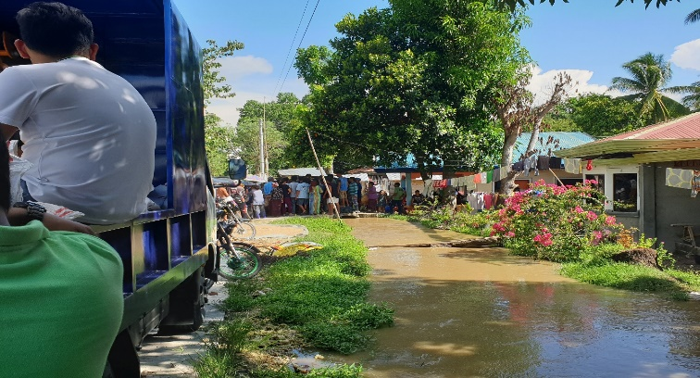
PHOTO DOCUMENTATION
