DSWD DROMIC Preparedness for Response Report #1 on
Tropical Depression “EGAY”
as of 01 July 2019, 5PM

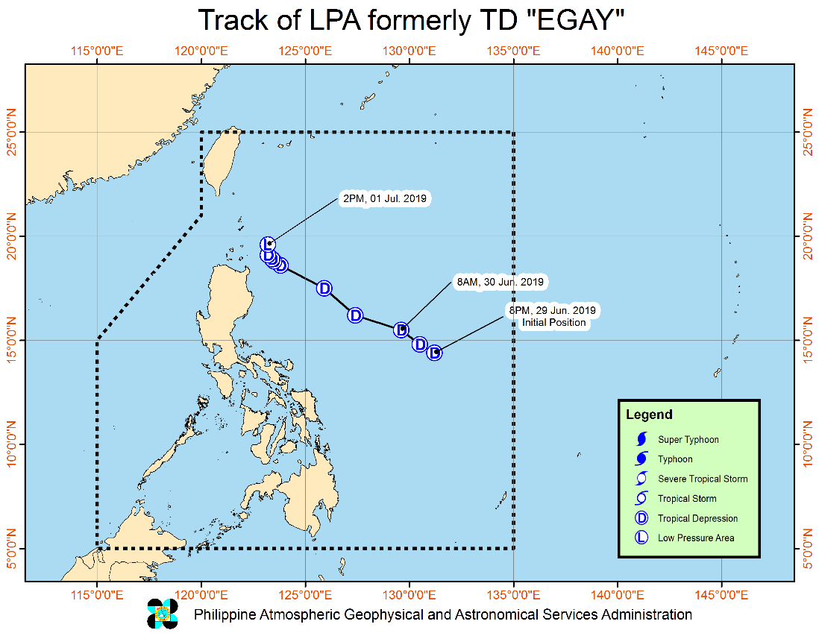
Situation Overview

Issued at 05:00 PM today, Tropical Depression "EGAY" has weakened into a low pressure area.
- Tropical Depression “EGAY” weakened into a Low Pressure Area at 2:00 PM today. Furthermore, this weather disturbance may dissipate in the next 24 to 48 hours.
- Tropical Cyclone Wind Signal #1 over Batanes and Babuyan Group of Islands has been lifted.
- Due to the Low Pressure Area, light to moderate with at times heavy rains will be experienced over Batanes and the northern portions of Ilocos Norte, Apayao and Cagayan (including Babuyan Group of Islands) this afternoon until tomorrow early morning.
- The Southwest Monsoon will continue to bring light to moderate with at times heavy monsoon rains over Metro Manila, Central Luzon, CALABARZON and MIMAROPA this afternoon until tomorrow early morning. Meanwhile, cloudy skies with scattered rainshowers and thunderstorms will prevail over Visayas and the rest of Luzon.
- Residents in the aforementioned areas, especially those living in areas identified to be at high risk of flooding and landslides, are advised to take precautionary measures, coordinate with local disaster risk reduction and management offices, and continue monitoring for updates, especially the Thunderstorm Advisories and Heavy Rainfall Warnings to be issued by PAGASA Regional Services Divisions.
- Moderate to rough seas will prevail over the seaboards of Northern Luzon and the western seaboards of Central and Southern Luzon in the next 24 hours. Those with small seacrafts are advised not the venture out in these areas.
At 4:00 PM today, the Low Pressure Area (LPA) formerly "EGAY" was estimated based on all available data at 190 km East Northeast of Calayan, Cagayan (19.7 °N, 123.2 °E )

Source: DOST-PAGASA Severe Weather Bulletin

Status of Prepositioned Resources: Stockpile and Standby Funds

The DSWD Central Office (CO), Field Offices (FOs), and National Resource Operations Center (NROC) have stockpiles and standby funds amounting to ₱1,974,755,075.16 with breakdown as follows (see Table 1):

- Standby Funds
A total of ₱1,174,771,923.28 standby funds in the CO and FOs. Of the said amount, ₱1,128,751,613.00 is the available Quick Response Fund (QRF) in the CO.

- Stockpiles
A total of 319,478 Family Food Packs (FFPs) amounting to ₱122,137,558.80 and available Food and Non-food Items (FNIs) amounting to ₱677,845,593.08.

FIELD OFFICE | STANDBY FUNDS | STOCKPILES |  |  |  |  | Total STANDBY FUNDS & STOCKPILE
 |  | Family Food Packs |  | Other Food Items | Non Food Items | SUB-TOTAL (Food and NFIs)
 |  | Quantity | Total Cost | Total Cost | Total Cost
TOTAL | 1,174,771,923.28 | 319,478 | 122,137,558.80 | 172,726,260.97 | 505,119,332.11 | 677,845,593.08 | 1,974,755,075.16
Central Office | 1,128,751,613.00 |  |  |  |  |  | 1,128,751,613.00
NRLMB - NROC | 0.00 | 98,900 | 38,581,422.00 | 85,134,129.94 | 337,783,491.28 | 422,917,621.22 | 461,499,043.22
NRLMB - VDRC | 0.00 | 11,700 | 4,212,000.00 | 1,203,200.00 | 5,224,562.31 | 6,427,762.31 | 10,639,762.31
I | 2,379,275.00 | 6,206 | 2,280,540.84 | 2,725,567.60 | 32,634,081.35 | 35,359,648.95 | 40,019,464.79
II | 2,607,537.00 | 17,434 | 5,731,851.40 | 3,352,676.29 | 349,602.75 | 3,702,279.04 | 12,041,667.44
III | 2,484,557.00 | 18,595 | 8,411,049.16 | 899,919.70 | 241,706.00 | 1,141,625.70 | 12,037,231.86
CALABARZON | 2,544,350.00 | 4,859 | 1,750,614.94 | 3,418,826.40 | 2,398,989.61 | 5,817,816.01 | 10,112,780.95
MIMAROPA | 2,488,811.58 | 23,129 | 9,667,922.00 | 2,881,805.25 | 859,605.00 | 3,741,410.25 | 15,898,143.83
V | 3,000,000.00 | 23,217 | 9,009,854.54 | 11,417,748.72 | 40,793,105.97 | 52,210,854.69 | 64,220,709.23
VI | 3,000,317.60 | 7,391 | 2,665,696.32 | 9,290,508.10 | 3,738,152.50 | 13,028,660.60 | 18,694,674.52
VII | 3,000,000.00 | 15,675 | 5,643,000.00 | 21,186,085.97 | 19,988,685.42 | 41,174,771.39 | 49,817,771.39
VIII | 3,001,960.00 | 29,306 | 10,591,774.52 | 1,331,019.04 | 1,163,983.00 | 2,495,002.04 | 16,088,736.56
IX | 2,510,721.35 | 10,119 | 3,642,840.00 | 813,730.00 | 3,793,242.35 | 4,606,972.35 | 10,760,533.70
X | 3,000,000.00 | 7,253 | 2,735,396.42 | 5,539,268.20 | 32,474,481.66 | 38,013,749.86 | 43,749,146.28
XI | 3,028,750.00 | 12,731 | 4,600,983.40 | 10,673,200.00 | 10,286,218.61 | 20,959,418.61 | 28,589,152.01
XII | 3,680,801.30 | 5,908 | 2,369,108.00 | 2,769,132.67 | 851,017.26 | 3,620,149.93 | 9,670,059.23
CARAGA | 3,000,000.00 | 9,608 | 3,502,386.00 | 1,707,388.90 | 6,695,907.45 | 8,403,296.35 | 14,905,682.35
NCR | 3,292,543.50 | 1,119 | 385,740.30 | 2,960,333.89 | 928,770.00 | 3,889,103.89 | 7,567,387.69
CAR | 3,000,685.95 | 16,328 | 6,355,378.96 | 5,421,720.30 | 4,913,729.59 | 10,335,449.89 | 19,691,514.80
*Quick Response Fund (QRF) as of 28 June 2019

Situational Reports

DSWD-DRMB
DATE | SITUATIONS / ACTIONS UNDERTAKEN
01 July 2019 | - The Disaster Response Management Bureau (DRMB) is on BLUE Alert Status and is closely coordinating with the concerned DSWD-Field Offices for significant disaster preparedness for response updates.  - All QRT members and emergency equipment are on standby and ready for deployment.

DSWD-FO CAR
DATE | SITUATIONS / ACTIONS UNDERTAKEN
01 July 2019 | - The Disaster Response Operations Monitoring and Information Center (DROMIC) of the DSWD-FO CAR is on standby alert and is continuously monitoring the situation on the different provinces.  - P/SWAD PDOs were on standby alert for possible effects of the typhoon.

DSWD-FO CALABARZON
DATE | SITUATIONS / ACTIONS UNDERTAKEN
01 July 2019 | - DSWD-FO CALABARZON Emergency Operations Center (OpCen) is already activated to monitor the possible effects of TD Egay.  - DSWD-FO CALABARZON through the Disaster Response Management Division (DRMD) has been maintaining contact and constant communication with the Local Social Welfare and Development Offices (LSWDOs) with pre-disaster assessments being conducted.  - DSWD-FO CALABARZON instructed LSWDOs and LDRRMOs to be on standby alert and to prepare their respective evacuation centers, and family food packs should need arises.  - DSWD-FO CALABARZON coordinated with SWAD Team Leaders and Provincial Action Team of CALABARZON Provinces.  - DSWD-FO CALABARZON coordinated with RDRRMC CALABARZON OpCen for updates on the preparedness level of the members of the Response Cluster of the region.  - DSWD-FO CALABARZON has informed member agencies of the response cluster to be on stand-by alert status and ready for mobilization in case the situation arises.  - The Disaster Response Management Division (DRMD) of DSWD-FO CALABARZON is in close coordination with the Local Government Units (LGUs) with regard to the preparedness efforts undertaken in the Flood, Landslide and Storm Surge prone areas.

*****
The Disaster Response Operations Monitoring and Information Center (DROMIC) of the DSWD-DRMB is closely monitoring the effects of TD Egay and is coordinating with the concerned DSWD-Field Offices for any significant updates.

PREPARED BY:

MARIE JOYCE G. RAFANAN

KIM AUSTIN A. ASPILLAGA
Releasing Officer

