DSWD DROMIC Preparedness for Response Report #1 on
Tropical Depression “FALCON”
as of 16 July 2019, 12NN

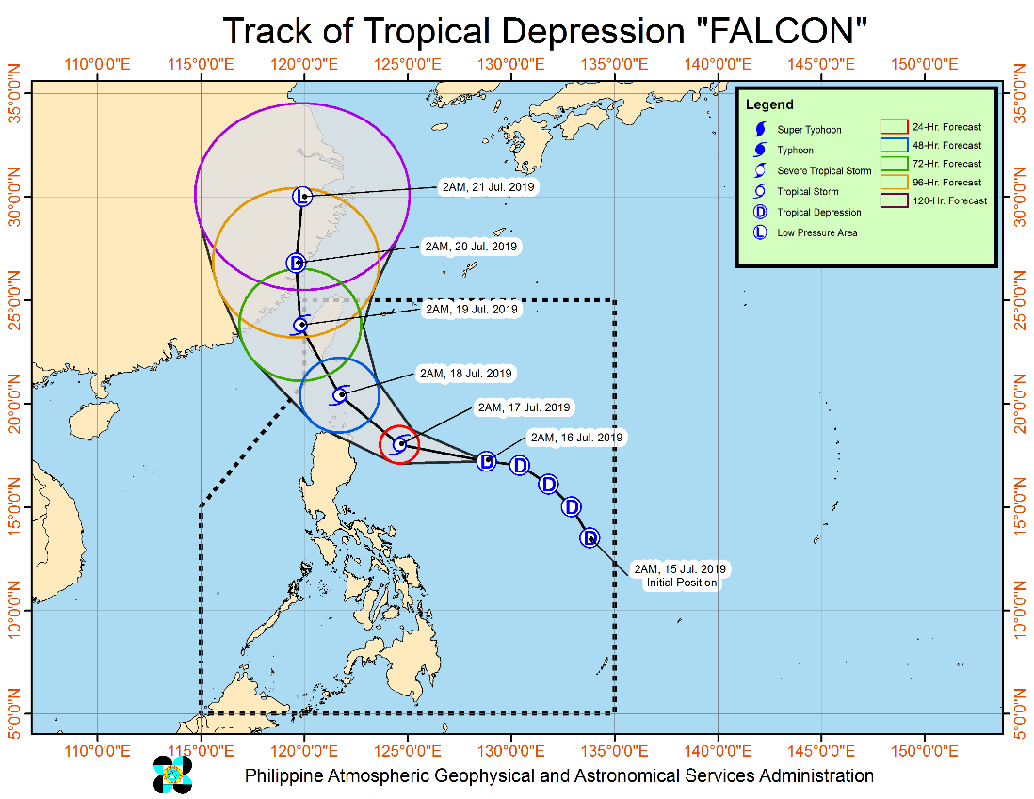
Situation Overview

Issued at 05:00 AM today, Tropical Depression "FALCON" is now moving westward over the Philippine sea.
- Today (16 July), light to moderate with occasional heavy monsoon rains will prevail over MIMAROPA, Western Visayas, Albay, Masbate, Sorsogon and Northern Samar.
- Tomorrow (17 July), moderate to heavy rains will be experienced over Ilocos Region, Cordillera Administrative Region, Cagayan Valley, Zambales, Bataan and Mindoro Provinces due to the combined effects of “FALCON” and the enhanced Southwest Monsoon. Meanwhile, light to moderate with occasional heavy monsoon rains will prevail over Metro Manila, CALABARZON, Western Visayas, and the rest of Central Luzon and MIMAROPA.
- On Thursday (18 July), moderate to heavy rains will be experienced over Ilocos Region, Zambales, Bataan and Mindoro Provinces. Meanwhile, light to moderate with occasional heavy monsoon rains will prevail over Metro Manila, CALABARZON, and the rest of Central Luzon and MIMAROPA.
- Residents in the aforementioned areas, especially those living in areas identified to be at risk of flooding and landslides, are advised to take precautionary measures, coordinate with local disaster risk reduction and management offices, and continue monitoring for updates, especially the Thunderstorm Advisories and Heavy Rainfall Warnings to be issued by PAGASA Regional Services Divisions.
- Fisherfolks and those with small seacrafts are advised not to venture out over the seaboards of areas under TCWS#1 and the eastern seaboards of Southern Luzon, Visayas and Mindanao.
- "FALCON" may intensify into a Tropical Storm as it approaches Extreme Northern Luzon tomorrow afternoon or evening.
At 4:00 AM today, the center of Tropical Depression "FALCON" was estimated based on all available data at 690 km East of Tuguegarao City, Cagayan (17.2 °N, 128.2 °E)
Source: DOST-PAGASA Severe Weather Bulletin

PREDICTIVE ANALYTICS FOR HUMANITARIAN RESPONSE

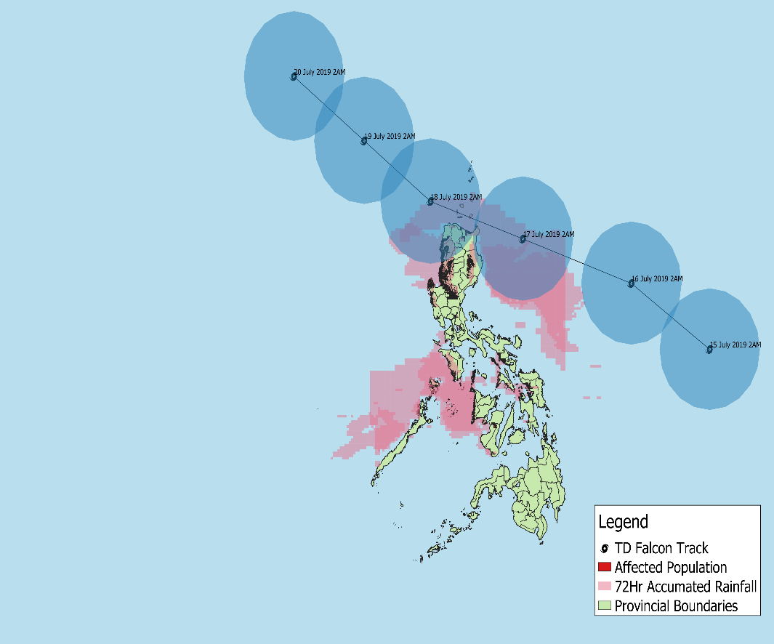
REGIONS THAT WILL RECEIVE AN
ACCUMULATED RAINFALL
OF AT LEAST 100 MM FOR THE NEXT 72 HOURS
AND THE POPULATION EXPOSED

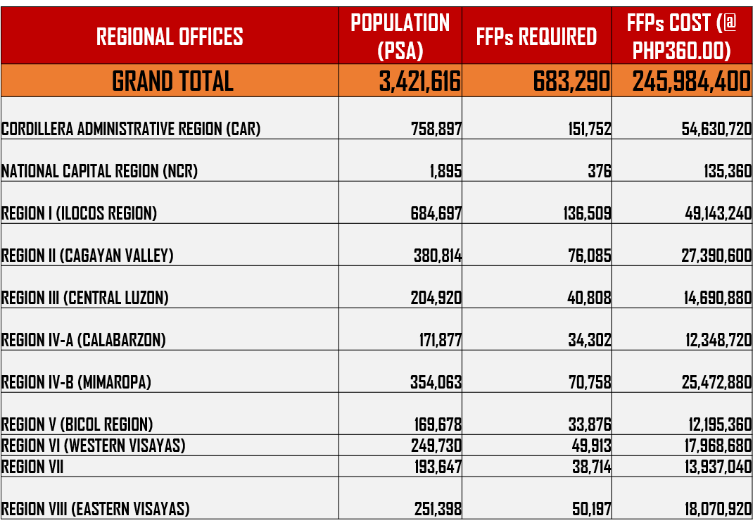

Status of Prepositioned Resources: Stockpile and Standby Funds

The DSWD Central Office (CO), Field Offices (FOs), and National Resource Operations Center (NROC) have stockpiles and standby funds amounting to ₱1,984,745,767.19 with breakdown as follows (see Table 1):

- Standby Funds
A total of ₱1,190,869,415.84 standby funds in the CO and FOs. Of the said amount, ₱1,146,974,543.16 is the available Quick Response Fund (QRF) in the CO.

- Stockpiles
A total of 359,124 Family Food Packs (FFPs) amounting to ₱134,922,306.28 and available Food and Non-food Items (FNIs) amounting to ₱658,954,045.07.

FIELD OFFICE | STANDBY FUNDS | STOCKPILES |  |  |  |  | Total STANDBY FUNDS & STOCKPILE
 |  | Family Food Packs |  | Other Food Items | Non Food Items | SUB-TOTAL (Food and NFIs)
 |  | Quantity | Total Cost | Total Cost | Total Cost
 |  | 359,124 | 134,922,306.28 | 161,342,886.34 | 497,611,158.73
TOTAL | 1,190,869,415.84 | 359,124 | 134,922,306.28 | 161,342,886.34 | 497,611,158.73 | 658,954,045.07 | 1,984,745,767.19
Central Office | 1,146,974,543.16 |  |  |  |  |  | 1,146,974,543.16
NRLMB - NROC | 0.00 | 98,800 | 37,261,432.00 | 79,438,561.86 | 330,957,856.78 | 410,396,418.64 | 447,657,850.64
NRLMB - VDRC | 0.00 | 11,700 | 4,212,000.00 | 1,203,200.00 | 5,224,562.31 | 6,427,762.31 | 10,639,762.31
I | 2,379,275.00 | 7,846 | 2,824,560.00 | 2,257,200.00 | 37,869,937.80 | 40,127,137.80 | 45,330,972.80
II | 2,607,537.00 | 17,434 | 5,731,851.40 | 3,352,676.29 | 349,602.75 | 3,702,279.04 | 12,041,667.44
III | 2,404,557.00 | 26,229 | 11,140,309.24 | 899,919.70 | 241,706.00 | 1,141,625.70 | 14,686,491.94
CALABARZON | 2,544,350.00 | 4,859 | 1,750,614.94 | 3,418,826.40 | 2,398,989.61 | 5,817,816.01 | 10,112,780.95
MIMAROPA | 1,494,971.58 | 24,764 | 10,351,352.00 | 2,243,173.55 | 859,605.00 | 3,102,778.55 | 14,949,102.13
V | 3,000,000.00 | 20,187 | 7,823,020.34 | 11,417,748.72 | 40,704,948.22 | 52,122,696.94 | 62,945,717.28
VI | 3,000,000.00 | 20,373 | 7,497,110.00 | 8,109,495.37 | 3,738,152.50 | 11,847,647.87 | 22,344,757.87
VII | 3,000,000.00 | 20,232 | 7,283,520.00 | 17,439,687.87 | 14,879,591.20 | 32,319,279.07 | 42,602,799.07
VIII | 3,001,960.00 | 29,306 | 10,591,774.52 | 1,304,119.84 | 1,163,983.00 | 2,468,102.84 | 16,061,837.36
IX | 1,768,321.35 | 10,119 | 3,642,840.00 | 813,730.00 | 3,793,242.35 | 4,606,972.35 | 10,018,133.70
X | 3,000,000.00 | 9,004 | 3,241,440.00 | 6,564,325.20 | 31,673,552.96 | 38,237,878.16 | 44,479,318.16
XI | 3,028,750.00 | 19,181 | 6,932,013.40 | 11,053,700.00 | 10,869,627.34 | 21,923,327.34 | 31,884,090.74
XII | 3,680,801.30 | 5,908 | 2,369,108.00 | 2,769,132.67 | 851,017.26 | 3,620,149.93 | 9,670,059.23
CARAGA | 3,000,000.00 | 13,617 | 4,966,096.50 | 1,682,002.00 | 6,193,295.05 | 7,875,297.05 | 15,841,393.55
NCR | 3,292,543.50 | 3,665 | 1,341,789.14 | 1,998,746.57 | 928,770.00 | 2,927,516.57 | 7,561,849.21
CAR | 2,691,805.95 | 15,900 | 5,961,474.80 | 5,376,640.30 | 4,912,718.60 | 10,289,358.90 | 18,942,639.65
*Quick Response Fund (QRF) as of 12 July 2019

Situational Reports

DSWD-DRMB
DATE | SITUATIONS / ACTIONS UNDERTAKEN
16 July 2019 | - The Disaster Response Management Bureau (DRMB) is closely coordinating with the concerned DSWD-Field Offices for significant disaster preparedness for response updates.  - All QRT members and emergency equipment are on standby and ready for deployment.

DSWD-FO CAR
DATE | SITUATIONS / ACTIONS UNDERTAKEN
16 July 2019 | - The Disaster Response Operations Monitoring and Information Center (DROMIC) of the DSWD-FO CAR is on BLUE Alert Level Status.  - The Provincial Social Welfare and Development Teams (PSWADT) DRMD PDO IIs are alerted; members are on standby for possible effects of the weather disturbance.  - Rapid Emergency Telecommunications Team (RETT) including the International Maritime/Marine Satellite (INMARSAT) equipment are on standby.

DSWD-FO II
DATE | SITUATIONS / ACTIONS UNDERTAKEN
- July 2019 | - DSWD-FO II is closely coordinating with the Social Welfare and Development (SWAD) Teams, Provincial/City/Municipal Disaster Risk Reduction and Management Councils (P/C/MDRRMCs), and the Provincial/City/Municipal Social Welfare and Development Offices (P/C/MSWDOs).

DSWD-FO MIMAROPA
DATE | SITUATIONS / ACTIONS UNDERTAKEN
- July 2019 | - DSWD-FO MIMAROPA through the Disaster Response Management Division ensures an on-call and standby duty of the R/P/C/M Quick Response Teams for possible activation of Operations Center.  - All members of Rapid Emergency Telecommunications Team are on standby status ready for deployment if needed.  - DSWD-FO MIMAROPA ensures that relief goods are readily available for distribution.  - DSWD-FO MIMAROPA is in close coordination with the Office of Civil Defense (OCD) and RDRRMC MIMAROPA for any warning signal updates in response to the areas that will be affected.

DSWD-FO V
DATE | SITUATIONS / ACTIONS UNDERTAKEN
- July 2019 | - DSWD-FO V is continuously monitoring weather updates and information.  - DSWD-FO V QRTs are on standby for 24/7 duty at the DRMD Operations Center. QRTs are alerted and advised to be prepared for augmentation support needed from the field.  - The PAT and MAT members in the 6 provinces are on standby and to coordinate with the P/MDRRMOs for status reports and updates.
DSWD-FO XI
DATE | SITUATIONS / ACTIONS UNDERTAKEN
- July 2019 | - DSWD-FO XI has a total of 19,181 readily available family food packs.  - DSWD-FO XI activated the Field Office’s and RPMO’s (SWADTs, PATs, MATs, CATs) Quick Response Team as “On-Call Duty”  - DSWD-FO XI is closely coordinating with all SWADOs and PSWDOs/CSWDO/MSWDOs for monitoring of the situation in the different parts of Davao Region.  - DSWD-FO XI is closely coordinating with Office of Civil Defense (OCD) XI for monitoring purposes and response mechanisms.

*****
The Disaster Response Operations Monitoring and Information Center (DROMIC) of the DSWD-DRMB is closely monitoring the effects of TD Falcon and is coordinating with the concerned DSWD-Field Offices for any significant updates.

PREPARED BY:

MARIEL B. FERRARIZ

RODEL V. CABADDU
Releasing Officer

