DSWD DROMIC Preparedness for Response Report #3 on
Tropical Storm “FALCON”
as of 17 July 2019, 6AM

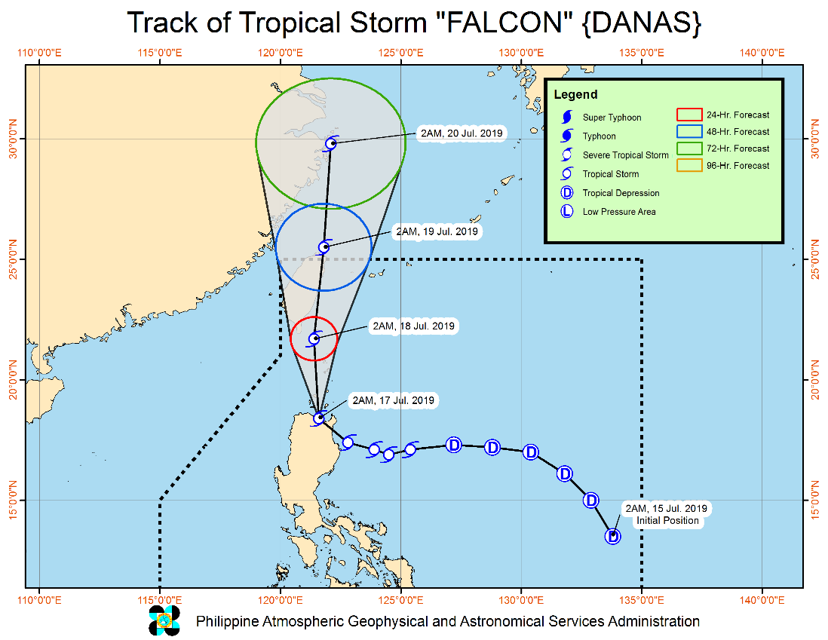
Situation Overview

"FALCON" IS NOW OFF THE COAST OF APARRI, CAGAYAN AND HEADED TOWARDS BABUYAN GROUP OF ISLANDS.
- Today, moderate to heavy rains will be experienced over Ilocos Region, Cordillera Administrative Region, Cagayan Valley, Central Luzon, Cavite, Batangas, Occidental Mindoro, northern Palawan including Calamian and Cuyo Islands, Aklan, Antique, Capiz, Iloilo, and Guimaras. Meanwhile, light to moderate with at times heavy rains will be experienced over Metro Manila, CALABARZON, Bicol Region, and the rest of Visayas, and the rest of MIMAROPA.
- Tomorrow (July 18) evening, moderate to heavy rains may prevail over Ilocos Region, Zambales, Bataan, Batangas, Cavite, and Occidental Mindoro. Meanwhile, light to moderate with at times heavy rains may prevail over the Metro Manila, Cagayan Valley, Cordillera Administrative Region, rest of Central Luzon and CALABARZON, and MIMAROPA.
- Residents in the aforementioned areas, especially those living in areas identified to be at risk of flooding and landslides, are advised to take precautionary measures, coordinate with local disaster risk reduction and management offices, and continue monitoring for updates, especially the Thunderstorm Advisories and Heavy Rainfall Warnings to be issued by PAGASA Regional Services Divisions.
- Sea travel is risky over the seaboards of areas under TCWS, the eastern seaboard of Central Luzon, the seaboard of Southern Luzon, and the eastern and western seaboards of Visayas.
- This weather may exit the Philippine Area of Responsibility on Friday (19 July) morning.
At 4:00 AM today, the center of Tropical Storm "FALCON" was estimated based on all available data in the coastal waters of Aparri, Cagayan (18.5 °N, 121.5 °E)
Source: DOST-PAGASA Severe Weather Bulletin
PREDICTIVE ANALYTICS FOR HUMANITARIAN RESPONSE

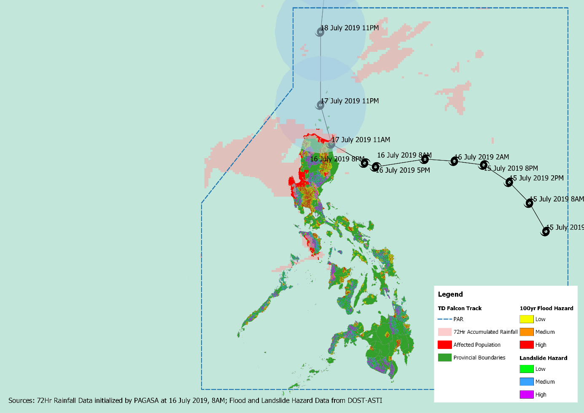
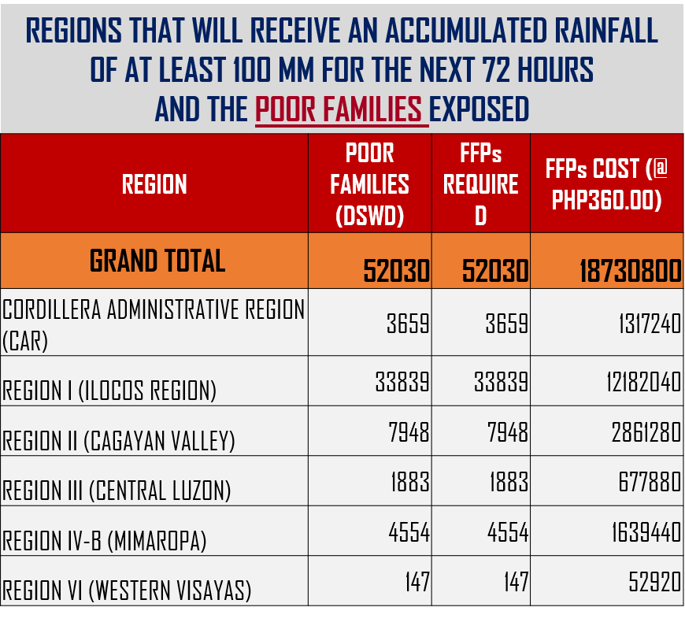

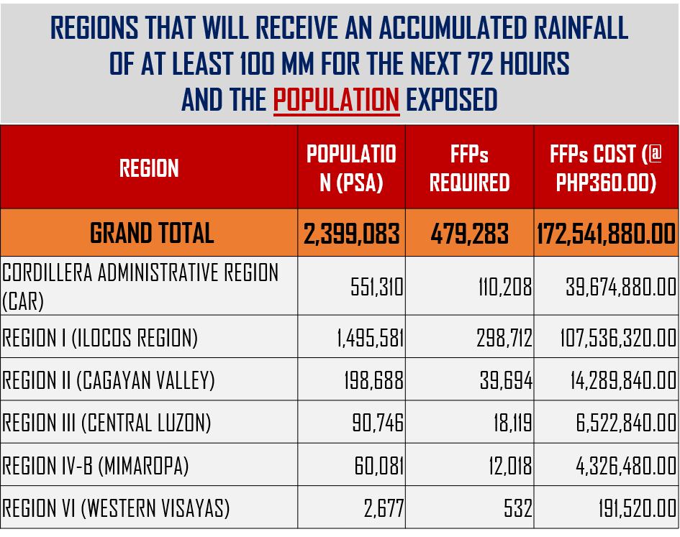

Status of Prepositioned Resources: Stockpile and Standby Funds

The DSWD Central Office (CO), Field Offices (FOs), and National Resource Operations Center (NROC) have stockpiles and standby funds amounting to ₱1,984,745,767.19 with breakdown as follows (see Table 1):

- Standby Funds
A total of ₱1,190,869,415.84 standby funds in the CO and FOs. Of the said amount, ₱1,146,974,543.16 is the available Quick Response Fund (QRF) in the CO.

- Stockpiles
A total of 359,124 Family Food Packs (FFPs) amounting to ₱134,922,306.28 and available Food and Non-food Items (FNIs) amounting to ₱658,954,045.07.

FIELD OFFICE | STANDBY FUNDS | STOCKPILES |  |  |  |  | Total STANDBY FUNDS & STOCKPILE
 |  | Family Food Packs |  | Other Food Items | Non Food Items | SUB-TOTAL (Food and NFIs)
 |  | Quantity | Total Cost | Total Cost | Total Cost
 |  | 359,124 | 134,922,306.28 | 161,342,886.34 | 497,611,158.73
TOTAL | 1,190,869,415.84 | 359,124 | 134,922,306.28 | 161,342,886.34 | 497,611,158.73 | 658,954,045.07 | 1,984,745,767.19
Central Office | 1,146,974,543.16 |  |  |  |  |  | 1,146,974,543.16
NRLMB - NROC | 0.00 | 98,800 | 37,261,432.00 | 79,438,561.86 | 330,957,856.78 | 410,396,418.64 | 447,657,850.64
NRLMB - VDRC | 0.00 | 11,700 | 4,212,000.00 | 1,203,200.00 | 5,224,562.31 | 6,427,762.31 | 10,639,762.31
I | 2,379,275.00 | 7,846 | 2,824,560.00 | 2,257,200.00 | 37,869,937.80 | 40,127,137.80 | 45,330,972.80
II | 2,607,537.00 | 17,434 | 5,731,851.40 | 3,352,676.29 | 349,602.75 | 3,702,279.04 | 12,041,667.44
III | 2,404,557.00 | 26,229 | 11,140,309.24 | 899,919.70 | 241,706.00 | 1,141,625.70 | 14,686,491.94
CALABARZON | 2,544,350.00 | 4,859 | 1,750,614.94 | 3,418,826.40 | 2,398,989.61 | 5,817,816.01 | 10,112,780.95
MIMAROPA | 1,494,971.58 | 24,764 | 10,351,352.00 | 2,243,173.55 | 859,605.00 | 3,102,778.55 | 14,949,102.13
V | 3,000,000.00 | 20,187 | 7,823,020.34 | 11,417,748.72 | 40,704,948.22 | 52,122,696.94 | 62,945,717.28
VI | 3,000,000.00 | 20,373 | 7,497,110.00 | 8,109,495.37 | 3,738,152.50 | 11,847,647.87 | 22,344,757.87
VII | 3,000,000.00 | 20,232 | 7,283,520.00 | 17,439,687.87 | 14,879,591.20 | 32,319,279.07 | 42,602,799.07
VIII | 3,001,960.00 | 29,306 | 10,591,774.52 | 1,304,119.84 | 1,163,983.00 | 2,468,102.84 | 16,061,837.36
IX | 1,768,321.35 | 10,119 | 3,642,840.00 | 813,730.00 | 3,793,242.35 | 4,606,972.35 | 10,018,133.70
X | 3,000,000.00 | 9,004 | 3,241,440.00 | 6,564,325.20 | 31,673,552.96 | 38,237,878.16 | 44,479,318.16
XI | 3,028,750.00 | 19,181 | 6,932,013.40 | 11,053,700.00 | 10,869,627.34 | 21,923,327.34 | 31,884,090.74
XII | 3,680,801.30 | 5,908 | 2,369,108.00 | 2,769,132.67 | 851,017.26 | 3,620,149.93 | 9,670,059.23
CARAGA | 3,000,000.00 | 13,617 | 4,966,096.50 | 1,682,002.00 | 6,193,295.05 | 7,875,297.05 | 15,841,393.55
NCR | 3,292,543.50 | 3,665 | 1,341,789.14 | 1,998,746.57 | 928,770.00 | 2,927,516.57 | 7,561,849.21
CAR | 2,691,805.95 | 15,900 | 5,961,474.80 | 5,376,640.30 | 4,912,718.60 | 10,289,358.90 | 18,942,639.65
*Quick Response Fund (QRF) as of 12 July 2019

Situational Reports

DSWD-DRMB
DATE | SITUATIONS / ACTIONS UNDERTAKEN
17 July 2019 | - The Disaster Response Management Bureau (DRMB) is on BLUE Alert Status and is closely coordinating with the concerned DSWD-Field Offices for significant disaster preparedness for response updates.  - All QRT members and emergency equipment are on standby and ready for deployment.

DSWD-FO CAR
DATE | SITUATIONS / ACTIONS UNDERTAKEN
16 July 2019 | - The Disaster Response Operations Monitoring and Information Center (DROMIC) of the DSWD-FO CAR is on BLUE Alert Level Status.  - The Provincial Social Welfare and Development Teams (PSWADT) DRMD PDO IIs are alerted; members are on standby for possible effects of the weather disturbance.  - Rapid Emergency Telecommunications Team (RETT) including the International Maritime/Marine Satellite (INMARSAT) equipment are on standby.

DSWD-FO I
DATE | SITUATIONS / ACTIONS UNDERTAKEN
- July 2019 | - The Disaster Response Management Division (DRMD) staff of DSWD-FO I together with the Provincial Operations Offices (POOs) are closely monitoring the possible effects of the current weather condition and ensuring submission of reports when needed.  - DRMD attended and presided the Emergency Response Plan (ERP)/ Pre-Disaster Risk Assessment (PDRA) Meeting at the Regional Disaster Risk Reduction and Management Council Emergency Operations Center (RDRRMC-EOC) to synchronize plans and activities that would lessen the adverse effect that might be brought by the tropical depression.

DSWD-FO II
DATE | SITUATIONS / ACTIONS UNDERTAKEN
- July 2019 | - DSWD-FO II is RED on Alert Status. Thus, the Regional Disaster Management and Response Team (RDMRT), SWAD Cagayan and Isabela, C/MATS of the said provinces are now on 24-hour duty to monitor the possible effects of TD Falcon.  - As per report of SWAD Team Leader of Batanes, the PDRRMO already distributed nylon ropes to all houses made of light materials to six municipalities in the event that TD Falcon accelerates its strength.  - DSWD-FO II is continuously coordinating with SWADTs and C/MATs for weather advisories.

DSWD-FO CALABARZON
DATE | SITUATIONS / ACTIONS UNDERTAKEN
- July 2019 | - DSWD-FO CALABARZON Emergency Operations Center is already activated to monitor the possible effects of TD Falcon.  - DSWD-FO CALABARZON through the Disaster Response Management Division (DRMD) is constantly coordinating with the Local Social Welfare and Development Offices (LSWDOs) with pre-disaster assessments being conducted.  - DRMD is in close coordination with LGUs with regards to the preparedness efforts undertaken in the Flood, Landslide and Storm Surge prone areas.  - DRMD is continuously coordinating with SWAD Team Leaders and Provincial Action Team of CALABARZON Provinces and advised them to coordinate with LGUs to gather reports on the possible effects of TD Falcon.

DSWD-FO MIMAROPA
DATE | SITUATIONS / ACTIONS UNDERTAKEN
- July 2019 | - DSWD-FO MIMAROPA through the Disaster Response Management Division ensures an on-call and standby duty of the R/P/C/M Quick Response Teams for possible activation of Operations Center.  - All members of Rapid Emergency Telecommunications Team are on standby status ready for deployment if needed.  - DSWD-FO MIMAROPA ensures that relief goods are readily available for distribution.  - DSWD-FO MIMAROPA is in close coordination with the Office of Civil Defense (OCD) and RDRRMC MIMAROPA for any warning signal updates in response to the areas that will be affected.
DSWD-FO V
DATE | SITUATIONS / ACTIONS UNDERTAKEN
- July 2019 | - DSWD-FO V is continuously monitoring weather updates and information.  - DSWD-FO V QRTs are on standby for 24/7 duty at the DRMD Operations Center. QRTs are alerted and advised to be prepared for augmentation support needed from the field.  - The PAT and MAT members in the 6 provinces are on standby and to coordinate with the P/MDRRMOs for status reports and updates.
DSWD-FO XI
DATE | SITUATIONS / ACTIONS UNDERTAKEN
- July 2019 | - DSWD-FO XI has a total of 19,181 readily available family food packs.  - DSWD-FO XI activated the Field Office’s and RPMO’s (SWADTs, PATs, MATs, CATs) Quick Response Team as “On-Call Duty”  - DSWD-FO XI is closely coordinating with all SWADOs and PSWDOs/CSWDO/MSWDOs for monitoring of the situation in the different parts of Davao Region.  - DSWD-FO XI is closely coordinating with Office of Civil Defense (OCD) XI for monitoring purposes and response mechanisms.

*****
The Disaster Response Operations Monitoring and Information Center (DROMIC) of the DSWD-DRMB is closely monitoring the effects of TS Falcon and is coordinating with the concerned DSWD-Field Offices for any significant updates.

PREPARED BY:

MARIEL B. FERRARIZ

CLARRIE MAE A. CASTILLO

KIM AUSTIN A. ASPILLAGA
Releasing Officer

