DSWD DROMIC Report #1
on the Earthquake Incident in Carrascal, Surigao del Sur
as of 14 July 2019, 4PM

Situation Overview
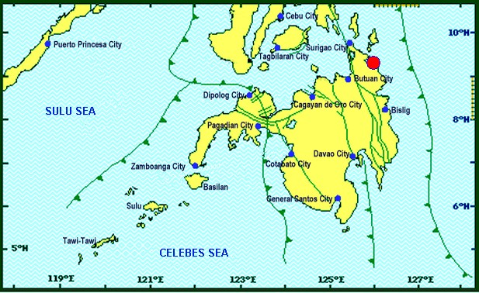

On July 13, 2019 at 4;42 AM, a 5.5 magnitude earthquake jolted the municipality of Carrascal, Surigao del Sur (09.32°N, 125.99°E - 007 km S 37° E) with a tectonic origin and a depth of focus of 4km. The earthquake was also felt in the neighboring municipalities of Surigao del Sur and in some parts of the region.
Reported Intensities : | Intensity VI - Carrascal, Cantilan, Carmen, Lanuza, and Madrid, Surigao Del Sur  Intensity V - Bayabas, and Cortes, Surigao Del Sur; Butuan City  Intensity IV - Surigao City; Tandag City; Gingoog City; Claver, Surigao Del Norte; Magsaysay,  Misamis Oriental; Talacogon, Agusan Del Sur  Intensity III - Cagwait, Surigao Del Sur; Socorro, Surigao Del Norte; Balingasag, Balingoan,  Jasaan, Salay, and Villanueva, Misamis Oriental; Pintuyan, San Francisco, and San Ricardo,  Southern Leyte; Cagayan De Oro City  Intensity II - Mambajao, Camiguin  Instrumental Intensities:  Intensity IV - Gingoog City  Intensity II - Cebu City; Borongan City  Intensity I - Bislig City; Cagayan de Oro City; Palo, Leyte
Expecting Damage: | YES
Expecting Aftershocks: | YES

Source: DOST-PHIVOLCS Earthquake Bulletin
- Status of Affected Families / Persons
206 families or 826 persons are affected in 9 barangays (see Table 1).

Table 1. Affected Families / Persons
REGION / PROVINCE / MUNICIPALITY |  | NUMBER OF AFFECTED
 |  | Barangays | Families | Persons
GRAND TOTAL |  | 9 | 206 | 826
CARAGA |  | 9 | 206 | 826
Surigao del Sur |  | 9 | 206 | 826
 | Carmen | 8 | 204 | 816
 | Lanuza | 1 | 2 | 10
Note: Ongoing assessment and validation
Source: DSWD-FO CARAGA

- Damaged Houses
A total of 206 houses were damaged by the fire; of which, 5 houses were totally damaged and 201 houses were partially damaged (see Table 2).

Table 2. Number of Damaged Houses
REGION / PROVINCE / MUNICIPALITY |  | NO. OF DAMAGED HOUSES
 |  | Total | Totally | Partially
GRAND TOTAL |  | 206 | 5 | 201
CARAGA |  | 206 | 5 | 201
Surigao del Sur |  | 206 | 5 | 201
 | Carmen | 204 | 4 | 200
 | Lanuza | 2 | 1 | 1
Note: Ongoing assessment and validation
Source: DSWD-FO CARAGA

Situational Reports

DSWD-DRMB
DATE | SITUATIONS / ACTIONS UNDERTAKEN
14 July 2019 | - The Disaster Response Operations Monitoring and Information Center (DROMIC) of the DSWD-DRMB continues to closely coordinate with DSWD-FO CARAGA for significant reports on the status of affected families, assistance, and relief efforts.

DSWD-FO CARAGA
DATE | ACTION(S) TAKEN
14 July 2019 | - DSWD-FO CARAGA thru the Disaster Response and Management Division (DRMD) together with the SWAD Team Leader of Surigao del Sur is conducting an assessment and validation to the affected areas in Surigao del Sur for possible intervention of the injured individuals in the form medical assistance and food subsidy.  - The Field Office will facilitate the distribution of 448 family food packs to the affected families in Carmen, Surigao del Sur amounting to PhP163,296.00.  - The Field Office is constantly coordinating and monitoring with the LSWDOs and LDRRMOs with their situation. Subsequent updates will be provided once the LGUs submit their report regarding the incident.

***
The Disaster Response Operations Monitoring and Information Center (DROMIC) of the DSWD-DRMB is closely coordinating with DSWD-FO CARAGA for any significant disaster response updates.

Prepared by:

MADELINE B. SALAMAT

JOANNA CAMILLE R. JACINTO
Releasing Officer

