DSWD DROMIC Report #1
on the Earthquake Incident in Itbayat, Batanes
as of 27 July 2019, 4PM

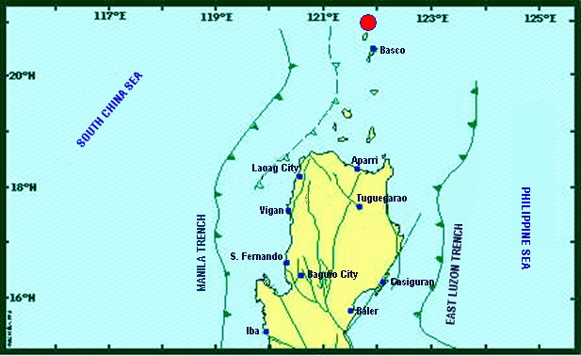

Situation Overview

On 27 July 2019 at 4:16 AM, a 5.4 magnitude earthquake jolted the municipality of Itbayat, Batanes (20.90°N, 121.85°E - 012 km N 04° E) with a tectonic origin and a depth of focus of 12 km. The earthquake was also felt in the neighboring municipalities of Batanes.

Date/Time: | 27 Jul 2019 - 04:16:54 AM
Reported Intensities: | Intensity VI - Itbayat, Batanes  Intensity III - Basco and Sabtang, Batanes  Instrumental Intensity:  Intensity III - Basco, Batanes
Expecting Damage: | YES
Expecting Aftershocks: | YES
Source: DOST-PHIVOLCS Earthquake Bulletin

- Status of Affected Families / Persons
A total of 911 families or 2,963 persons were affected by the earthquake incident in 5 barangays in Itbayat, Batanes (see Table 1).

Table 1. Number of Affected Families / Persons
REGION / PROVINCE / MUNICIPALITY |  | NUMBER OF AFFECTED
 |  | Barangays | Families | Persons
GRAND TOTAL |  | 5 | 911 | 2,963
REGION II |  | 5 | 911 | 2,963
Batanes |  | 5 | 911 | 2,963
 | Itbayat | 5 | 911 | 2,963
Note: Ongoing assessment and validation being conducted.
Source: DSWD-FO II

- Status of Displaced Families / Persons
911 families or 2,963 persons are currently staying at the Public Market in Brgy. San Rafael, Itbayat, Batanes (see Table 2).

Table 2. Number of Displaced Families / Persons Inside Evacuation Center
REGION / PROVINCE / MUNICIPALITY |  | NUMBER OF EVACUATION CENTERS (ECs) |  | INSIDE ECs
 |  |  |  | Families |  | Persons
 |  | CUM | NOW | CUM | NOW | CUM | NOW
GRAND TOTAL |  | 1 | 1 | 911 | 911 | 2,963 | 2,963
REGION II |  | 1 | 1 | 911 | 911 | 2,963 | 2,963
Batanes |  | 1 | 1 | 911 | 911 | 2,963 | 2,963
 | Itbayat | 1 | 1 | 911 | 911 | 2,963 | 2,963
Note: Ongoing assessment and validation
Source: DSWD-FO II

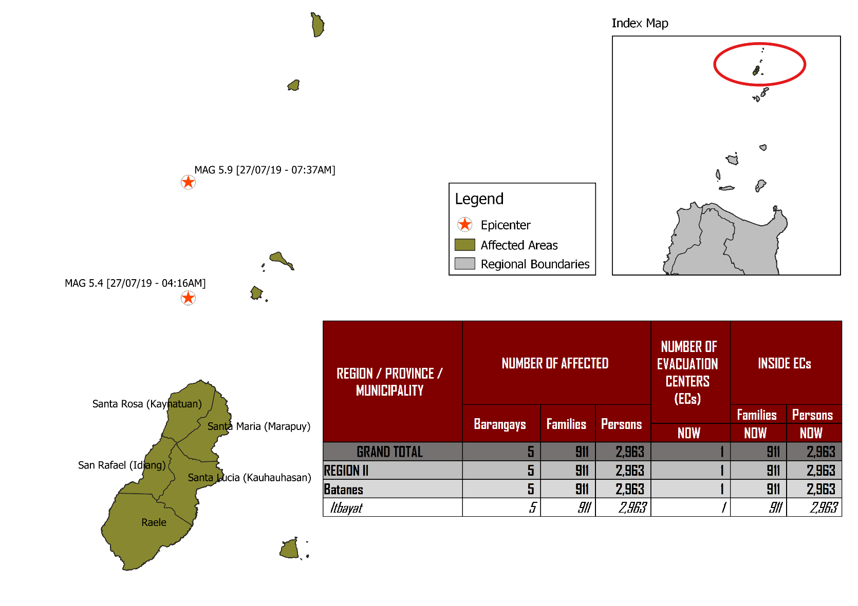
DSWD DISASTER RESPONSE INFORMATION
Source: DRMB-DROMIC GIS Specialists

Status of Prepositioned Resources: Stockpile and Standby Funds

The DSWD Central Office (CO), Field Offices (FOs), and National Resource Operations Center (NROC) have stockpiles and standby funds amounting to ₱1,973,907,180.67 with breakdown as follows (see Table 1):

- Standby Funds
A total of ₱1,183,258,066.22 standby funds in the CO and FOs. Of the said amount, ₱1,146,974,543.16 is the available Quick Response Fund (QRF) in the CO.

- Stockpiles
A total of 359,879 Family Food Packs (FFPs) amounting to ₱134,019,340.42 and available Food and Non-food Items (FNIs) amounting to ₱656,629,774.03.

FIELD OFFICE | STANDBY FUNDS | STOCKPILES |  |  |  |  | Total STANDBY FUNDS & STOCKPILE
 |  | Family Food Packs |  | Other Food Items | Non Food Items | SUB-TOTAL (Food and NFIs)
 |  | Quantity | Total Cost | Total Cost | Total Cost
TOTAL | 1,183,258,066.22 | 359,879 | 134,019,340.42 | 160,756,170.36 | 495,873,603.67 | 656,629,774.03 | 1,973,907,180.67
Central Office | 1,146,974,543.16 |  |  |  |  |  | 1,146,974,543.16
NRLMB - NROC | 0.00 | 103,200 | 38,920,848.00 | 82,564,936.86 | 330,634,906.88 | 413,199,843.74 | 452,120,691.74
NRLMB - VDRC | 0.00 | 11,700 | 4,212,000.00 | 1,203,200.00 | 5,224,562.31 | 6,427,762.31 | 10,639,762.31
I | 2,379,275.00 | 14,393 | 5,181,480.00 | 1,094,185.92 | 33,381,090.79 | 34,475,276.71 | 42,036,031.71
II | 2,607,537.00 | 26,616 | 8,499,924.40 | 526,640.00 | 349,602.75 | 876,242.75 | 11,983,704.15
III | 2,404,557.00 | 26,192 | 10,257,281.28 | 899,919.70 | 241,406.00 | 1,141,325.70 | 13,803,163.98
CALABARZON | 1,960,100.00 | 4,697 | 1,689,515.26 | 3,898,207.60 | 3,288,354.81 | 7,186,562.41 | 10,836,177.67
MIMAROPA | 1,938,971.58 | 24,756 | 10,348,008.00 | 2,243,173.55 | 859,605.00 | 3,102,778.55 | 15,389,758.13
V | 3,000,000.00 | 18,521 | 7,223,190.00 | 10,485,948.72 | 40,704,948.22 | 51,190,896.94 | 61,414,086.94
VI | 1,150,000.00 | 18,194 | 6,755,520.00 | 7,299,157.17 | 3,713,837.50 | 11,012,994.67 | 18,918,514.67
VII | 3,000,000.00 | 16,135 | 5,808,600.00 | 18,731,977.83 | 18,505,387.11 | 37,237,364.94 | 46,045,964.94
VIII | 1,401,960.00 | 24,167 | 8,734,437.14 | 1,304,119.84 | 896,387.00 | 2,200,506.84 | 12,336,903.98
IX | 843,321.35 | 10,119 | 3,642,840.00 | 813,730.00 | 3,793,242.35 | 4,606,972.35 | 9,093,133.70
X | 3,000,000.00 | 1,512 | 544,320.00 | 6,593,047.20 | 30,362,019.90 | 36,955,067.10 | 40,499,387.10
XI | 3,028,750.00 | 25,381 | 9,185,285.40 | 11,053,700.00 | 10,921,627.34 | 21,975,327.34 | 34,189,362.74
XII | 584,701.68 | 4,724 | 1,894,324.00 | 3,484,211.10 | 2,348,437.26 | 5,832,648.36 | 8,311,674.04
CARAGA | 3,000,000.00 | 10,014 | 3,821,443.00 | 946,748.00 | 4,806,699.85 | 5,753,447.85 | 12,574,890.85
NCR | 3,292,543.50 | 3,665 | 1,341,789.14 | 1,998,746.57 | 928,770.00 | 2,927,516.57 | 7,561,849.21
CAR | 2,691,805.95 | 15,893 | 5,958,534.80 | 5,614,520.30 | 4,912,718.60 | 10,527,238.90 | 19,177,579.65
*Quick Response Fund (QRF) as of 26 July 2019

Situational Reports

DSWD-DRMB
DATE | SITUATIONS / ACTIONS UNDERTAKEN
27 July 2019 | - The Disaster Response Management Bureau (DRMB) is on BLUE Alert Level Status and is closely coordinating with the DSWD-Field Office II for significant disaster preparedness for response updates.  - All QRT members and emergency equipment are on standby and ready for deployment.

DSWD-FO II
DATE | ACTION(S) TAKEN
27 July 2019 | - DSWD-FO II is on RED Alert Level Status.  - There are a total of 100 Family Food Packs worth ₱36,000 and 100 boxes of instant coffee readily available for pick-up at the DSWD-FO to be delivered to Itbayat, Batanes.  - The DRMD Staff will be deployed to the province of Batanes for augmentation support.  - DSWD-FO II is requesting for 100 family tents and 400 sleeping kits.  - DSWD-FO II is continuously coordinating with SWADT Batanes and MSWDO of Itbayat for updates and request on augmentation support.

***
The Disaster Response Operations Monitoring and Information Center (DROMIC) of the DSWD-DRMB is closely coordinating with DSWD-FO II for any significant disaster response updates.

Prepared by:

MARIE JOYCE G. RAFANAN

RODEL V. CABADDU
Releasing Officer

