DSWD DROMIC Report #1
on the Earthquake Incident in Makilala, North Cotabato
as of 14 July 2019, 12PM

Situation Overview

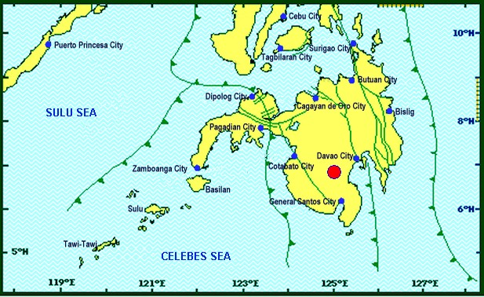

On July 9, 2019 at exactly 8:37 PM, a Magnitude 5.6 earthquake shook Makilala, North Cotabato. The epicenter of the earthquake was located 06.83°N, 125.02°E - 016 km S 30° W of Makilala (North Cotabato) with a depth focus of 010 km and with a Tectonic origin.

Reported Intensities (11:00 AM): | Intensity VI - Makilala, Kidapawan City, Matalam, M'lang, Antipas &Tulunan, North Cotabato  Intensity V - Koronadal City; Santa Cruz & Magsaysay, Davao Del Sur; Digos, City  Intensity IV - Magpet & Kabacan North Cotabato; Davao City; Polomolok, Tupi, Tampakan,  & Sto. Nino, South Cotabato; Tacurong City; President Quirino, Sultan Kudarat; Glan,  Alabel & Malungon, Sarangani; Bansalan, Davao Del Sur  Intensity III - General Santos City; Kiamba, Sarangani; Kalilangan & Damolog, Bukidnon;  Carmen, North Cotabato; Bagumbayan, Sultan Kudarat  Intensity II - Cotabato City; Nabunturan, Compostela Valley; Valencia City; Maramag, Lantapan,  Cabanglasan, Kadingilan, & Kibawe, Bukidnon; Pikit, North Cotabato; Cagayan de Oro City;  Alubijid, Balingasag, Balingoan, Binuangan, Claveria, Gitagum, Initao, Jasaan, Kinoguitan,  Lagonglong, Laguindingan, Libertad, Lugait, Magsaysay, Manticao, Medina, Naawan, Opol,  Salay, Sugbongcogon, Tagoloan, Talisayan and Villanueva, Misamis Oriental  Instrumental Intensities:  Intensity V - Kidapawan City  Intensity IV - Alabel, Sarangani  Intensity III - General Santos City  Intensity II - Cotabato City; Cagayan de Oro City  Intensity I - Zamboanga City; Gingoog City
Expecting Damage: | YES
Expecting Aftershocks: | YES

Source: DOST-PHIVOLCS Earthquake Bulletin

- Status of Affected Families / Persons
153 families or 765 persons are affected in 9 barangays (see Table 1).

Table 1. Affected Families / Persons
REGION / PROVINCE / MUNICIPALITY |  | NUMBER OF AFFECTED
 |  | Barangays | Families | Persons
GRAND TOTAL |  | 9 | 153 | 765
REGION XII |  | 9 | 153 | 765
North Cotabato |  | 9 | 153 | 765
 | Makilala | 9 | 153 | 765
Note: Ongoing assessment and validation
Source: DSWD-FO XII

- Status of Displaced Families, Persons

There are 153 families or 765 persons who are currently staying with their relatives and/or friends (See Table 2).

Table 2. Number of Displaced Families Outside Evacuation Centers
REGION / PROVINCE / MUNICIPALITY |  | OUTSIDE ECs
 |  | Families |  | Persons
 |  | CUM | NOW | CUM | NOW
GRAND TOTAL |  | 153 | 153 | 765 | 765
REGION XII |  | 153 | 153 | 765 | 765
North Cotabato |  | 153 | 153 | 765 | 765
 | Makilala | 153 | 153 | 765 | 765
Note: Ongoing assessment and validation
Source: DSWD-FO XII

Situational Reports

DSWD-DRMB
DATE | SITUATIONS / ACTIONS UNDERTAKEN
14 July 2019 | - The Disaster Response Operations Monitoring and Information Center (DROMIC) of the DSWD-DRMB continues to closely coordinate with DSWD-FO XII for significant reports on the status of affected families, assistance, and relief efforts.

DSWD-FO XII
DATE | ACTION(S) TAKEN
14 July 2019 | - DSWD Field Office XII is in close coordination with MSWDO of North Cotabato for monitoring and validation of the incident.  - DSWD Field Office XII is conducting on-going assessment on damaged houses.

***
The Disaster Response Operations Monitoring and Information Center (DROMIC) of the DSWD-DRMB continues to closely coordinate with the concerned DSWD Field Offices for updating of regional situation and preparedness for response.

Prepared by:

JOANNA CAMILLE R. JACINTO

RODEL V. CABADDU
Releasing Officer

