DSWD DROMIC Report #10
on the Earthquake Incident in Itbayat, Batanes
as of 02 August 2019, 5PM

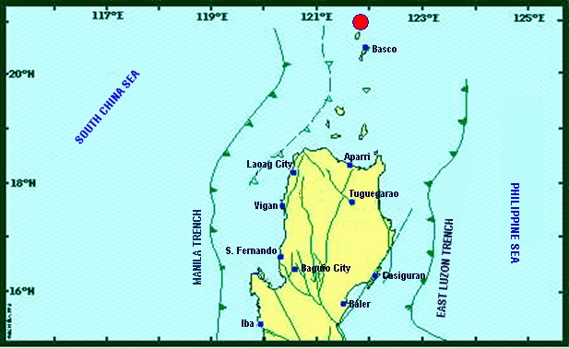

Situation Overview

On 27 July 2019 at 4:16 AM, a 5.4 magnitude earthquake jolted the municipality of Itbayat, Batanes (20.90°N, 121.85°E - 012 km N 04°E) with a tectonic origin and a depth of focus of 12 km. The earthquake was also felt in the neighboring municipalities of Batanes.

Date/Time: | 27 Jul 2019 - 04:16:54 AM
Reported Intensities: | Intensity VI - Itbayat, Batanes  Intensity III - Basco and Sabtang, Batanes  Instrumental Intensity:  Intensity III - Basco, Batanes
Expecting Damage: | YES
Expecting Aftershocks: | YES

Source: DOST-PHIVOLCS Earthquake Bulletin

At 3:00 PM today, the Low Pressure Area (LPA) was estimated based on all available data at 1,060 km East of Virac, Catanduanes (14.4°N, 134.0°E). The rest of the country including Batanes will experience partly cloudy to cloudy skies with isolated rainshowers caused by localized thunderstorms. Possible impacts are flashfloods during severe thunderstorms. The rest of Luzon will experience light to moderate wind speed flowing from North to Northwest with moderate to rough / (1.2 to 3.4 meters) coastal water.

Source: PAGASA Daily Weather Forecast

- Status of Affected Families / Persons
A total of 1,025 families or 2,968 persons were affected by the earthquake incident in 5 barangays in Itbayat, Batanes (see Table 1).

Table 1. Number of Affected Families / Persons
REGION / PROVINCE / MUNICIPALITY |  | NUMBER OF AFFECTED
 |  | Barangays | Families | Persons
GRAND TOTAL |  | 5 | 1,025 | 2,968
REGION II |  | 5 | 1,025 | 2,968
Batanes |  | 5 | 1,025 | 2,968
 | Itbayat | 5 | 1,025 | 2,968
Note: Ongoing assessment and validation being conducted.
Source: DSWD-FO II

- Status of Displaced Families / Persons
109 families or 379 persons are currently staying at the Covered Court/Municipal Plaza in Brgy. San Rafael, Itbayat, Batanes (see Table 2).

Table 2. Number of Displaced Families / Persons Inside Evacuation Center
REGION / PROVINCE / MUNICIPALITY |  | NUMBER OF EVACUATION CENTERS (ECs) |  | INSIDE ECs
 |  |  |  | Families |  | Persons
 |  | CUM | NOW | CUM | NOW | CUM | NOW
GRAND TOTAL |  | 1 | 1 | 742 | 109 | 2,368 | 379
REGION II |  | 1 | 1 | 742 | 109 | 2,368 | 379
Batanes |  | 1 | 1 | 742 | 109 | 2,368 | 379
 | Itbayat | 1 | 1 | 742 | 109 | 2,368 | 379
Note: Ongoing assessment and validation being conducted.
Source: DSWD-FO II

- Damaged Houses
There are 207 damaged houses; of which, 27 are partially damaged and 180 are totally damaged (see Table 3).

Table 3. Number of Damaged Houses
REGION / PROVINCE / MUNICIPALITY |  | NO. OF DAMAGED HOUSES
 |  | Total | Totally | Partially
GRAND TOTAL |  | 207 | 180 | 27
REGION II |  | 207 | 180 | 27
Batanes |  | 207 | 180 | 27
 | Itbayat | 207 | 180 | 27
Note: Ongoing assessment and validation being conducted.
*The decrease in the number of damaged houses is based on the continuous validation being conducted by the Regional DANA Team, Barangay and LGU officials through MSWDO.
Source: DSWD-FO II

- Assistance Provided
A total of ₱128,880.00 worth of assistance was provided by DSWD to the affected families (see Table 4).

Table 4. Cost of Assistance Provided to Affected Families / Persons
REGION / PROVINCE / MUNICIPALITY |  | TOTAL COST OF ASSISTANCE
 |  | DSWD | LGU | NGOs | OTHERS | GRAND TOTAL
GRAND TOTAL |  | 128,880.00 | - | - | - | 128,880.00
REGION II |  | 128,880.00 | - | - | - | 128,880.00
Batanes |  | 128,880.00 | - | - | - | 128,880.00
 | Itbayat | 128,880.00 | - | - | - | 128,880.00

Source: DSWD-FO II

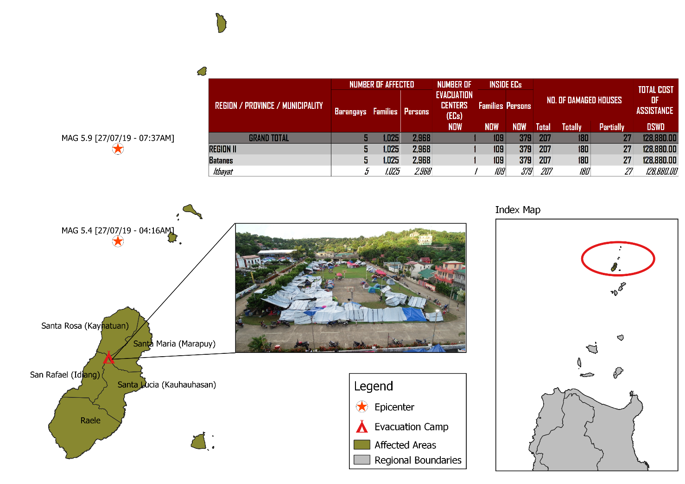
DSWD DISASTER RESPONSE INFORMATION

Source: DRMB-DROMIC GIS Specialists

Status of Prepositioned Resources: Stockpile and Standby Funds
The DSWD Central Office (CO), Field Offices (FOs), and National Resource Operations Center (NROC) have stockpiles and standby funds amounting to ₱1,972,905,977.22 with breakdown as follows (see Table 1):

- Standby Funds
A total of ₱1,181,581,331.18 standby funds in the CO and FOs. Of the said amount, ₱1,146,974,543.16 is the available Quick Response Fund (QRF) in the CO.

- Stockpiles
A total of 358,136 Family Food Packs (FFPs) amounting to ₱134,470,535.44 and available Food and Non-food Items (FNIs) amounting to ₱656,854,110.60.
FIELD OFFICE | STANDBY FUNDS | STOCKPILES |  |  |  |  | Total STANDBY FUNDS & STOCKPILE
 |  | Family Food Packs |  | Other Food Items | Non Food Items | SUB-TOTAL (Food and NFIs)
 |  | Quantity | Total Cost | Total Cost | Total Cost
TOTAL | 1,181,581,331.18 | 358,136 | 134,470,535.44 | 161,926,836.96 | 494,927,273.64 | 656,854,110.60 | 1,972,905,977.22
Central Office* | 1,146,974,543.16 | - | - | - | - | - | 1,146,974,543.16
NRLMB - NROC | - | 103,200 | 38,920,848.00 | 82,564,936.86 | 330,634,906.88 | 413,199,843.74 | 452,120,691.74
NRLMB - VDRC | - | 11,700 | 4,212,000.00 | 1,203,200.00 | 5,224,562.31 | 6,427,762.31 | 10,639,762.31
I | 2,379,275.00 | 14,393 | 5,181,480.00 | 1,094,185.92 | 33,381,090.79 | 34,475,276.71 | 42,036,031.71
II** | 930,801.96 | 28,562 | 10,282,282.00 | 526,640.00 | 349,602.75 | 876,242.75 | 12,089,326.71
III | 2,404,557.00 | 26,192 | 10,257,281.28 | 899,919.70 | 241,406.00 | 1,141,325.70 | 13,803,163.98
CALABARZON | 1,960,100.00 | 4,697 | 1,689,515.26 | 3,898,207.60 | 3,288,354.81 | 7,186,562.41 | 10,836,177.67
MIMAROPA | 1,938,971.58 | 24,756 | 10,348,008.00 | 2,243,173.55 | 859,605.00 | 3,102,778.55 | 15,389,758.13
V | 3,000,000.00 | 18,521 | 7,223,190.00 | 10,485,948.72 | 40,704,948.22 | 51,190,896.94 | 61,414,086.94
VI | 1,150,000.00 | 15,694 | 5,855,520.00 | 8,682,157.17 | 3,713,837.50 | 12,395,994.67 | 19,401,514.67
VII | 3,000,000.00 | 17,145 | 6,172,200.00 | 18,519,644.43 | 17,559,057.08 | 36,078,701.51 | 45,250,901.51
VIII | 1,401,960.00 | 21,968 | 7,939,674.56 | 1,304,119.84 | 896,387.00 | 2,200,506.84 | 11,542,141.40
IX | 843,321.35 | 10,119 | 3,642,840.00 | 813,730.00 | 3,793,242.35 | 4,606,972.35 | 9,093,133.70
X | 3,000,000.00 | 1,512 | 544,320.00 | 6,593,047.20 | 30,362,019.90 | 36,955,067.10 | 40,499,387.10
XI | 3,028,750.00 | 25,381 | 9,185,285.40 | 11,053,700.00 | 10,921,627.34 | 21,975,327.34 | 34,189,362.74
XII | 584,701.68 | 4,724 | 1,894,324.00 | 3,484,211.10 | 2,348,437.26 | 5,832,648.36 | 8,311,674.04
CARAGA | 3,000,000.00 | 10,014 | 3,821,443.00 | 946,748.00 | 4,806,699.85 | 5,753,447.85 | 12,574,890.85
NCR | 3,292,543.50 | 3,665 | 1,341,789.14 | 1,998,746.57 | 928,770.00 | 2,927,516.57 | 7,561,849.21
CAR | 2,691,805.95 | 15,893 | 5,958,534.80 | 5,614,520.30 | 4,912,718.60 | 10,527,238.90 | 19,177,579.65
*Quick Response Fund (QRF) as of 27 July 2019
**Status of Standby Funds and Stockpile of FO II as of 30 July 2019

Situational Reports

DSWD-DRMB
DATE | SITUATIONS / ACTIONS UNDERTAKEN
02 August 2019 | - The Disaster Response Management Bureau (DRMB) downgraded from BLUE alert level status to WHITE but will continuously coordinate with DSWD-FO II for significant disaster response updates.  - All QRT members and emergency equipment are on standby and ready for deployment.  - The four (4) staff from DSWD-DRMB who have arrived in Basco, Batanes to relieve the first team deployed last 27 July to 01 August 2019 and augment on CCCM, IDP Protection, and FNIs activities have already been provided with clearance to proceed to Itbayat including the 400 sleeping kits and 65 family tents from Clark Airport that were already loaded to the Faluwa boat. However, cause of delay of transport to Itbayat, Batanes is due to rough waters.
01 August 2019 | - DSWD-DRMB Team is in close coordination with the Procurement Service relative to the emergency procurement of the Satellite Phones Load.

DSWD-NRLMB
DATE | SITUATIONS / ACTIONS UNDERTAKEN
02 August 2019 | - Six (6) trucks from NROC carrying: 6,000 FFPs, 3,600 3kg vacuum-packed rice, 60,000 sachets of coffee, 1,500 mosquito nets, and 50 rolls of laminated sacks were delivered to Tuguegarao City.  - The BFAR vessel MCS 3010 departed Sangley Point, Cavite at 10 AM, 01 August 2019 and the two (2) Coast Guard vessels which departed at 4 AM in Manila carrying the following DSWD NRLMS dispatched items: 100 tents, 400 sleeping kits and 10 laminated sacks are temporarily sheltered at Subic bay due to bad weather. Awaiting for the estimated time of arrival of the three (3) vessels at Port Irene, Sta. Ana, Cagayan and Basco, Batanes.
31 July 2019 | - The 6,400 3kg-vacuum packed rice and 50 folding beds that has been delivered to DSWD-FO II on 29 July 2019 are stored in their warehouse for standby delivery to Itbayat, Batanes.
30 July 2019 | - The 100 family tents and 60 folding beds from NROC have been delivered to DSWD-FO II in Tuguegarao City.  - The requested 25 family tents and 400 sleeping kits from DSWD-FO I were delivered to Tuguegarao City.

DSWD-FO II
DATE | ACTION(S) TAKEN
02 August 2019 | - DSWD-FO II remains on RED alert level status.  - A total of ₱172,000.00 worth of financial assistance was provided to the affected families; of which, eight (8) families were provided with ₱10,000.00 burial assistance per family, eleven (11) affected individuals received food assistance at ₱5,000.00 each, one (1) affected individual was provided with ₱3,000.00 worth of food assistance, eight (8) affected individuals received medical assistance at ₱3,000.00 each, and two (2) affected individuals was provided with ₱5,000.00 worth of medical assistance.  - A total of ₱852,000.00 worth of social pension assistance was provided to the 284 affected senior citizens who received ₱3,000.00 each for the 1st and 2nd quarters. Ongoing distribution of financial assistance is being conducted for the remaining 26 senior citizens.  - For Unconditional Cash Transfer (UCT) for social pension, 166 or 68.31% out of the two hundred forty-three (243) beneficiaries paid. The team is continuously serving those remaining unpaid beneficiaries.  - The 3rd team of DSWD-FO II Staff will be joining the NHA and OCD teams tomorrow through C295 to conduct pay-out and to continue augmentation of CISD to the affected families.  - Five (5) DSWD-FO II staff are still in Itbayat, Batanes to continuously conduct stress debriefing, house-to-house visit relative to the assessment of damaged houses and continues provision of burial, medical, and food assistance.  - The Municipal Social Welfare Officer, Ms. Rosalia Castillo and the DSWD-FO II Social Welfare Officer II, Ms. Marlyn Tuazon are in Brgy. Raele and Sitio Yawran, Brgy. San Rafael to distribute the social pension of the twenty six (26) and seven (7) beneficiaries respectively who cannot afford to go to the town proper to receive the subsidy for the 1st and 2nd quarters.  - The LGU Piat, Cagayan donated 203 family food packs at ₱242.00 per pack for affected families in Itbayat, Batanes.
02 August 2019, 4AM | - The DSWD staff, Ms. Amparo Tobias and Ms. Mia Edsel Carbonell, DRMD PDO II attended the General Assembly convened by Gov. Marilou Cayco to discuss the early recovery on possible assistance to be extended to those affected families especially those with damaged houses. As part of the agreement, the DSWD will provide Emergency Shelter Assistance (ESA) to those families whose houses was totally/ partially damaged while the National Housing Authority (NHA) and the Provincial Government of Batanes will provide Temporary Shelter Assistance.
01 August 2019 | - The 312 FFPs from Tuguegarao Airport including the requested 25 family tents and 400 sleeping kits from DSWD-FO I, and 60 folding beds and 100 family tents from NRLMB were delivered from Tuguegarao City to Port Irene in Sta. Ana, Cagayan.
31 July 2019 | - The 158 FFPs worth ₱56,880.00 delivered to Itbayat, Batanes were already distributed to the 158 affected families inside EC.

***
The Disaster Response Operations Monitoring and Information Center (DROMIC) of the DSWD-DRMB is closely coordinating with DSWD-FO II for any significant disaster response updates.

Prepared by:

MARIE JOYCE G. RAFANAN

MARC LEO L. BUTAC
Releasing Officer
Photo Documentations
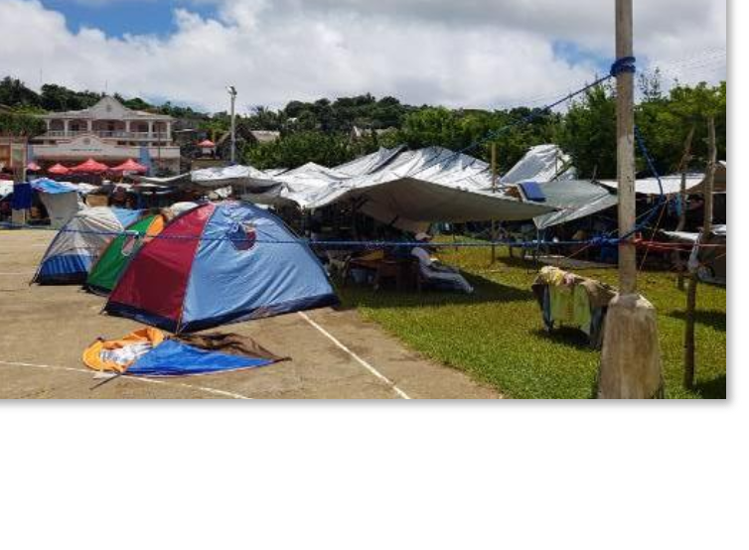
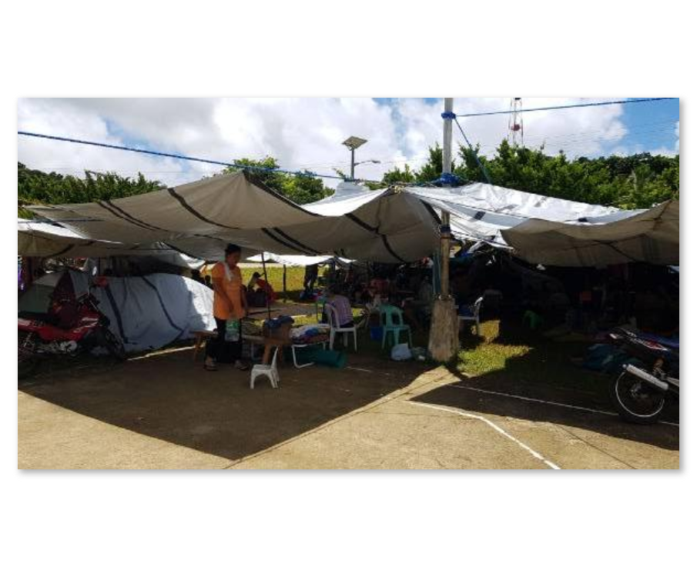
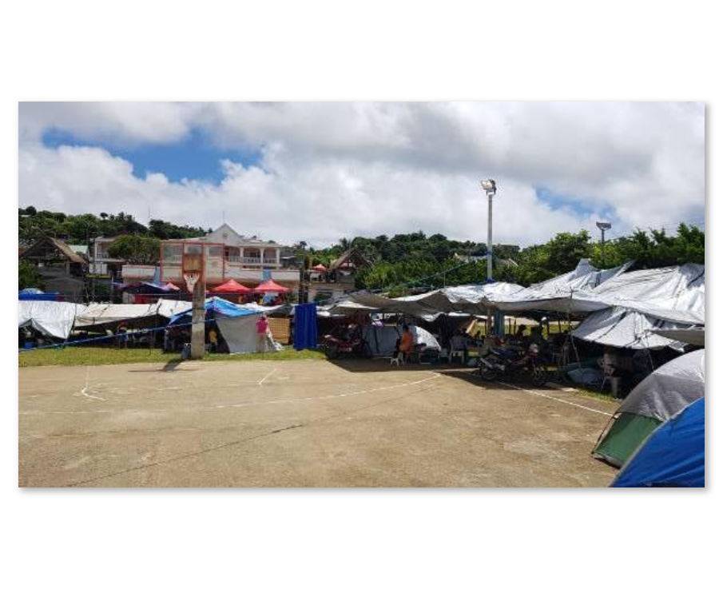
Covered Court/Municipal Plaza Open Ground Evacuation Center
Photos taken on 29 July 2019
Families are staying under makeshift tents.
As per coordination with Incident Commander (IC) Ms. Sharmaine Gato, validation of DPWH and Barangay Officials regarding damaged houses and public facilities is on 1/3 completion for assessment of damaged houses as of yesterday.
Classes will only resume until safety of buildings is ensured.

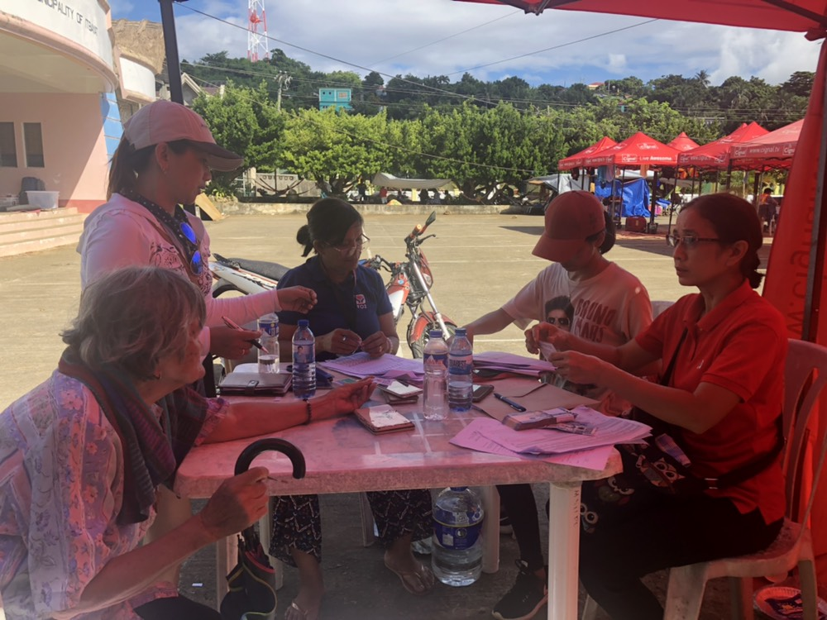

DSWD-FO II providing Social Pension to the senior citizens affected by the earthquake incident.

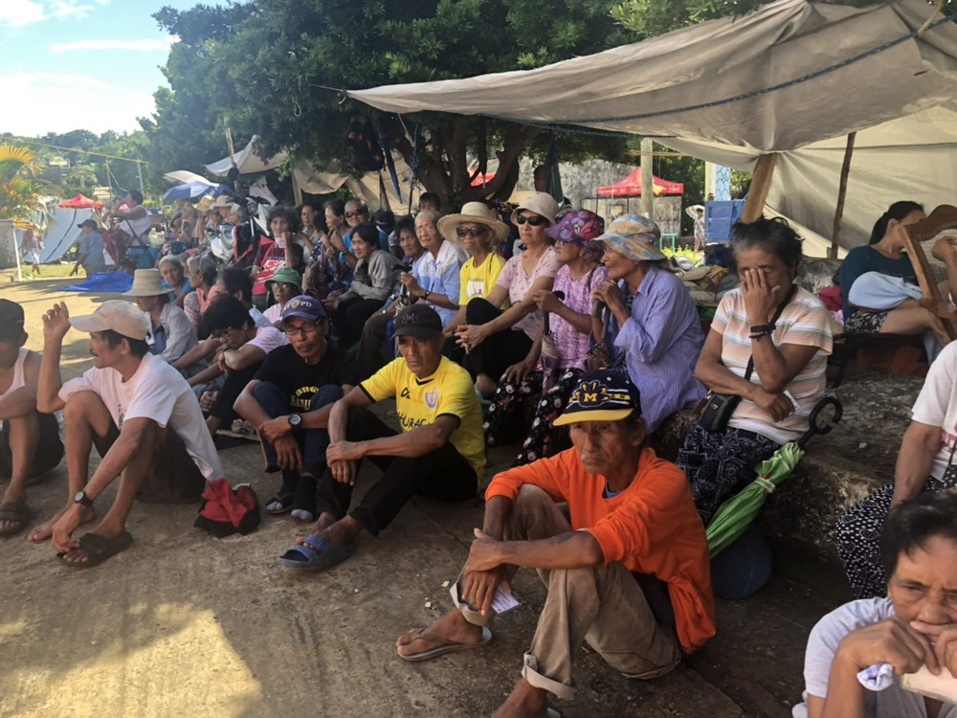

Photos taken on 29 July 2019
The senior citizens affected by the earthquake incident patiently waiting for their turn to receive financial assistance thru Social Pension.
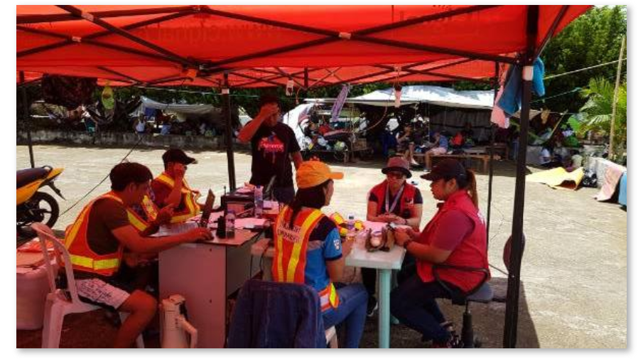
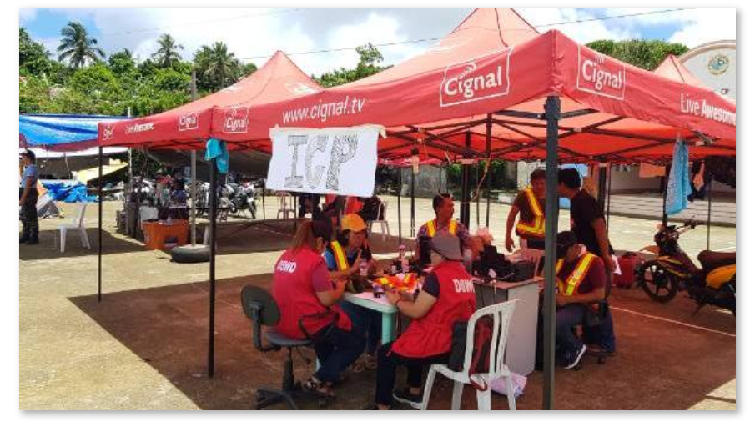
Photos taken on 29 July 2019
Incident Command Post

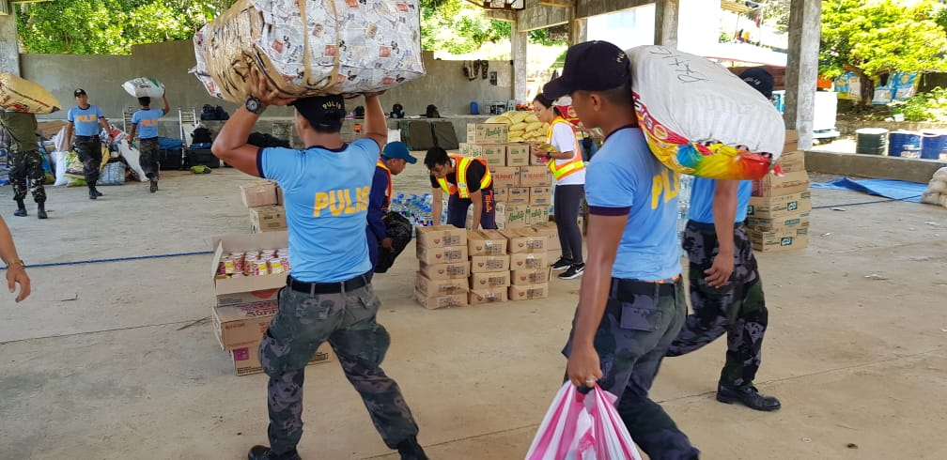
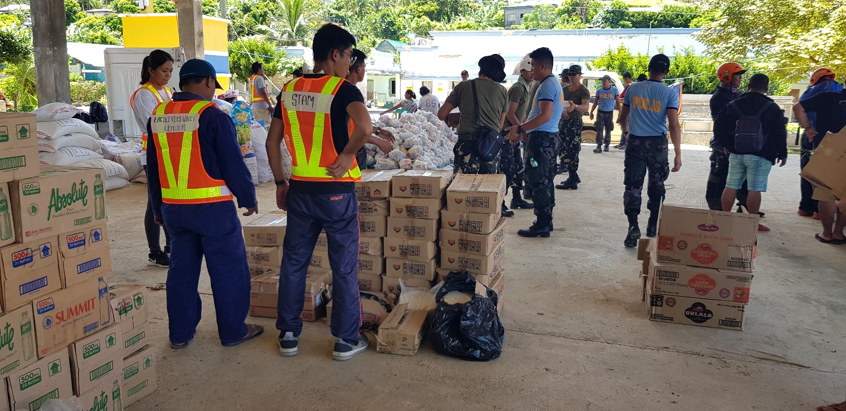
Photos taken on 29 July 2019
FNIs delivered in Itbayat, Batanes

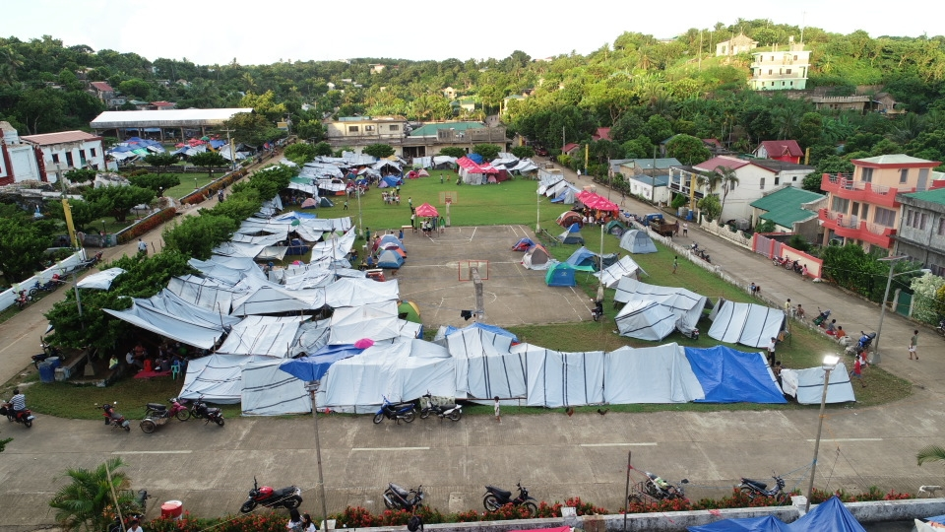
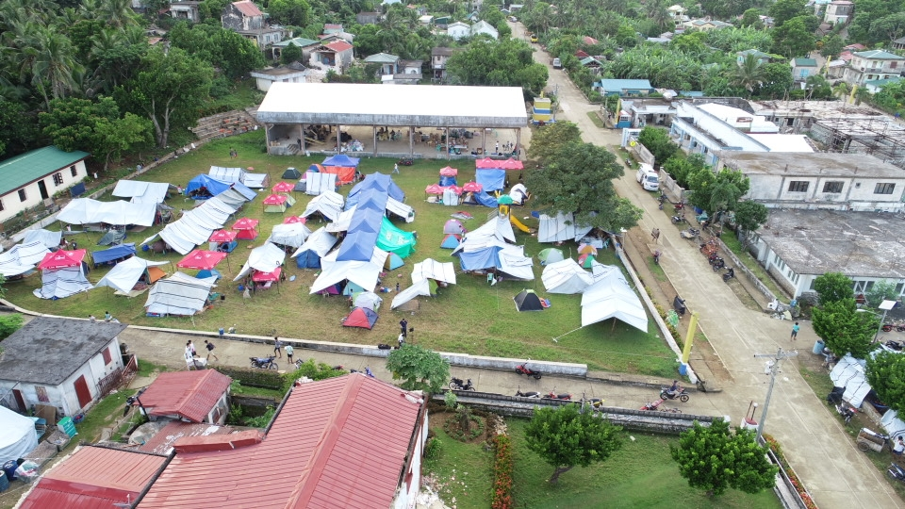
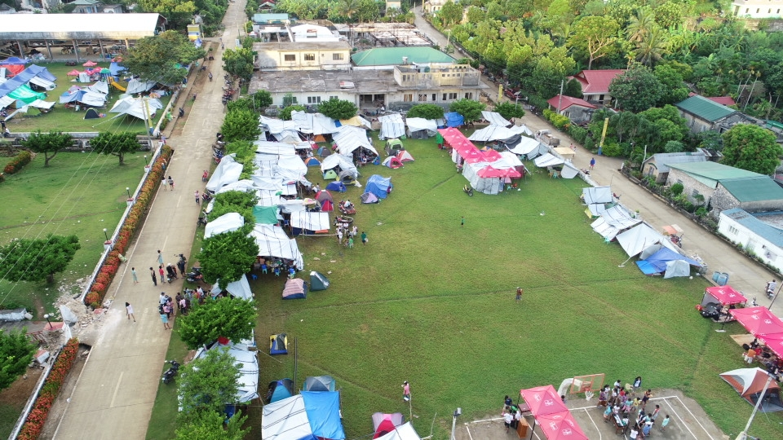
Aerial View of the Municipal Plaza as Evacuation Center

Photos taken on 30 July 2019

Photos taken on 31 July 2019
Psychosocial debriefing to children by PHIVOLCS Staff
PHIVOLCS staff explaining what happens during an earthquake

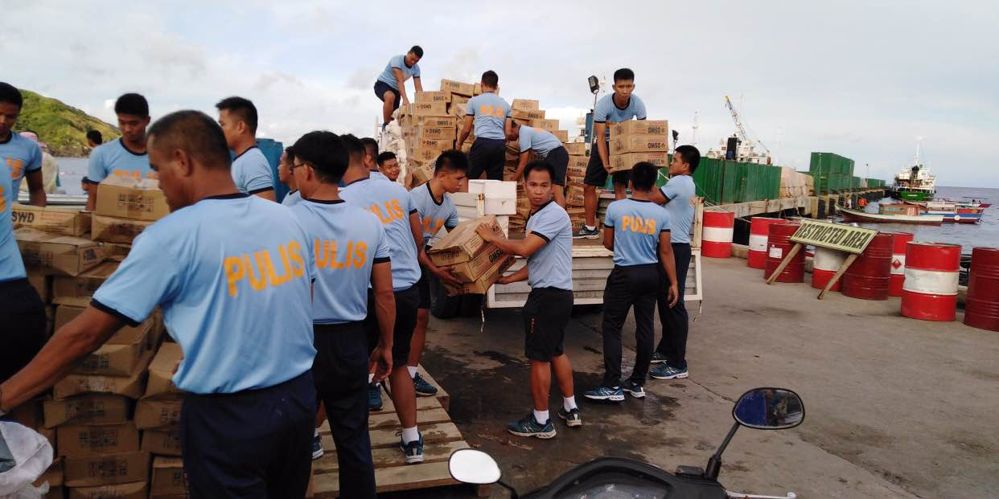
Loading of the sleeping kits and family tents at the Basco Port

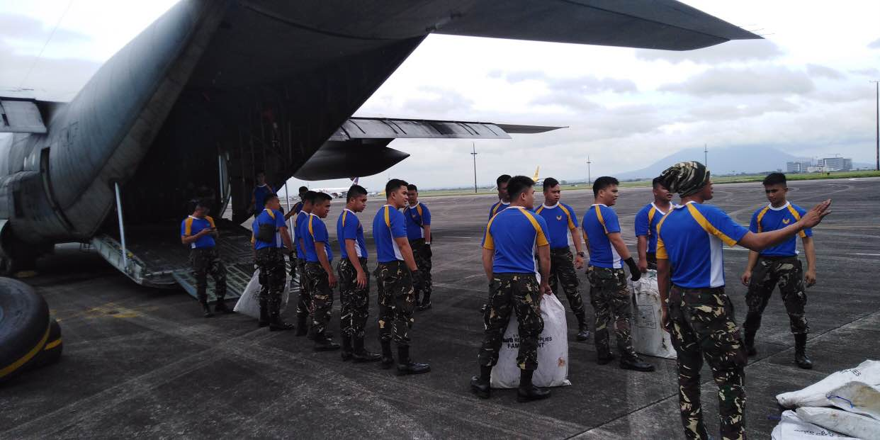

Photos taken on 01 August 2019
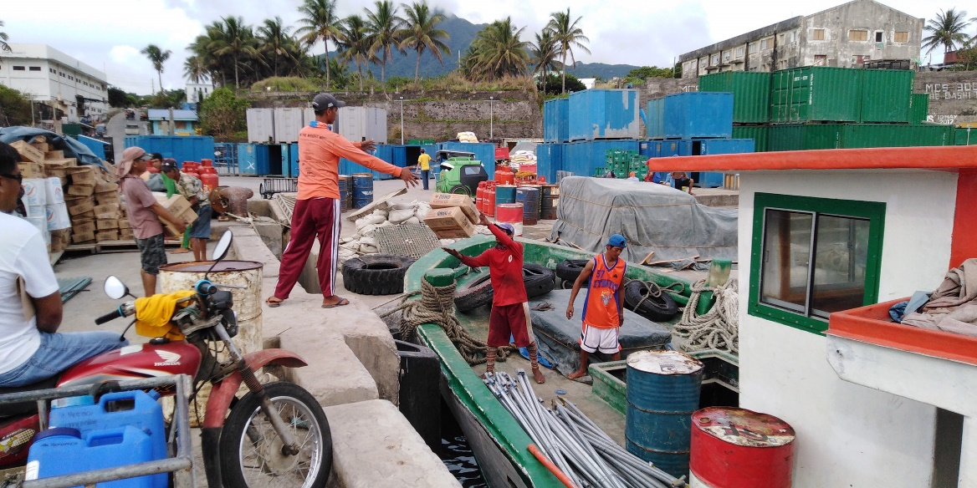

Photo taken on 02 August 2019

