DSWD DROMIC Report #2
on the Earthquake Incident in Carrascal, Surigao del Sur
as of 15 July 2019, 6PM

Situation Overview
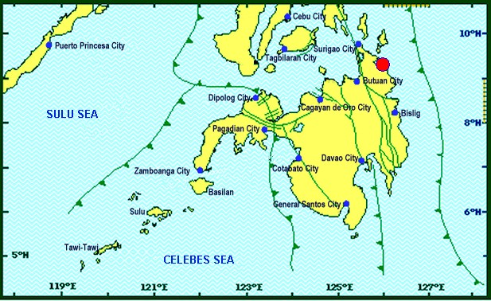

On July 13, 2019 at 4;42 AM, a 5.5 magnitude earthquake jolted the municipality of Carrascal, Surigao del Sur (09.32°N, 125.99°E - 007 km S 37° E) with a tectonic origin and a depth of focus of 4km. The earthquake was also felt in the neighboring municipalities of Surigao del Sur and in some parts of the region.
Reported Intensities : | Intensity VI - Carrascal, Cantilan, Carmen, Lanuza, and Madrid, Surigao Del Sur  Intensity V - Bayabas, and Cortes, Surigao Del Sur; Butuan City  Intensity IV - Surigao City; Tandag City; Gingoog City; Claver, Surigao Del Norte; Magsaysay,  Misamis Oriental; Talacogon, Agusan Del Sur  Intensity III - Cagwait, Surigao Del Sur; Socorro, Surigao Del Norte; Balingasag, Balingoan,  Jasaan, Salay, and Villanueva, Misamis Oriental; Pintuyan, San Francisco, and San Ricardo,  Southern Leyte; Cagayan De Oro City  Intensity II - Mambajao, Camiguin  Instrumental Intensities:  Intensity IV - Gingoog City  Intensity II - Cebu City; Borongan City  Intensity I - Bislig City; Cagayan de Oro City; Palo, Leyte
Expecting Damage: | YES
Expecting Aftershocks: | YES

Source: DOST-PHIVOLCS Earthquake Bulletin
- Status of Affected Families / Persons
470 families or 2,350 persons are affected in 12 barangays (see Table 1).

Table 1. Affected Families / Persons
REGION / PROVINCE / MUNICIPALITY |  | NUMBER OF AFFECTED
 |  | Barangays | Families | Persons
GRAND TOTAL |  | 12 | 470 | 2,350
CARAGA |  | 12 | 470 | 2,350
Surigao del Sur |  | 12 | 470 | 2,350
 | Carmen | 8 | 372 | 1,860
 | Carrascal | 3 | 96 | 480
 | Lanuza | 1 | 2 | 10
Note: Ongoing assessment and validation
Source: DSWD-FO CARAGA

- Damaged Houses
A total of 470 houses were damaged by the fire; of which, 19 houses were totally damaged and 451 houses were partially damaged (see Table 2).

Table 2. Number of Damaged Houses
REGION / PROVINCE / MUNICIPALITY |  | NO. OF DAMAGED HOUSES
 |  | Total | Totally | Partially
GRAND TOTAL |  | 470 | 19 | 451
CARAGA |  | 470 | 19 | 451
Surigao del Sur |  | 470 | 19 | 451
 | Carmen | 372 | 4 | 368
 | Carrascal | 96 | 14 | 82
 | Lanuza | 2 | 1 | 1
Note: Ongoing assessment and validation
Source: DSWD-FO CARAGA

- Cost of Assistance
A total of ₱611,296.00 worth of assistance was provided to the affected families; of which, ₱163,296.00 was provided by DSWD and ₱448,000.00 was provided by the LGU (see Table 3).

Table 3. Cost of Assistance Provided to Affected Families / Persons
REGION / PROVINCE / MUNICIPALITY |  | TOTAL COST OF ASSISTANCE
 |  | DSWD | LGU | NGOs | OTHERS | GRAND TOTAL
GRAND TOTAL |  | 163,296.00 | 448,000.00 | - | - | 611,296.00
CARAGA |  | 163,296.00 | 448,000.00 | - | - | 611,296.00
Surigao del Sur |  | 163,296.00 | 448,000.00 | - | - | 611,296.00
 | Carmen | 163,296.00 | - | - | - | 163,296.00
 | Carrascal | - | - | - | - | -
 | Lanuza | - | - | - | - | -
 | Province of Surigao del Sur |  | 448,000.00 |  |  | 448,000.00
Note: Ongoing assessment and validation being conducted
Source: DSWD-FO CARAGA

Situational Reports

DSWD-DRMB
DATE | SITUATIONS / ACTIONS UNDERTAKEN
15 July 2019 | - The Disaster Response Operations Monitoring and Information Center (DROMIC) of the DSWD-DRMB continues to closely coordinate with DSWD-FO CARAGA for significant reports on the status of affected families, assistance, and relief efforts.

DSWD-FO CARAGA
DATE | ACTION(S) TAKEN
15 July 2019 | - DSWD-FO CARAGA thru the Disaster Response and Management Division (DRMD) together with the SWAD Team Leader of Surigao del Sur is continuously conducting an assessment and validation to the affected areas in Surigao del Sur for possible intervention.  - The Field Office will facilitate the distribution of 744 family food packs to the affected families in Carmen, Surigao del Sur amounting to PhP271,188.00.  - The Field Office advised the P/C/MAT to conduct validation and assessment for those totally and partially damaged houses.  - The Field Office is conducting an on-going assessment for those who are admitted/confined in local hospitals in Surigao del Sur.  - The Field Office is constantly coordinating and monitoring with the LSWDOs and LDRRMOs with their situation. Subsequent updates will be provided once the LGUs submit their report regarding the incident.

***
The Disaster Response Operations Monitoring and Information Center (DROMIC) of the DSWD-DRMB is closely coordinating with DSWD-FO CARAGA for any significant disaster response updates.

JOANNA CAMILLE R. JACINTO
Releasing Officer

