DSWD DROMIC Report #3
on the Earthquake Incident in Itbayat, Batanes
as of 28 July 2019, 4PM

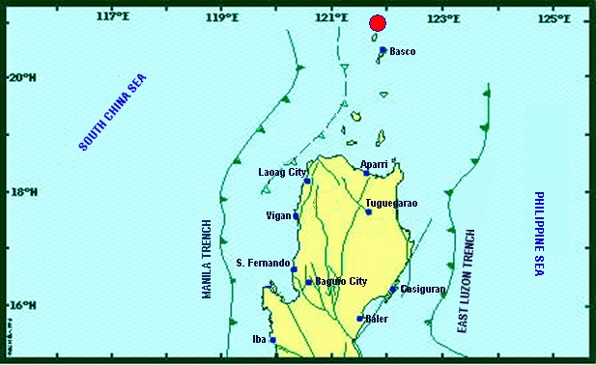

Situation Overview

On 27 July 2019 at 4:16 AM, a 5.4 magnitude earthquake jolted the municipality of Itbayat, Batanes (20.90°N, 121.85°E - 012 km N 04°E) with a tectonic origin and a depth of focus of 12 km. The earthquake was also felt in the neighboring municipalities of Batanes.

Date/Time: | 27 Jul 2019 - 04:16:54 AM
Reported Intensities: | Intensity VI - Itbayat, Batanes  Intensity III - Basco and Sabtang, Batanes  Instrumental Intensity:  Intensity III - Basco, Batanes
Expecting Damage: | YES
Expecting Aftershocks: | YES
Source: DOST-PHIVOLCS Earthquake Bulletin

- Status of Affected Families / Persons
A total of 911 families or 2,963 persons were affected by the earthquake incident in 5 barangays in Itbayat, Batanes (see Table 1).

Table 1. Number of Affected Families / Persons
REGION / PROVINCE / MUNICIPALITY |  | NUMBER OF AFFECTED
 |  | Barangays | Families | Persons
GRAND TOTAL |  | 5 | 911 | 2,963
REGION II |  | 5 | 911 | 2,963
Batanes |  | 5 | 911 | 2,963
 | Itbayat | 5 | 911 | 2,963
Note: Ongoing assessment and validation being conducted. Based on the Progress Report submitted by FO II, there are no significant changes as to the number of affected families or persons due to telecommunications signal being down in Itbayat, Batanes.

Source: DSWD-FO II

- Status of Displaced Families / Persons
911 families or 2,963 persons are currently staying at the Public Market in Brgy. San Rafael, Itbayat, Batanes (see Table 2).

Table 2. Number of Displaced Families / Persons Inside Evacuation Center
REGION / PROVINCE / MUNICIPALITY |  | NUMBER OF EVACUATION CENTERS (ECs) |  | INSIDE ECs
 |  |  |  | Families |  | Persons
 |  | CUM | NOW | CUM | NOW | CUM | NOW
GRAND TOTAL |  | 1 | 1 | 911 | 911 | 2,963 | 2,963
REGION II |  | 1 | 1 | 911 | 911 | 2,963 | 2,963
Batanes |  | 1 | 1 | 911 | 911 | 2,963 | 2,963
 | Itbayat | 1 | 1 | 911 | 911 | 2,963 | 2,963
Note: Ongoing assessment and validation being conducted.
Source: DSWD-FO II

- Damaged Houses
15 houses were damaged by the earthquake incident. Ongoing assessment is being conducted.
Source: DSWD-FO II

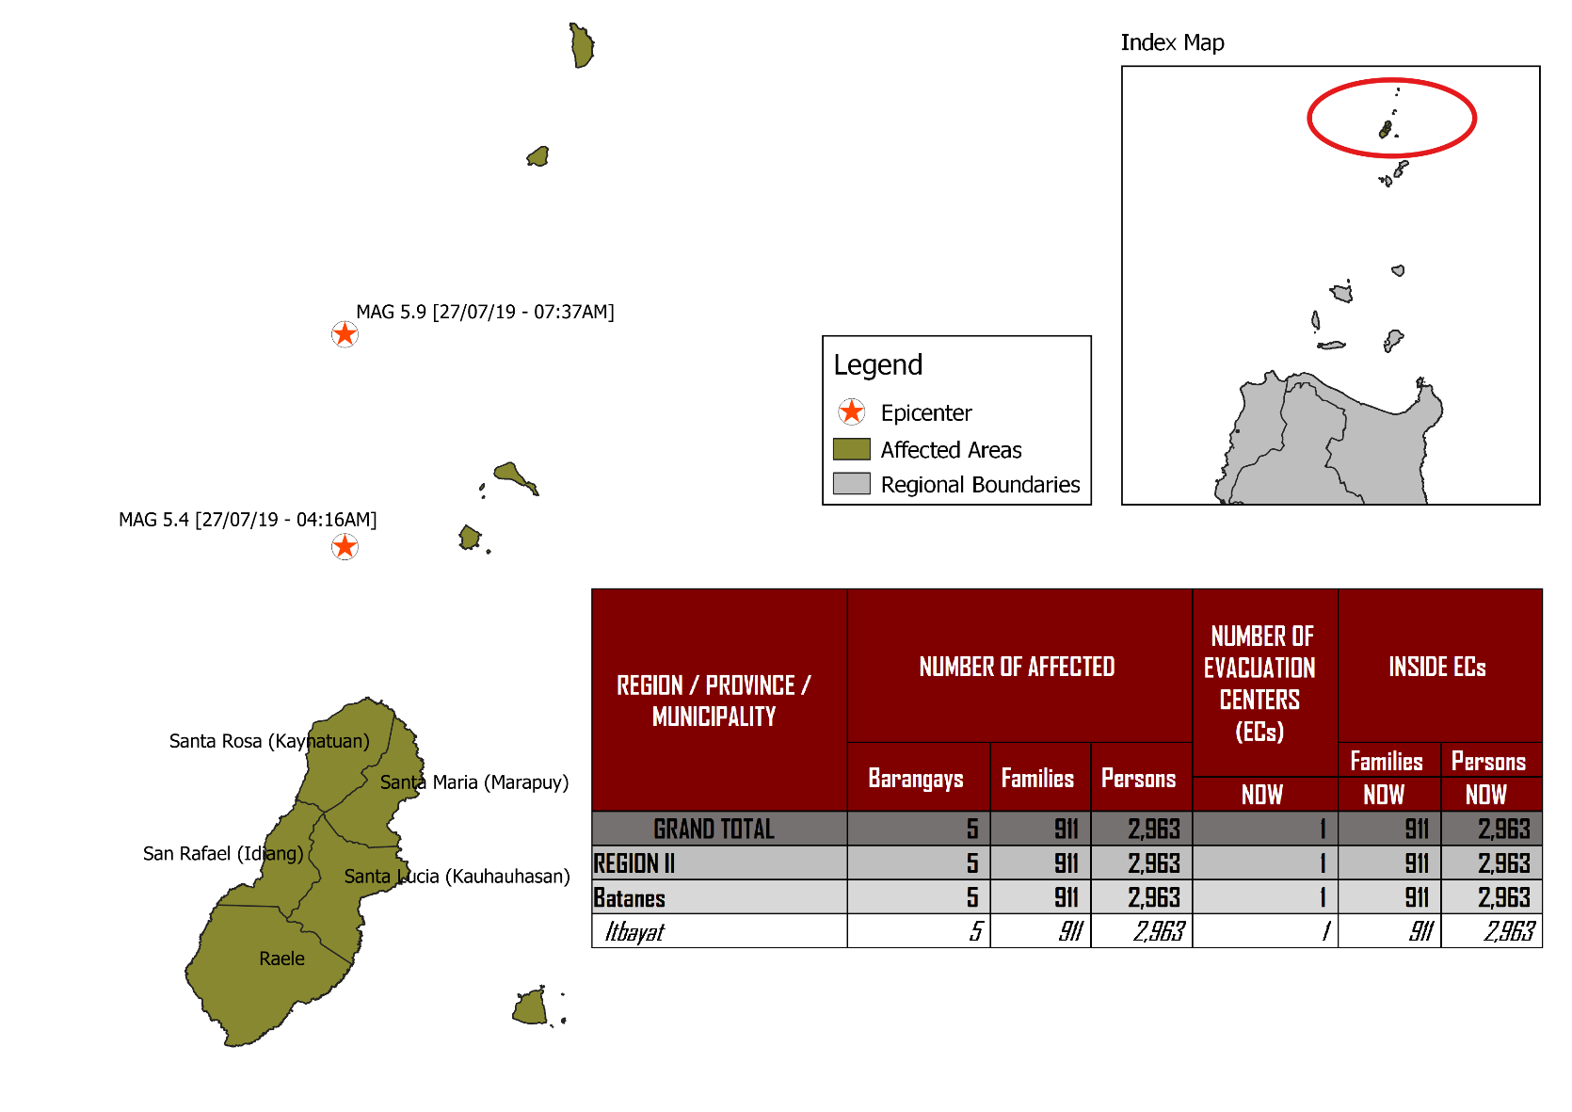
DSWD DISASTER RESPONSE INFORMATION
Source: DRMB-DROMIC GIS Specialists

Status of Prepositioned Resources: Stockpile and Standby Funds

The DSWD Central Office (CO), Field Offices (FOs), and National Resource Operations Center (NROC) have stockpiles and standby funds amounting to ₱1,974,281,401.23 with breakdown as follows (see Table 1):

- Standby Funds
A total of ₱1,181,581,331.18 standby funds in the CO and FOs. Of the said amount, ₱1,146,974,543.16 is the available Quick Response Fund (QRF) in the CO.

- Stockpiles
A total of 362,571 Family Food Packs (FFPs) amounting to ₱136,070,296.02 and available Food and Non-food Items (FNIs) amounting to ₱656,629,774.03.

FIELD OFFICE | STANDBY FUNDS | STOCKPILE |  |  |  |  | TOTAL STANDBY FUNDS AND STOCKPILE
 |  | Family Food Packs |  | Food | Non-Food | Sub-Total  (Food and NFIs)
 |  | Quantity | Total Cost
TOTAL | 1,181,581,331.18 | 362,571 | 136,070,296.02 | 160,756,170.36 | 495,873,603.67 | 656,629,774.03 | 1,974,281,401.23
Central Office* | 1,146,974,543.16 |  |  |  |  |  | 1,146,974,543.16
NRLMB - NROC | 0 | 103,200 | 38,920,848.00 | 82,564,936.86 | 330,634,906.88 | 413,199,843.74 | 452,120,691.74
NRLMB - VDRC | 0 | 11,700 | 4,212,000.00 | 1,203,200.00 | 5,224,562.31 | 6,427,762.31 | 10,639,762.31
I | 2,379,275.00 | 14,393 | 5,181,480.00 | 1,094,185.92 | 33,381,090.79 | 34,475,276.71 | 42,036,031.71
II | 930,801.96 | 29,308 | 10,550,880.00 | 526,640.00 | 349,602.75 | 876,242.75 | 12,357,924.71
III | 2,404,557.00 | 26,192 | 10,257,281.28 | 899,919.70 | 241,406.00 | 1,141,325.70 | 13,803,163.98
CALABARZON | 1,960,100.00 | 4,697 | 1,689,515.26 | 3,898,207.60 | 3,288,354.81 | 7,186,562.41 | 10,836,177.67
MIMAROPA | 1,938,971.58 | 24,756 | 10,348,008.00 | 2,243,173.55 | 859,605.00 | 3,102,778.55 | 15,389,758.13
V | 3,000,000.00 | 18,521 | 7,223,190.00 | 10,485,948.72 | 40,704,948.22 | 51,190,896.94 | 61,414,086.94
VI | 1,150,000.00 | 18,194 | 6,755,520.00 | 7,299,157.17 | 3,713,837.50 | 11,012,994.67 | 18,918,514.67
VII | 3,000,000.00 | 16,135 | 5,808,600.00 | 18,731,977.83 | 18,505,387.11 | 37,237,364.94 | 46,045,964.94
VIII | 1,401,960.00 | 24,167 | 8,734,437.14 | 1,304,119.84 | 896,387.00 | 2,200,506.84 | 12,336,903.98
IX | 843,321.35 | 10,119 | 3,642,840.00 | 813,730.00 | 3,793,242.35 | 4,606,972.35 | 9,093,133.70
X | 3,000,000.00 | 1,512 | 544,320.00 | 6,593,047.20 | 30,362,019.90 | 36,955,067.10 | 40,499,387.10
XI | 3,028,750.00 | 25,381 | 9,185,285.40 | 11,053,700.00 | 10,921,627.34 | 21,975,327.34 | 34,189,362.74
XII | 584,701.68 | 4,724 | 1,894,324.00 | 3,484,211.10 | 2,348,437.26 | 5,832,648.36 | 8,311,674.04
CARAGA | 3,000,000.00 | 10,014 | 3,821,443.00 | 946,748.00 | 4,806,699.85 | 5,753,447.85 | 12,574,890.85
NCR | 3,292,543.50 | 3,665 | 1,341,789.14 | 1,998,746.57 | 928,770.00 | 2,927,516.57 | 7,561,849.21
CAR | 2,691,805.95 | 15,893 | 5,958,534.80 | 5,614,520.30 | 4,912,718.60 | 10,527,238.90 | 19,177,579.65
*Quick Response Fund (QRF) as of 27 July 2019

Situational Reports

DSWD-DRMB
DATE | SITUATIONS / ACTIONS UNDERTAKEN
28 July 2019 | - The Disaster Response Management Bureau (DRMB) is on BLUE alert level status and is closely coordinating with the DSWD-FO II for significant disaster response updates.  - All QRT members and emergency equipment are on standby and ready for deployment.  - DRMB Team will join the Office of Civil Defense (OCD) for the Rapid Damage Assessment and Needs Analysis (RDANA) and provide technical assistance along delivery of response services to the affected families.  - DRMB Team is continuously coordinating with OCD Regional Office III with regards to the schedule of C130 flight to Batanes and NRLMB for the status of delivery of FNIs to Field Office II.  - DRMB Team coordinated with the Procurement Service in relation to the emergency procurement of the Satellite Phones Load.

DSWD-NRLMB
DATE | SITUATIONS / ACTIONS UNDERTAKEN
28 July 2019, 4AM | - DSWD-NRLMB will augment to DSWD-FO II non-food items such as 120 units of tents, 50 pieces of folding beds, and 400 pieces of sleeping kits for the affected families. These goods will be transported from Clark, Pampanga to Batanes through C130.

DSWD-FO II
DATE | ACTION(S) TAKEN
28 July 2019 | - DSWD-FO II is still on RED alert level status.  - There are 358 family food packs worth ₱128,880 accommodated in the C130 flight in Basco, Batanes to be delivered to Itbayat, Batanes.  - Two (2) staff from DSWD-FO II was deployed to Batanes for augmentation support.  - Staff from the Disaster Response Management Division (DRMD) attended a meeting set by BFAR Regional Office II re: Plan for the deployment of one offshore vessel to bring necessary and urgent needs of the affected families in Itbayat. The said agency has offered space for food and non-food items such as tents, sleeping kits, folding beds and other available NFIs.  - DSWD-FO II coordinated with NRLMB for the delivery of 9,400 vacuumed packed rice at 3kg per pack and 50 pieces folding beds.
27 July 2019 | - DSWD-FO II is on RED alert level status.  - There are a total of 100 family food packs worth ₱36,000 and 100 boxes of instant coffee readily available for pick-up at the DSWD-FO II to be delivered to Itbayat, Batanes.  - The DRMD staff will be deployed to the province of Batanes for augmentation support.  - DSWD-FO II is continuously coordinating with SWADT Batanes and MSWDO of Itbayat for updates and request for augmentation support.  - Two (2) social workers will be deployed as DSWD representatives to augment the DOH Stress debriefers. Likewise, one (1) DRMD staff will augment the SWAD Team in gathering and validating reports.

***
The Disaster Response Operations Monitoring and Information Center (DROMIC) of the DSWD-DRMB is closely coordinating with DSWD-FO II for any significant disaster response updates.

Prepared by:

MARIE JOYCE G. RAFANAN

RODEL V. CABADDU
Releasing Officer

