DSWD DROMIC Report #4
on the Earthquake Incident in Carrascal, Surigao del Sur
as of 18 July 2019, 7PM

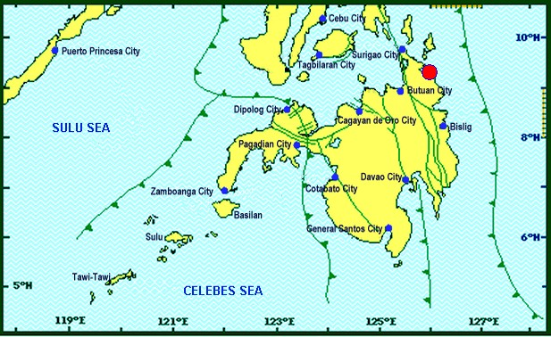
Situation Overview
On July 13, 2019 at 4;42 AM, a 5.5 magnitude earthquake jolted the municipality of Carrascal, Surigao del Sur (09.32°N, 125.99°E - 007 km S 37° E) with a tectonic origin and a depth of focus of 4km. The earthquake was also felt in the neighboring municipalities of Surigao del Sur and in some parts of the region.

Reported Intensities : | Intensity VI - Carrascal, Cantilan, Carmen, Lanuza, and Madrid, Surigao Del Sur  Intensity V - Bayabas, and Cortes, Surigao Del Sur; Butuan City  Intensity IV - Surigao City; Tandag City; Gingoog City; Claver, Surigao Del Norte; Magsaysay,  Misamis Oriental; Talacogon, Agusan Del Sur  Intensity III - Cagwait, Surigao Del Sur; Socorro, Surigao Del Norte; Balingasag, Balingoan,  Jasaan, Salay, and Villanueva, Misamis Oriental; Pintuyan, San Francisco, and San Ricardo,  Southern Leyte; Cagayan De Oro City  Intensity II - Mambajao, Camiguin  Instrumental Intensities:  Intensity IV - Gingoog City  Intensity II - Cebu City; Borongan City  Intensity I - Bislig City; Cagayan de Oro City; Palo, Leyte
Expecting Damage: | YES
Expecting Aftershocks: | YES

Source: DOST-PHIVOLCS Earthquake Bulletin

- Status of Affected Families / Persons
A total of 1,905 families or 9,525 persons were affected by the earthquake incident in 40 barangays in Surigao del Sur (see Table 1).

Table 1. Affected Families / Persons
REGION / PROVINCE / MUNICIPALITY |  | NUMBER OF AFFECTED
 |  | Barangays | Families | Persons
GRAND TOTAL |  | 40 | 1,905 | 9,525
CARAGA |  | 40 | 1,905 | 9,525
Surigao del Sur |  | 40 | 1,905 | 9,525
 | Cantilan | 14 | 937 | 4,685
 | Carmen | 8 | 372 | 1,860
 | Carrascal | 3 | 117 | 585
 | Lanuza | 1 | 3 | 15
 | Madrid | 14 | 476 | 2,380
Note: Ongoing assessment and validation being conducted.
Source: DSWD-FO CARAGA
- Damaged Houses
1,905 houses were damaged by the earthquake incident; of which, 66 houses were totally damaged and 1,839 houses were partially damaged (see Table 2).

Table 2. Number of Damaged Houses
REGION / PROVINCE / MUNICIPALITY |  | NO. OF DAMAGED HOUSES
 |  | Total | Totally | Partially
GRAND TOTAL |  | 1,905 | 66 | 1,839
CARAGA |  | 1,905 | 66 | 1,839
Surigao del Sur |  | 1,905 | 66 | 1,839
 | Cantilan | 937 | 39 | 898
 | Carmen | 372 | 4 | 368
 | Carrascal | 117 | 14 | 103
 | Lanuza | 3 | 2 | 1
 | Madrid | 476 | 7 | 469
Note: Ongoing assessment and validation being conducted.
Source: DSWD-FO CARAGA

- Cost of Assistance
A total of ₱ 2,503,203.00 worth of assistance was provided to the affected families; of which, ₱1,551,203.00 was provided by DSWD and ₱952,000.00 was provided by LGU (see Table 3).

Table 3. Cost of Assistance Provided to Affected Families / Persons
REGION / PROVINCE / MUNICIPALITY |  | TOTAL COST OF ASSISTANCE
 |  | DSWD | LGU | NGOs | OTHERS | GRAND TOTAL
GRAND TOTAL |  | 1,551,203.00 | 952,000.00 | - | - | 2,503,203.00
CARAGA |  | 1,551,203.00 | 952,000.00 | - | - | 2,503,203.00
Surigao del Sur |  | 1,551,203.00 | 952,000.00 | - | - | 2,503,203.00
 | Province of Surigao Del Sur | - | 902,000.00 | - | - | 902,000.00
 | Cantilan | 828,613.20 | - | - | - | 828,613.20
 | Carmen | 286,115.20 | - | - | - | 286,115.20
 | Carrascal | 85,293.00 | 50,000.00 | - | - | 135,293.00
 | Lanuza | 5,189.80 | - | - | - | 5,189.80
 | Madrid | 345,991.80 | - | - | - | 345,991.80
Note: Ongoing assessment and validation being conducted.
Source: DSWD-FO CARAGA
Situational Reports

DSWD-DRMB
DATE | SITUATIONS / ACTIONS UNDERTAKEN
18 July 2019 | - The Disaster Response Operations Monitoring and Information Center (DROMIC) of the DSWD-DRMB continues to closely coordinate with DSWD-FO CARAGA for significant reports on the status of affected families, assistance, and relief efforts.

DSWD-FO CARAGA
DATE | ACTION(S) TAKEN
18 July 2019 | - DSWD-FO CARAGA provided 744 family food packs to the affected families in Carmen, Surigao del Sur.  - DSWD-FO CARAGA distributed non-food items specifically, 4 Mosquito Nets, 4 pieces of Malong, 4 Blankets, 4 Plastic Mats, 4 Kitchen Kits and 4 Family Kits to the 4 families with totally damaged houses in Carmen, Surigao del Sur.  - DSWD-FO CARAGA distributed food and non-food items specifically, 4 Family Food Packs, 1 Malong, 1 Blanket, 1 Mosquito Net, 1 Plastic Mat, and 1 Kitchen Kit to the family with totally damaged house in Lanuza, Surigao del Sur.  - DSWD-FO CARAGA distributed 3,058 FFPs amounting to PhP 1,114,357.80 to the affected families in Cantilan, Carrascal and Madrid, Surigao del Sur.  - DSWD-FO CARAGA distributed non-food items (39 Family Kits, 39 Kitchen Kits, 39 Malong, 39 Plastic Mats, 39 Mosquito Nets, and 39 Blankets) to the 39 families with totally damaged houses in Cantilan, Surigao del Sur.  - DSWD-FO CARAGA is constantly coordinating with LSWDOs and LDRRMOs for further updates.

***
The Disaster Response Operations Monitoring and Information Center (DROMIC) of the DSWD-DRMB is closely coordinating with DSWD-FO CARAGA for any significant disaster response updates.

Prepared by:

MARIE JOYCE G. RAFANAN

RODEL V. CABADDU
Releasing Officer

