DSWD DROMIC Report #4
on the Earthquake Incident in Itbayat, Batanes
as of 29 July 2019, 7PM

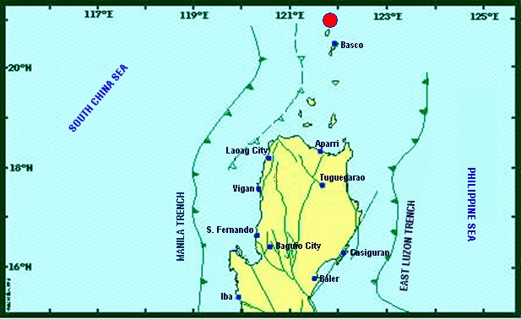

Situation Overview

On 27 July 2019 at 4:16 AM, a 5.4 magnitude earthquake jolted the municipality of Itbayat, Batanes (20.90°N, 121.85°E - 012 km N 04°E) with a tectonic origin and a depth of focus of 12 km. The earthquake was also felt in the neighboring municipalities of Batanes.

Date/Time: | 27 Jul 2019 - 04:16:54 AM
Reported Intensities: | Intensity VI - Itbayat, Batanes  Intensity III - Basco and Sabtang, Batanes  Instrumental Intensity:  Intensity III - Basco, Batanes
Expecting Damage: | YES
Expecting Aftershocks: | YES
Source: DOST-PHIVOLCS Earthquake Bulletin

- Status of Affected Families / Persons
A total of 911 families or 2,963 persons were affected by the earthquake incident in 5 barangays in Itbayat, Batanes (see Table 1).

Table 1. Number of Affected Families / Persons
REGION / PROVINCE / MUNICIPALITY |  | NUMBER OF AFFECTED
 |  | Barangays | Families | Persons
GRAND TOTAL |  | 5 | 911 | 2,963
REGION II |  | 5 | 911 | 2,963
Batanes |  | 5 | 911 | 2,963
 | Itbayat | 5 | 911 | 2,963
Note: Based on the Progress Report submitted by FO II, there are no significant changes as to the number of affected families or persons since ongoing assessment and validation is being conducted.
Source: DSWD-FO II

- Status of Displaced Families / Persons
805 families or 2,616 persons are currently staying at the Public Market/Municipal Plaza in Brgy. San Rafael, Itbayat, Batanes (see Table 2).

Table 2. Number of Displaced Families / Persons Inside Evacuation Center
REGION / PROVINCE / MUNICIPALITY |  | NUMBER OF EVACUATION CENTERS (ECs) |  | INSIDE ECs
 |  |  |  | Families |  | Persons
 |  | CUM | NOW | CUM | NOW | CUM | NOW
GRAND TOTAL |  | 1 | 1 | 805 | 805 | 2,616 | 2,616
REGION II |  | 1 | 1 | 805 | 805 | 2,616 | 2,616
Batanes |  | 1 | 1 | 805 | 805 | 2,616 | 2,616
 | Itbayat | 1 | 1 | 805 | 805 | 2,616 | 2,616
Note: Ongoing assessment and validation being conducted. 106 families or 347 persons in Brgy. Raele did not evacuate. Thus, they are currently staying in their respective houses.
Source: DSWD-FO II

- Damaged Houses
15 houses were damaged by the earthquake incident. Ongoing assessment is being conducted.
Source: DSWD-FO II

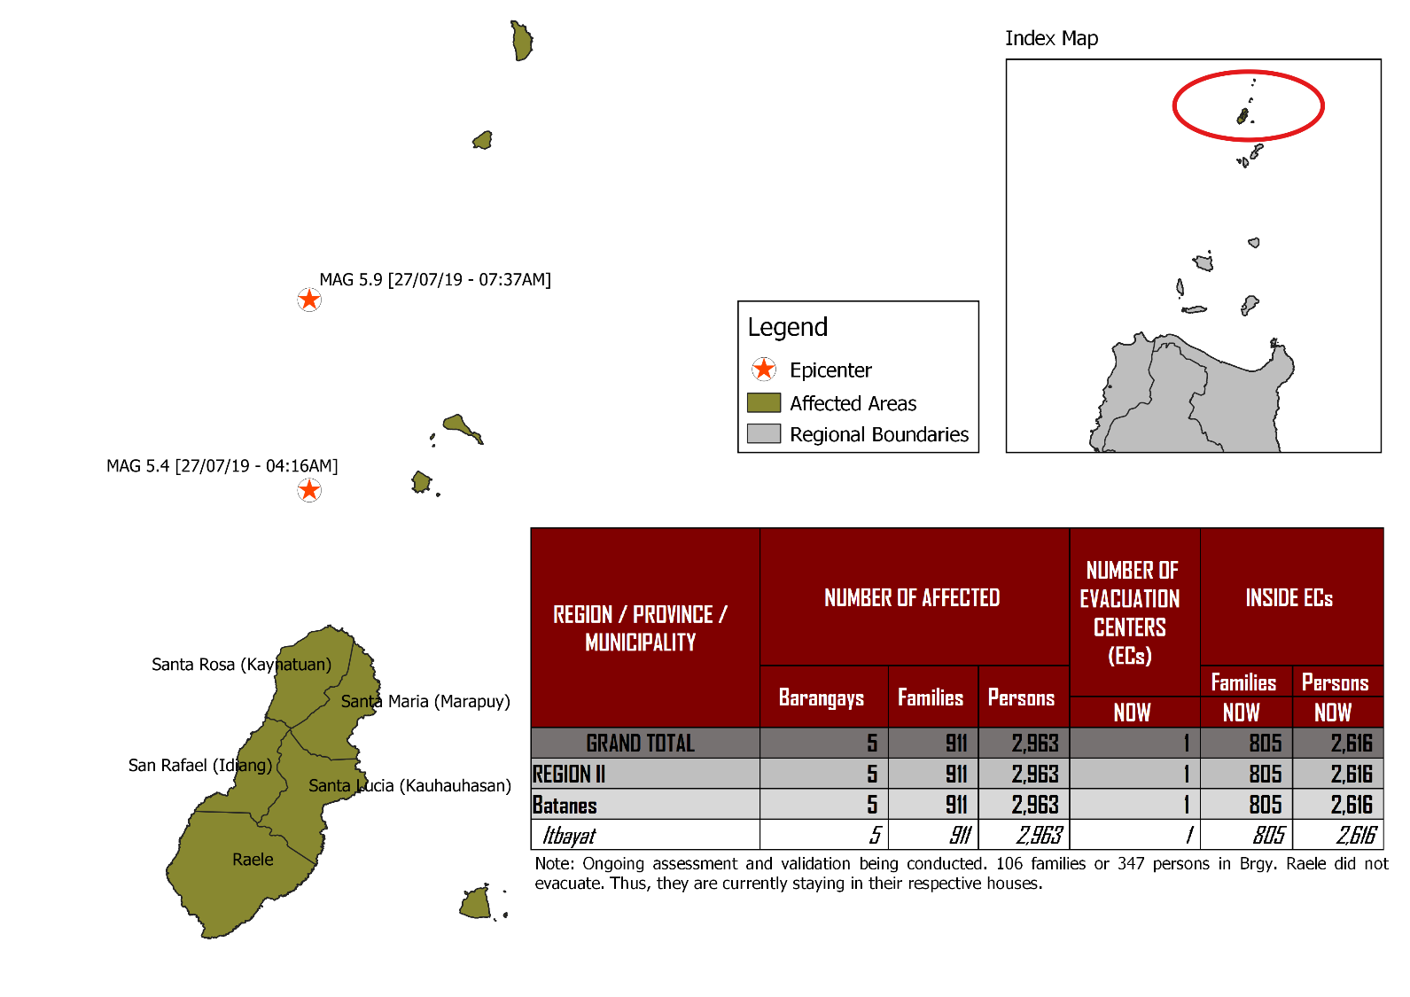
DSWD DISASTER RESPONSE INFORMATION
Source: DRMB-DROMIC GIS Specialists

Status of Prepositioned Resources: Stockpile and Standby Funds
The DSWD Central Office (CO), Field Offices (FOs), and National Resource Operations Center (NROC) have stockpiles and standby funds amounting to ₱1,974,281,401.23 with breakdown as follows (see Table 1):

- Standby Funds
A total of ₱1,181,581,331.18 standby funds in the CO and FOs. Of the said amount, ₱1,146,974,543.16 is the available Quick Response Fund (QRF) in the CO.

- Stockpiles
A total of 362,571 Family Food Packs (FFPs) amounting to ₱136,070,296.02 and available Food and Non-food Items (FNIs) amounting to ₱656,629,774.03.

FIELD OFFICE | STANDBY FUNDS | STOCKPILE |  |  |  |  | TOTAL STANDBY FUNDS AND STOCKPILE
 |  | Family Food Packs |  | Food | Non-Food | Sub-Total  (Food and NFIs)
 |  | Quantity | Total Cost
TOTAL | 1,181,581,331.18 | 362,571 | 136,070,296.02 | 160,756,170.36 | 495,873,603.67 | 656,629,774.03 | 1,974,281,401.23
Central Office* | 1,146,974,543.16 | - | - | - | - | - | 1,146,974,543.16
NRLMB - NROC | - | 103,200 | 38,920,848.00 | 82,564,936.86 | 330,634,906.88 | 413,199,843.74 | 452,120,691.74
NRLMB - VDRC | - | 11,700 | 4,212,000.00 | 1,203,200.00 | 5,224,562.31 | 6,427,762.31 | 10,639,762.31
I | 2,379,275.00 | 14,393 | 5,181,480.00 | 1,094,185.92 | 33,381,090.79 | 34,475,276.71 | 42,036,031.71
II | 930,801.96 | 29,308 | 10,550,880.00 | 526,640.00 | 349,602.75 | 876,242.75 | 12,357,924.71
III | 2,404,557.00 | 26,192 | 10,257,281.28 | 899,919.70 | 241,406.00 | 1,141,325.70 | 13,803,163.98
CALABARZON | 1,960,100.00 | 4,697 | 1,689,515.26 | 3,898,207.60 | 3,288,354.81 | 7,186,562.41 | 10,836,177.67
MIMAROPA | 1,938,971.58 | 24,756 | 10,348,008.00 | 2,243,173.55 | 859,605.00 | 3,102,778.55 | 15,389,758.13
V | 3,000,000.00 | 18,521 | 7,223,190.00 | 10,485,948.72 | 40,704,948.22 | 51,190,896.94 | 61,414,086.94
VI | 1,150,000.00 | 18,194 | 6,755,520.00 | 7,299,157.17 | 3,713,837.50 | 11,012,994.67 | 18,918,514.67
VII | 3,000,000.00 | 16,135 | 5,808,600.00 | 18,731,977.83 | 18,505,387.11 | 37,237,364.94 | 46,045,964.94
VIII | 1,401,960.00 | 24,167 | 8,734,437.14 | 1,304,119.84 | 896,387.00 | 2,200,506.84 | 12,336,903.98
IX | 843,321.35 | 10,119 | 3,642,840.00 | 813,730.00 | 3,793,242.35 | 4,606,972.35 | 9,093,133.70
X | 3,000,000.00 | 1,512 | 544,320.00 | 6,593,047.20 | 30,362,019.90 | 36,955,067.10 | 40,499,387.10
XI | 3,028,750.00 | 25,381 | 9,185,285.40 | 11,053,700.00 | 10,921,627.34 | 21,975,327.34 | 34,189,362.74
XII | 584,701.68 | 4,724 | 1,894,324.00 | 3,484,211.10 | 2,348,437.26 | 5,832,648.36 | 8,311,674.04
CARAGA | 3,000,000.00 | 10,014 | 3,821,443.00 | 946,748.00 | 4,806,699.85 | 5,753,447.85 | 12,574,890.85
NCR | 3,292,543.50 | 3,665 | 1,341,789.14 | 1,998,746.57 | 928,770.00 | 2,927,516.57 | 7,561,849.21
CAR | 2,691,805.95 | 15,893 | 5,958,534.80 | 5,614,520.30 | 4,912,718.60 | 10,527,238.90 | 19,177,579.65
*Quick Response Fund (QRF) as of 27 July 2019

Situational Reports

DSWD-DRMB
DATE | SITUATIONS / ACTIONS UNDERTAKEN
29 July 2019 | - The Disaster Response Management Bureau (DRMB) remains on BLUE alert level status and is closely coordinating with the DSWD-FO II for significant disaster response updates.  - All QRT members and emergency equipment are on standby and ready for deployment.  - Two staff from DSWD-DRMB are already deployed in Itbayat, Batanes for technical assistance and to provide resource augmentation.  - DSWD-DRMB Team is in close coordination with NRLMB, DSWD-FOs I and II with regard to the status of delivery of FNIs to Itbayat, Batanes.  - One (1) DSWD-DRMB staff is on standby waiting for the airlift of FFPs and family tents at Clark Airport.  - Coordinated with OCD regarding the airlift of the FFPs and family tents.  - DSWD-DRMB Team is in close coordination with the Procurement Service relative to the emergency procurement of the Satellite Phones Load.

DSWD-NRLMB
DATE | SITUATIONS / ACTIONS UNDERTAKEN
29 July 2019 | - 6,400 3kg-vacuum packed rice and 50 folding beds were delivered to DSWD-FO II in Tuguegarao City.  - DSWD-NRLMB requested assistance from FO I to augment 25 family tents and 400 sleeping kits which are already in transit to Tuguegarao City, Cagayan.  - 100 family tents and 60 folding beds from NROC are in transit to Tuguegarao City, Cagayan.
28 July 2019 | - DSWD-NRLMB transported 100 family tents and 400 sleeping kits to Clark Airport in Pampanga.

DSWD-FO II
DATE | ACTION(S) TAKEN
29 July 2019 | - DSWD-FO II is still on RED alert level status.  - 200 FFPs were delivered to Basco, Batanes; of which, 158 FFPs were already transported to Itbayat, Batanes.  - Additional 200 FFPs are at the Tuguegarao Airport for possible loading in the C295 aircraft.  - DSWD-FO II staff, Ms. Mia Carbonel of DRMD and Ms. Marlene Tuazon, along with Ms. Amparo Tobias, SWAD Batanes Team Lead arrived in Itbayat, Batanes this morning.  - The above stated social workers are currently providing Critical Incident Stress Debriefing (CISD) to the affected families in the Public Market (EC) in Brgy. San Rafael, Itbayat, Batanes. Also, affected senior citizens are being provided with social pension.  - There are 310 senior citizens affected by the earthquake incident.  - DSWD-FO II extended assistance to some affected families such as food assistance, burial assistance, and medical assistance amounting to a total of ₱45,000.00.  - DSWD-FO II will conduct an interview to those families with damaged houses as DSWD will extend financial assistance amounting to ₱30,000 per family with totally damaged house and ₱10,000 per family with partially damaged house. List of the said affected families are for consolidation within this week. DSWD-FO II shall process the documents for assistance for request for funding.  - As a result of the meeting with BFAR on 28 July 2019, DSWD-FO II is allocated a space for 1,000 FFPs, 25 family tents and 400 sleeping kits to be ferried directly to Itbayat by Wednesday afternoon, 31 July 2019.  - DPWH personnel and Barangay Officials are conducting assessment on damaged houses and public facilities.  - A community kitchen was established to provide food/hot meals to IDPs.  - Ongoing relief distribution is being conducted by LGU Itbayat, Batanes

***
The Disaster Response Operations Monitoring and Information Center (DROMIC) of the DSWD-DRMB is closely coordinating with DSWD-FO II for any significant disaster response updates.

Prepared by:

MARIE JOYCE G. RAFANAN

MARC LEO L. BUTAC
Releasing Officer

Photo Documentations
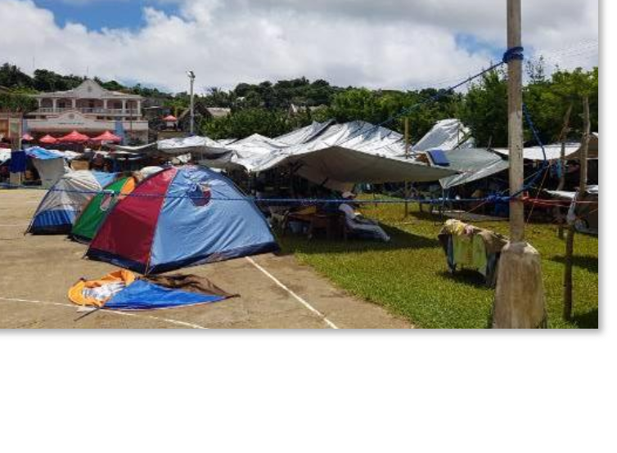
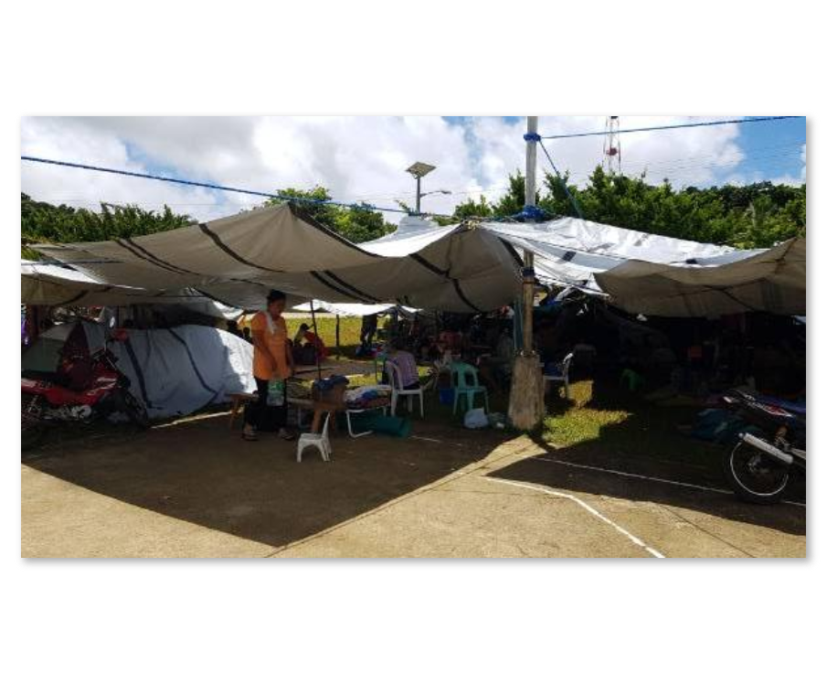
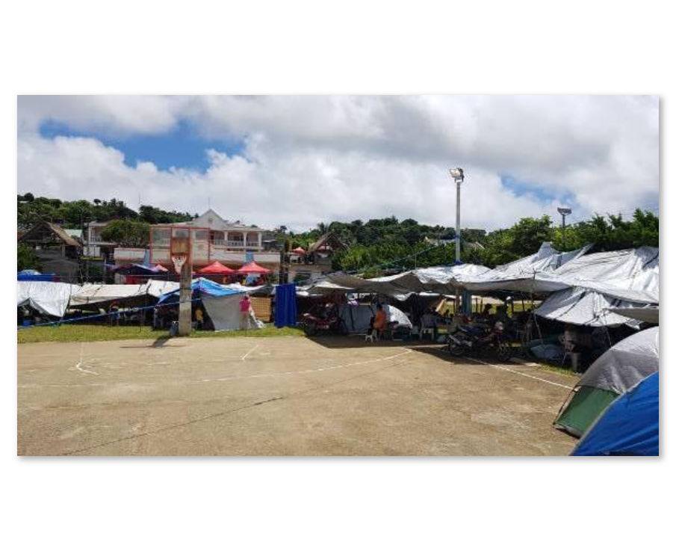
Public Market/Municipal Plaza Open Ground Evacuation Center
Families are staying under makeshift tents.
As per coordination with Incident Commander (IC) Ms. Sharmaine Gato, validation of DPWH and Barangay Officials regarding damaged houses and public facilities is on 1/3 completion for assessment of damaged houses as of yesterday.
Classes will only resume until safety of buildings is ensured.

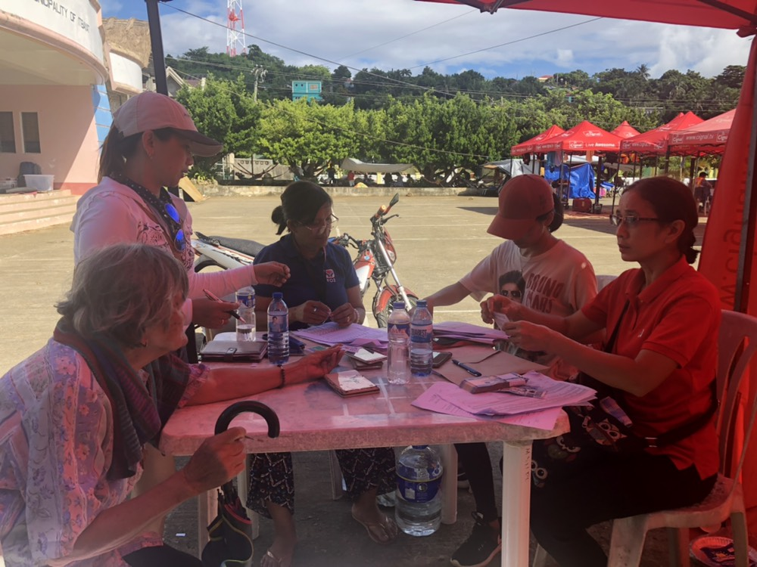

DSWD-FO II providing Social Pension to the senior citizens affected by the earthquake incident.

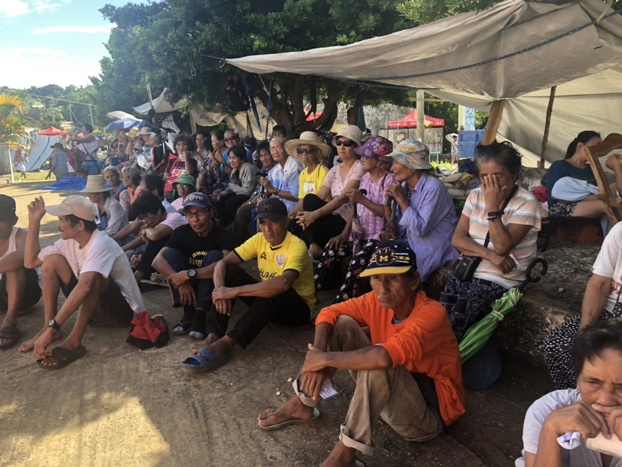
The senior citizens affected by the earthquake incident patiently waiting for their turn to receive financial assistance thru Social Pension.
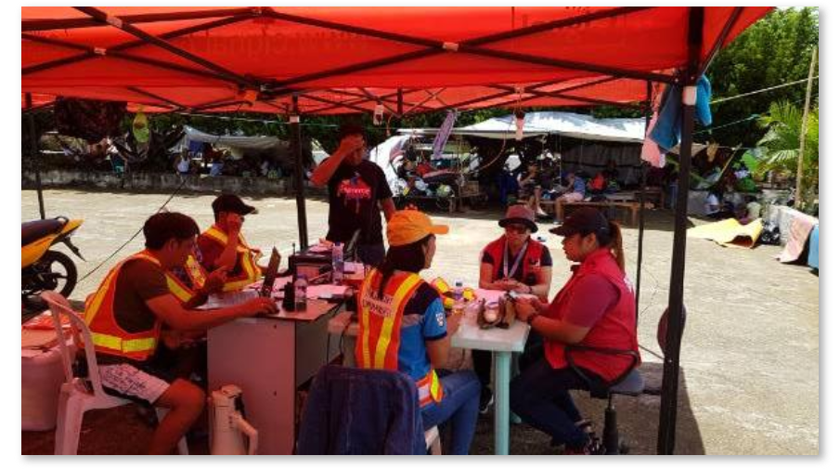
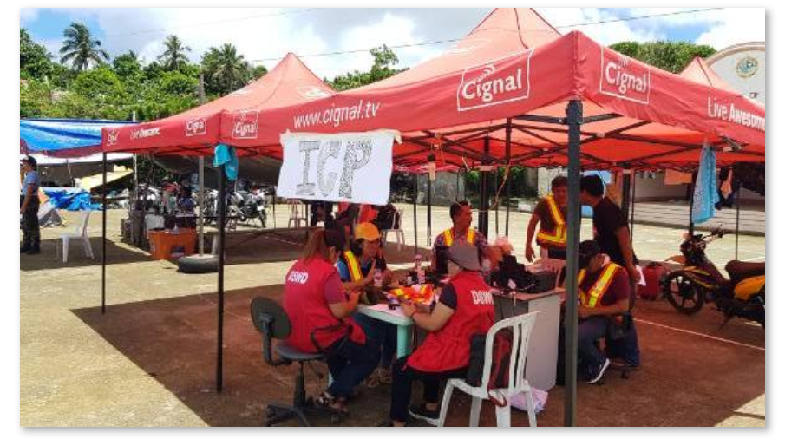
Incident Command Post

