DSWD DROMIC Report #5 on
Tropical Storm “FALCON”
as of 18 July 2019, 6AM

Situation Overview

On 15 July 2019, the Low Pressure Area east of Guiuan, Eastern Samar has developed into a Tropical Depression and was named “Falcon”. It has generally moved northwestward. On 16 July 2019, “Falcon” has intensified into a tropical storm as it continues to move westward.
Source: DOST-PAGASA Severe Weather Bulletin

- Status of Affected Families / Persons
A total of 449 families or 1,874 persons were affected by the effects of Tropical Storm “Falcon” in 21 Barangays in CAR, Region I and Region II (see Table 1).

Table 1. Number of Affected Families / Persons
REGION / PROVINCE / MUNICIPALITY |  | NUMBER OF AFFECTED
 |  | Barangays | Families | Persons
GRAND TOTAL |  | 21 | 449 | 1,874
REGION I |  | 1 | 1 | 5
Ilocos Norte |  | 1 | 1 | 5
 | Burgos | 1 | 1 | 5
REGION II |  | 11 | 284 | 1,385
Cagayan |  | 11 | 284 | 1,385
 | Allacapan | 1 | 33 | 165
 | Aparri | 1 | 2 | 5
 | Baggao | 1 | 1 | 3
 | Camalaniugan | 1 | 5 | 10
 | Gonzaga | 2 | 9 | 41
 | Lal-lo | 1 | 5 | 25
 | Lasam | 1 | 8 | 39
 | Santa Teresita | 2 | 219 | 1,091
 | Solana | 1 | 2 | 6
CAR |  | 9 | 164 | 484
Abra |  | 1 | 1 | 2
 | Lagayan | 1 | 1 | 2
Apayao |  | 7 | 146 | 398
 | Pudtol | 2 | 2 | 10
 | Santa Marcela | 5 | 144 | 388
Mountain Province |  | 1 | 17 | 84
 | Sabangan | 1 | 17 | 84
Note: Ongoing assessment and validation being conducted.
Source: CAR, DSWD-FO I and DSWD-FO II

- Status of Displaced Families / Persons

- Inside Evacuation Center
A total of 69 families or 305 persons took temporary shelter in 10 evacuation centers in Region II while 10 families or 37 persons are currently staying inside 3 evacuation centers. (see Table 2).

Table 2. Number of Served Families / Persons Inside ECs
REGION / PROVINCE / MUNICIPALITY |  | NUMBER OF EVACUATION CENTERS (ECs) |  | INSIDE ECs
 |  |  |  | Families |  | Persons
 |  | CUM | NOW | CUM | NOW | CUM | NOW
GRAND TOTAL |  | 13 | 3 | 79 | 10 | 342 | 37
REGION II |  | 10 | - | 69 | - | 305 | -
Cagayan |  | 10 | - | 69 | - | 305 | -
 | Allacapan | 1 | - | 33 | - | 165 | -
 | Aparri | 1 | - | 2 | - | 5 | -
 | Baggao | 1 | - | 1 | - | 3 | -
 | Camalaniugan | 1 | - | 5 | - | 10 | -
 | Gonzaga | 2 | - | 9 | - | 41 | -
 | Lal-lo | 1 | - | 5 | - | 25 | -
 | Lasam | 1 | - | 8 | - | 39 | -
 | Santa Teresita | 1 | - | 4 | - | 11 | -
 | Solana | 1 | - | 2 | - | 6 | -
CAR |  | 3 | 3 | 10 | 10 | 37 | 37
Apayao |  | 2 | 2 | 7 | 7 | 18 | 18
 | Santa Marcela | 2 | 2 | 7 | 7 | 18 | 18
Mountain Province |  | 1 | 1 | 3 | 3 | 19 | 19
 | Sabangan | 1 | 1 | 3 | 3 | 19 | 19
Note: Ongoing assessment and validation being conducted.
Source: CAR and DSWD-FO II

- Outside Evacuation Center
A total of 125 families or 452 persons are temporarily staying with their friends and/or relatives (see Table 3).

Table 3. Number of Served Families / Persons Outside ECs
REGION / PROVINCE / MUNICIPALITY |  | OUTSIDE ECs
 |  | Families |  | Persons
 |  | CUM | NOW | CUM | NOW
GRAND TOTAL |  | 128 | 125 | 463 | 452
REGION I |  | 1 | 1 | 5 | 5
Ilocos Norte |  | 1 | 1 | 5 | 5
 | Burgos | 1 | 1 | 5 | 5
REGION II |  | 3 | - | 11 | -
Cagayan |  | 3 | - | 11 | -
 | Santa Teresita | 3 | - | 11 | -
CAR |  | 124 | 124 | 447 | 447
Abra |  | 1 | 1 | 2 | 2
 | Lagayan | 1 | 1 | 2 | 2
Apayao |  | 109 | 109 | 380 | 380
 | Pudtol | 2 | 2 | 10 | 10
 | Santa Marcela | 107 | 107 | 370 | 370
Mountain Province |  | 14 | 14 | 65 | 65
 | Sabangan | 14 | 14 | 65 | 65
Note: Ongoing assessment and validation being conducted.
Source: CAR, DSWD-FO I and DSWD-FO II

- Damaged Houses
There are 3 damaged houses; of which 1 is totally damaged and 2 are partially damaged (see Table 4).

Table 4. Number of Damaged Houses
REGION / PROVINCE / MUNICIPALITY |  | NO. OF DAMAGED HOUSES
 |  | Total | Totally | Partially
GRAND TOTAL |  | 3 | 1 | 2
REGION I |  | 1 | - | 1
Ilocos Norte |  | 1 | - | 1
 | Burgos | 1 | - | 1
CAR |  | 2 | 1 | 1
Apayao |  | 2 | 1 | 1
 | Pudtol | 2 | 1 | 1
Note: Ongoing assessment and validation being conducted.
Source: CAR and DSWD-FO I

- Assistance Provided
A total of ₱606,560.00 worth of assistance was provided to the affected families; of which, ₱155,160.00 was provided by DSWD, ₱1,400.00 was provided by LGU and ₱450,000.00 was provided by OTHER PARTNERS (see Table 5).

Table 5. Cost of Assistance Provided to Affected Families / Persons
REGION / PROVINCE / MUNICIPALITY |  | TOTAL COST OF ASSISTANCE
 |  | DSWD | LGU | NGOs | OTHERS | GRAND TOTAL
GRAND TOTAL |  | 155,160.00 | 1,400.00 | - | 450,000.00 | 606,560.00
REGION II |  | 144,000.00 | - | - | 450,000.00 | 594,000.00
Cagayan |  | 144,000.00 | - | - | - | 144,000.00
 | Santa Teresita | 144,000.00 | - | - | - | 144,000.00
Isabela |  | - | - | - | 450,000.00 | 450,000.00
 | Dinapigue | - | - | - | 112,500.00 | 112,500.00
 | Divilacan | - | - | - | 112,500.00 | 112,500.00
 | Maconacon | - | - | - | 112,500.00 | 112,500.00
 | Palanan | - | - | - | 112,500.00 | 112,500.00
CAR |  | 11,160.00 | 1,400.00 | - | - | 12,560.00
Abra |  | - | 1,400.00 | - | - | 1,400.00
 | Lagayan | - | 1,400.00 | - | - | 1,400.00
Mountain Province |  | 11,160.00 | - | - | - | 11,160.00
 | Sabangan | 11,160.00 | - | - | - | 11,160.00
Note: Ongoing assessment and validation being conducted.
Source: DSWD-FO II and CAR

DSWD DISASTER RESPONSE INFORMATION
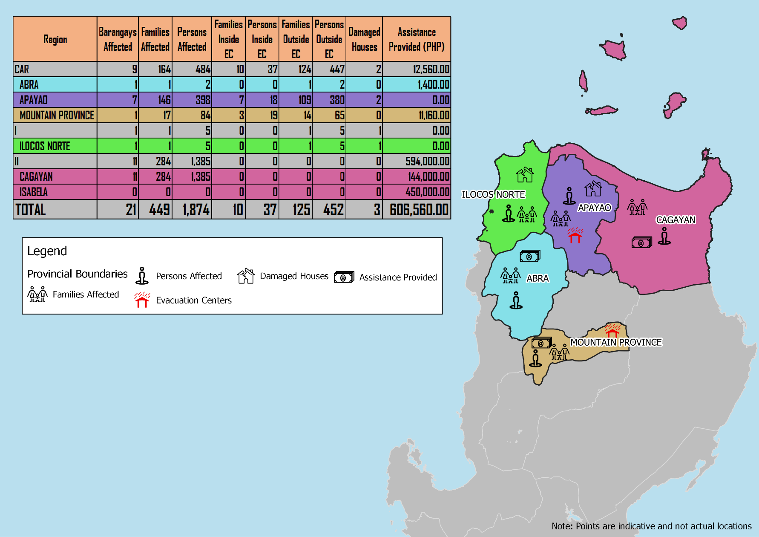

Situational Reports

DSWD-DRMB
DATE | SITUATIONS / ACTIONS UNDERTAKEN
18 July 2019 | - The Disaster Response Management Bureau (DRMB) is on BLUE Alert Status and is closely coordinating with the concerned DSWD-Field Offices for significant disaster preparedness for response updates.  - All QRT members and emergency equipment are on standby and ready for deployment.

DSWD-FO CAR
DATE | SITUATIONS / ACTIONS UNDERTAKEN
18 July 2019 | - DSWD-FO CAR through the Disaster Response Management Division (DRMD) is on BLUE Alert Level Status.  - DRMD is continuously monitoring weather updates and information.  - The Provincial Social Welfare and Development Teams (PSWADT) DRMD PDO IIs are alerted; members are on standby for possible effects of the weather disturbance.  - DRMD is continuously coordinating with PSWADTs and LDRRMOs for updates.  - DRMD is in close coordination with Office of Civil Defense for monitoring and response mechanisms.  - Ongoing delivery of goods to 503 rd IB, PA, Tabuk City, Kalinga.  - Regional Resource Operations Section has a total of 15,900 family food packs readily available.

DSWD-FO I
DATE | SITUATIONS / ACTIONS UNDERTAKEN
18 July 2019 | - DSWD-FO I through the Disaster Response Management Division (DRMD) is on BLUE Alert Level Status.  - DRMD staff of DSWD-FO I together with the Provincial Operations Offices (POOs) are closely monitoring the possible effects of the current weather condition and ensuring submission of reports when needed.  - DSWD-FO I is in close coordination with the Office of Civil Defense (OCD) Region 1, Provincial/City/Municipal Disaster Risk Reduction and Management Councils (PDRRMCs), and the Provincial/City/Municipal Social Welfare Development Offices (P/C/MSWDOs) for any effects brought by the tropical storm.

DSWD-FO II
DATE | SITUATIONS / ACTIONS UNDERTAKEN
18 July 2019 | - DSWD-FO II is on RED Alert Status.  - DSWD-FO II augmented four hundred (400) Family Food Packs (FFPs) to the municipality of Santa Teresita, Cagayan as support to the affected families.  - DSWD-FO II is continuously coordinating with SWADTs and C/MATs for weather advisories.  - PDRRMC of Isabela province distributed two hundred fifty (250) Family Food Packs (FFPs) amounting to ₱450,000.00 to the coastal areas namely Divilacan, Maconacon, Dinapigue and Palanan as part of the no sail policy due to gale warning to fisher folks.

DSWD-FO III
DATE | SITUATIONS / ACTIONS UNDERTAKEN
- July 2019 | - DSWD-FO III is conducting Stockpiling and Prepositioning of Food and Non-Food Items in the Satellite Warehouses.  - DSWD-FO III is continuously monitoring the weather updates in coordination with the RDRRMC III.

DSWD-FO CALABARZON
DATE | SITUATIONS / ACTIONS UNDERTAKEN
- July 2019 | - DSWD-FO CALABARZON Emergency Operations Center is already activated to monitor the possible effects of TD Falcon.  - DSWD-FO CALABARZON through the Disaster Response Management Division (DRMD) is constantly coordinating with the Local Social Welfare and Development Offices (LSWDOs) with pre-disaster assessments being conducted.  - DRMD is in close coordination with LGUs with regards to the preparedness efforts undertaken in the Flood, Landslide and Storm Surge prone areas.  - DRMD is continuously coordinating with SWAD Team Leaders and Provincial Action Team of CALABARZON Provinces and advised them to coordinate with LGUs to gather reports on the possible effects of TD Falcon.

DSWD-FO MIMAROPA
DATE | SITUATIONS / ACTIONS UNDERTAKEN
- July 2019 | - DSWD-FO MIMAROPA through the Disaster Response Management Division ensures an on-call and standby duty of the R/P/C/M Quick Response Teams for possible activation of Operations Center.  - All members of Rapid Emergency Telecommunications Team are on standby status ready for deployment if needed.  - DSWD-FO MIMAROPA ensures that relief goods are readily available for distribution.  - DSWD-FO MIMAROPA is in close coordination with the Office of Civil Defense (OCD) and RDRRMC MIMAROPA for any warning signal updates in response to the areas that will be affected.

DSWD-FO V
DATE | SITUATIONS / ACTIONS UNDERTAKEN
- July 2019 | - DSWD-FO V is continuously monitoring weather updates and information.  - DSWD-FO V QRTs are on standby for 24/7 duty at the DRMD Operations Center. QRTs are alerted and advised to be prepared for augmentation support needed from the field.  - The PAT and MAT members in the 6 provinces are on standby and to coordinate with the P/MDRRMOs for status reports and updates.
DSWD-FO XI
DATE | SITUATIONS / ACTIONS UNDERTAKEN
- July 2019 | - DSWD-FO XI has a total of 19,181 readily available family food packs.  - DSWD-FO XI activated the Field Office’s and RPMO’s (SWADTs, PATs, MATs, CATs) Quick Response Team as “On-Call Duty”  - DSWD-FO XI is closely coordinating with all SWADOs and PSWDOs/CSWDO/MSWDOs for monitoring of the situation in the different parts of Davao Region.  - DSWD-FO XI is closely coordinating with Office of Civil Defense (OCD) XI for monitoring purposes and response mechanisms.

*****
The Disaster Response Operations Monitoring and Information Center (DROMIC) of the DSWD-DRMB is closely monitoring the effects of TS Falcon and is coordinating with the concerned DSWD-Field Offices for any significant updates.

Prepared by:

MARIEL B. FERRARIZ
CLARRIE MAE A. CASTILLO

KIM AUSTIN A. ASPILLAGA
Releasing Officer

