DSWD DROMIC Report #5
on the Earthquake Incident in Carrascal, Surigao del Sur
as of 19 July 2019, 7PM

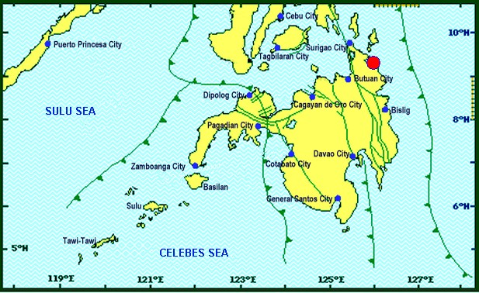
Situation Overview
On July 13, 2019 at 4;42 AM, a 5.5 magnitude earthquake jolted the municipality of Carrascal, Surigao del Sur (09.32°N, 125.99°E - 007 km S 37° E) with a tectonic origin and a depth of focus of 4km. The earthquake was also felt in the neighboring municipalities of Surigao del Sur and in some parts of the region.

Reported Intensities : | Intensity VI - Carrascal, Cantilan, Carmen, Lanuza, and Madrid, Surigao Del Sur  Intensity V - Bayabas, and Cortes, Surigao Del Sur; Butuan City  Intensity IV - Surigao City; Tandag City; Gingoog City; Claver, Surigao Del Norte; Magsaysay,  Misamis Oriental; Talacogon, Agusan Del Sur  Intensity III - Cagwait, Surigao Del Sur; Socorro, Surigao Del Norte; Balingasag, Balingoan,  Jasaan, Salay, and Villanueva, Misamis Oriental; Pintuyan, San Francisco, and San Ricardo,  Southern Leyte; Cagayan De Oro City  Intensity II - Mambajao, Camiguin  Instrumental Intensities:  Intensity IV - Gingoog City  Intensity II - Cebu City; Borongan City  Intensity I - Bislig City; Cagayan de Oro City; Palo, Leyte
Expecting Damage: | YES
Expecting Aftershocks: | YES

Source: DOST-PHIVOLCS Earthquake Bulletin

- Status of Affected Families / Persons
A total of 2,152 families or 9,609 persons were affected by the earthquake incident in 40 barangays in Surigao del Sur (see Table 1).

Table 1. Affected Families / Persons
REGION / PROVINCE / MUNICIPALITY |  | NUMBER OF AFFECTED
 |  | Barangays | Families | Persons
GRAND TOTAL |  | 40 | 2,152 | 9,609
CARAGA |  | 40 | 2,152 | 9,609
Surigao del Sur |  | 40 | 2,152 | 9,609
 | Cantilan | 14 | 1,184 | 4,769
 | Carmen | 8 | 372 | 1,860
 | Carrascal | 3 | 117 | 585
 | Lanuza | 1 | 3 | 15
 | Madrid | 14 | 476 | 2,380
Note: Ongoing assessment and validation being conducted.
Source: DSWD-FO CARAGA
- Damaged Houses
2,152 houses were damaged by the earthquake incident; of which, 67 houses were totally damaged and 2,085 houses were partially damaged (see Table 2).

Table 2. Number of Damaged Houses
REGION / PROVINCE / MUNICIPALITY |  | NO. OF DAMAGED HOUSES
 |  | Total | Totally | Partially
GRAND TOTAL |  | 2,152 | 67 | 2,085
CARAGA |  | 2,152 | 67 | 2,085
Surigao del Sur |  | 2,152 | 67 | 2,085
 | Cantilan | 1,184 | 40 | 1,144
 | Carmen | 372 | 4 | 368
 | Carrascal | 117 | 14 | 103
 | Lanuza | 3 | 2 | 1
 | Madrid | 476 | 7 | 469
Note: Ongoing assessment and validation being conducted.
Source: DSWD-FO CARAGA
- Cost of Assistance
A total of ₱2,743,773.00 worth of assistance was provided to the affected families; of which, ₱1,791,773.00 was provided by DSWD and ₱952,000.00 was provided by LGU (see Table 3).

Table 3. Cost of Assistance Provided to Affected Families / Persons
REGION / PROVINCE / MUNICIPALITY |  | TOTAL COST OF ASSISTANCE
 |  | DSWD | LGU | NGOs | OTHERS | GRAND TOTAL
GRAND TOTAL |  | 1,791,773.00 | 952,000.00 | - | - | 2,743,773.00
CARAGA |  | 1,791,773.00 | 952,000.00 | - | - | 2,743,773.00
Surigao del Sur |  | 1,791,773.00 | 952,000.00 | - | - | 2,743,773.00
 | Province of Surigao del Sur | - | 902,000.00 | - | - | 902,000.00
 | Cantilan | 1,008,676.20 | - | - | - | 1,008,676.20
 | Carmen | 286,115.20 | - | - | - | 286,115.20
 | Carrascal | 91,125.00 | 50,000.00 | - | - | 141,125.00
 | Lanuza | 5,189.80 | - | - | - | 5,189.80
 | Madrid | 400,666.80 | - | - | - | 400,666.80
Note: Ongoing assessment and validation being conducted.
Source: DSWD-FO CARAGA

Situational Reports

DSWD-DRMB
DATE | SITUATIONS / ACTIONS UNDERTAKEN
19 July 2019 | - The Disaster Response Operations Monitoring and Information Center (DROMIC) of the DSWD-DRMB continues to closely coordinate with DSWD-FO CARAGA for significant reports on the status of affected families, assistance, and relief efforts.

DSWD-FO CARAGA
DATE | ACTION(S) TAKEN
- July 2019 | - DSWD-FO CARAGA distributed a total of 4,466 family food packs amounting to ₱1,627,573.80 to the affected families in Cantilan, Carrascal and Madrid, Lanuza and Carmen, Surigao del Sur.  - DSWD-FO CARAGA is constantly coordinating with LSWDOs and LDRRMOs for further updates.

***
The Disaster Response Operations Monitoring and Information Center (DROMIC) of the DSWD-DRMB is closely coordinating with DSWD-FO CARAGA for any significant disaster response updates.

Prepared by:

MARIE JOYCE G. RAFANAN

RODEL V. CABADDU
Releasing Officer

