DSWD DROMIC Report #6
on the Earthquake Incident in Carrascal, Surigao del Sur
as of 23 July 2019, 12NN

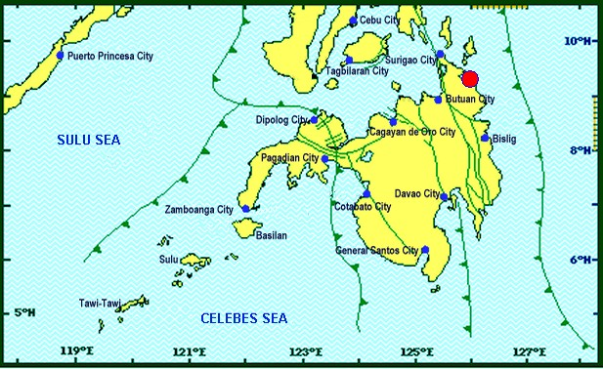
Situation Overview
On 13 July 2019 at 4:42 AM, a 5.5 magnitude earthquake jolted the municipality of Carrascal, Surigao del Sur (09.32°N, 125.99°E - 007 km S 37°E) with a tectonic origin and a depth of focus of 4km. The earthquake was also felt in the neighboring municipalities of Surigao del Sur and in some parts of the region.

Date/Time: | 13 Jul 2019 - 04:42:54 AM
Reported Intensities: | Intensity VI - Carrascal, Cantilan, Carmen, Lanuza, and Madrid, Surigao Del Sur  Intensity V - Bayabas, and Cortes, Surigao Del Sur; Butuan City  Intensity IV - Surigao City; Tandag City; Gingoog City; Claver, Surigao Del Norte; Magsaysay,  Misamis Oriental; Talacogon, Agusan Del Sur  Intensity III - Cagwait, Surigao Del Sur; Socorro, Surigao Del Norte; Balingasag, Balingoan,  Jasaan, Salay, and Villanueva, Misamis Oriental; Pintuyan, San Francisco, and San Ricardo,  Southern Leyte; Cagayan De Oro City  Intensity II - Mambajao, Camiguin  Instrumental Intensities:  Intensity IV - Gingoog City  Intensity II - Cebu City; Borongan City  Intensity I - Bislig City; Cagayan de Oro City; Palo, Leyte
Expecting Damage: | YES
Expecting Aftershocks: | YES

Source: DOST-PHIVOLCS Earthquake Bulletin

- Status of Affected Families / Persons
A total of 2,215 families or 10,473 persons were affected by the earthquake incident in 41 barangays in Surigao del Sur (see Table 1).

Table 1. Number of Affected Families / Persons
REGION / PROVINCE / MUNICIPALITY |  | NUMBER OF AFFECTED
 |  | Barangays | Families | Persons
GRAND TOTAL |  | 41 | 2,215 | 10,473
CARAGA |  | 41 | 2,215 | 10,473
Surigao del Sur |  | 41 | 2,215 | 10,473
 | Cantilan | 14 | 1,184 | 5,318
 | Carmen | 8 | 400 | 2,000
 | Carrascal | 4 | 147 | 735
 | Lanuza | 1 | 8 | 40
 | Madrid | 14 | 476 | 2,380
Note: Ongoing assessment and validation being conducted.
Source: DSWD-FO CARAGA

- Damaged Houses
2,215 houses were damaged by the earthquake incident; of which, 53 houses were totally damaged and 2,162 houses were partially damaged (see Table 2).

Table 2. Number of Damaged Houses
REGION / PROVINCE / MUNICIPALITY |  | NO. OF DAMAGED HOUSES
 |  | Total | Totally | Partially
GRAND TOTAL |  | 2,215 | 53 | 2,162
CARAGA |  | 2,215 | 53 | 2,162
Surigao del Sur |  | 2,215 | 53 | 2,162
 | Cantilan | 1,184 | 40 | 1,144
 | Carmen | 400 | 4 | 396
 | Carrascal | 147 | 1 | 146
 | Lanuza | 8 | 1 | 7
 | Madrid | 476 | 7 | 469
Note: The decrease in the number of totally damaged houses is based on the validated data in the update report submitted by LGUs of Carrascal and Lanuza.
Source: DSWD-FO CARAGA

- Cost of Assistance
A total of ₱3,766,673.00 worth of assistance was provided to the affected families; of which, ₱1,791,773.00 was provided by DSWD and ₱1,974,900.00 was provided by LGUs (see Table 3).

Table 3. Cost of Assistance Provided to Affected Families / Persons
REGION / PROVINCE / MUNICIPALITY |  | TOTAL COST OF ASSISTANCE
 |  | DSWD | LGUs | NGOs | OTHERS | GRAND TOTAL
GRAND TOTAL |  | 1,791,773.00 | 1,974,900.00 | - | - | 3,766,673.00
CARAGA |  | 1,791,773.00 | 1,974,900.00 | - | - | 3,766,673.00
Surigao del Sur |  | 1,791,773.00 | 1,974,900.00 | - | - | 3,766,673.00
 | Province of Surigao del Sur | - | 1,910,000.00 | - | - | 1,910,000.00
 | Cantilan | 1,008,676.20 | - | - | - | 1,008,676.20
 | Carmen | 286,115.20 | - | - | - | 286,115.20
 | Carrascal | 91,125.00 | 64,900.00 | - | - | 156,025.00
 | Lanuza | 5,189.80 | - | - | - | 5,189.80
 | Madrid | 400,666.80 | - | - | - | 400,666.80
Note: Ongoing assessment and validation being conducted.
Source: DSWD-FO CARAGA
Situational Reports

DSWD-DRMB
DATE | SITUATIONS / ACTIONS UNDERTAKEN
23 July 2019 | - The Disaster Response Operations Monitoring and Information Center (DROMIC) of the DSWD-DRMB continues to closely coordinate with DSWD-FO Caraga for significant reports on the status of affected families, assistance, and relief efforts.

DSWD-FO CARAGA
DATE | ACTION(S) TAKEN
23 July 2019 | - DSWD-FO Caraga is waiting for the submission of project proposals and validation reports for consolidation and endorsement to the Central Office for possible funding support for the provision of Emergency Shelter Assistance.  - DSWD-FO Caraga is constantly coordinating with LSWDOs and LDRRMOs for further update reports regarding the earthquake incident.

***
The Disaster Response Operations Monitoring and Information Center (DROMIC) of the DSWD-DRMB is closely coordinating with DSWD-FO Caraga for any significant disaster response updates.

Prepared by:

MARIE JOYCE G. RAFANAN

MARC LEO L. BUTAC
Releasing Officer

