DSWD DROMIC Report #6
on the Earthquake Incident in Itbayat, Batanes
as of 31 July 2019, 4AM

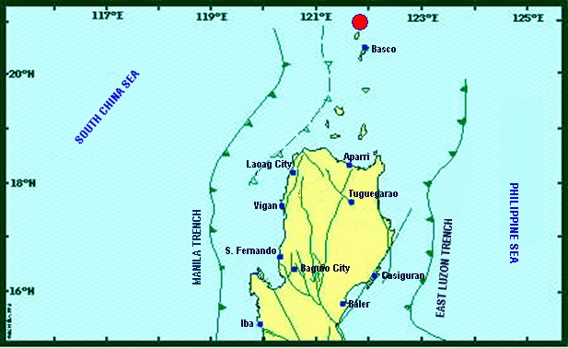

Situation Overview

On 27 July 2019 at 4:16 AM, a 5.4 magnitude earthquake jolted the municipality of Itbayat, Batanes (20.90°N, 121.85°E - 012 km N 04°E) with a tectonic origin and a depth of focus of 12 km. The earthquake was also felt in the neighboring municipalities of Batanes.

Date/Time: | 27 Jul 2019 - 04:16:54 AM
Reported Intensities: | Intensity VI - Itbayat, Batanes  Intensity III - Basco and Sabtang, Batanes  Instrumental Intensity:  Intensity III - Basco, Batanes
Expecting Damage: | YES
Expecting Aftershocks: | YES
Source: DOST-PHIVOLCS Earthquake Bulletin

- Status of Affected Families / Persons
A total of 911 families or 2,963 persons were affected by the earthquake incident in 5 barangays in Itbayat, Batanes (see Table 1).

Table 1. Number of Affected Families / Persons
REGION / PROVINCE / MUNICIPALITY |  | NUMBER OF AFFECTED
 |  | Barangays | Families | Persons
GRAND TOTAL |  | 5 | 911 | 2,963
REGION II |  | 5 | 911 | 2,963
Batanes |  | 5 | 911 | 2,963
 | Itbayat | 5 | 911 | 2,963
Note: Based on the Progress Report submitted by FO II, there are no significant changes as to the number of affected families or persons since ongoing assessment and validation is being conducted.
Source: DSWD-FO II

- Status of Displaced Families / Persons
805 families or 2,616 persons are currently staying at the Covered Court/Municipal Plaza in Brgy. San Rafael, Itbayat, Batanes (see Table 2).

Table 2. Number of Displaced Families / Persons Inside Evacuation Center
REGION / PROVINCE / MUNICIPALITY |  | NUMBER OF EVACUATION CENTERS (ECs) |  | INSIDE ECs
 |  |  |  | Families |  | Persons
 |  | CUM | NOW | CUM | NOW | CUM | NOW
GRAND TOTAL |  | 1 | 1 | 805 | 805 | 2,616 | 2,616
REGION II |  | 1 | 1 | 805 | 805 | 2,616 | 2,616
Batanes |  | 1 | 1 | 805 | 805 | 2,616 | 2,616
 | Itbayat | 1 | 1 | 805 | 805 | 2,616 | 2,616
Note: Ongoing assessment and validation being conducted. 106 families or 347 persons in Brgy. Raele did not evacuate. Thus, they are currently staying in their respective houses.
Source: DSWD-FO II

- Damaged Houses
There are 266 damaged houses; of which, 81 are partially damaged and 185 are totally damaged (see Table 3).

Table 3. Number of Damaged Houses
REGION / PROVINCE / MUNICIPALITY |  | NO. OF DAMAGED HOUSES
 |  | Total | Totally | Partially
GRAND TOTAL |  | 266 | 185 | 81
REGION II |  | 266 | 185 | 81
Batanes |  | 266 | 185 | 81
 | Itbayat | 266 | 185 | 81
Note: Ongoing assessment and validation being conducted.
*Based on the Proposed Early Recovery and Rehabilitation Plan submitted by DSWD-FO II.
Source: DSWD-FO II

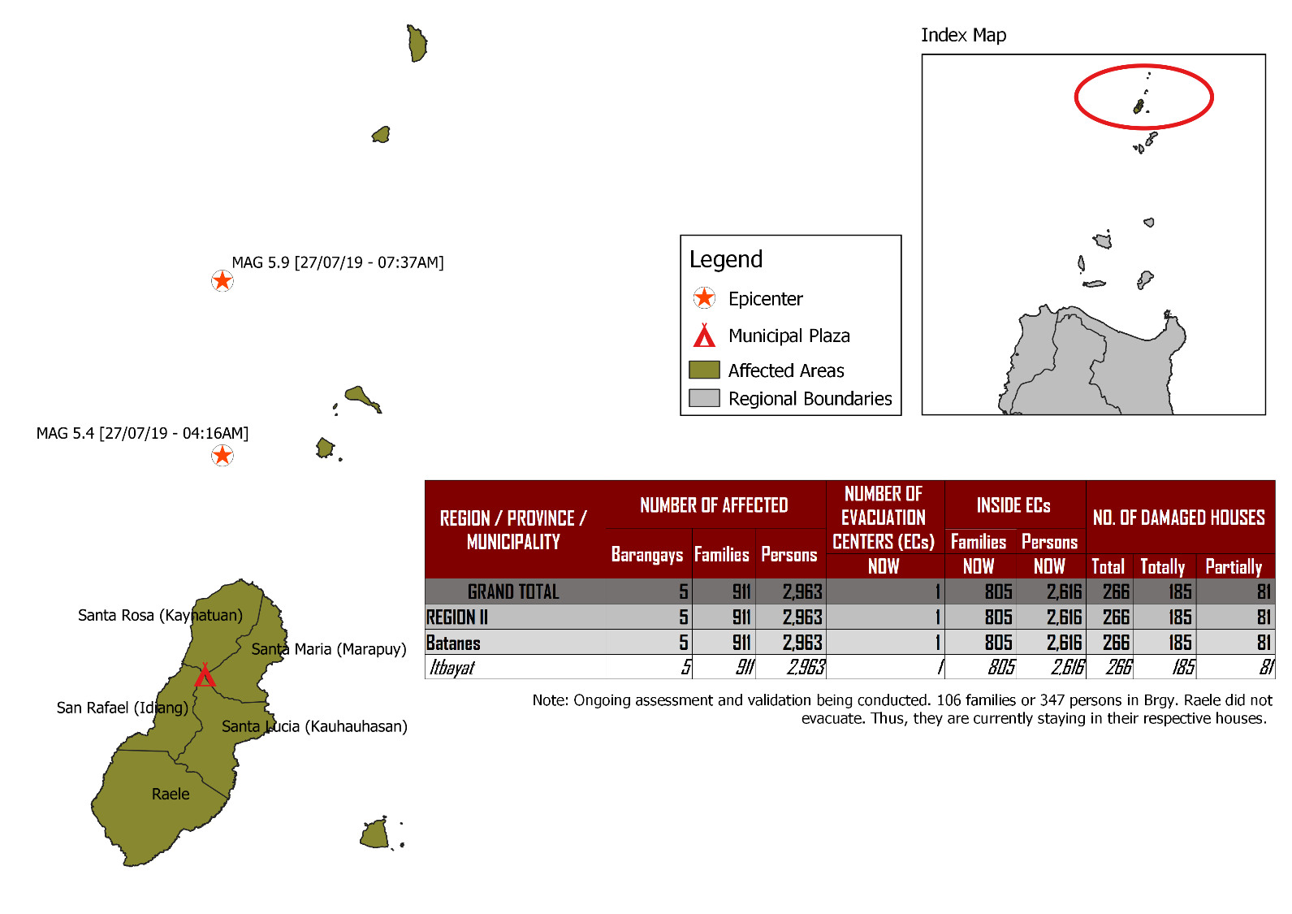
DSWD DISASTER RESPONSE INFORMATION
Source: DRMB-DROMIC GIS Specialists
Status of Prepositioned Resources: Stockpile and Standby Funds
The DSWD Central Office (CO), Field Offices (FOs), and National Resource Operations Center (NROC) have stockpiles and standby funds amounting to ₱1,972,905,977.22 with breakdown as follows (see Table 1):

- Standby Funds
A total of ₱1,181,581,331.18 standby funds in the CO and FOs. Of the said amount, ₱1,146,974,543.16 is the available Quick Response Fund (QRF) in the CO.

- Stockpiles
A total of 358,136 Family Food Packs (FFPs) amounting to ₱134,470,535.44 and available Food and Non-food Items (FNIs) amounting to ₱656,854,110.60.

FIELD OFFICE | STANDBY FUNDS | STOCKPILES |  |  |  |  | Total STANDBY FUNDS & STOCKPILE
 |  | Family Food Packs |  | Other Food Items | Non Food Items | SUB-TOTAL (Food and NFIs)
 |  | Quantity | Total Cost | Total Cost | Total Cost
TOTAL | 1,181,581,331.18 | 358,136 | 134,470,535.44 | 161,926,836.96 | 494,927,273.64 | 656,854,110.60 | 1,972,905,977.22
Central Office | *1,146,974,543.16 |  |  |  |  |  | 1,146,974,543.16
NRLMB - NROC | 0.00 | 103,200 | 38,920,848.00 | 82,564,936.86 | 330,634,906.88 | 413,199,843.74 | 452,120,691.74
NRLMB - VDRC | 0.00 | 11,700 | 4,212,000.00 | 1,203,200.00 | 5,224,562.31 | 6,427,762.31 | 10,639,762.31
I | 2,379,275.00 | 14,393 | 5,181,480.00 | 1,094,185.92 | 33,381,090.79 | 34,475,276.71 | 42,036,031.71
II | 930,801.96 | 28,562 | 10,282,282.00 | 526,640.00 | 349,602.75 | 876,242.75 | 12,089,326.71
III | 2,404,557.00 | 26,192 | 10,257,281.28 | 899,919.70 | 241,406.00 | 1,141,325.70 | 13,803,163.98
CALABARZON | 1,960,100.00 | 4,697 | 1,689,515.26 | 3,898,207.60 | 3,288,354.81 | 7,186,562.41 | 10,836,177.67
MIMAROPA | 1,938,971.58 | 24,756 | 10,348,008.00 | 2,243,173.55 | 859,605.00 | 3,102,778.55 | 15,389,758.13
V | 3,000,000.00 | 18,521 | 7,223,190.00 | 10,485,948.72 | 40,704,948.22 | 51,190,896.94 | 61,414,086.94
VI | 1,150,000.00 | 15,694 | 5,855,520.00 | 8,682,157.17 | 3,713,837.50 | 12,395,994.67 | 19,401,514.67
VII | 3,000,000.00 | 17,145 | 6,172,200.00 | 18,519,644.43 | 17,559,057.08 | 36,078,701.51 | 45,250,901.51
VIII | 1,401,960.00 | 21,968 | 7,939,674.56 | 1,304,119.84 | 896,387.00 | 2,200,506.84 | 11,542,141.40
IX | 843,321.35 | 10,119 | 3,642,840.00 | 813,730.00 | 3,793,242.35 | 4,606,972.35 | 9,093,133.70
X | 3,000,000.00 | 1,512 | 544,320.00 | 6,593,047.20 | 30,362,019.90 | 36,955,067.10 | 40,499,387.10
XI | 3,028,750.00 | 25,381 | 9,185,285.40 | 11,053,700.00 | 10,921,627.34 | 21,975,327.34 | 34,189,362.74
XII | 584,701.68 | 4,724 | 1,894,324.00 | 3,484,211.10 | 2,348,437.26 | 5,832,648.36 | 8,311,674.04
CARAGA | 3,000,000.00 | 10,014 | 3,821,443.00 | 946,748.00 | 4,806,699.85 | 5,753,447.85 | 12,574,890.85
NCR | 3,292,543.50 | 3,665 | 1,341,789.14 | 1,998,746.57 | 928,770.00 | 2,927,516.57 | 7,561,849.21
CAR | 2,691,805.95 | 15,893 | 5,958,534.80 | 5,614,520.30 | 4,912,718.60 | 10,527,238.90 | 19,177,579.65
*Quick Response Fund (QRF) as of 27 July 2019

Situational Reports

DSWD-DRMB
DATE | SITUATIONS / ACTIONS UNDERTAKEN
30 July 2019 | - The Disaster Response Management Bureau (DRMB) remains on BLUE alert level status and is closely coordinating with DSWD-FO II for significant disaster response updates.  - All QRT members and emergency equipment are on standby and ready for deployment.  - Two staff from DSWD-DRMB are providing technical assistance and Critical Incident Stress Debriefing (CISD) to the affected families.  - The 400 sleeping kits and 65 family tents in Clark Airport are in transit to Basco, Batanes.  - DSWD-DRMB Team is in close coordination with the Procurement Service relative to the emergency procurement of the Satellite Phones Load.

DSWD-NRLMB
DATE | SITUATIONS / ACTIONS UNDERTAKEN
30 July 2019 | - The 100 family tents and 60 folding beds from NROC have been delivered to DSWD-FO II in Tuguegarao City.  - The requested 25 family tents and 400 sleeping kits from DSWD-FO I were delivered to Tuguegarao City.
29 July 2019 | - 6,400 3kg-vacuum packed rice and 50 folding beds were delivered to DSWD-FO II in Tuguegarao City.

DSWD-FO II
DATE | ACTION(S) TAKEN
31 July 2019 | - DSWD-FO II remains on RED alert level status.  - DSWD-FO II send two (2) Social Workers, Ms. Mary Jane Paliuanan and Ms. Alma Caranguian to assist in psychosocial intervention and augment in the assessment of damaged houses for possible assistance thru Emergency Shelter Assistance (ESA) and one (1) PDO II, Mr. Rafael De Leon to assist in warehouse/ response management and validation of damaged houses.  - A total of 312 FFPs which was not accommodated by the plane at the airport is ferried through CEZA delivery truck to port Irene at Sta. Ana, Cagayan awaiting to the offshore vessel of BFAR  - The 1,000 FFPs, 25 family tents and 400 sleeping kits from DSWD FO-I and the 60 folding beds and 100 family tents from NRLMB is transported from Tuguegarao City to Port Irene, Sta. Ana, Cagayan to be loaded to BFAR vessel to ferry the goods directly to Itbayat, Batanes.
30 July 2019 | - The 158 FFPs worth ₱56,880.00 delivered to Itbayat, Batanes are ready for distribution.  - A total of ₱489,000.00 worth of social pension assistance was provided to the 163 affected senior citizens who received ₱3,000.00 each for the 1st and 2nd quarters. Ongoing distribution of financial assistance is being conducted for the remaining 147 senior citizens.  - DSWD-FO II will provide Emergency Shelter Assistance (ESA) amounting to ₱30,000 per family with totally damaged house and ₱10,000 per family with partially damaged house.  - DSWD-FO II staff, Ms. Mia Carbonel of DRMD and Ms. Marlene Tuazon, along with Ms. Amparo Tobias, SWAD Batanes Team Lead are continuously providing Critical Incident Stress Debriefing (CISD) to the affected families in the Public Market (EC) in Brgy. San Rafael, Itbayat, Batanes and conducting distribution of social pension to affected senior citizens.
29 July 2019 | - DSWD-FO II extended assistance to some affected families such as food assistance, burial assistance, and medical assistance amounting to a total of ₱45,000.00.  - As a result of the meeting on 28 July 2019, BFAR-Region 2 allocated a space for the FNIs of DSWD-FO II such as 1,000 FFPs, 25 family tents and 400 sleeping kits to be ferried directly to Itbayat by Wednesday afternoon, 31 July 2019.

***
The Disaster Response Operations Monitoring and Information Center (DROMIC) of the DSWD-DRMB is closely coordinating with DSWD-FO II for any significant disaster response updates.

Prepared by:

MARIJOY V. SAN BUENAVENTURA

JAN ERWIN ANDREW I. ONTANILLAS
Releasing Officer
Photo Documentations
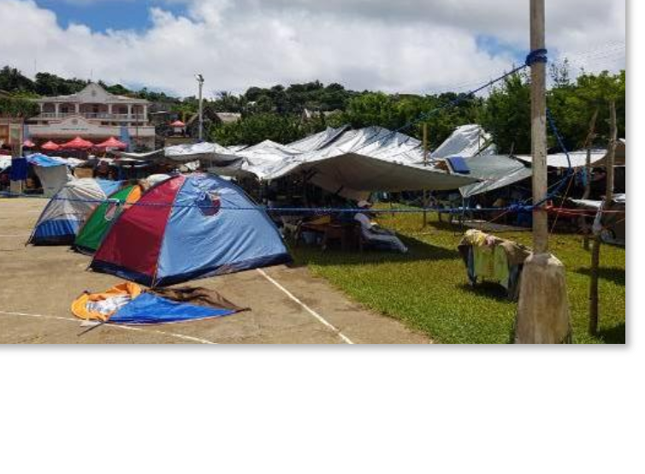
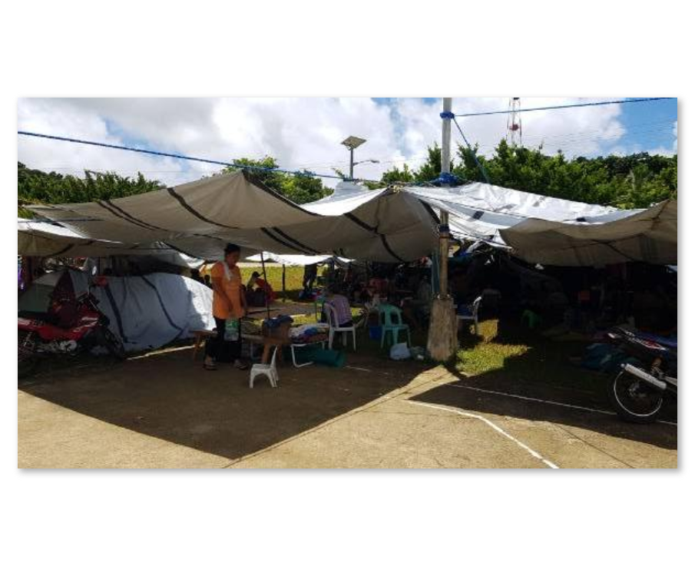
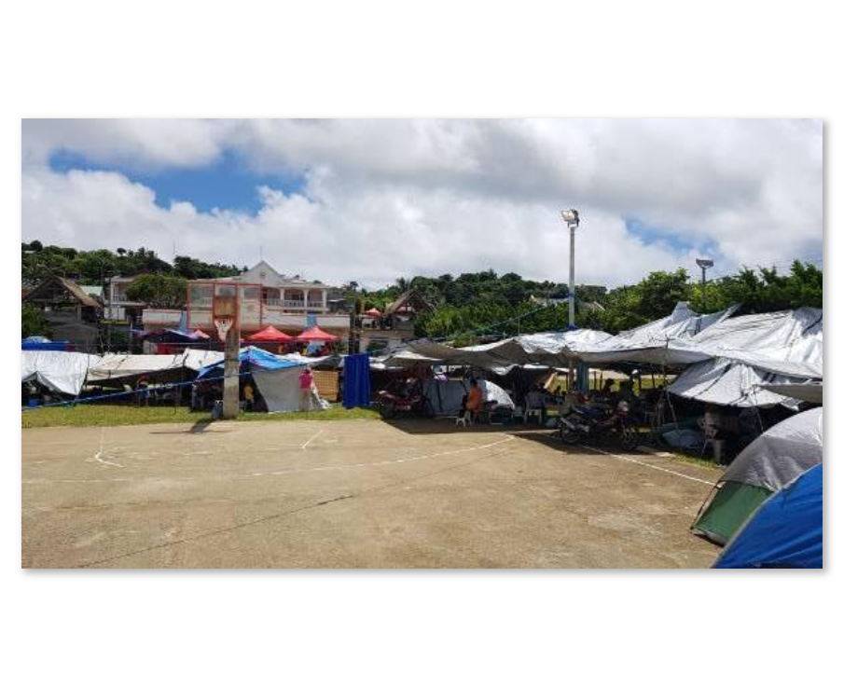
Public Market/Municipal Plaza Open Ground Evacuation Center
Families are staying under makeshift tents.
As per coordination with Incident Commander (IC) Ms. Sharmaine Gato, validation of DPWH and Barangay Officials regarding damaged houses and public facilities is on 1/3 completion for assessment of damaged houses as of yesterday.
Classes will only resume until safety of buildings is ensured.

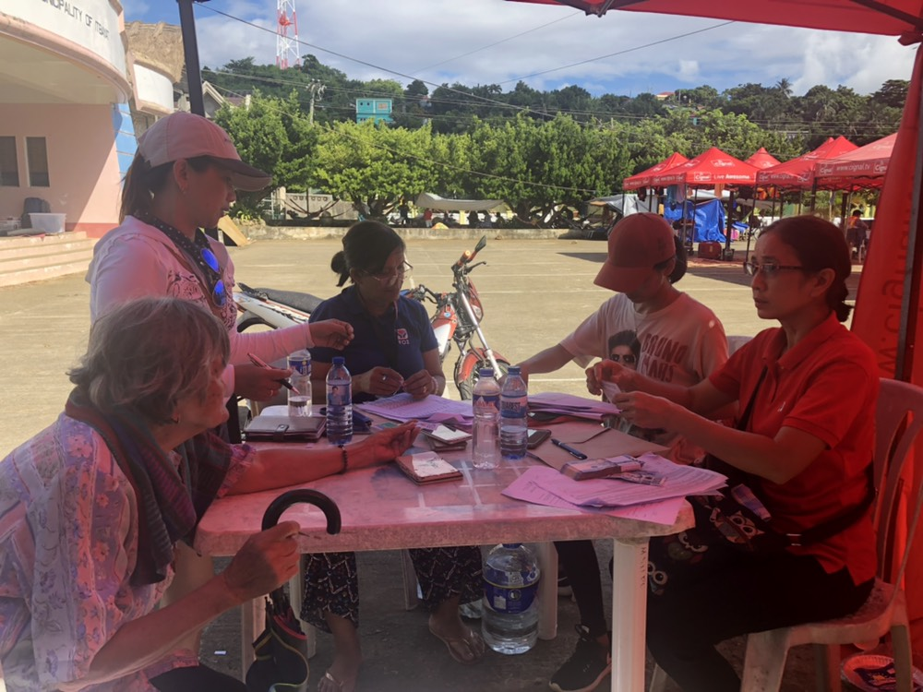

DSWD-FO II providing Social Pension to the senior citizens affected by the earthquake incident.

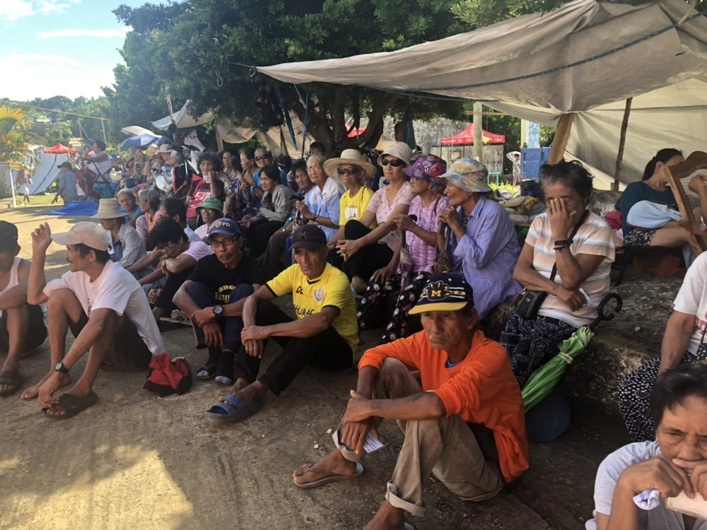
The senior citizens affected by the earthquake incident patiently waiting for their turn to receive financial assistance thru Social Pension.
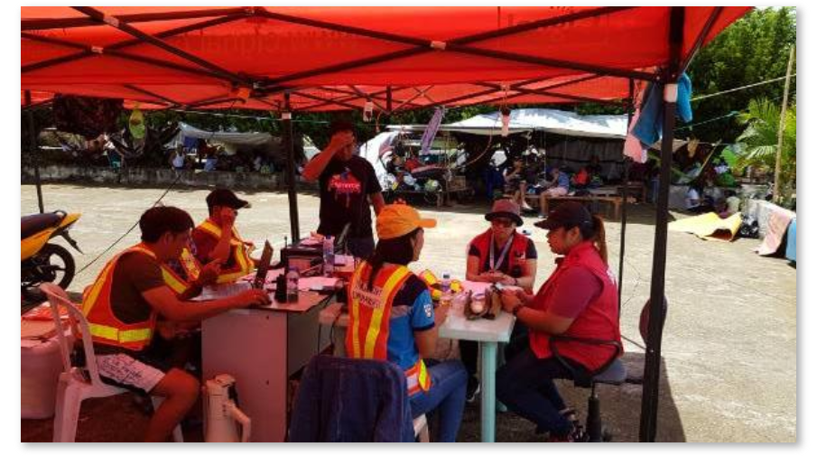
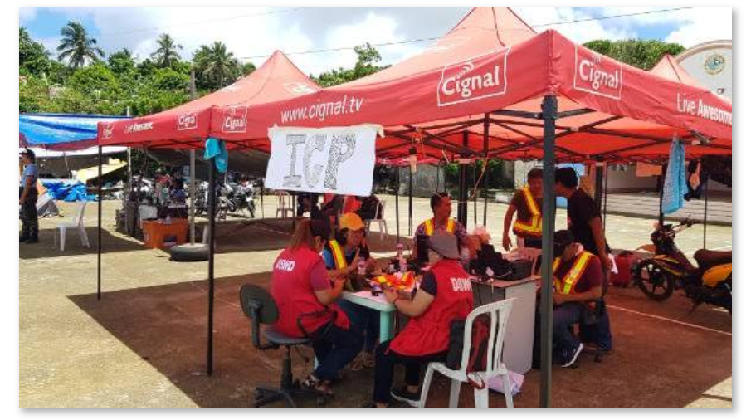
Incident Command Post

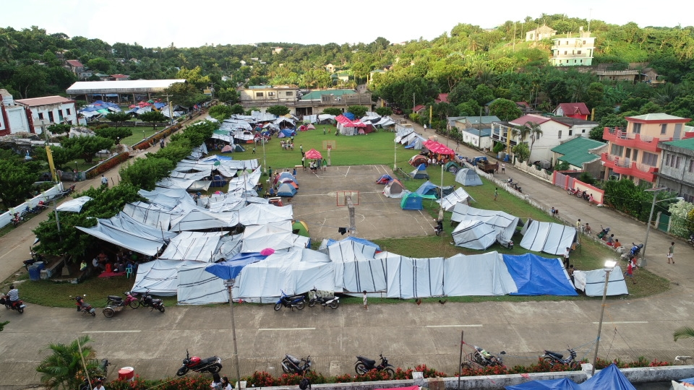
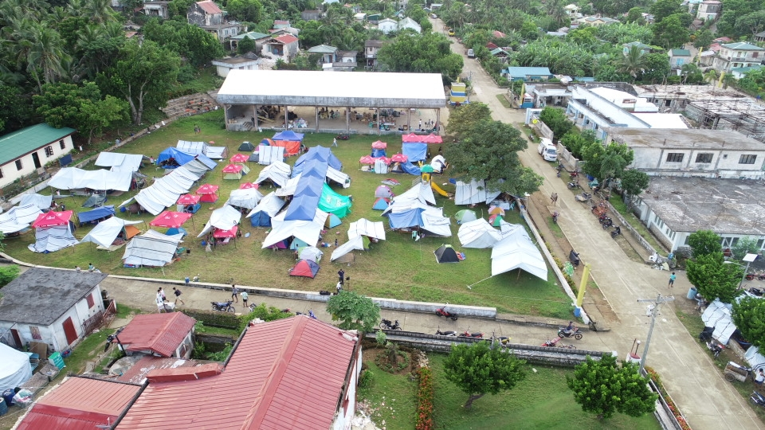
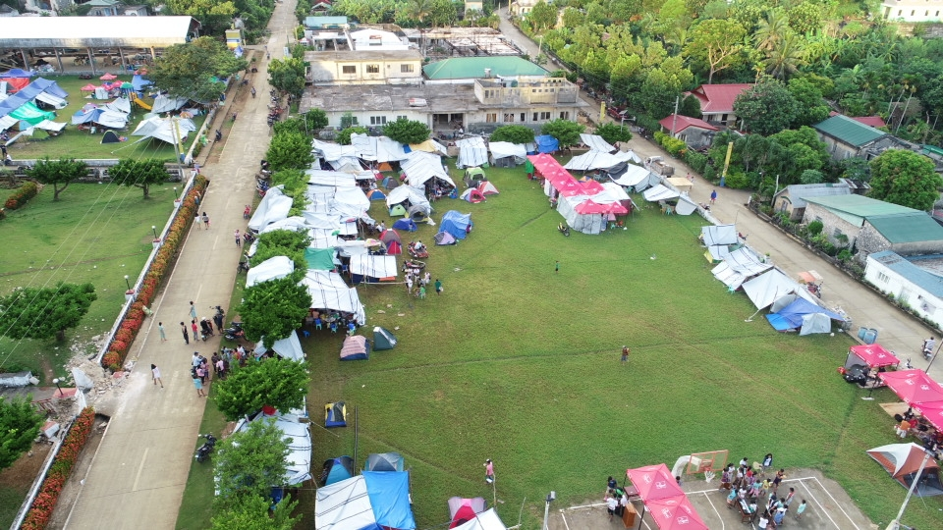
Aerial View of the Municipal Plaza as Evacuation Center

