DSWD DROMIC Report #7 on
Tropical Storm “FALCON”
as of 19 July 2019, 6PM

Situation Overview

On 15 July 2019, the Low Pressure Area east of Guiuan, Eastern Samar has developed into a Tropical Depression and was named “Falcon”. It has generally moved northwestward. Tropical Storm "Falcon" is now outside the Philippine Area of Responsibility (PAR).

Source: DOST-PAGASA Severe Weather Bulletin

- Status of Affected Families / Persons
A total of 431 families or 1,918 persons were affected by the effects of Tropical Storm “Falcon” in 26 Barangays in Region I, Region II, Region III and CAR (see Table 1).

Table 1. Number of Affected Families / Persons
REGION / PROVINCE / MUNICIPALITY |  | NUMBER OF AFFECTED
 |  | Barangays | Families | Persons
GRAND TOTAL |  | 26 | 431 | 1,918
REGION I |  | 1 | 1 | 5
Ilocos Norte |  | 1 | 1 | 5
 | Burgos | 1 | 1 | 5
REGION II |  | 14 | 290 | 1,407
Cagayan |  | 14 | 290 | 1,407
 | Allacapan | 1 | 33 | 165
 | Aparri | 1 | 2 | 5
 | Baggao | 1 | 1 | 3
 | Camalaniugan | 1 | 5 | 10
 | Gonzaga | 2 | 9 | 41
 | Lal-lo | 3 | 11 | 47
 | Lasam | 1 | 8 | 39
 | Santa Teresita | 3 | 219 | 1,091
 | Solana | 1 | 2 | 6
REGION III |  | 1 | 2 | 11
Bataan |  | 1 | 2 | 11
 | Abucay | 1 | 2 | 11
CAR |  | 10 | 138 | 495
Abra |  | 1 | 1 | 2
 | Lagayan | 1 | 1 | 2
Apayao |  | 8 | 120 | 409
 | Pudtol | 2 | 2 | 12
 | Santa Marcela | 6 | 118 | 397
Mountain Province |  | 1 | 17 | 84
 | Sabangan | 1 | 17 | 84
Note: Ongoing assessment and validation being conducted.
Source: DSWD-FOs I, II, III and CAR

- Status of Displaced Families / Persons

- Inside Evacuation Center
There are 19 families or 95 persons who are currently staying inside 18 evacuation centers in Region III and CAR (see Table 2).

Table 2. Number of Served Families / Persons Inside ECs
REGION / PROVINCE / MUNICIPALITY |  | NUMBER OF EVACUATION CENTERS (ECs) |  | INSIDE ECs
 |  |  |  | Families |  | Persons
 |  | CUM | NOW | CUM | NOW | CUM | NOW
GRAND TOTAL |  | 32 | 18 | 102 | 19 | 442 | 95
REGION II |  | 12 | - | 75 | - | 327 | -
Cagayan |  | 12 | - | 75 | - | 327 | -
 | Allacapan | 1 | - | 33 | - | 165 | -
 | Aparri | 1 | - | 2 | - | 5 | -
 | Baggao | 1 | - | 1 | - | 3 | -
 | Camalaniugan | 1 | - | 5 | - | 10 | -
 | Gonzaga | 2 | - | 9 | - | 41 | -
 | Lal-lo | 3 | - | 11 | - | 47 | -
 | Lasam | 1 | - | 8 | - | 39 | -
 | Santa Teresita | 1 | - | 4 | - | 11 | -
 | Solana | 1 | - | 2 | - | 6 | -
REGION III |  | 1 | 1 | 2 | 2 | 11 | 11
Bataan |  | 1 | 1 | 2 | 2 | 11 | 11
 | Abucay | 1 | 1 | 2 | 2 | 11 | 11
CAR |  | 19 | 17 | 25 | 17 | 104 | 84
Apayao |  | 2 | - | 8 | - | 20 | -
 | Santa Marcela | 2 | - | 8 | - | 20 | -
Mountain Province |  | 17 | 17 | 17 | 17 | 84 | 84
 | Sabangan | 17 | 17 | 17 | 17 | 84 | 84
Note: Ongoing assessment and validation being conducted.
Source: DSWD-FOs II, III and CAR

- Outside Evacuation Center
A total of 3 families or 15 persons are temporarily staying with their friends and/or relatives (see Table 3).

Table 3. Number of Served Families / Persons Outside ECs
REGION / PROVINCE / MUNICIPALITY |  | OUTSIDE ECs
 |  | Families |  | Persons
 |  | CUM | NOW | CUM | NOW
GRAND TOTAL |  | 117 | 3 | 405 | 15
REGION I |  | 1 | 1 | 5 | 5
Ilocos Norte |  | 1 | 1 | 5 | 5
 | Burgos | 1 | 1 | 5 | 5
REGION II |  | 3 | - | 11 | -
Cagayan |  | 3 | - | 11 | -
 | Santa Teresita | 3 | - | 11 | -
CAR |  | 113 | 2 | 389 | 10
Abra |  | 1 | - | 2 | -
 | Lagayan | 1 | - | 2 | -
Apayao |  | 112 | 2 | 387 | 10
 | Pudtol | 2 | 2 | 10 | 10
 | Santa Marcela | 110 | - | 377 | -
Note: Ongoing assessment and validation being conducted.
Source: DSWD-FOs I, II, and CAR

- Damaged Houses
There are 3 damaged houses; of which 1 is totally damaged and 2 are partially damaged (see Table 4).

Table 4. Number of Damaged Houses
REGION / PROVINCE / MUNICIPALITY |  | NO. OF DAMAGED HOUSES
 |  | Total | Totally | Partially
GRAND TOTAL |  | 3 | 1 | 2
REGION I |  | 1 | - | 1
Ilocos Norte |  | 1 | - | 1
 | Burgos | 1 | - | 1
CAR |  | 2 | 1 | 1
Apayao |  | 2 | 1 | 1
 | Pudtol | 2 | 1 | 1
Note: Ongoing assessment and validation being conducted.
Source: DSWD-FOs I and CAR

- Assistance Provided
A total of ₱699,210.00 worth of assistance was provided to the affected families; of which, ₱185,400.00 was provided by DSWD and ₱513,810.00 was provided by LGU (see Table 5).

Table 5. Cost of Assistance Provided to Affected Families / Persons
REGION / PROVINCE / MUNICIPALITY |  | TOTAL COST OF ASSISTANCE
 |  | DSWD | LGU | NGOs | OTHERS | GRAND TOTAL
GRAND TOTAL |  | 185,400.00 | 513,810.00 | - | - | 699,210.00
REGION I |  | - | 6,500.00 | - | - | 6,500.00
Ilocos Norte |  | - | 6,500.00 | - | - | 6,500.00
 | Burgos | - | 6,500.00 | - | - | 6,500.00
REGION II |  | 174,240.00 | 458,778.00 | - | - | 633,018.00
Cagayan |  | 174,240.00 | 8,778.00 | - | - | 183,018.00
 | Calayan | 30,240.00 | - | - | - | 30,240.00
 | Gonzaga | - | 2,394.00 | - | - | 2,394.00
 | Lal-lo | - | 6,384.00 | - | - | 6,384.00
 | Santa Teresita | 144,000.00 | - | - | - | 144,000.00
Isabela |  | - | 450,000.00 | - | - | 450,000.00
 | Dinapigue | - | 112,500.00 | - | - | 112,500.00
 | Divilacan | - | 112,500.00 | - | - | 112,500.00
 | Maconacon | - | 112,500.00 | - | - | 112,500.00
 | Palanan | - | 112,500.00 | - | - | 112,500.00
CAR |  | 11,160.00 | 48,532.00 | - | - | 59,692.00
Abra |  | - | 1,400.00 | - | - | 1,400.00
 | Lagayan | - | 1,400.00 | - | - | 1,400.00
Apayao |  | - | 47,132.00 | - | - | 47,132.00
 | Pudtol | - | 3,000.00 | - | - | 3,000.00
 | Santa Marcela | - | 44,132.00 | - | - | 44,132.00
Mountain Province |  | 11,160.00 | - | - | - | 11,160.00
 | Sabangan | 11,160.00 | - | - | - | 11,160.00
Note: Ongoing assessment and validation being conducted.
Source: DSWD-FOs I, II and CAR

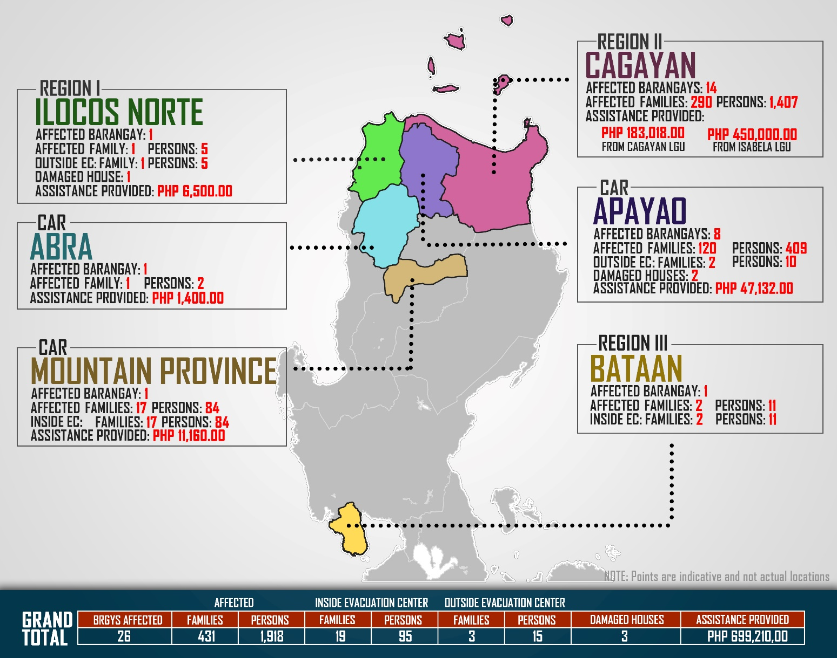
DSWD DISASTER RESPONSE INFORMATION

Source: DRMB-DROMIC GIS and IT Specialists

Situational Reports

DSWD-DRMB
DATE | SITUATIONS / ACTIONS UNDERTAKEN
19 July 2019 | - The Disaster Response Management Bureau (DRMB) is on BLUE Alert Status and is closely coordinating with the concerned DSWD-Field Offices for significant disaster preparedness for response updates.

DSWD-FO CAR
DATE | SITUATIONS / ACTIONS UNDERTAKEN
19 July 2019 | - DSWD-FO CAR through the Disaster Response Management Division (DRMD) is still on BLUE Alert Status.  - DRMD is continuously coordinating with PSWADTs and LDRRMOs for updates.  - DRMD is in close coordination with Office of Civil Defense for monitoring and response mechanisms.  - Regional Resource Operations Section has a total of 15,900 family food packs readily available.  - DRMD is continuously monitoring weather updates and information.

DSWD-FO I
DATE | SITUATIONS / ACTIONS UNDERTAKEN
19 July 2019 | - DSWD-FO I through the Disaster Response Management Division (DRMD) is on BLUE Alert Status.  - DSWD-FO I is in close coordination with the Provincial/City/Municipal Disaster Risk Reduction and Management Councils (PDRRMCs), and the Provincial/City/Municipal Social Welfare Development Offices (P/C/MSWDOs) for further augmentation support needed.  - DSWD-FO I is continuously coordinating with the Provincial Operations Offices (POOs), the Provincial/City/Municipal Disaster Risk Reduction and Management Councils (P/C/MDRRMCs), and the Provincial/City/Municipal Social Welfare and Development Offices (P/C/[IISWDOs) for weather conditions throughout the Region and to ensure submission of reports when needed.

DSWD-FO II
DATE | SITUATIONS / ACTIONS UNDERTAKEN
19 July 2019 | - DSWD-FO II is now on WHITE Alert Status.  - DSWD-FO II augmented four hundred (400) Family Food Packs (FFPs) to the municipality of Santa Teresita, Cagayan and eighty-four (84) FFPs to the municipality of Calayan, Cagayan as support to the affected families.  - DSWD-FO II is continuously coordinating with SWADTs and C/MATs for weather advisories.

DSWD-FO III
DATE | SITUATIONS / ACTIONS UNDERTAKEN
- July 2019 | - DSWD-FO III is conducting Stockpiling and Prepositioning of Food and Non-Food Items in the Satellite Warehouses.  - DSWD-FO III is continuously monitoring the weather updates in coordination with the RDRRMC III.

*****
The Disaster Response Operations Monitoring and Information Center (DROMIC) of the DSWD-DRMB is closely monitoring the effects of TS Falcon and is coordinating with the concerned DSWD-Field Offices for any significant updates.

Prepared by:

MARIE JOYCE G. RAFANAN

JAN ERWIN ANDREW I. ONTANILLAS
Releasing Officer

