DSWD DROMIC Terminal Report
on the Earthquake Incident in Carrascal, Surigao del Sur
03 September 2019, 8PM

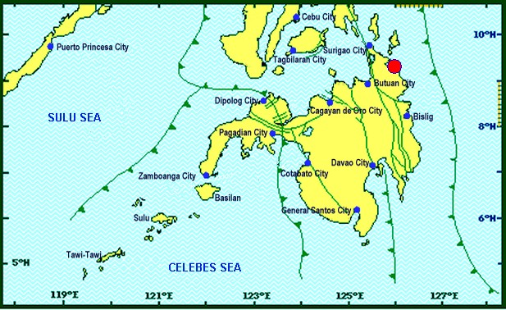
Situation Overview
On 13 July 2019 at 4:42 AM, a 5.5 magnitude earthquake jolted the municipality of Carrascal, Surigao del Sur (09.32°N, 125.99°E - 007 km S 37°E) with a tectonic origin and a depth of focus of 4km. The earthquake was also felt in the neighboring municipalities of Surigao del Sur and in some parts of the region.

Date/Time: | 13 Jul 2019 - 04:42:54 AM
Reported Intensities: | Intensity VI - Carrascal, Cantilan, Carmen, Lanuza, and Madrid, Surigao Del Sur  Intensity V - Bayabas, and Cortes, Surigao Del Sur; Butuan City  Intensity IV - Surigao City; Tandag City; Gingoog City; Claver, Surigao Del Norte; Magsaysay,  Misamis Oriental; Talacogon, Agusan Del Sur  Intensity III - Cagwait, Surigao Del Sur; Socorro, Surigao Del Norte; Balingasag, Balingoan,  Jasaan, Salay, and Villanueva, Misamis Oriental; Pintuyan, San Francisco, and San Ricardo,  Southern Leyte; Cagayan De Oro City  Intensity II - Mambajao, Camiguin  Instrumental Intensities:  Intensity IV - Gingoog City  Intensity II - Cebu City; Borongan City  Intensity I - Bislig City; Cagayan de Oro City; Palo, Leyte
Expecting Damage: | YES
Expecting Aftershocks: | YES

Source: DOST-PHIVOLCS Earthquake Bulletin

- Status of Affected Families / Persons
A total of 2,215 families or 10,473 persons were affected by the earthquake incident in 41 barangays in Surigao del Sur (see Table 1).

Table 1. Number of Affected Families / Persons
REGION / PROVINCE / MUNICIPALITY |  | NUMBER OF AFFECTED
 |  | Barangays | Families | Persons
GRAND TOTAL |  | 41 | 2,215 | 10,473
CARAGA |  | 41 | 2,215 | 10,473
Surigao del Sur |  | 41 | 2,215 | 10,473
 | Cantilan | 14 | 1,184 | 5,318
 | Carmen | 8 | 400 | 2,000
 | Carrascal | 4 | 147 | 735
 | Lanuza | 1 | 8 | 40
 | Madrid | 14 | 476 | 2,380
Source: DSWD-FO CARAGA

- Damaged Houses
2,215 houses were damaged by the earthquake incident; of which, 53 houses were totally damaged and 2,162 houses were partially damaged (see Table 2).

Table 2. Number of Damaged Houses
REGION / PROVINCE / MUNICIPALITY |  | NO. OF DAMAGED HOUSES
 |  | Total | Totally | Partially
GRAND TOTAL |  | 2,215 | 53 | 2,162
CARAGA |  | 2,215 | 53 | 2,162
Surigao del Sur |  | 2,215 | 53 | 2,162
 | Cantilan | 1,184 | 40 | 1,144
 | Carmen | 400 | 4 | 396
 | Carrascal | 147 | 1 | 146
 | Lanuza | 8 | 1 | 7
 | Madrid | 476 | 7 | 469
Source: DSWD-FO CARAGA

- Cost of Assistance
A total of ₱3,978,083.00 worth of assistance was provided to the affected families; of which, ₱2,003,183.00 was provided by DSWD and ₱1,974,900.00 was provided by LGUs (see Table 3).

Table 3. Cost of Assistance Provided to Affected Families / Persons
REGION / PROVINCE / MUNICIPALITY |  | TOTAL COST OF ASSISTANCE
 |  | DSWD | LGU | NGOs | OTHERS | GRAND TOTAL
GRAND TOTAL |  | 2,003,183.00 | 1,974,900.00 | - | - | 3,978,083.00
CARAGA |  | 2,003,183.00 | 1,974,900.00 | - | - | 3,978,083.00
Surigao del Sur |  | 2,003,183.00 | 1,974,900.00 | - | - | 3,978,083.00
 | Province of Surigao Del Sur | - | 1,910,000.00 | - | - | 1,910,000.00
 | Cantilan | 1,008,676.20 | - | - | - | 1,008,676.20
 | Carmen | 286,115.20 | - | - | - | 286,115.20
 | Carrascal | 91,125.00 | 64,900.00 | - | - | 156,025.00
 | Lanuza | 5,189.80 | - | - | - | 5,189.80
 | Madrid | 612,076.80 | - | - | - | 612,076.80
Source: DSWD-FO CARAGA

Situational Reports

DSWD-FO CARAGA
DATE | ACTION(S) TAKEN
03 September 2019 | - DSWD-FO Caraga submitted their terminal report.

***
The Disaster Response Operations Monitoring and Information Center (DROMIC) of the DSWD-DRMB continues to closely coordinate with DSWD-FO Caraga for any request of Technical Assistance and Resource Augmentation (TARA).

Prepared by:

CLARRIE MAE A. CASTILLO

RODEL V. CABADDU
Releasing Officer

