DSWD DROMIC Terminal Report on the Fire Incident
in Brgy. Ibo, Lapu-Lapu City
08 July 2020, 6PM

This is the final report on the fire incident that occurred in Sitio Tacan, Brgy. Ibo, Lapu-Lapu City, Cebu on 21 July 2019 at 12:55 AM.
Source: DSWD-FO VII

SUMMARY

- Status of Affected Families / Persons
A total of 383 families or 974 persons were affected by the fire incident in Brgy. Ibo, Lapu-Lapu City (see Table 1).

Table 1. Number of Affected Families / Persons
REGION / PROVINCE / MUNICIPALITY |  | NUMBER OF AFFECTED
 |  | Barangays | Families | Persons
GRAND TOTAL |  | 1 | 383 | 974
REGION VII |  | 1 | 383 | 974
Cebu |  | 1 | 383 | 974
 | Lapu-Lapu City | 1 | 383 | 974
Source: DSWD-FO VII

- Status of Displaced Families / Persons
  - Inside Evacuation Center
A total of 87 families or 259 persons took temporary shelter at the Barangay Gym (see Table 2).

Table 2. Number of Displaced Families / Persons Inside Evacuation Center
REGION / PROVINCE / MUNICIPALITY |  | NUMBER OF EVACUATION CENTERS (ECs) |  | INSIDE ECs
 |  |  |  | Families |  | Persons
 |  | CUM | NOW | CUM | NOW | CUM | NOW
GRAND TOTAL |  | 1 | - | 87 | - | 259 | -
REGION VII |  | 1 | - | 87 | - | 259 | -
Cebu |  | 1 | - | 87 | - | 259 | -
 | Lapu-Lapu City | 1 | - | 87 | - | 259 | -
Source: DSWD-FO VII

  - Outside Evacuation Center
A total of 296 families or 715 persons have temporarily stayed with their relatives and/or friends (see Table 3).

Table 3. Number of Displaced Families / Persons Outside Evacuation Center
REGION / PROVINCE / MUNICIPALITY | OUTSIDE ECs
 | Families |  | Persons
 | CUM | NOW | CUM | NOW
GRAND TOTAL | 296 | - | 715 | -
REGION VII | 296 | - | 715 | -
Cebu | 296 | - | 715 | -
Lapu-Lapu City | 296 | - | 715 | -
Source: DSWD-FO VII

- Damaged Houses
There were 111 damaged houses; of which, 105 were totally damaged and 6 were partially damaged (see Table 4).

Table 4. Number of Damaged Houses
REGION / PROVINCE / MUNICIPALITY |  | NO. OF DAMAGED HOUSES
 |  | Total | Totally | Partially
GRAND TOTAL |  | 111 | 105 | 6
REGION VII |  | 111 | 105 | 6
Cebu |  | 111 | 105 | 6
 | Lapu-Lapu City | 111 | 105 | 6
Source: DSWD-FO VII

- Assistance Provided
A total of ₱1,822,703.30 worth of assistance was provided by the DSWD to the affected families (see Table 5).

Table 5. Cost of Assistance Provided to Affected Families / Persons
REGION / PROVINCE / MUNICIPALITY |  | TOTAL COST OF ASSISTANCE
 |  | DSWD | LGU | NGOs | OTHERS | GRAND TOTAL
GRAND TOTAL |  | 1,822,703.30 | - | - | - | 1,822,703.30
REGION VII |  | 1,822,703.30 | - | - | - | 1,822,703.30
Cebu |  | 1,822,703.30 | - | - | - | 1,822,703.30
 | Lapu-Lapu City | 1,822,703.30 | - | - | - | 1,822,703.30
Source: DSWD-FO VII

SITUATIONAL REPORT

DSWD-FO VII
DATE | SITUATIONS / ACTIONS UNDERTAKEN
06 July 2020 | - DSWD-FO VII submitted their terminal report.  - DSWD-FO VII provided family food packs and non-food items which consisted of hygiene kit dining kit, cooking set, malong, and tarpaulins.

*****
The Disaster Response Operations Monitoring and Information Center (DROMIC) of the DSWD-DRMB continues to closely coordinate with DSWD-FO VII for any request of Technical Assistance and Resource Augmentation (TARA).

Prepared by:

MARIE JOYCE G. RAFANAN

MARC LEO L. BUTAC
Releasing Officer

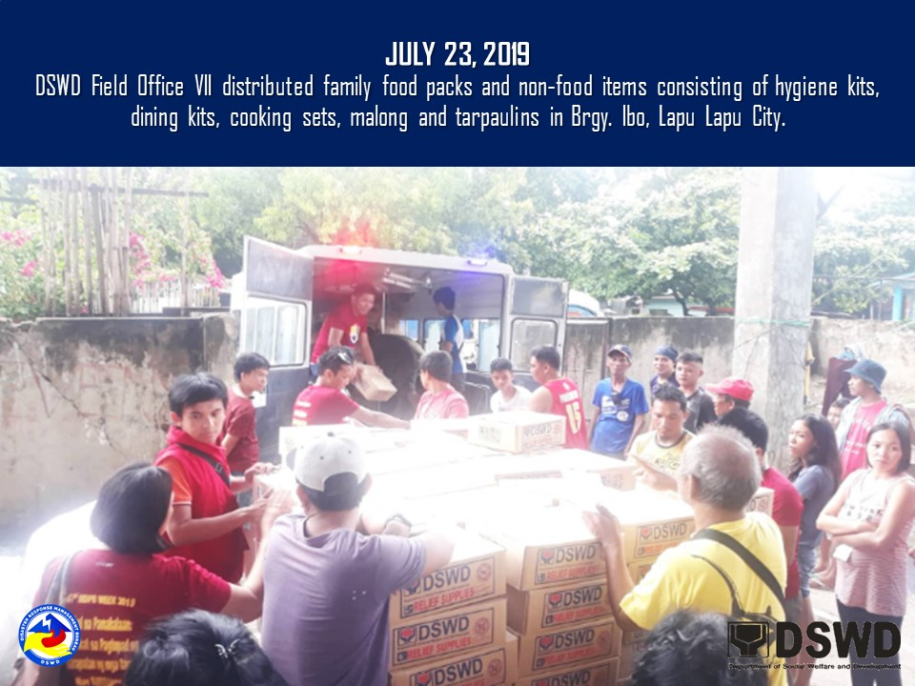
PHOTO DOCUMENTATION

