DSWD DROMIC Preparedness for Response Report
#1 on Tropical Storm "INENG"
as of 23 August 2019, 4PM

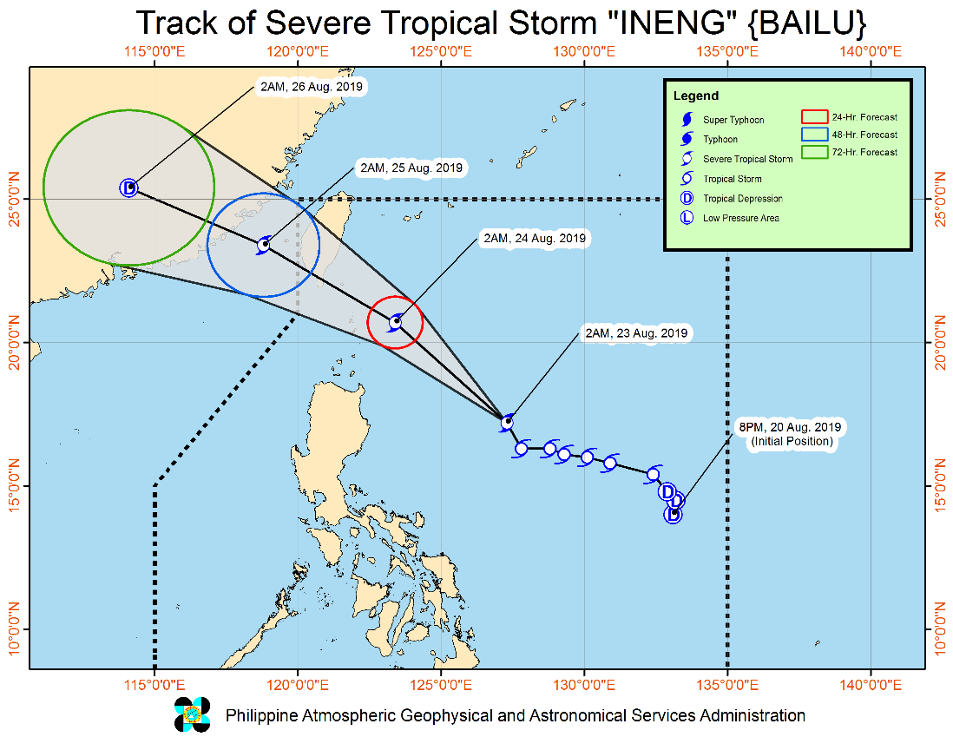
Situation Overview

"INENG" HAS INTENSIFIED INTO A SEVERE TROPICAL STORM.
- Today, moderate to heavy rains may be experienced over Batanes, Cagayan (including Babuyan Group of Islands), Ilocos Norte and Apayao. Light to moderate with intermittent heavy rains may prevail over Metro Manila, Central Luzon, Cavite, Batangas, Mindoro Provinces, northern portions of Palawan (including Calamian and Cuyo Islands), and the rest of Ilocos Region, Cordillera Administrative Region and Cagayan Valley.
- Tomorrow (24 August), moderate to heavy rains may be experienced over Ilocos Region, Cordillera Administrative Region, Batanes, Cagayan (including Babuyan Group of Islands), and Mindoro Provinces. Light to moderate with intermittent heavy rains may prevail over Central Luzon, Cavite, Batangas, northern portions of Palawan (including Calamian and Cuyo Islands), Aklan, Antique, Iloilo, Guimaras, and the rest of Cagayan Valley.
- Residents in the aforementioned areas, especially those living in areas identified to be highly or very highly susceptible to floods and rain-induced landslides, are advised to take precautionary measures, coordinate with local disaster risk reduction and management offices, and continue monitoring for updates, especially the Thunderstorm Advisories and Heavy Rainfall Warnings to be issued by PAGASA Regional Services Divisions.

- "INENG" remains less likely to make landfall over any part of the country. Furthermore, it is expected to exit the Philippine Area of Responsibility (PAR) between Saturday (24 August) late evening and Sunday (25 August) early morning.
- Sea travel is risky over the seaboards of areas under TCWS and the eastern seaboards of Central Luzon, Southern Luzon, and Visayas due to potentially rough sea conditions.
At 4:00 AM today, the center of Severe Tropical Storm "INENG" was estimated based on all available data at 580 km East of Tuguegarao City, Cagayan (17.4 °N, 127.2 °E)
Source: DOST-PAGASA Severe Weather Bulletin
PREDICTIVE ANALYTICS FOR HUMANITARIAN RESPONSE

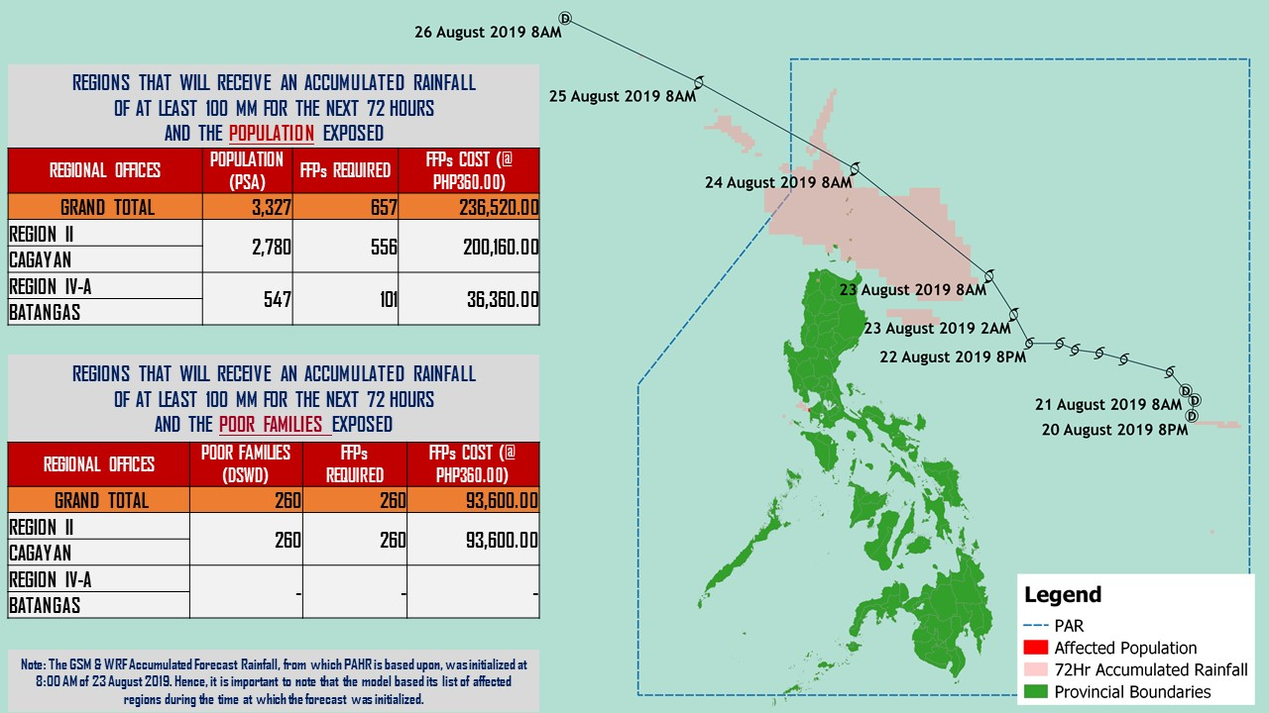

Status of Prepositioned Resources: Stockpile and Standby Funds

The DSWD Central Office (CO), Field Offices (FOs), and National Resource Operations Center (NROC) have stockpiles and standby funds amounting to ₱1,868,058,006.81 with breakdown as follows (see Table 1):

- Standby Funds
A total of ₱1,121,520,550.00 standby funds in the CO and FOs. Of the said amount, ₱1,076,221,717.34 is the available Quick Response Fund (QRF) in the CO.

- Stockpiles
A total of 360,320 Family Food Packs (FFPs) amounting to ₱137,510,537.82 and available Food and Non-food Items (FNIs) amounting to ₱609,026,918.99.

FIELD OFFICE | STANDBY FUNDS | STOCKPILES |  |  |  |  | Total STANDBY FUNDS & STOCKPILE
 |  | Family Food Packs |  | Other Food Items | Non Food Items | SUB-TOTAL (Food and NFIs)
 |  | Quantity | Total Cost | Total Cost | Total Cost
 |  | 359,124 | 134,922,306.28 | 161,342,886.34 | 497,611,158.73
TOTAL | 1,121,520,550.00 | 360,320 | 137,510,537.82 | 139,908,337.80 | 469,118,581.19 | 609,026,918.99 | 1,868,058,006.81
Central Office | 1,076,221,717.34 |  |  |  |  |  | 1,076,221,717.34
NRLMB - NROC | 0.00 | 110,049 | 43,957,337.86 | 75,619,850.18 | 324,598,189.10 | 400,218,039.28 | 444,175,377.14
NRLMB - VDRC | 0.00 | 11,700 | 4,212,000.00 | 1,203,200.00 | 5,224,562.31 | 6,427,762.31 | 10,639,762.31
I | 2,379,275.00 | 14,674 | 5,282,640.00 | 1,525,319.12 | 17,615,504.54 | 19,140,823.66 | 26,802,738.66
II | 3,743,301.60 | 28,662 | 9,214,300.12 | 84,672.00 | 349,602.75 | 434,274.75 | 13,391,876.47
III | 3,068,057.00 | 22,690 | 9,565,871.00 | 979,469.70 | 241,406.00 | 1,220,875.70 | 13,854,803.70
CALABARZON | 3,000,100.00 | 4,802 | 1,725,244.66 | 3,790,447.60 | 3,423,852.37 | 7,214,299.97 | 11,939,644.63
MIMAROPA | 2,999,971.58 | 30,668 | 12,819,224.00 | 1,565,352.90 | 859,605.00 | 2,424,957.90 | 18,244,153.48
V | 3,000,000.00 | 21,045 | 8,207,550.00 | 8,958,033.52 | 40,704,948.22 | 49,662,981.74 | 60,870,531.74
VI | 3,000,000.00 | 5,691 | 2,057,295.72 | 8,594,920.49 | 3,711,406.00 | 12,306,326.49 | 17,363,622.21
VII | 3,001,150.00 | 15,338 | 5,521,680.00 | 15,857,416.70 | 16,424,206.18 | 32,281,622.88 | 40,804,452.88
VIII | 3,202,960.00 | 9,818 | 3,548,421.56 | 1,304,119.84 | 896,387.00 | 2,200,506.84 | 8,951,888.40
IX | 2,652,839.35 | 10,006 | 3,602,160.00 | 809,140.00 | 3,793,242.35 | 4,602,382.35 | 10,857,381.70
X | 237,377.00 | 8,637 | 3,109,320.00 | 6,195,576.80 | 28,928,315.92 | 35,123,892.72 | 38,470,589.72
XI | 3,028,750.00 | 30,704 | 11,096,425.60 | 3,163,200.00 | 10,768,720.09 | 13,931,920.09 | 28,057,095.69
XII | 3,000,701.68 | 4,724 | 1,894,324.00 | 3,484,211.10 | 866,517.26 | 4,350,728.36 | 9,245,754.04
CARAGA | 3,000,000.00 | 10,631 | 4,038,389.50 | 194,954.00 | 4,771,072.70 | 4,966,026.70 | 12,004,416.20
NCR | 3,292,543.50 | 5,484 | 2,052,190.36 | 1,162,526.29 | 1,038,066.00 | 2,200,592.29 | 7,545,326.15
CAR | 2,691,805.95 | 14,997 | 5,606,163.44 | 5,415,927.56 | 4,902,977.40 | 10,318,904.96 | 18,616,874.35
*Quick Response Fund (QRF) as of 22 August 2019

Situational Reports

DSWD-DRMB
DATE | SITUATIONS / ACTIONS UNDERTAKEN
23 August 2019 | - The Disaster Response Management Bureau (DRMB) is closely coordinating with the concerned DSWD-Field Offices for significant disaster preparedness for response updates.  - All QRT members and emergency equipment are on standby and ready for deployment.

DSWD-FO I
DATE | SITUATIONS / ACTIONS UNDERTAKEN
- August 2019 | - The Disaster Response Management Division (DRMD) staff of DSWD-FO I staff are monitoring the possible effects of the current weather condition  - Provincial Operations Offices (POOs) in close coordination with the different Provincial/City/Municipal Disaster Risk Reduction and Management Councils (P/C/MDRRMCs) and Provincial/City/Municipal Social Welfare and Development Offices (P/C/MSWDOs) are currently monitoring the adverse effect that might be brought by the weather disturbance.

DSWD-FO II
DATE | SITUATIONS / ACTIONS UNDERTAKEN
- August 2019 | - The DSWD-FO II attended Pre-Disaster Risk Assessment (PDRA) Meeting at the Office of Civil Defense (OCD) Regional Office for Tropical Storm “INENG”.
DSWD-FO MIMAROPA
DATE | SITUATIONS / ACTIONS UNDERTAKEN
- August 2019 | - DSWD-FO MIMAROPA through the Disaster Response Management Division ensures an on-call and standby duty of the R/P/C/M Quick Response Teams for possible activation of Operations Center.  - All members of Rapid Emergency Telecommunications Team are on standby status ready for deployment if needed.  - DSWD-FO MIMAROPA ensures that relief goods are readily available for distribution.  - DSWD-FO MIMAROPA is in close coordination with the Office of Civil Defense (OCD) and RDRRMC MIMAROPA for any warning signal updates in response to the areas that will be affected.

DSWD-FO V
DATE | SITUATIONS / ACTIONS UNDERTAKEN
- August 2019 | - DSWD FO V QRTs were alerted and advised to be prepared for augmentation support needed from the field and/or 24/7 duty at the DRMD Operation Center.  - PAT and MAT members in the 6 provinces are on standby and were instructed to coordinate with the P/MDRRMOs for status reports and updates.

DSWD-FO VIII
DATE | SITUATIONS / ACTIONS UNDERTAKEN
- August 2019 | - DSWD-FO VIII is in in close coordination with SWADTs, QRTs and PDOs for any eventualities on the ground.  - All Quick Response Team (QRT) members and Disaster Response Management Division (DRMD) are alerted in case augmentation of workforce is needed.  - Regional Resource Operation Section (RROS) are also alerted to ensure the readiness of dispatching the Food and Non-Food commodities whenever needed.

*****
The Disaster Response Operations Monitoring and Information Center (DROMIC) of the DSWD-DRMB is closely monitoring the effects of TS Ineng and is coordinating with the concerned DSWD-Field Offices for any significant updates.

PREPARED BY:

MARIEL B. FERRARIZ

RODEL V. CABADDU
Releasing Officer

