DSWD DROMIC Preparedness for Response Report
#1 on Tropical Storm "JENNY"
as of 27 August 2019, 4PM

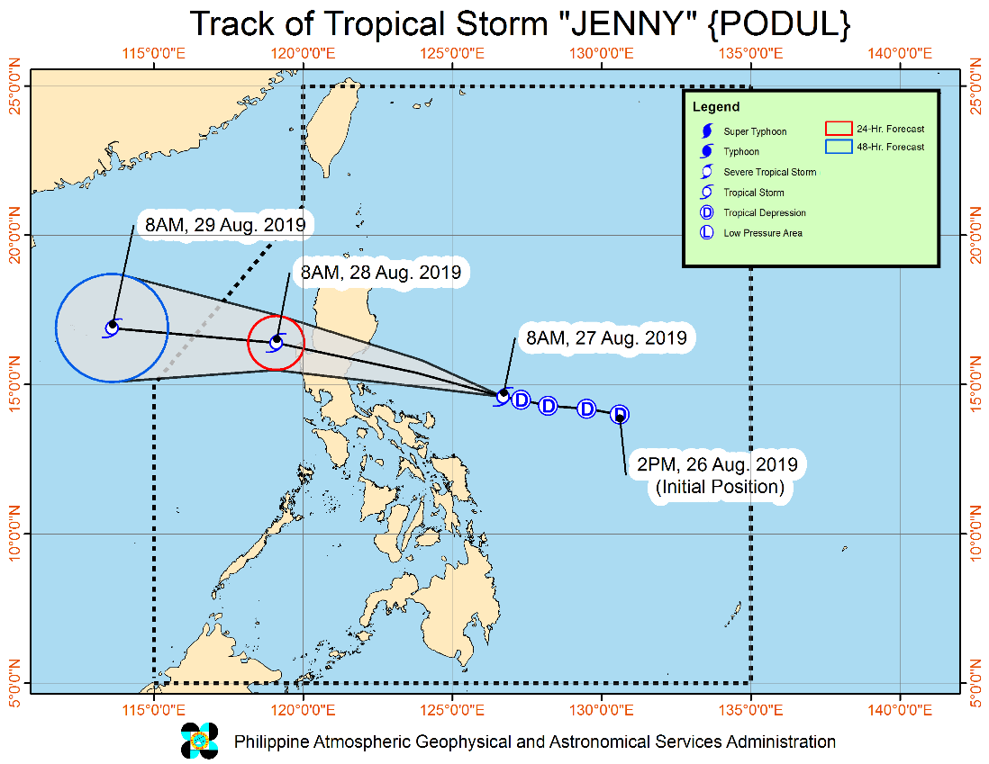
Situation Overview

"JENNY" HAS INTENSIFIED INTO A TROPICAL STORM AS IT CONTINUES TO MOVE TOWARDS CENTRAL LUZON.
- "JENNY" is forecasted to make landfall in Aurora tonight or tomorrow early morning.
- Between this morning and tonight, intermittent to frequent moderate to heavy rains will be experienced over Bicol Region, Samar Provinces, Quezon, Rizal, Bulacan, Pampanga, Nueva Ecija, Aurora, Nueva Vizcaya, Quirino, Isabela and Cagayan. Light to moderate with intermittent heavy rains will affect Metro Manila, the rest of Luzon and Visayas, and the regions of Zamboanga Peninsula, Northern Mindanao, and Bangsamoro.
Between tonight and tomorrow (28 August) morning, intermittent to frequent moderate to heavy rains may be experienced over Central Luzon, Metro Manila, Rizal, northern portion of Quezon (including Polillo Island), Nueva Vizcaya, Quirino, Benguet, Pangasinan, and La Union. Light to moderate with intermittent heavy rains may affect Western Visayas and the rest of Luzon.
- Between tomorrow morning and tomorrow evening, light to moderate with intermittent to occasional heavy rains may affect Western Visayas, Mindoro Provinces, northern portion of Palawan (including Calamian and Cuyo Islands), Zambales and Bataan.
- Residents in the aforementioned areas, especially those living in areas identified to be highly or very highly susceptible to floods and rain-induced landslides, are advised to take precautionary measures, coordinate with local disaster risk reduction and management offices, and continue monitoring for updates, especially the Thunderstorm Advisories and Heavy Rainfall Warnings to be issued by PAGASA Regional Services Divisions.
- Areas under TCWS #2 are advised to take precautionary measures against potentially strong winds while occasional gusty conditions may occur over areas under TCWS #1. Occasional gusty conditions may also occur in Visayas and other areas of Luzon due to the Southwest Monsoon.
- Sea travel remains risky over the seaboards of areas under TCWS due to potentially rough sea conditions.
At 10:00 AM today, the center of Tropical Storm "JENNY" was estimated based on all available data at 360 km East Northeast of Daet, Camarines Norte or 490 km East of Infanta, Quezon (14.9 °N, 126.2 °E )
Source: DOST-PAGASA Severe Weather Bulletin
PREDICTIVE ANALYTICS FOR HUMANITARIAN RESPONSE

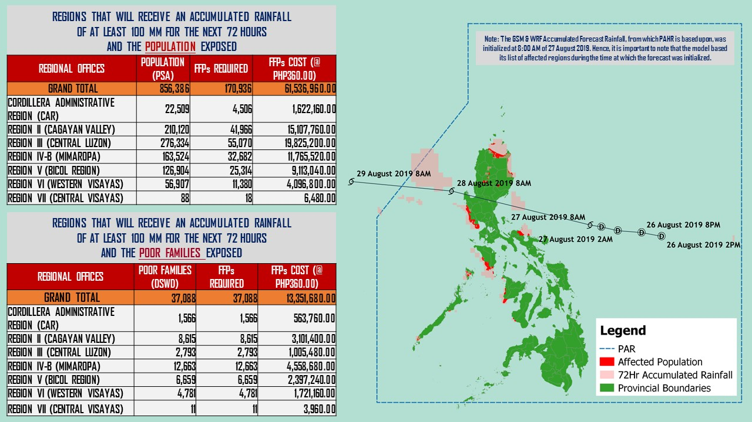

Status of Prepositioned Resources: Stockpile and Standby Funds

The DSWD Central Office (CO), Field Offices (FOs), and National Resource Operations Center (NROC) have stockpiles and standby funds amounting to ₱1,863,042,677.57 with breakdown as follows (see Table 1):

- Standby Funds
A total of ₱1,121,520,550.00 standby funds in the CO and FOs. Of the said amount, ₱1,076,221,717.34 is the available Quick Response Fund (QRF) in the CO.

- Stockpiles
A total of 359,124 Family Food Packs (FFPs) amounting to ₱134,922,306.28 and available Food and Non-food Items (FNIs) amounting to ₱605,811,589.75.

FIELD OFFICE | STANDBY FUNDS | STOCKPILES |  |  |  |  | Total STANDBY FUNDS & STOCKPILE
 |  | Family Food Packs |  | Other Food Items | Non Food Items | SUB-TOTAL (Food and NFIs)
 |  | Quantity | Total Cost | Total Cost | Total Cost
 |  | 359,124 | 134,922,306.28 | 161,342,886.34 | 497,611,158.73
TOTAL | 1,121,520,550.00 | 355,320 | 135,710,537.82 | 136,699,481.84 | 469,112,107.91 | 605,811,589.75 | 1,863,042,677.57
Central Office | 1,076,221,717.34 |  |  |  |  |  | 1,076,221,717.34
NRLMB - NROC | 0.00 | 110,049 | 43,957,337.86 | 75,619,850.18 | 324,598,189.10 | 400,218,039.28 | 444,175,377.14
NRLMB - VDRC | 0.00 | 6,700 | 2,412,000.00 | 179,200.00 | 5,224,562.31 | 5,403,762.31 | 7,815,762.31
I | 2,379,275.00 | 14,674 | 5,282,640.00 | 1,525,319.12 | 17,615,504.54 | 19,140,823.66 | 26,802,738.66
II | 3,743,301.60 | 28,662 | 9,214,300.12 | 84,672.00 | 349,602.75 | 434,274.75 | 13,391,876.47
III | 3,068,057.00 | 22,690 | 9,565,871.00 | 979,469.70 | 241,406.00 | 1,220,875.70 | 13,854,803.70
CALABARZON | 3,000,100.00 | 4,802 | 1,725,244.66 | 3,790,447.60 | 3,423,852.37 | 7,214,299.97 | 11,939,644.63
MIMAROPA | 2,999,971.58 | 30,668 | 12,819,224.00 | 1,565,352.90 | 859,605.00 | 2,424,957.90 | 18,244,153.48
V | 3,000,000.00 | 21,045 | 8,207,550.00 | 8,958,033.52 | 40,704,948.22 | 49,662,981.74 | 60,870,531.74
VI | 3,000,000.00 | 5,691 | 2,057,295.72 | 8,594,920.49 | 3,711,406.00 | 12,306,326.49 | 17,363,622.21
VII | 3,001,150.00 | 15,338 | 5,521,680.00 | 13,672,560.74 | 16,417,732.90 | 30,090,293.64 | 38,613,123.64
VIII | 3,202,960.00 | 9,818 | 3,548,421.56 | 1,304,119.84 | 896,387.00 | 2,200,506.84 | 8,951,888.40
IX | 2,652,839.35 | 10,006 | 3,602,160.00 | 809,140.00 | 3,793,242.35 | 4,602,382.35 | 10,857,381.70
X | 237,377.00 | 8,637 | 3,109,320.00 | 6,195,576.80 | 28,928,315.92 | 35,123,892.72 | 38,470,589.72
XI | 3,028,750.00 | 30,704 | 11,096,425.60 | 3,163,200.00 | 10,768,720.09 | 13,931,920.09 | 28,057,095.69
XII | 3,000,701.68 | 4,724 | 1,894,324.00 | 3,484,211.10 | 866,517.26 | 4,350,728.36 | 9,245,754.04
CARAGA | 3,000,000.00 | 10,631 | 4,038,389.50 | 194,954.00 | 4,771,072.70 | 4,966,026.70 | 12,004,416.20
NCR | 3,292,543.50 | 5,484 | 2,052,190.36 | 1,162,526.29 | 1,038,066.00 | 2,200,592.29 | 7,545,326.15
CAR | 2,691,805.95 | 14,997 | 5,606,163.44 | 5,415,927.56 | 4,902,977.40 | 10,318,904.96 | 18,616,874.35
*Quick Response Fund (QRF) as of 23 August 2019

Situational Reports

DSWD-DRMB
DATE | SITUATIONS / ACTIONS UNDERTAKEN
27 August 2019 | - The Disaster Response Management Bureau (DRMB) is closely coordinating with the concerned DSWD-Field Offices for significant disaster preparedness for response updates.  - All QRT members and emergency equipment are on standby and ready for deployment.

DSWD-FO CAR
DATE | SITUATIONS / ACTIONS UNDERTAKEN
- August 2019 | - The DSWD-FO CAR is on BLUE Alert Level Status.  - The DRMD is continuously monitoring the situation on ground  - The Provincial Social Welfare and Development Teams (PSWADT) DRMD PDO IIs are alerted, members are on stand by for the possible effects of the weather disturbance.  - Rapid Emergency Telecommunications Team (RETT) including the International Maritime/Marine Satellite (INMARSAT) equipment are on standby.

DSWD-FO I
DATE | SITUATIONS / ACTIONS UNDERTAKEN
- August 2019 | - The DSWD-FO CAR is on BLUE Alert Level Status.  - The Disaster Response Management Division (DRMD) staff of DSWD-FO I staff are monitoring the possible effects of the current weather condition  - Provincial Operations Offices (POOs) in close coordination with the different Provincial/City/Municipal Disaster Risk Reduction and Management Councils (P/C/MDRRMCs) and Provincial/City/Municipal Social Welfare and Development Offices (P/C/MSWDOs) are currently monitoring the adverse effect that might be brought by the weather disturbance.  - The Disaster Response Management Division (DRMD) staff Ms. Maricel S. Caleja, attended the Pre-Disaster Risk Assessment (PDRA) meeting

DSWD-FO MIMAROPA
DATE | SITUATIONS / ACTIONS UNDERTAKEN
- August 2019 | - DSWD-FO MIMAROPA through the Disaster Response Management Division ensures an on-call and standby duty of the R/P/C/M Quick Response Teams for possible activation of Operations Center.  - All members of Rapid Emergency Telecommunications Team are on standby status ready for deployment if needed.  - DSWD-FO MIMAROPA ensures that relief goods are readily available for distribution.  - DSWD-FO MIMAROPA is in close coordination with the Office of Civil Defense (OCD) and RDRRMC MIMAROPA for any warning signal updates in response to the areas that will be affected.

DSWD-FO V
DATE | SITUATIONS / ACTIONS UNDERTAKEN
- August 2019 | - DSWD FO V QRTs were alerted and advised to be prepared for augmentation support needed from the field and/or 24/7 duty at the DRMD Operation Center.  - PAT and MAT members in the 6 provinces are on standby and were instructed to coordinate with the P/MDRRMOs for status reports and updates.

DSWD-FO VIII
DATE | SITUATIONS / ACTIONS UNDERTAKEN
- August 2019 | - DSWD-FO VIII is in in close coordination with SWADTs, QRTs and PDOs for any eventualities on the ground.  - All Quick Response Team (QRT) members and Disaster Response Management Division (DRMD) are alerted in case augmentation of workforce is needed.  - Disaster Response Information Management Section (DRIMS) is in close coordination with SWADTs, QRTs and PDOs for any eventualities on the ground.  - Regional Resource Operation Section (RROS) are also alerted to ensure the readiness of dispatching the Food and Non-Food commodities whenever needed.

*****
The Disaster Response Operations Monitoring and Information Center (DROMIC) of the DSWD-DRMB is closely monitoring the effects of TS Jenny and is coordinating with the concerned DSWD-Field Offices for any significant updates.

PREPARED BY:

MARIEL B. FERRARIZ

RODEL V. CABADDU
Releasing Officer

