DSWD DROMIC Report #1 on the Fire Incident
in Tabaan Norte, Tuba, Benguet
as of 02 August 2019, 12NN

SUMMARY

On 22 June 2019, a fire incident occurred in Sitio Jana, Tabaan Norte, Tuba, Benguet. The cause of fire is due to two children playing with fire within the vicinity of the house.
Source: DSWD-FO CAR

- Status of Affected Families / Persons
A total of 1 family or 4 persons were affected by the fire incident in Sitio Jana, Tabaan Norte, Tuba, Benguet (see Table 1).

Table 1. Number of Affected Families / Persons
REGION / PROVINCE / MUNICIPALITY | NUMBER OF AFFECTED
 | Barangays | Families | Persons
GRAND TOTAL | 1 | 1 | 4
REGION CAR | 1 | 1 | 4
Benguet | 1 | 1 | 4
Tuba | 1 | 1 | 4
Note: Ongoing assessment and validation
Source: DSWD-FO CAR

- Status of Displaced Families / Persons
A total of 1 family or 4 persons are temporarily staying with their relatives and/or friends (see Table 2).

Table 2. Number of Displaced Families / Persons Inside Evacuation Center
REGION / PROVINCE / MUNICIPALITY | OUTSIDE ECs
 | Families |  | Persons
 | CUM | NOW | CUM | NOW
GRAND TOTAL | 1 | 1 | 4 | 4
REGION CAR | 1 | 1 | 4 | 4
Benguet | 1 | 1 | 4 | 4
Tuba | 1 | 1 | 4 | 4
Note: Ongoing assessment and validation
Source: DSWD-FO CAR

- Damaged Houses
There is 1 totally damaged house (see table 3).

Table 3. Number of Damaged Houses
REGION / PROVINCE / MUNICIPALITY | NO. OF DAMAGED HOUSES
 | Total | Totally | Partially
GRAND TOTAL | 1 | 1 | -
REGION CAR | 1 | 1 | -
Benguet | 1 | 1 | -
Tuba | 1 | 1 | -
Note: Ongoing assessment and validation
Source: DSWD-FO CAR

- Assistance Provided
A total of ₱8,957.75 worth of assistance was provided to the affected family; of which, ₱3,957.75 was provided by DSWD, and ₱5,000.00 was provided by the LGU (see table 4).

Table 4. Cost of Assistance Provided to the Affected Families
REGION / PROVINCE / MUNICIPALITY | TOTAL COST OF ASSISTANCE
 | DSWD | LGU | NGOs | OTHERS | GRAND TOTAL
GRAND TOTAL | 3,957.75 | 5,000.00 | - | - | 8,957.75
REGION CAR | 3,957.75 | 5,000.00 | - | - | 8,957.75
Benguet | 3,957.75 | 5,000.00 | - | - | 8,957.75
Tuba | 3,957.75 | 5,000.00 | - | - | 8,957.75
Note: Ongoing assessment and validation
Source: DSWD-FO CAR

SITUATIONAL REPORT

DSWD-DRMB
DATE | SITUATIONS / ACTIONS UNDERTAKEN
01 August 2019 | - The Disaster Response Operations Monitoring and Information Center (DROMIC) of the DSWD-DRMB is closely coordinating with DSWD-FO CAR for significant reports on the status of affected family, assistance, and relief efforts.

DSWD-FO CAR
DATE | SITUATIONS / ACTIONS UNDERTAKEN
01 August 2019 | - DSWD-FO CAR distributed one (1) family kit and one (1) hygiene kit to the displaced family / persons.  - DSWD-FO CAR endorsed the affected family to National Housing Authority for housing assistance.  - DSWD-FO CAR through Tuba LGU referred the affected family to the Office of Provincial Social Worker for Shelter Assistance.  - DSWD-FO CAR is closely monitoring and coordinating with the MSWDO for further assistance needed.

*****
The Disaster Response Operations Monitoring and Information Center (DROMIC) of the DSWD-DRMB is closely coordinating with the concerned DSWD-FO CAR for any significant disaster response updates.

Prepared by:

JOANNA CAMILLE R. JACINTO

MARC LEO L. BUTAC
Releasing Officer

PHOTO DOCUMENTATION

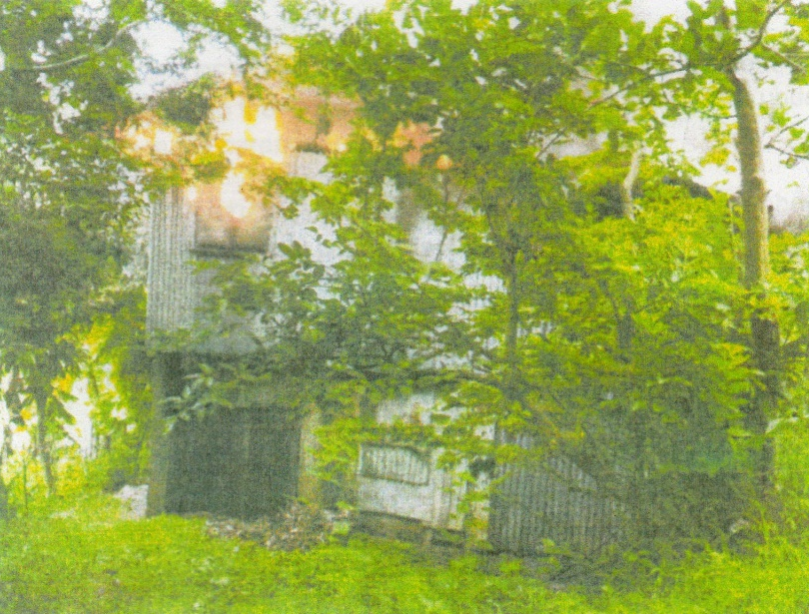
A picture of the house being razed by fire in the morning of 22 June 2019.

