DSWD DROMIC Report #14
on the Earthquake Incident in Itbayat, Batanes
as of 07 August 2019, 6PM

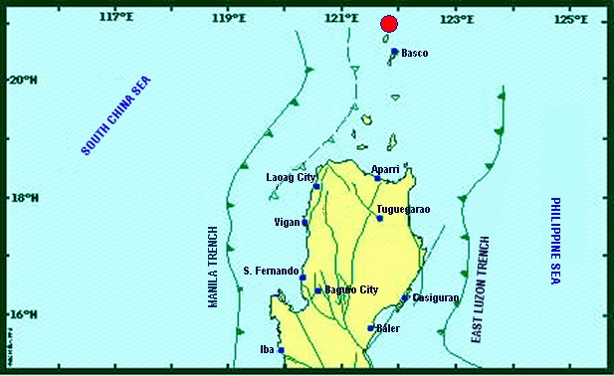

Situation Overview

On 27 July 2019 at 4:16 AM, a 5.4 magnitude earthquake jolted the municipality of Itbayat, Batanes (20.90°N, 121.85°E - 012 km N 04°E) with a tectonic origin and a depth of focus of 12 km. The earthquake was also felt in the neighboring municipalities of Batanes.

Date/Time: | 27 Jul 2019 - 04:16:54 AM
Reported Intensities: | Intensity VI - Itbayat, Batanes  Intensity III - Basco and Sabtang, Batanes  Instrumental Intensity:  Intensity III - Basco, Batanes
Expecting Damage: | YES
Expecting Aftershocks: | YES
Source: DOST-PHIVOLCS Earthquake Bulletin

At 3:00 PM today, the eye of TYPHOON "HANNA" {LEKIMA} was estimated based on all available data at 600 km East of Basco, Batanes (21.0°N, 127.7°E) with maximum sustained winds of 140 km/h near the center and gustiness of up to 170 km/h. It is moving West Northwest at 15 km/h. Meanwhile, the Low Pressure Area (LPA) was estimated based on all available data at 325°km West of Dagupan City, Pangasinan (16.0°N, 117.3°E). Southwest Monsoon affecting the whole country.
Source: PAGASA Daily Weather Forecast

- Status of Affected Families / Persons
A total of 1,025 families or 2,982 persons were affected by the earthquake incident in 5 barangays in Itbayat, Batanes (see Table 1).

Table 1. Number of Affected Families / Persons
REGION / PROVINCE / MUNICIPALITY |  | NUMBER OF AFFECTED
 |  | Barangays | Families | Persons
GRAND TOTAL |  | 5 | 1,025 | 2,982
REGION II |  | 5 | 1,025 | 2,982
Batanes |  | 5 | 1,025 | 2,982
 | Itbayat | 5 | 1,025 | 2,982
Note: Ongoing assessment and validation being conducted.
Source: DSWD-FO II

- Status of Displaced Families / Persons
90 families or 295 persons are still staying at the Covered Court/Municipal Plaza in Brgy. San Rafael, Itbayat, Batanes (see Table 2).

Table 2. Number of Displaced Families / Persons Inside Evacuation Center
REGION / PROVINCE / MUNICIPALITY |  | NUMBER OF EVACUATION CENTERS (ECs) |  | INSIDE ECs
 |  |  |  | Families |  | Persons
 |  | CUM | NOW | CUM | NOW | CUM | NOW
GRAND TOTAL |  | 1 | 1 | 742 | 90 | 2,365 | 295
REGION II |  | 1 | 1 | 742 | 90 | 2,365 | 295
Batanes |  | 1 | 1 | 742 | 90 | 2,365 | 295
 | Itbayat | 1 | 1 | 742 | 90 | 2,365 | 295
Note: Ongoing assessment and validation being conducted.
Source: DSWD-FO II

- Damaged Houses
There are 209 damaged houses; of which, 27 are partially damaged and 182 are totally damaged (see Table 3).

Table 3. Number of Damaged Houses
REGION / PROVINCE / MUNICIPALITY |  | NO. OF DAMAGED HOUSES
 |  | Total | Totally | Partially
GRAND TOTAL |  | 209 | 182 | 27
REGION II |  | 209 | 182 | 27
Batanes |  | 209 | 182 | 27
 | Itbayat | 209 | 182 | 27
Note: Ongoing assessment and validation being conducted.
Source: DSWD-FO II

- Assistance Provided
A total of ₱447,380.00 worth of assistance was provided by DSWD to the affected families (see Table 4).

Table 4. Cost of Assistance Provided to Affected Families / Persons
REGION / PROVINCE / MUNICIPALITY |  | TOTAL COST OF ASSISTANCE
 |  | DSWD | LGU | NGOs | OTHERS | GRAND TOTAL
GRAND TOTAL |  | 447,380.00 | - | - | - | 447,380.00
REGION II |  | 447,380.00 | - | - | - | 447,380.00
Batanes |  | 447,380.00 | - | - | - | 447,380.00
 | Itbayat | 447,380.00 | - | - | - | 447,380.00
Source: DSWD-FO II

DSWD DISASTER RESPONSE INFORMATION
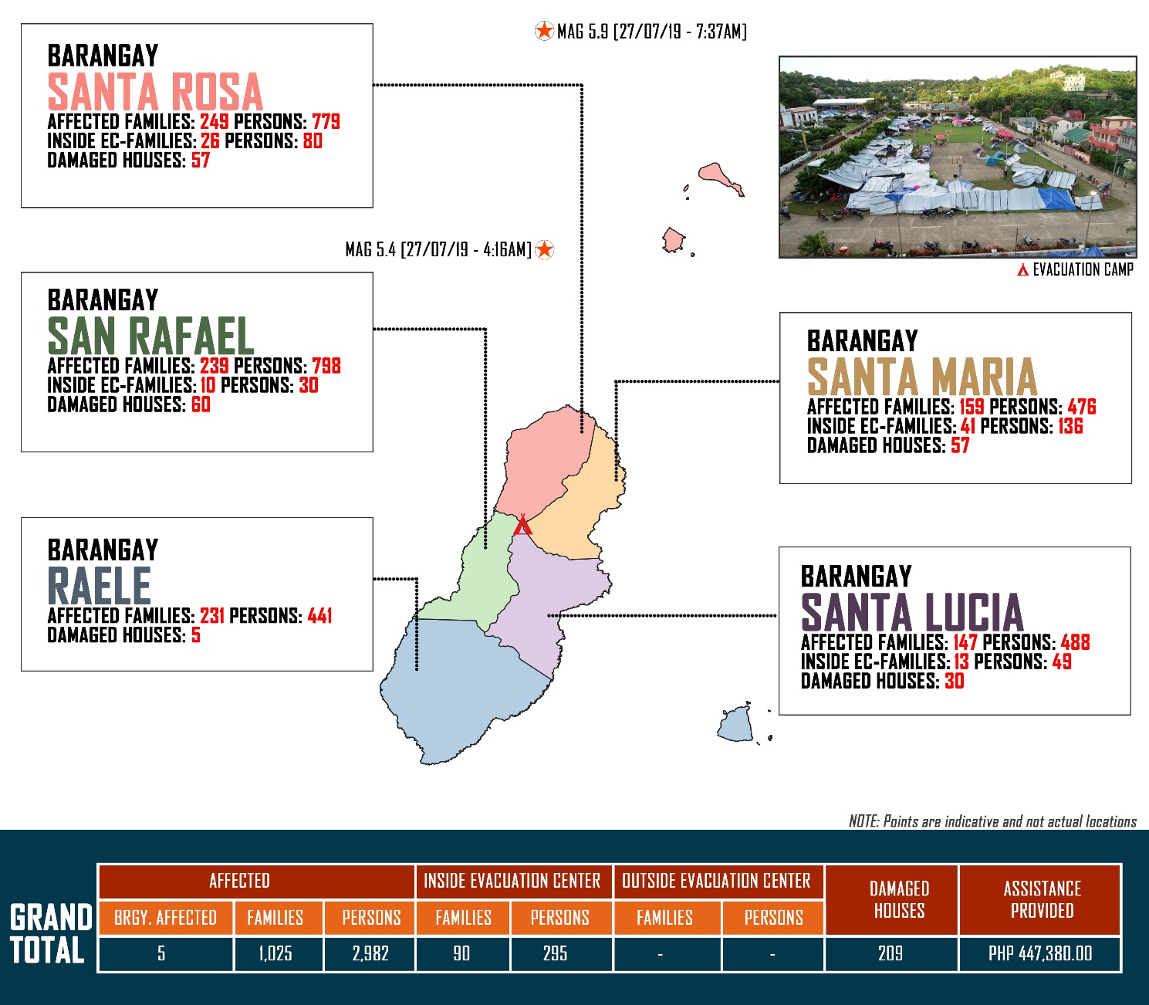

Source: DRMB-DROMIC GIS Specialists

Status of Prepositioned Resources: Stockpile and Standby Funds
The DSWD Central Office (CO), Field Offices (FOs), and National Resource Operations Center (NROC) have stockpiles and standby funds amounting to ₱1,941,136,034.88 with breakdown as follows (see Table 1):

- Standby Funds
A total of ₱1,175,605,085.36 standby funds in the CO and FOs. Of the said amount, ₱1,136,065,297.34 is the available Quick Response Fund (QRF) in the CO.

- Stockpiles
A total of 354,981 Family Food Packs (FFPs) amounting to ₱132,348,213.10 and available Food and Non-food Items (FNIs) amounting to ₱633,182,736.42.

FIELD OFFICE | STANDBY FUNDS | STOCKPILES |  |  |  |  | Total STANDBY FUNDS & STOCKPILE
 |  | Family Food Packs |  | Other Food Items | Non Food Items | SUB-TOTAL (Food and NFIs)
 |  | Quantity | Total Cost | Total Cost | Total Cost
TOTAL | 1,175,605,085.36 | 354,981 | 132,348,213.10 | 156,493,769.07 | 476,688,967.35 | 633,182,736.42 | 1,941,136,034.88
Central Office | 1,136,065,297.34 |  |  |  |  |  | 1,136,065,297.34
NRLMB - NROC | 0.00 | 104,600 | 39,448,844.00 | 82,580,988.36 | 326,908,247.68 | 409,489,236.04 | 448,938,080.04
NRLMB - VDRC | 0.00 | 11,700 | 4,212,000.00 | 1,203,200.00 | 5,224,562.31 | 6,427,762.31 | 10,639,762.31
I | 2,379,275.00 | 14,258 | 5,132,880.00 | 1,249,585.92 | 20,020,136.19 | 21,269,722.11 | 28,781,877.11
II | 930,801.96 | 26,616 | 8,499,924.40 | 526,640.00 | 349,602.75 | 876,242.75 | 10,306,969.11
III | 2,404,557.00 | 26,186 | 10,255,018.44 | 979,469.70 | 241,406.00 | 1,220,875.70 | 13,880,451.14
CALABARZON | 3,000,100.00 | 4,802 | 1,725,244.66 | 3,796,847.60 | 3,308,412.37 | 7,105,259.97 | 11,830,604.63
MIMAROPA | 2,999,971.58 | 24,756 | 10,348,008.00 | 2,241,793.55 | 859,605.00 | 3,101,398.55 | 16,449,378.13
V | 3,000,000.00 | 21,205 | 8,269,950.00 | 8,958,033.52 | 40,704,948.22 | 49,662,981.74 | 60,932,931.74
VI | 1,150,000.00 | 15,691 | 5,854,440.00 | 8,682,157.17 | 3,711,406.00 | 12,393,563.17 | 19,398,003.17
VII | 3,000,000.00 | 13,169 | 4,740,840.00 | 17,781,517.64 | 17,077,542.18 | 34,859,059.82 | 42,599,899.82
VIII | 3,001,960.00 | 17,918 | 6,475,923.56 | 1,304,119.84 | 1,594,387.00 | 2,898,506.84 | 12,376,390.40
IX | 2,075,321.35 | 9,476 | 3,411,360.00 | 809,140.00 | 3,793,242.35 | 4,602,382.35 | 10,089,063.70
X | 3,000,000.00 | 3,323 | 1,196,280.00 | 6,120,272.20 | 30,362,019.90 | 36,482,292.10 | 40,678,572.10
XI | 3,028,750.00 | 26,281 | 9,510,545.40 | 9,035,200.00 | 10,856,452.09 | 19,891,652.09 | 32,430,947.49
XII | 584,701.68 | 4,724 | 1,894,324.00 | 3,484,211.10 | 866,517.26 | 4,350,728.36 | 6,829,754.04
CARAGA | 3,000,000.00 | 10,729 | 4,077,050.50 | 186,600.00 | 4,968,991.45 | 5,155,591.45 | 12,232,641.95
NCR | 3,292,543.50 | 3,665 | 1,341,789.14 | 1,998,746.57 | 928,770.00 | 2,927,516.57 | 7,561,849.21
CAR | 2,691,805.95 | 15,882 | 5,953,791.00 | 5,555,245.90 | 4,912,718.60 | 10,467,964.50 | 19,113,561.45
* Quick Response Fund (QRF) as of 03 August 2019
** Status of Standby Funds and Stockpile of FO II as of 03 August 2019

Situational Reports

DSWD-DRMB
DATE | SITUATIONS / ACTIONS UNDERTAKEN
07 August 2019 | - The Disaster Response Management Bureau (DRMB) is continuously coordinating with DSWD-FO II for significant disaster response updates.
04 August 2019 | - DRMB Team in Basco, Batanes have been demobilized since flights in and out of Itbayat are already limited due to bad weather. Remaining flight hours of choppers have been reserved for emergency purposes only.  - DSWD has turned over all goods including family tents and sleeping kits unloaded in Basco to LGU Batanes with PDRRMO due to bad weather and difficulty in transport.

DSWD-NRLMB
DATE | SITUATIONS / ACTIONS UNDERTAKEN
06 August 2019 | - The two (2) Coast Guard Vessels carrying 100 tents, 400 sleeping kits and 10 rolls of laminated sacks from DSWD-NRLMB are still docked at Subic Port due to bad weather.
04 August 2019 | - The 65 family tents in Basco Port were delivered to Itbayat, Batanes.
03 August 2019 | - 35 Family tents were delivered to Basco, Batanes via C130.  - Transportation of the 400 sleeping kits at Basco Port was cancelled due to unfavorable sea condition.
02 August 2019 | - Six (6) trucks from NROC carrying 6,000 FFPs, 3,600 3kg vacuum-packed rice, 60,000 sachets of coffee, 1,500 mosquito nets, and 50 rolls of laminated sacks were delivered to Tuguegarao City.
31 July 2019 | - The 6,400 3kg-vacuum packed rice and 50 folding beds that has been delivered to DSWD-FO II on 29 July 2019 are stored in their warehouse for standby delivery to Itbayat, Batanes.
30 July 2019 | - The 100 family tents and 60 folding beds from NROC have been delivered to DSWD-FO II in Tuguegarao City.  - The requested 25 family tents and 400 sleeping kits from DSWD-FO I were delivered to Tuguegarao City.

DSWD-FO II
DATE | ACTION(S) TAKEN
07 August 2019 | - Navy vessels carrying 1,000 family food packs from DFSWD-FO2 has arrived at Itbayat, Batanes.
05 August 2019 | - DSWD-FO II is now on WHITE alert level status.  - The BFAR vessel at Subic Port was forced to return to Manila due to unfavorable sea condition.  - The Navy Vessel carrying 100 tents, 400 sleeping kits and 10 rolls of laminated sacks from NRLMB have arrived at Port Irene, Sta. Ana this morning in lieu of the BFAR vessel. The vessel was able to load 1,000 family food packs. To date, all FNIs were delivered to Itbayat, Batanes.  - The 30 tents, 700 packs non-food items composed of blankets, mosquito nets, slippers, towels and hygiene kits from PAGCOR is set to arrive at DSWD-FO II tomorrow, August 6, 2019.  - The DSWD-FO II staff are currently conducting pay-out on Emergency Shelter Assistance (ESA) to beneficiaries with totally and partially damaged houses in Itbayat, Batanes.  - A total of ₱870,000.00 worth of social pension assistance was provided to the 290 affected senior citizens who received ₱3,000.00 each for the 1st and 2nd quarters. Ongoing distribution of financial assistance is being conducted for the remaining 20 senior citizens.  - For Unconditional Cash Transfer (UCT) for social pension, 198 or 81.48% out of the two hundred forty-three (243) beneficiaries paid. The team was continuously serving those remaining unpaid beneficiaries.  - DSWD-DRMD staff headed by the OIC-Chief DRMD, Mr. Franco G. Lopez and a finance staff flew on C212 of Philippine Air Force plane and landed in Itbayat, Batanes this morning. In addition, Regional Director Fernando R. De Villa, OIC-Protective Services Division Chief Mr. Marciano D. Dameg and three other staff are also in Batanes to take concerns on Social Pension, Assistance to Individuals in Crisis Situation, and assist/monitor in disaster-related concerns especially on the occurrences caused the by the recent earthquake.  - The five (5) DSWD-FO II staff in Itbayat, Batanes who conducted stress debriefing, house-to-house visit relative to the assessment of damaged houses and provided burial, medical, and food assistance have already been demobilized.
02 August 2019 | - A total of ₱172,000.00 worth of financial assistance was provided to the affected families; of which, eight (8) families were provided with ₱10,000.00 burial assistance per family, eleven (11) affected individuals received food assistance at ₱5,000.00 each, one (1) affected individual was provided with ₱3,000.00 worth of food assistance, eight (8) affected individuals received medical assistance at ₱3,000.00 each, and two (2) affected individuals was provided with ₱5,000.00 worth of medical assistance.  - The LGU Piat, Cagayan donated 203 family food packs at ₱242.00 per pack for affected families in Itbayat, Batanes.
01 August 2019 | - The 312 FFPs from Tuguegarao Airport including the requested 25 family tents and 400 sleeping kits from DSWD-FO I, and 60 folding beds and 100 family tents from NRLMB were delivered from Tuguegarao City to Port Irene in Sta. Ana, Cagayan.
31 July 2019 | - The 158 FFPs worth ₱56,880.00 delivered to Itbayat, Batanes were already distributed to the 158 affected families inside EC.

***
The Disaster Response Operations Monitoring and Information Center (DROMIC) of the DSWD-DRMB is closely coordinating with DSWD-FO II for any significant disaster response updates.

Prepared by:

JAN ERWIN ANDREW I. ONTANILLAS
Releasing Officer
Photo Documentations
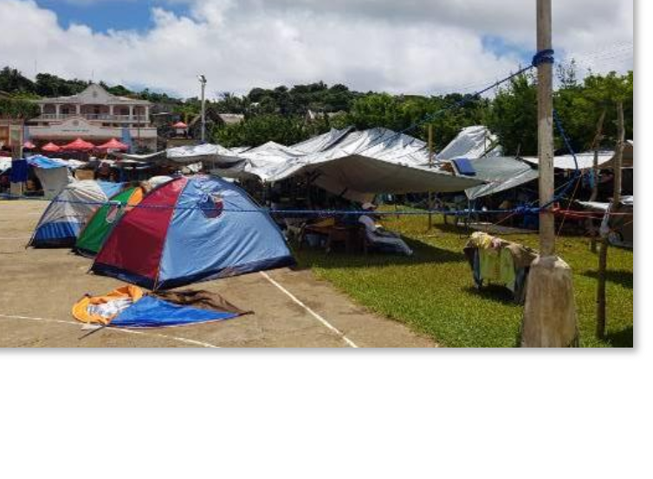
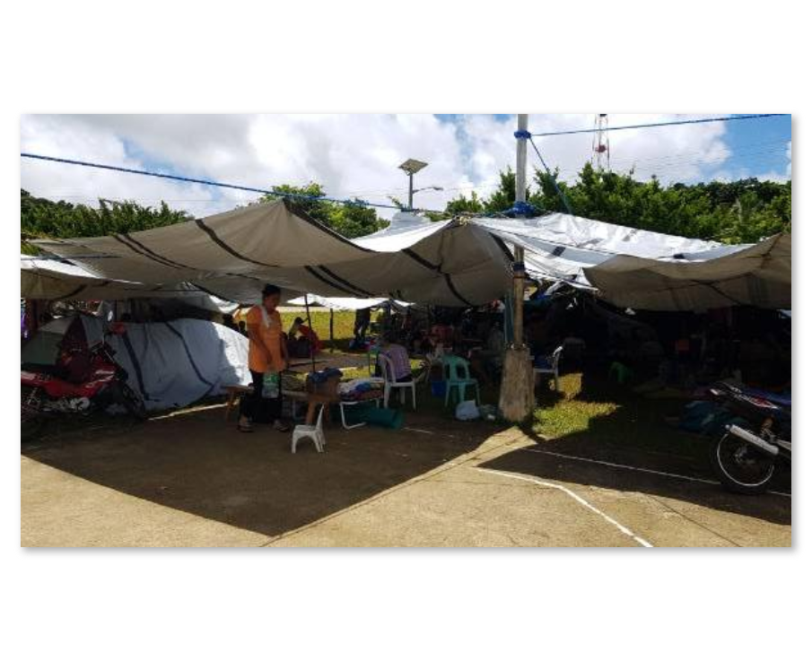
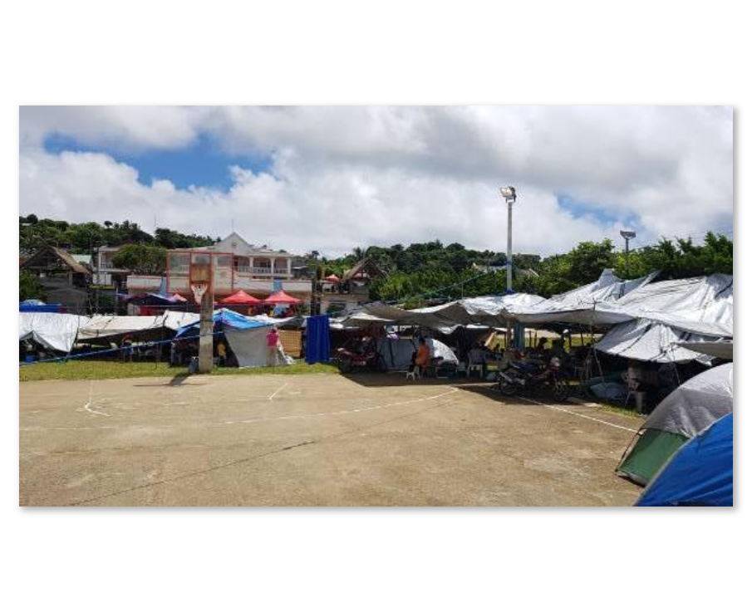
Covered Court/Municipal Plaza Open Ground Evacuation Center
Photos taken on 29 July 2019
Families are staying under makeshift tents.
As per coordination with Incident Commander (IC) Ms. Sharmaine Gato, validation of DPWH and Barangay Officials regarding damaged houses and public facilities is on 1/3 completion for assessment of damaged houses as of yesterday.
Classes will only resume until safety of buildings is ensured.

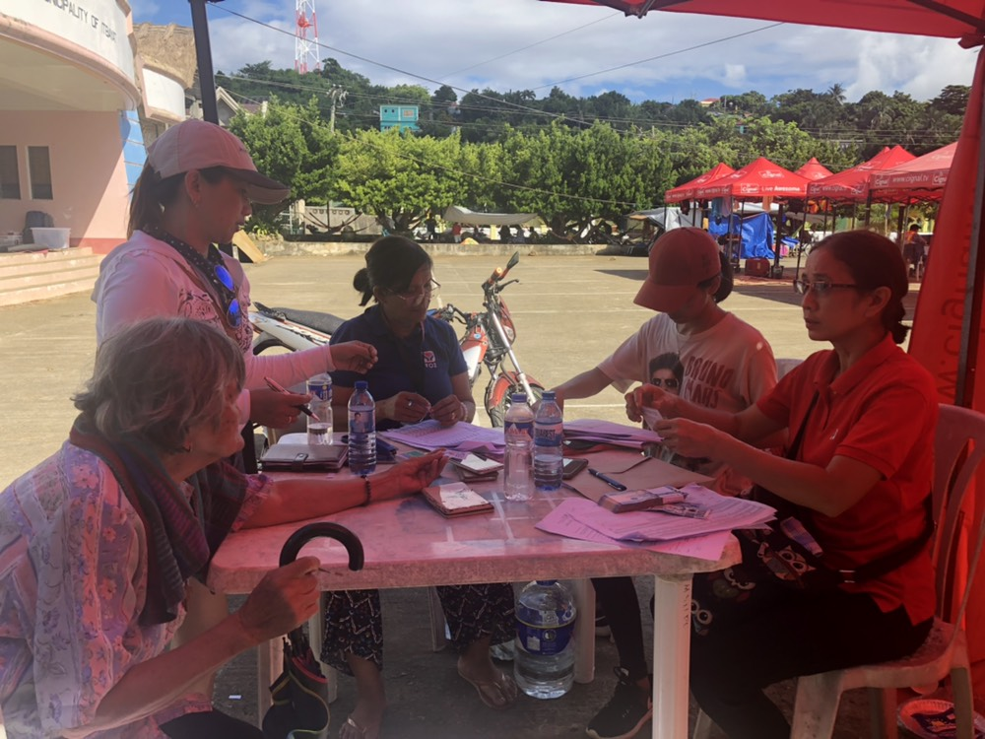

DSWD-FO II providing Social Pension to the senior citizens affected by the earthquake incident.

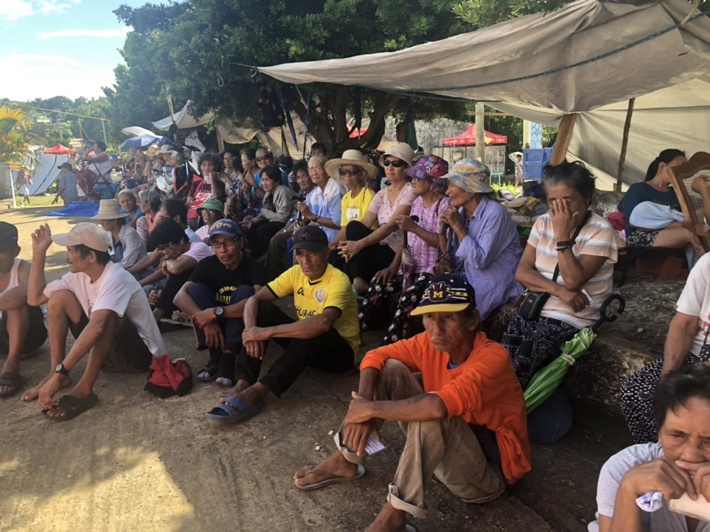

Photos taken on 29 July 2019
The senior citizens affected by the earthquake incident patiently waiting for their turn to receive financial assistance thru Social Pension.
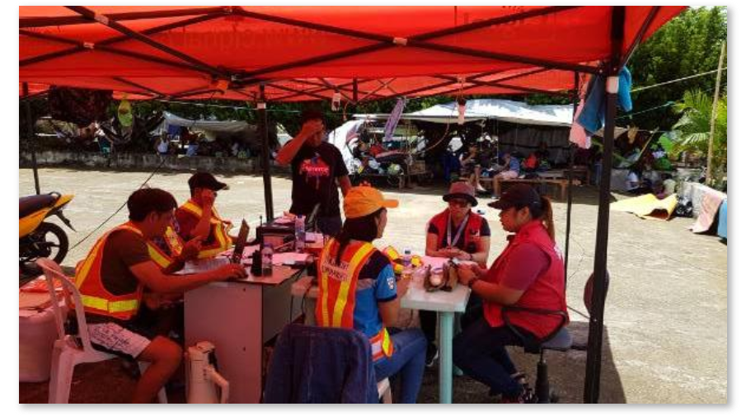
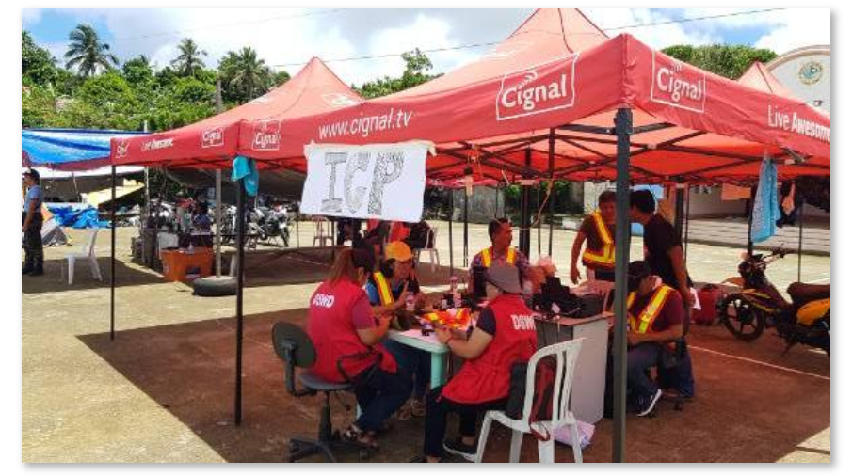
Photos taken on 29 July 2019
Incident Command Post

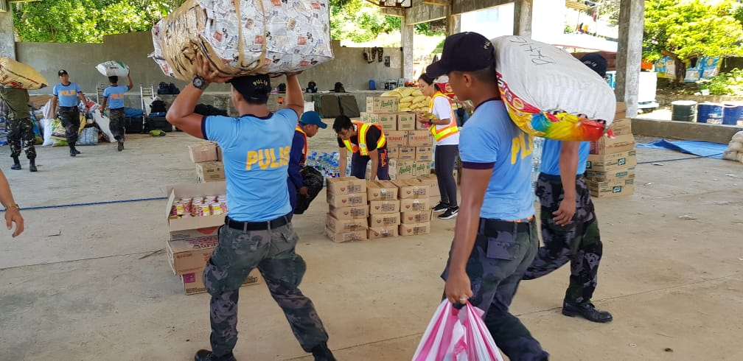
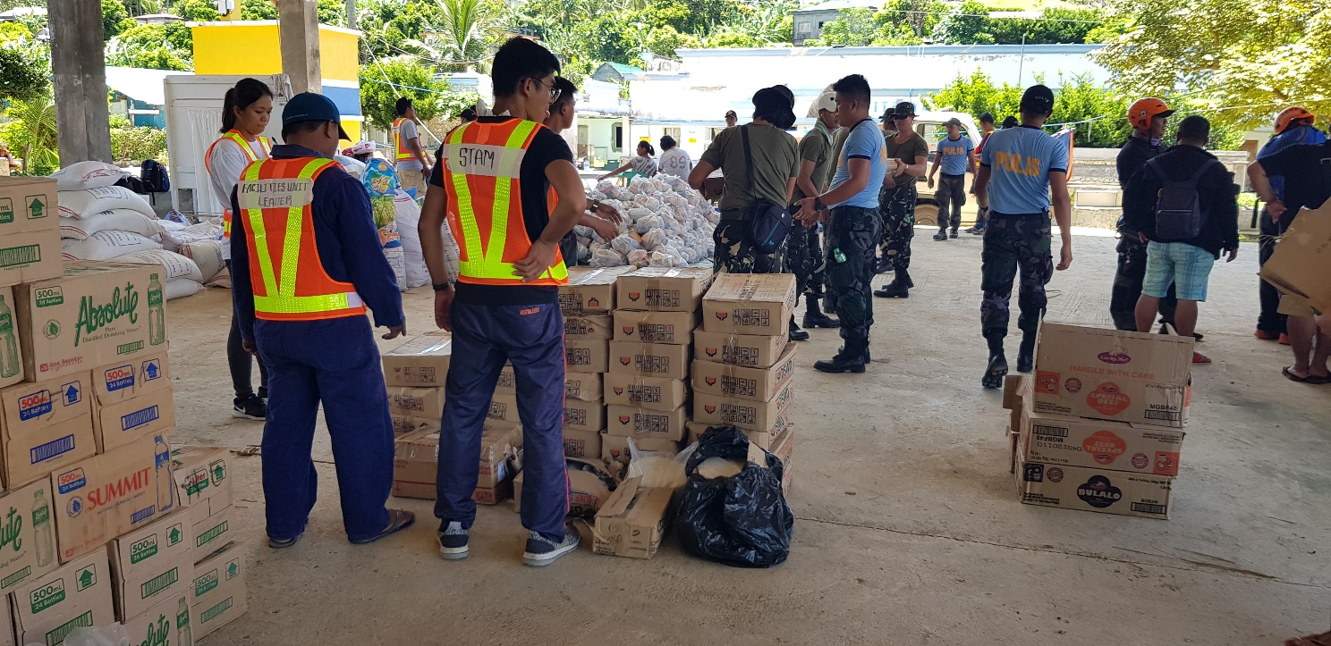
Photos taken on 29 July 2019
FNIs delivered in Itbayat, Batanes

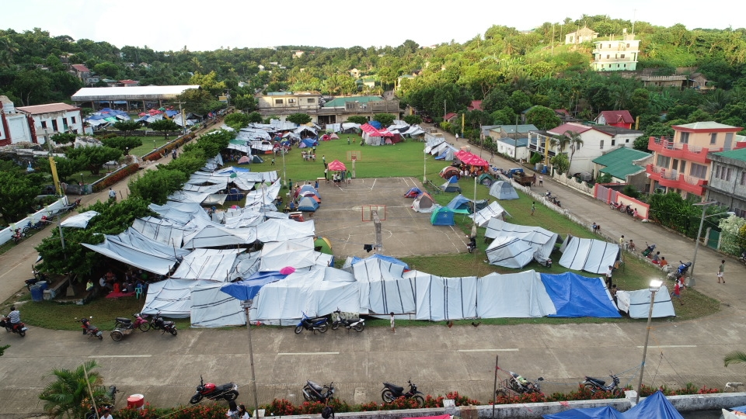
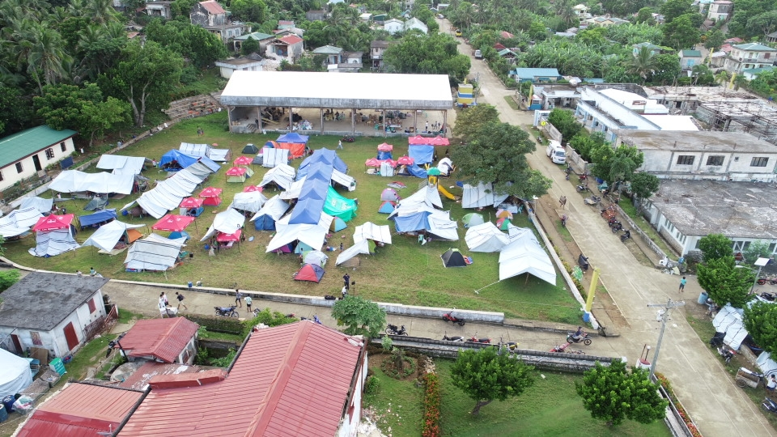
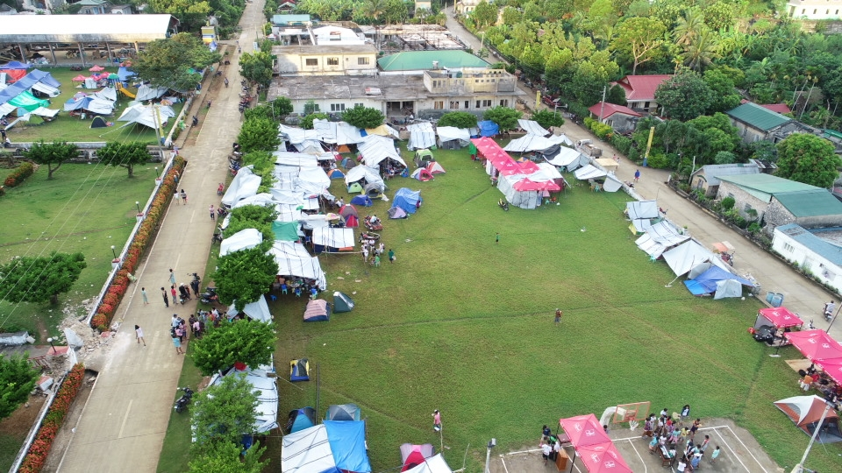
Aerial View of the Municipal Plaza as Evacuation Center

Photos taken on 30 July 2019

Photos taken on 31 July 2019
Psychosocial debriefing to children by PHIVOLCS Staff
PHIVOLCS staff explaining what happens during an earthquake

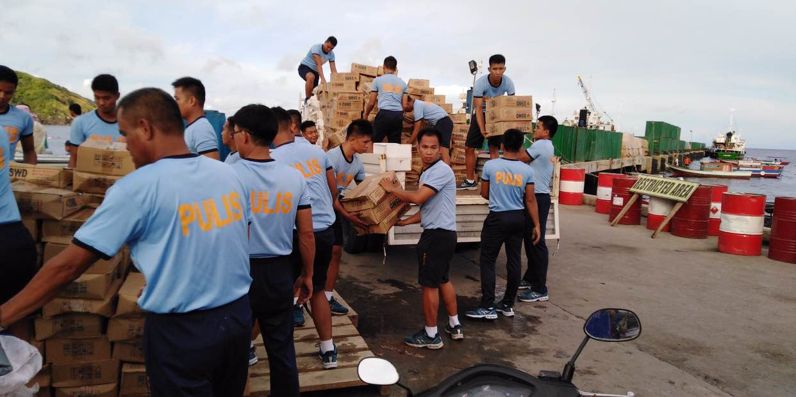
Loading of the sleeping kits and family tents at the Basco Port

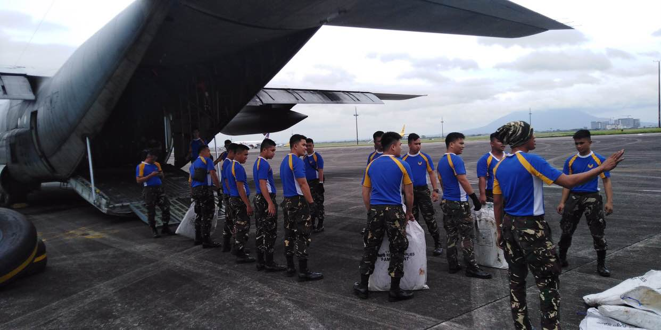

Photos taken on 01 August 2019
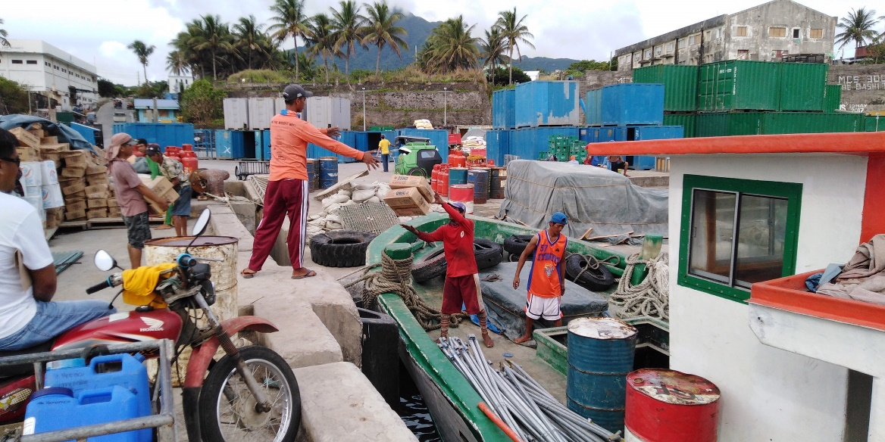

Photo taken on 02 August 2019

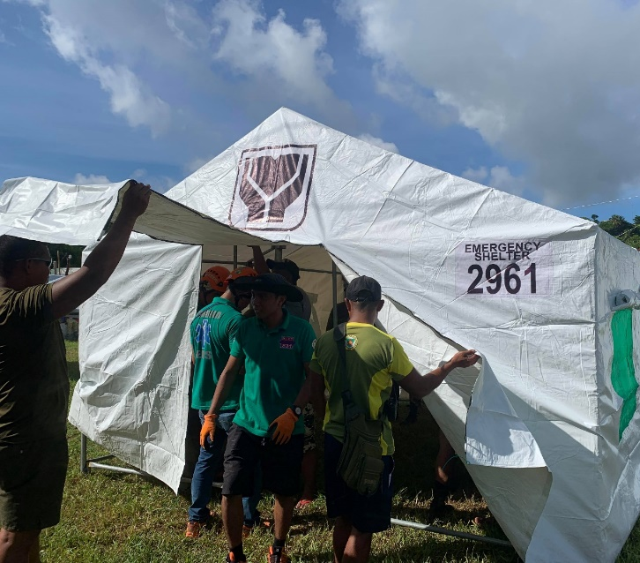
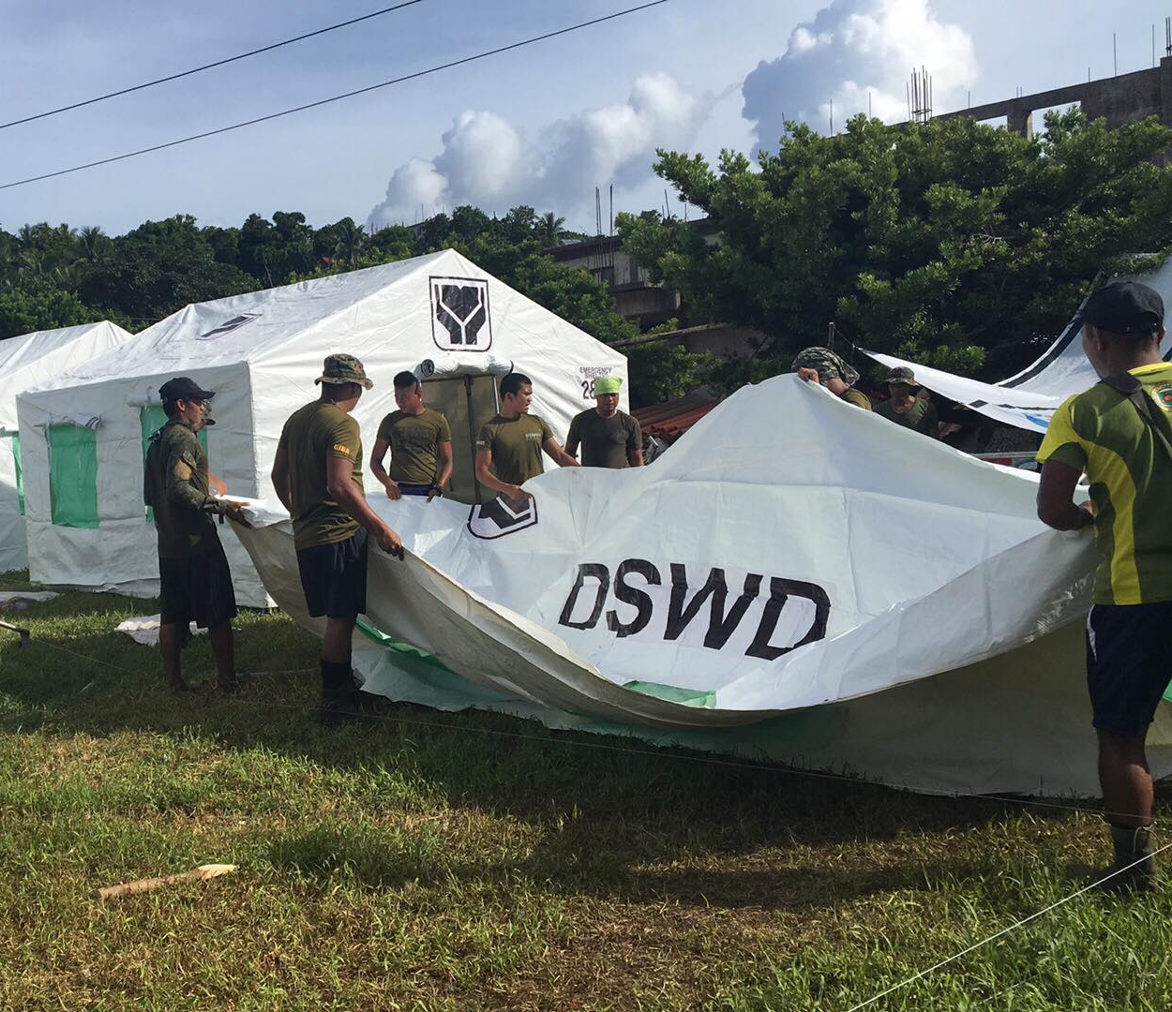
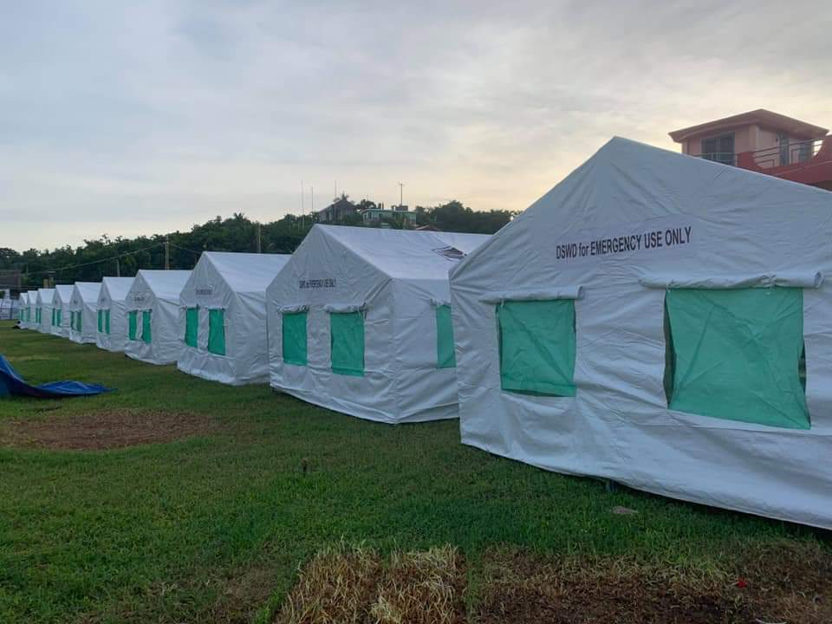
Photo taken on 04 August 2019
DSWD Tents being set-up at Itbayat Evacuation Camp

