DSWD DROMIC Report
#2 on Tropical Storm "INENG"
as of 24 August 2019, 4PM

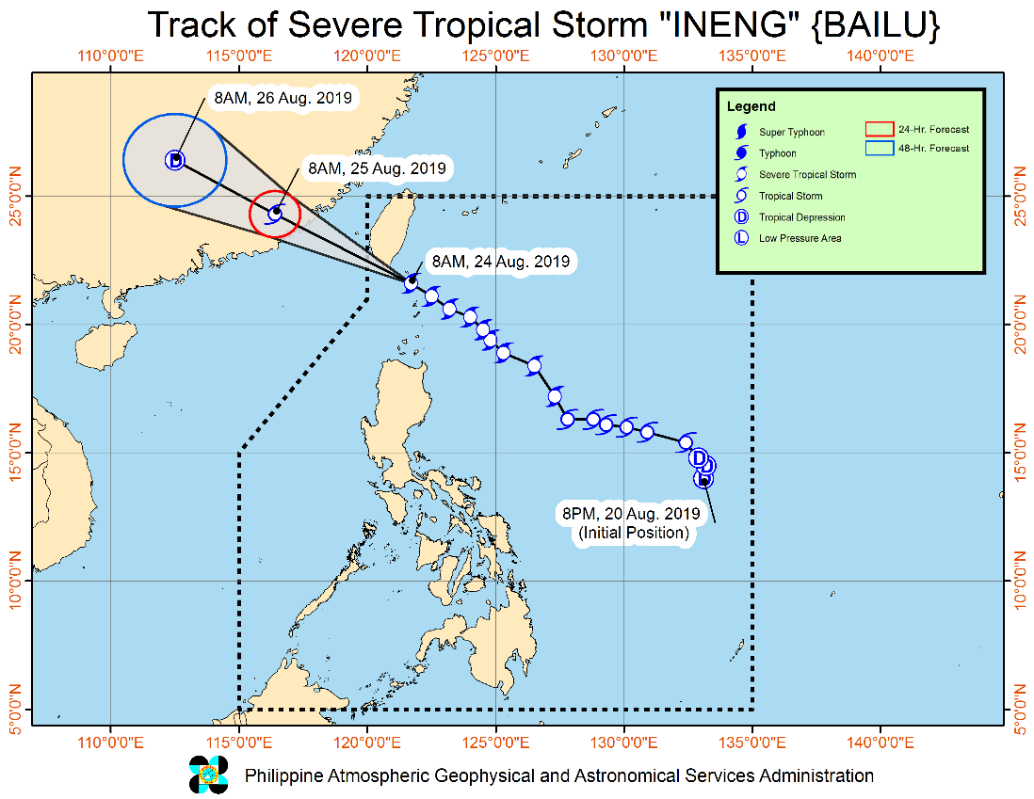
Situation Overview

On 20 August 2019, Low pressure area East of Virac, Catanduanes has developed into a Tropical Depression and was named “Ineng”. It has generally moved northwestward. “Ineng” has intensified into a severe Tropical Storm on 23 August 2019 and is now making close approach to Batanes Area.
Source: bagong. pagasa.dost.gov.ph Severe Weather Bulletin

- Status of Affected Families / Persons
A total of 35 families or 103 persons were affected by the effects of Tropical Storm Ineng in 4 barangays in Region II (see Table 1).

Table 1. Number of Affected Families / Persons
REGION / PROVINCE / MUNICIPALITY |  | NUMBER OF AFFECTED
 |  | Barangays | Families | Persons
GRAND TOTAL |  | 4 | 35 | 103
REGION II |  | 4 | 35 | 103
Batanes |  | 4 | 35 | 103
 | Itbayat | 4 | 35 | 103
Note: Ongoing assessment and validation being conducted.
Source: DSWD-FO II

- Status of Displaced Families / Persons
35 families or 103 persons who are currently staying with their relatives and / or friends (see Table 2).

Table 2. Number of Displaced Families / Persons Outside Evacuation Center
REGION / PROVINCE / MUNICIPALITY |  | OUTSIDE ECs
 |  | Families |  | Persons
 |  | CUM | NOW | CUM | NOW
GRAND TOTAL |  | 35 | 35 | 103 | 103
REGION II |  | 35 | 35 | 103 | 103
Batanes |  | 35 | 35 | 103 | 103
 | Itbayat | 35 | 35 | 103 | 103
Note: Ongoing assessment and validation being conducted.
Source: DSWD-FO II

DSWD DISASTER RESPONSE INFORMATION

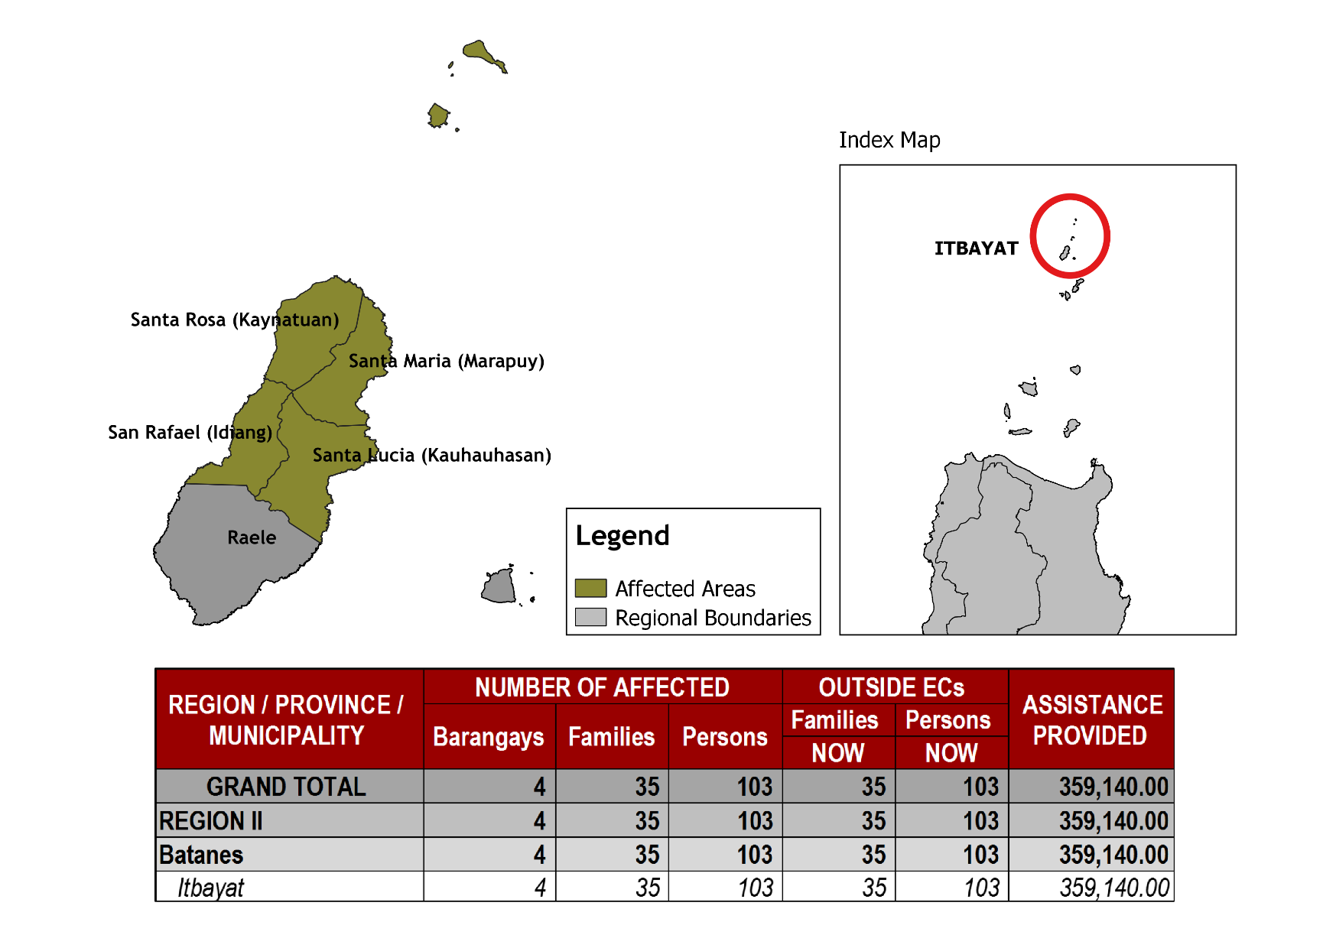
Status of Prepositioned Resources: Stockpile and Standby Funds

The DSWD Central Office (CO), Field Offices (FOs), and National Resource Operations Center (NROC) have stockpiles and standby funds amounting to ₱1,863,042,677.57 with breakdown as follows (see Table 1):

- Standby Funds
A total of ₱1,121,520,550.00 standby funds in the CO and FOs. Of the said amount, ₱1,076,221,717.34 is the available Quick Response Fund (QRF) in the CO.

- Stockpiles
A total of 355,320 Family Food Packs (FFPs) amounting to ₱135,710,537.82 and available Food and Non-food Items (FNIs) amounting to ₱605,811,589.75.

FIELD OFFICE |  | STANDBY FUNDS | STOCKPILES |  |  |  |  | Total STANDBY FUNDS & STOCKPILE
 |  |  | Family Food Packs |  | Other Food Items | Non Food Items | SUB-TOTAL (Food and NFIs)
 |  |  | Quantity | Total Cost | Total Cost | Total Cost
TOTAL |  | 1,121,520,550.00 | 355,320 | 135,710,537.82 | 136,699,481.84 | 469,112,107.91 | 605,811,589.75 | 1,863,042,677.57
Central Office |  | 1,076,221,717.34 |  |  |  |  |  | 1,076,221,717.34
NRLMB - NROC |  | 0.00 | 110,049 | 43,957,337.86 | 75,619,850.18 | 324,598,189.10 | 400,218,039.28 | 444,175,377.14
NRLMB - VDRC |  | 0.00 | 6,700 | 2,412,000.00 | 179,200.00 | 5,224,562.31 | 5,403,762.31 | 7,815,762.31
I |  | 2,379,275.00 | 14,674 | 5,282,640.00 | 1,525,319.12 | 17,615,504.54 | 19,140,823.66 | 26,802,738.66
II |  | 3,743,301.60 | 28,662 | 9,214,300.12 | 84,672.00 | 349,602.75 | 434,274.75 | 13,391,876.47
III |  | 3,068,057.00 | 22,690 | 9,565,871.00 | 979,469.70 | 241,406.00 | 1,220,875.70 | 13,854,803.70
CALABARZON |  | 3,000,100.00 | 4,802 | 1,725,244.66 | 3,790,447.60 | 3,423,852.37 | 7,214,299.97 | 11,939,644.63
MIMAROPA |  | 2,999,971.58 | 30,668 | 12,819,224.00 | 1,565,352.90 | 859,605.00 | 2,424,957.90 | 18,244,153.48
V |  | 3,000,000.00 | 21,045 | 8,207,550.00 | 8,958,033.52 | 40,704,948.22 | 49,662,981.74 | 60,870,531.74
VI |  | 3,000,000.00 | 5,691 | 2,057,295.72 | 8,594,920.49 | 3,711,406.00 | 12,306,326.49 | 17,363,622.21
VII |  | 3,001,150.00 | 15,338 | 5,521,680.00 | 13,672,560.74 | 16,417,732.90 | 30,090,293.64 | 38,613,123.64
VIII |  | 3,202,960.00 | 9,818 | 3,548,421.56 | 1,304,119.84 | 896,387.00 | 2,200,506.84 | 8,951,888.40
IX |  | 2,652,839.35 | 10,006 | 3,602,160.00 | 809,140.00 | 3,793,242.35 | 4,602,382.35 | 10,857,381.70
X |  | 237,377.00 | 8,637 | 3,109,320.00 | 6,195,576.80 | 28,928,315.92 | 35,123,892.72 | 38,470,589.72
XI |  | 3,028,750.00 | 30,704 | 11,096,425.60 | 3,163,200.00 | 10,768,720.09 | 13,931,920.09 | 28,057,095.69
XII |  | 3,000,701.68 | 4,724 | 1,894,324.00 | 3,484,211.10 | 866,517.26 | 4,350,728.36 | 9,245,754.04
CARAGA |  | 3,000,000.00 | 10,631 | 4,038,389.50 | 194,954.00 | 4,771,072.70 | 4,966,026.70 | 12,004,416.20
NCR |  | 3,292,543.50 | 5,484 | 2,052,190.36 | 1,162,526.29 | 1,038,066.00 | 2,200,592.29 | 7,545,326.15
CAR |  | 2,691,805.95 | 14,997 | 5,606,163.44 | 5,415,927.56 | 4,902,977.40 | 10,318,904.96 | 18,616,874.35
*Quick Response Fund (QRF) as of 22 August 2019

Situational Reports

DSWD-DRMB
DATE | SITUATIONS / ACTIONS UNDERTAKEN
24 August 2019 | - The Disaster Response Management Bureau (DRMB) is closely coordinating with the concerned DSWD-Field Offices for significant disaster response updates.

DSWD-FO CAR
DATE | SITUATIONS / ACTIONS UNDERTAKEN
24 August 2019 | - DSWD-FO II is on blue alert status  - DRMD PDO IIs are continuously coordinating with PSWADTs with LDRRMOs for updates.  - Rapid Emergency Telecommunication Team (RETT) including the International Maritime/ Marine Satellite (INMARSAT) equipment are on standby.

DSWD-FO I
DATE | SITUATIONS / ACTIONS UNDERTAKEN
- August 2019 | - The Disaster Response Management Division (DRMD) staff of DSWD-FO I staff are monitoring the possible effects of the current weather condition  - Provincial Operations Offices (POOs) in close coordination with the different Provincial/City/Municipal Disaster Risk Reduction and Management Councils (P/C/MDRRMCs) and Provincial/City/Municipal Social Welfare and Development Offices (P/C/MSWDOs) are currently monitoring the adverse effect that might be brought by the weather disturbance.
DSWD-FO II
DATE | SITUATIONS / ACTIONS UNDERTAKEN
24 August 2019 | - DSWD-FO II is continuously monitoring and coordinating with P/C/ MATs/ SWADTs for any eventualities to be addressed by the field office and additional augmentation support needed by the LGUs.

DSWD-FO MIMAROPA
DATE | SITUATIONS / ACTIONS UNDERTAKEN
23 August 2019 | - DSWD-FO MIMAROPA through the Disaster Response Management Division ensures an on-call and standby duty of the R/P/C/M Quick Response Teams for possible activation of Operations Center.  - All members of Rapid Emergency Telecommunications Team are on standby status ready for deployment if needed.  - DSWD-FO MIMAROPA ensures that relief goods are readily available for distribution.  - DSWD-FO MIMAROPA is in close coordination with the Office of Civil Defense (OCD) and RDRRMC MIMAROPA for any warning signal updates in response to the areas that will be affected.

DSWD-FO V
DATE | SITUATIONS / ACTIONS UNDERTAKEN
- August 2019 | - DSWD FO V QRTs were alerted and advised to be prepared for augmentation support needed from the field and/or 24/7 duty at the DRMD Operation Center.  - PAT and MAT members in the 6 provinces are on standby and were instructed to coordinate with the P/MDRRMOs for status reports and updates.

DSWD-FO VIII
DATE | SITUATIONS / ACTIONS UNDERTAKEN
- August 2019 | - DSWD-FO VIII is in in close coordination with SWADTs, QRTs and PDOs for any eventualities on the ground.  - All Quick Response Team (QRT) members and Disaster Response Management Division (DRMD) are alerted in case augmentation of workforce is needed.  - Regional Resource Operation Section (RROS) are also alerted to ensure the readiness of dispatching the Food and Non-Food commodities whenever needed.

*****
The Disaster Response Operations Monitoring and Information Center (DROMIC) of the DSWD-DRMB is continuously monitoring on the effects of “TS Ineng” and closely coordinating with the concerned DSWD-Field Offices for any significant updates.

PREPARED BY:

MARIJOY V. SAN BUENAVENTURA / DIANE C. PELEGRINO

RODEL V. CABADDU
Releasing Officer

