DSWD DROMIC Report #2 on Tropical Storm "JENNY"
as of 28 August 2019, 6PM

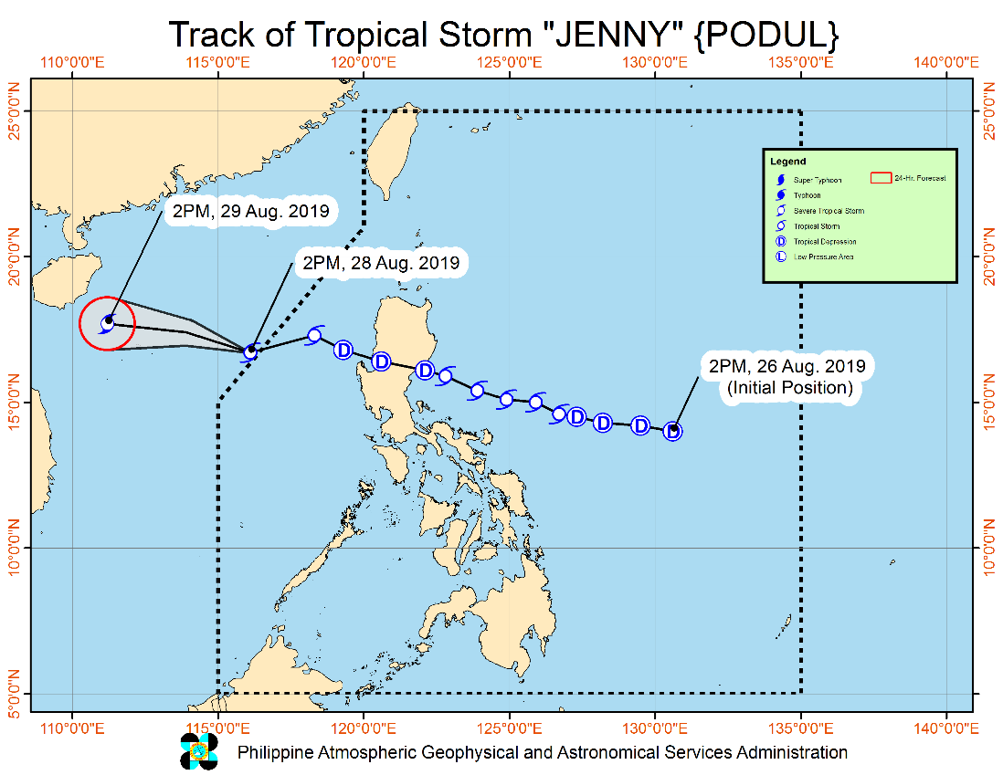
Situation Overview

TROPICAL STORM "JENNY" HAS SLIGHTLY INTENSIFIED AND IS NOW OUTSIDE THE PHILIPPINE AREA OF RESPONSIBILITY (PAR).
- Today, light to moderate with intermittent heavy rains will be experienced over Western Visayas, Negros Oriental, Mindoro Provinces, Romblon, and Palawan (including Calamian and Cuyo Islands) due to the Southwest Monsoon.
- Residents of these areas, especially those living in areas identified to be highly or very highly susceptible to floods and rain-induced landslides, are advised to take precautionary measures, coordinate with local disaster risk reduction and management offices, and continue monitoring for updates, especially the Thunderstorm or Rainfall Advisories and Heavy Rainfall Warnings to be issued by PAGASA Regional Services Divisions.
- Sea travel remains risky over the seaboards of Luzon and the western seaboard of Visayas due to potentially rough sea conditions.
At 4:00 PM today, the center of Tropical Storm "JENNY" was estimated based on all available data at 510 km West of Dagupan City, Pangasinan (OUTSIDE PAR) (16.6 °N, 115.6 °E)
Source: DOST-PAGASA Severe Weather Bulletin

- Status of Affected Families / Persons
A total of 3,117 families or 12,299 persons were affected by the effects of Tropical Storm Ineng in 45 barangays in Region I, III and CAR (see Table 1).

Table 1. Number of Affected Families / Persons
REGION / PROVINCE / MUNICIPALITY |  | NUMBER OF AFFECTED
 |  | Barangays | Families | Persons
GRAND TOTAL |  | 45 | 3,117 | 12,299
REGION I |  | 11 | 2,444 | 10,041
Pangasinan |  | 11 | 2,444 | 10,041
 | Calasiao | 10 | 2,428 | 9,965
 | Dagupan City | 1 | 16 | 76
REGION III |  | 28 | 552 | 1,936
Aurora |  | 23 | 491 | 1,734
 | Casiguran | 7 | 56 | 198
 | Dilasag | 3 | 208 | 677
 | Dinalungan | 8 | 188 | 730
 | Maria Aurora | 5 | 39 | 129
Zambales |  | 5 | 61 | 202
 | Santa Cruz | 5 | 61 | 202
CAR |  | 6 | 121 | 322
Abra |  | 3 | 63 | 148
 | Dolores | 3 | 63 | 148
Benguet |  | 3 | 58 | 174
 | Buguias | 1 | 3 | 8
 | Itogon | 1 | 52 | 162
 | Tuba | 1 | 3 | 4
Note: Ongoing assessment and validation being conducted.
Source: DSWD-FO I, III and CAR
- Status of Displaced Families / Persons
- Inside Evacuation Centers
A total of 123 families or 360 persons are currently taking shelter in 7 evacuation centers in Region I, III and CAR (see Table 2).

Table 2. Number of Displaced Families / Persons Outside Evacuation Center
REGION / PROVINCE / MUNICIPALITY |  | NUMBER OF EVACUATION CENTERS (ECs) |  | INSIDE ECs
 |  |  |  | Families |  | Persons
 |  | CUM | NOW | CUM | NOW | CUM | NOW
GRAND TOTAL |  | 37 | 7 | 464 | 123 | 1,612 | 360
REGION I |  | 1 | 1 | 16 | 16 | 76 | 76
Pangasinan |  | 1 | 1 | 16 | 16 | 76 | 76
 | Dagupan City | 1 | 1 | 16 | 16 | 76 | 76
REGION III |  | 31 | 1 | 354 | 13 | 1,294 | 42
Aurora |  | 26 | - | 293 | - | 1,092 | -
 | Casiguran | 6 | - | 52 | - | 187 | -
 | Dilasag | 2 | - | 14 | - | 46 | -
 | Dinalungan | 13 | - | 188 | - | 730 | -
 | Maria Aurora | 5 | - | 39 | - | 129 | -
Zambales |  | 5 | 1 | 61 | 13 | 202 | 42
 | Santa Cruz | 5 | 1 | 61 | 13 | 202 | 42
CAR |  | 5 | 5 | 94 | 94 | 242 | 242
Abra |  | 2 | 2 | 63 | 63 | 148 | 148
 | Dolores | 2 | 2 | 63 | 63 | 148 | 148
Benguet |  | 3 | 3 | 31 | 31 | 94 | 94
 | Itogon | 3 | 3 | 31 | 31 | 94 | 94
Note: Ongoing assessment and validation being conducted.
Source: DSWD-FO I, III and CAR

- Cost of Assistance
A total of ₱572,750.00 worth of assistance was provided to the affected families by LGU (see Table 3).

Table 3. Cost of Assistance Provided to Affected Families / Persons
REGION / PROVINCE / MUNICIPALITY |  | TOTAL COST OF ASSISTANCE
 |  | DSWD | LGU | NGOs | OTHERS | GRAND TOTAL
GRAND TOTAL |  | - | 572,750.00 | - | - | 572,750.00
REGION I |  | - | 473,000.00 | - | - | 473,000.00
Pangasinan |  | - | 473,000.00 | - | - | 473,000.00
 | Calasiao | - | 473,000.00 | - | - | 473,000.00
REGION III |  | - | 99,750.00 | - | - | 99,750.00
Aurora |  | - | 99,750.00 | - | - | 99,750.00
 | Dinalungan | - | 99,750.00 | - | - | 99,750.00
Note: Ongoing assessment and validation being conducted.
Source: DSWD-FO I and III

Situational Reports

DSWD-DRMB
DATE | SITUATIONS / ACTIONS UNDERTAKEN
28 August 2019 | - The Disaster Response Management Bureau (DRMB) is closely coordinating with the concerned DSWD-Field Offices for significant disaster preparedness for response updates.  - All QRT members and emergency equipment are on standby and ready for deployment.

DSWD-FO CAR
DATE | SITUATIONS / ACTIONS UNDERTAKEN
28 August 2019 | - The DSWD-FO CAR is on RED Alert Level Status.
- August 2019 | - The DRMD is continuously monitoring the situation on ground  - The Provincial Social Welfare and Development Teams (PSWADT) DRMD PDO IIs are alerted, members are on stand by for the possible effects of the weather disturbance.  - Rapid Emergency Telecommunications Team (RETT) including the International Maritime/Marine Satellite (INMARSAT) equipment are on standby.
DSWD-FO NCR
DATE | SITUATIONS / ACTIONS UNDERTAKEN
- August 2019 | - The Planning Section of FO-NCR and the FO-DROMIC Focal is assigned to prepare the consolidation of disaster reports in the event of 24 hours monitoring.  - The Quick Response Teams of FO-NCR composed of organic staff from the Field Office and Centers and Residential Care Facilities (C/RCFs) is activated and on standby in response to any eventualities. The assignment of said staff is scheduled per day.

DSWD-FO I
DATE | SITUATIONS / ACTIONS UNDERTAKEN
28 August 2019 | - The DSWD-FO CAR is still on BLUE Alert Level Status
- August 2019 | - The Disaster Response Management Division (DRMD) staff of DSWD-FO I staff are monitoring the possible effects of the current weather condition  - Provincial Operations Offices (POOs) in close coordination with the different Provincial/City/Municipal Disaster Risk Reduction and Management Councils (P/C/MDRRMCs) and Provincial/City/Municipal Social Welfare and Development Offices (P/C/MSWDOs) are currently monitoring the adverse effect that might be brought by the weather disturbance.  - The Disaster Response Management Division (DRMD) staff Ms. Maricel S. Caleja, attended the Pre-Disaster Risk Assessment (PDRA) meeting

DSWD-FO II
DATE | SITUATIONS / ACTIONS UNDERTAKEN
- August 2019 | - The DRMD attended Pre-Disaster Risk Assessment (PDRA) Meeting at the DSWD Field Office to discuss possible effects of TS Jenny  - The Regional Disaster Management and Response Team (RDMRT), SWADTs and P/C/MATs of Cagayan, lsabela, Nueva Vizcaya and Quirino are now on 24-hour duty to monitor the possible effects of TS "JENNY"  - The province of lsabela already prepositioned their family food packs from their stockpile in the four (4) coastal municipalities namely Palanan, Maconacon, Divilacan and Dinaoiaue.

DSWD-FO III
DATE | SITUATIONS / ACTIONS UNDERTAKEN
- August 2019 | - The DSWD-FO III is continuously monitoring of weather updates with the concerned LGUs  - The DSWD-FO III is in continuously coordination with the Municipality of Zambales on the status of open evacuation centers

DSWD-FO MIMAROPA
DATE | SITUATIONS / ACTIONS UNDERTAKEN
- August 2019 | - DSWD-FO MIMAROPA through the Disaster Response Management Division ensures an on-call and standby duty of the R/P/C/M Quick Response Teams for possible activation of Operations Center.  - All members of Rapid Emergency Telecommunications Team are on standby status ready for deployment if needed.  - DSWD-FO MIMAROPA ensures that relief goods are readily available for distribution.  - DSWD-FO MIMAROPA is in close coordination with the Office of Civil Defense (OCD) and RDRRMC MIMAROPA for any warning signal updates in response to the areas that will be affected.

DSWD-FO CALABARZON
DATE | SITUATIONS / ACTIONS UNDERTAKEN
- August 2019 | - DSWD-FO CALABARZON Emergency Operations Center is already activated to monitor the possible effects of TD Jenny.  - The DSWD-FO CALABARZON Coordinated with SWAD Team Leaders and Provincial Action Team of the CALABARZON and advised them to monitor and coordinate with the LGUs to gather reports on the possible effects of TD Jenny.

DSWD-FO V
DATE | SITUATIONS / ACTIONS UNDERTAKEN
- August 2019 | - DSWD FO V QRTs were alerted and advised to be prepared for augmentation support needed from the field and/or 24/7 duty at the DRMD Operation Center.  - PAT and MAT members in the 6 provinces are on standby and were instructed to coordinate with the P/MDRRMOs for status reports and updates.

DSWD-FO VIII
DATE | SITUATIONS / ACTIONS UNDERTAKEN
- August 2019 | - DSWD-FO VIII is in in close coordination with SWADTs, QRTs and PDOs for any eventualities on the ground.  - All Quick Response Team (QRT) members and Disaster Response Management Division (DRMD) are alerted in case augmentation of workforce is needed.  - Disaster Response Information Management Section (DRIMS) is in close coordination with SWADTs, QRTs and PDOs for any eventualities on the ground.  - Regional Resource Operation Section (RROS) are also alerted to ensure the readiness of dispatching the Food and Non-Food commodities whenever needed.

*****
The Disaster Response Operations Monitoring and Information Center (DROMIC) of the DSWD-DRMB is closely monitoring the effects of TS Jenny and is coordinating with the concerned DSWD-Field Offices for any significant updates.

PREPARED BY:

MARIJOY V. SAN BUENAVENTURA

RODEL V. CABADDU
Releasing Officer

