DSWD DROMIC Report
#3 on Tropical Storm "INENG"
as of 25 August 2019, 5PM

Situation Overview

On 20 August 2019, Low pressure area East of Virac, Catanduanes has developed into a Tropical Depression and was named “Ineng”. It has generally moved northwestward. “Ineng” has intensified into a severe Tropical Storm on 23 August 2019 and is now outside the Philippine Area of Responsibility.
Source: bagong. pagasa.dost.gov.ph Severe Weather Bulletin

- Status of Affected Families / Persons
A total of 8,008 families or 33,333 persons were affected by the effects of Tropical Storm Ineng in 156 barangays in Region I, II and III (see Table 1).
Table 1. Number of Affected Families / Persons
REGION / PROVINCE / MUNICIPALITY |  | NUMBER OF AFFECTED
 |  | Barangays | Families | Persons
GRAND TOTAL |  | 156 | 8,008 | 33,333
REGION I |  | 134 | 7,683 | 32,242
Ilocos Norte |  | 129 | 7,628 | 32,048
 | Bacarra | 8 | 117 | 475
 | CITY OF BATAC | 6 | 44 | 158
 | Burgos | 2 | 31 | 122
 | Dingras | 1 | 5 | 21
 | LAOAG CITY (Capital) | 23 | 1,957 | 7,759
 | Marcos | 2 | 45 | 139
 | Pagudpud | 1 | 151 | 604
 | Paoay | 16 | 1,171 | 3,613
 | Pasuquin | 9 | 562 | 2,569
 | Piddig | 21 | 900 | 4,500
 | San Nicolas | 19 | 2,222 | 10,311
 | Sarrat | 17 | 387 | 1,621
 | Vintar | 4 | 36 | 156
La Union |  | 5 | 55 | 194
 | Bauang | 1 | 23 | 92
 | CITY OF SAN FERNANDO (Capital) | 4 | 32 | 102
REGION II |  | 4 | 35 | 103
Batanes |  | 4 | 35 | 103
 | Itbayat | 4 | 35 | 103
REGION III |  | 18 | 290 | 988
Zambales |  | 18 | 290 | 988
 | Candelaria | 2 | 54 | 221
 | Masinloc | 4 | 45 | 174
 | Santa Cruz | 12 | 191 | 593
Note: Ongoing assessment and validation being conducted.
Source: DSWD-FO I, II and III

- Status of Displaced Families / Persons
- Inside Evacuation Centers

A total of 193 families or 601 persons are temporarily staying in 16 evacuation centers in Regions I and III (see Table 2).

Table 2. Number of Displaced Families / Persons Outside Evacuation Center
REGION / PROVINCE / MUNICIPALITY |  | NUMBER OF EVACUATION CENTERS (ECs) |  | INSIDE ECs
 |  |  |  | Families |  | Persons
 |  | CUM | NOW | CUM | NOW | CUM | NOW
GRAND TOTAL |  | 49 | 16 | 652 | 193 | 2,363 | 601
REGION I |  | 28 | 1 | 362 | 2 | 1,375 | 8
Ilocos Norte |  | 24 | 1 | 314 | 2 | 1,212 | 8
 | Bacarra | 1 | - | 5 | - | 16 | -
 | CITY OF BATAC | 3 | - | 8 | - | 28 | -
 | Burgos | 1 | - | 26 | - | 99 | -
 | Dingras | 1 | - | 5 | - | 21 | -
 | LAOAG CITY (Capital) | 13 | - | 110 | - | 411 | -
 | Pagudpud | 1 | - | 151 | - | 604 | -
 | San Nicolas | 3 | - | 7 | - | 25 | -
 | Vintar | 1 | 1 | 2 | 2 | 8 | 8
La Union |  | 4 | - | 48 | - | 163 | -
 | Bauang | 1 | - | 27 | - | 94 | -
 | CITY OF SAN FERNANDO (Capital) | 3 | - | 21 | - | 69 | -
REGION III |  | 21 | 15 | 290 | 191 | 988 | 593
Zambales |  | 21 | 15 | 290 | 191 | 988 | 593
 | Candelaria | 2 | - | 54 | - | 221 | -
 | Masinloc | 4 | - | 45 | - | 174 | -
 | Santa Cruz | 15 | 15 | 191 | 191 | 593 | 593
Note: Ongoing assessment and validation being conducted.
Source: DSWD-FO I and III

- Outside Evacuation Centers

A total of 48 families or 169 persons are currently taking temporary shelter with their relatives and/or friends Region I and II (see Table 3).

Table 3. Status of Displaced Families/ Persons Outside Evacuation Centers
REGION / PROVINCE / MUNICIPALITY |  | OUTSIDE ECs
 |  | Families |  | Persons
 |  | CUM | NOW | CUM | NOW
GRAND TOTAL |  | 69 | 48 | 246 | 169
REGION I |  | 34 | 13 | 143 | 66
Ilocos Norte |  | 23 | 13 | 110 | 66
 | Burgos | 5 | 1 | 23 | 5
 | LAOAG CITY (Capital) | 11 | 5 | 52 | 26
 | Piddig | 7 | 7 | 35 | 35
La Union |  | 11 | - | 33 | -
 | CITY OF SAN FERNANDO (Capital) | 11 | - | 33 | -
REGION II |  | 35 | 35 | 103 | 103
Batanes |  | 35 | 35 | 103 | 103
 | Itbayat | 35 | 35 | 103 | 103
Note: Ongoing assessment and validation being conducted.
Source: DSWD-FO I and III

- Damaged Houses

There are 43 damaged houses; of which, 17 are totally damaged and 26 are partially damaged see Table (see Table 4).

Table 4. Number of Damaged Houses
REGION / PROVINCE / MUNICIPALITY |  | NO. OF DAMAGED HOUSES
 |  | Total | Totally | Partially
GRAND TOTAL |  | 43 | 17 | 26
REGION I |  | 43 | 17 | 26
Ilocos Norte |  | 43 | 17 | 26
 | LAOAG CITY (Capital) | 24 | 8 | 16
 | Piddig | 7 | 7 | -
 | Vintar | 12 | 2 | 10
Note: Ongoing assessment and validation being conducted.
Source: DSWD-FO I

- Cost of Assistance
A total of ₱26,372.00 worth of assistance was provided to the affected families by the LGU (see Table 5).

Table 5. Cost of Assistance Provided to Affected Families / Persons
REGION / PROVINCE / MUNICIPALITY |  | TOTAL COST OF ASSISTANCE
 |  | DSWD | LGU | NGOs | OTHERS | GRAND TOTAL
GRAND TOTAL |  | - | 26,372.00 | - | - | 26,372.00
REGION I |  | - | 26,372.00 | - | - | 26,372.00
Ilocos Norte |  | - | 14,660.00 | - | - | 14,660.00
 | CITY OF BATAC | - | 12,160.00 | - | - | 12,160.00
 | Burgos | - | 1,000.00 | - | - | 1,000.00
 | Dingras | - | 1,500.00 | - | - | 1,500.00
La Union |  | - | 11,712.00 | - | - | 11,712.00
 | CITY OF SAN FERNANDO (Capital) | - | 11,712.00 | - | - | 11,712.00
Note: Ongoing assessment and validation being conducted.

Source: DSWD-FO I

DISASTER RESPONSE INFORMATION

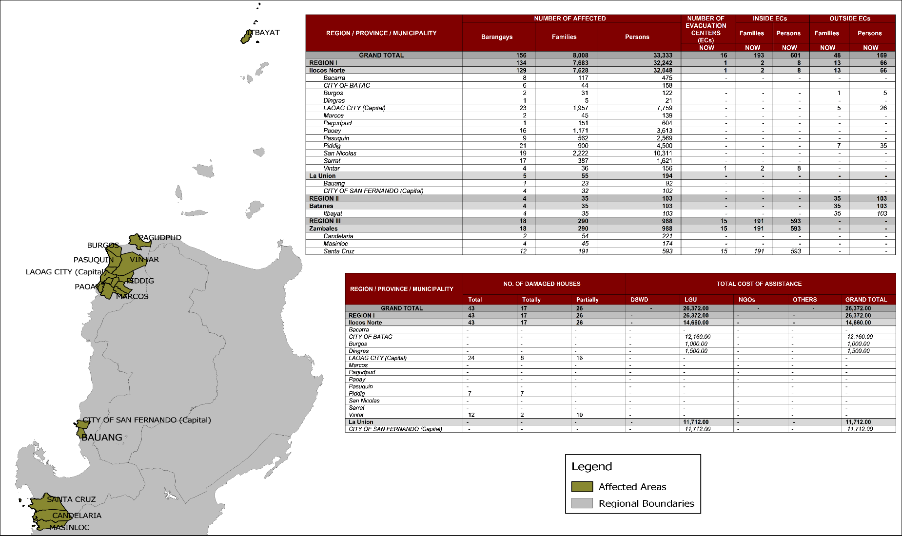

Status of Prepositioned Resources: Stockpile and Standby Funds

The DSWD Central Office (CO), Field Offices (FOs), and National Resource Operations Center (NROC) have stockpiles and standby funds amounting to ₱1,863,042,677.57 with breakdown as follows (see Table 1):

- Standby Funds
A total of ₱1,121,520,550.00 standby funds in the CO and FOs. Of the said amount, ₱1,076,221,717.34 is the available Quick Response Fund (QRF) in the CO.

- Stockpiles
A total of 355,320 Family Food Packs (FFPs) amounting to ₱135,710,537.82 and available Food and Non-food Items (FNIs) amounting to ₱605,811,589.75.

FIELD OFFICE |  | STANDBY FUNDS | STOCKPILES |  |  |  |  | Total STANDBY FUNDS & STOCKPILE
 |  |  | Family Food Packs |  | Other Food Items | Non Food Items | SUB-TOTAL (Food and NFIs)
 |  |  | Quantity | Total Cost | Total Cost | Total Cost
TOTAL |  | 1,121,520,550.00 | 355,320 | 135,710,537.82 | 136,699,481.84 | 469,112,107.91 | 605,811,589.75 | 1,863,042,677.57
Central Office |  | 1,076,221,717.34 |  |  |  |  |  | 1,076,221,717.34
NRLMB - NROC |  | 0.00 | 110,049 | 43,957,337.86 | 75,619,850.18 | 324,598,189.10 | 400,218,039.28 | 444,175,377.14
NRLMB - VDRC |  | 0.00 | 6,700 | 2,412,000.00 | 179,200.00 | 5,224,562.31 | 5,403,762.31 | 7,815,762.31
I |  | 2,379,275.00 | 14,674 | 5,282,640.00 | 1,525,319.12 | 17,615,504.54 | 19,140,823.66 | 26,802,738.66
II |  | 3,743,301.60 | 28,662 | 9,214,300.12 | 84,672.00 | 349,602.75 | 434,274.75 | 13,391,876.47
III |  | 3,068,057.00 | 22,690 | 9,565,871.00 | 979,469.70 | 241,406.00 | 1,220,875.70 | 13,854,803.70
CALABARZON |  | 3,000,100.00 | 4,802 | 1,725,244.66 | 3,790,447.60 | 3,423,852.37 | 7,214,299.97 | 11,939,644.63
MIMAROPA |  | 2,999,971.58 | 30,668 | 12,819,224.00 | 1,565,352.90 | 859,605.00 | 2,424,957.90 | 18,244,153.48
V |  | 3,000,000.00 | 21,045 | 8,207,550.00 | 8,958,033.52 | 40,704,948.22 | 49,662,981.74 | 60,870,531.74
VI |  | 3,000,000.00 | 5,691 | 2,057,295.72 | 8,594,920.49 | 3,711,406.00 | 12,306,326.49 | 17,363,622.21
VII |  | 3,001,150.00 | 15,338 | 5,521,680.00 | 13,672,560.74 | 16,417,732.90 | 30,090,293.64 | 38,613,123.64
VIII |  | 3,202,960.00 | 9,818 | 3,548,421.56 | 1,304,119.84 | 896,387.00 | 2,200,506.84 | 8,951,888.40
IX |  | 2,652,839.35 | 10,006 | 3,602,160.00 | 809,140.00 | 3,793,242.35 | 4,602,382.35 | 10,857,381.70
X |  | 237,377.00 | 8,637 | 3,109,320.00 | 6,195,576.80 | 28,928,315.92 | 35,123,892.72 | 38,470,589.72
XI |  | 3,028,750.00 | 30,704 | 11,096,425.60 | 3,163,200.00 | 10,768,720.09 | 13,931,920.09 | 28,057,095.69
XII |  | 3,000,701.68 | 4,724 | 1,894,324.00 | 3,484,211.10 | 866,517.26 | 4,350,728.36 | 9,245,754.04
CARAGA |  | 3,000,000.00 | 10,631 | 4,038,389.50 | 194,954.00 | 4,771,072.70 | 4,966,026.70 | 12,004,416.20
NCR |  | 3,292,543.50 | 5,484 | 2,052,190.36 | 1,162,526.29 | 1,038,066.00 | 2,200,592.29 | 7,545,326.15
CAR |  | 2,691,805.95 | 14,997 | 5,606,163.44 | 5,415,927.56 | 4,902,977.40 | 10,318,904.96 | 18,616,874.35
*Quick Response Fund (QRF) as of 22 August 2019

Situational Reports

DSWD-DRMB
DATE | SITUATIONS / ACTIONS UNDERTAKEN
25 August 2019 | - The Disaster Response Management Bureau (DRMB) is closely coordinating with the concerned DSWD-Field Offices for significant disaster response updates.

DSWD-FO CAR
DATE | SITUATIONS / ACTIONS UNDERTAKEN
25 August 2019 | - DRMD PDO IIs are continuously coordinating with PSWADTs with LDRRMOs for updates.  - Rapid Emergency Telecommunication Team (RETT) including the International Maritime/ Marine Satellite (INMARSAT) equipment are on standby.  - DSWD FO CAR is still on blue alert status.

DSWD-FO I
DATE | SITUATIONS / ACTIONS UNDERTAKEN
- August 2019 | - DSWD FO I is on Blue Alert Status  - The Disaster Response Management Division (DRMD) staff of DSWD-FO I staff are monitoring the possible effects of the current weather condition  - Provincial Operations Offices (POOs) in close coordination with the different Provincial/City/Municipal Disaster Risk Reduction and Management Councils (P/C/MDRRMCs) and Provincial/City/Municipal Social Welfare and Development Offices (P/C/MSWDOs) are currently monitoring the adverse effect that might be brought by the weather disturbance.

DSWD-FO II
DATE | SITUATIONS / ACTIONS UNDERTAKEN
25 August 2019 | - DSWD-FO II is continuously monitoring and coordinating with P/C/ MATs/ SWADTs for any eventualities to be addressed by the field office and additional augmentation support needed by the LGUs.

DSWD-FO MIMAROPA
DATE | SITUATIONS / ACTIONS UNDERTAKEN
23 August 2019 | - DSWD-FO MIMAROPA through the Disaster Response Management Division ensures an on-call and standby duty of the R/P/C/M Quick Response Teams for possible activation of Operations Center.  - All members of Rapid Emergency Telecommunications Team are on standby status ready for deployment if needed.  - DSWD-FO MIMAROPA ensures that relief goods are readily available for distribution.  - DSWD-FO MIMAROPA is in close coordination with the Office of Civil Defense (OCD) and RDRRMC MIMAROPA for any warning signal updates in response to the areas that will be affected.

DSWD-FO V
DATE | SITUATIONS / ACTIONS UNDERTAKEN
- August 2019 | - DSWD FO V QRTs were alerted and advised to be prepared for augmentation support needed from the field and/or 24/7 duty at the DRMD Operation Center.  - PAT and MAT members in the 6 provinces are on standby and were instructed to coordinate with the P/MDRRMOs for status reports and updates.

DSWD-FO VIII
DATE | SITUATIONS / ACTIONS UNDERTAKEN
- August 2019 | - DSWD-FO VIII is in in close coordination with SWADTs, QRTs and PDOs for any eventualities on the ground.  - All Quick Response Team (QRT) members and Disaster Response Management Division (DRMD) are alerted in case augmentation of workforce is needed.  - Regional Resource Operation Section (RROS) are also alerted to ensure the readiness of dispatching the Food and Non-Food commodities whenever needed.

*****
The Disaster Response Operations Monitoring and Information Center (DROMIC) of the DSWD-DRMB is continuously monitoring on the effects of “TS Ineng” and closely coordinating with the concerned DSWD-Field Offices for any significant updates.

PREPARED BY:

MARIJOY V. SAN BUENAVENTURA / CLARRIE MAE A. CASTILLO

RODEL V. CABADDU
Releasing Officer

