DSWD DROMIC Report #9
on the Earthquake Incident in Itbayat, Batanes
as of 02 August 2019, 4AM

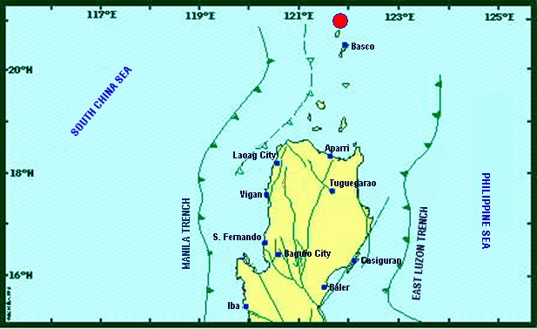

Situation Overview

On 27 July 2019 at 4:16 AM, a 5.4 magnitude earthquake jolted the municipality of Itbayat, Batanes (20.90°N, 121.85°E - 012 km N 04°E) with a tectonic origin and a depth of focus of 12 km. The earthquake was also felt in the neighboring municipalities of Batanes.

Date/Time: | 27 Jul 2019 - 04:16:54 AM
Reported Intensities: | Intensity VI - Itbayat, Batanes  Intensity III - Basco and Sabtang, Batanes  Instrumental Intensity:  Intensity III - Basco, Batanes
Expecting Damage: | YES
Expecting Aftershocks: | YES

Source: DOST-PHIVOLCS Earthquake Bulletin

According to the PAGASA weather forecast as of 3PM, 01 August 2019, the Low Pressure Area (LPA) was estimated based on all available data at°980 km East of Virac, Catanduanes (14.9°N, 133.2°E). Southwest Monsoon affecting the western section of Luzon

Source: PAGASA Daily Weather Forecast

- Status of Affected Families / Persons
A total of 1,025 families or 2,968 persons were affected by the earthquake incident in 5 barangays in Itbayat, Batanes (see Table 1).

Table 1. Number of Affected Families / Persons
REGION / PROVINCE / MUNICIPALITY |  | NUMBER OF AFFECTED
 |  | Barangays | Families | Persons
GRAND TOTAL |  | 5 | 1,025 | 2,968
REGION II |  | 5 | 1,025 | 2,968
Batanes |  | 5 | 1,025 | 2,968
 | Itbayat | 5 | 1,025 | 2,968
Note: Ongoing assessment and validation being conducted.
Source: DSWD-FO II

- Status of Displaced Families / Persons
742 families or 2,365 persons are currently staying at the Covered Court/Municipal Plaza in Brgy. San Rafael, Itbayat, Batanes (see Table 2).

Table 2. Number of Displaced Families / Persons Inside Evacuation Center
REGION / PROVINCE / MUNICIPALITY |  | NUMBER OF EVACUATION CENTERS (ECs) |  | INSIDE ECs
 |  |  |  | Families |  | Persons
 |  | CUM | NOW | CUM | NOW | CUM | NOW
GRAND TOTAL |  | 1 | 1 | 742 | 742 | 2,365 | 2,365
REGION II |  | 1 | 1 | 742 | 742 | 2,365 | 2,365
Batanes |  | 1 | 1 | 742 | 742 | 2,365 | 2,365
 | Itbayat | 1 | 1 | 742 | 742 | 2,365 | 2,365
Note: Ongoing assessment and validation being conducted.

Source: DSWD-FO II

- Damaged Houses
There are 266 damaged houses; of which, 81 are partially damaged and 185 are totally damaged (see Table 3).

Table 3. Number of Damaged Houses
REGION / PROVINCE / MUNICIPALITY |  | NO. OF DAMAGED HOUSES
 |  | Total | Totally | Partially
GRAND TOTAL |  | 266 | 185 | 81
REGION II |  | 266 | 185 | 81
Batanes |  | 266 | 185 | 81
 | Itbayat | 266 | 185 | 81
Note: Ongoing assessment and validation being conducted.
*Based on the Proposed Early Recovery and Rehabilitation Plan submitted by DSWD-FO II.
Source: DSWD-FO II

- Assistance Provided
A total of ₱128,880.00 worth of assistance was provided by DSWD to the affected families (see Table 4).

Table 4. Cost of Assistance Provided to Affected Families / Persons
REGION / PROVINCE / MUNICIPALITY |  | TOTAL COST OF ASSISTANCE
 |  | DSWD | LGU | NGOs | OTHERS | GRAND TOTAL
GRAND TOTAL |  | 128,880.00 | - | - | - | 128,880.00
REGION II |  | 128,880.00 | - | - | - | 128,880.00
Batanes |  | 128,880.00 | - | - | - | 128,880.00
 | Itbayat | 128,880.00 | - | - | - | 128,880.00

Source: DSWD-FO II

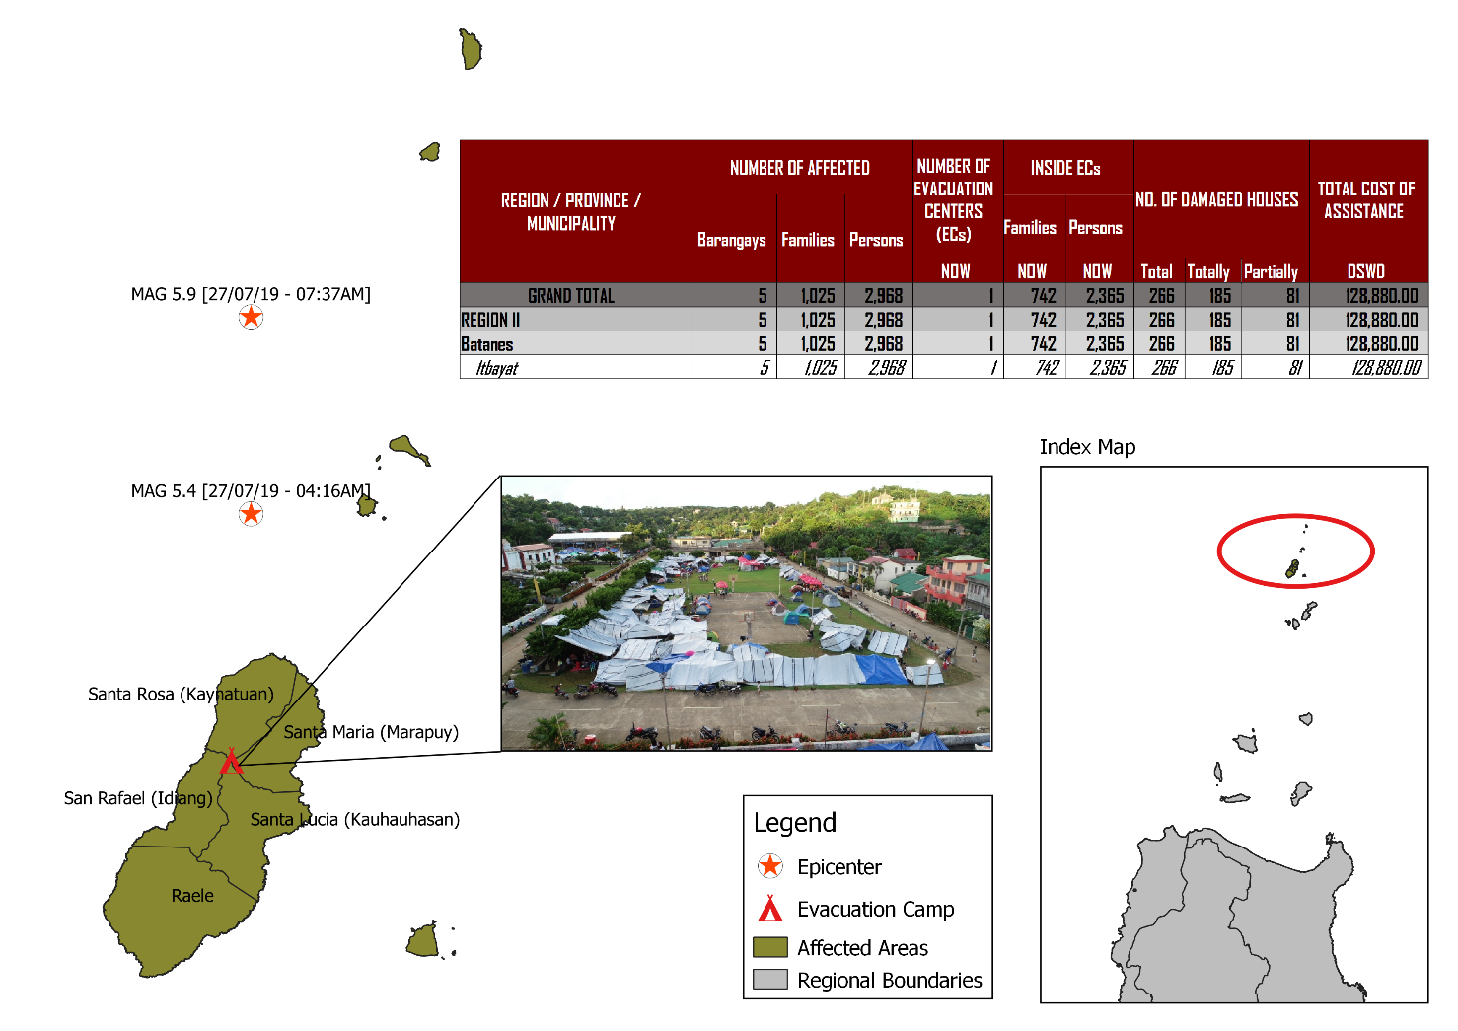
DSWD DISASTER RESPONSE INFORMATION

Source: DRMB-DROMIC GIS Specialists

Status of Prepositioned Resources: Stockpile and Standby Funds
The DSWD Central Office (CO), Field Offices (FOs), and National Resource Operations Center (NROC) have stockpiles and standby funds amounting to ₱1,972,905,977.22 with breakdown as follows (see Table 1):

- Standby Funds
A total of ₱1,181,581,331.18 standby funds in the CO and FOs. Of the said amount, ₱1,146,974,543.16 is the available Quick Response Fund (QRF) in the CO.

- Stockpiles
A total of 358,136 Family Food Packs (FFPs) amounting to ₱134,470,535.44 and available Food and Non-food Items (FNIs) amounting to ₱656,854,110.60.
FIELD OFFICE | STANDBY FUNDS | STOCKPILES |  |  |  |  | Total STANDBY FUNDS & STOCKPILE
 |  | Family Food Packs |  | Other Food Items | Non Food Items | SUB-TOTAL (Food and NFIs)
 |  | Quantity | Total Cost | Total Cost | Total Cost
TOTAL | 1,181,581,331.18 | 358,136 | 134,470,535.44 | 161,926,836.96 | 494,927,273.64 | 656,854,110.60 | 1,972,905,977.22
Central Office* | 1,146,974,543.16 | - | - | - | - | - | 1,146,974,543.16
NRLMB - NROC | - | 103,200 | 38,920,848.00 | 82,564,936.86 | 330,634,906.88 | 413,199,843.74 | 452,120,691.74
NRLMB - VDRC | - | 11,700 | 4,212,000.00 | 1,203,200.00 | 5,224,562.31 | 6,427,762.31 | 10,639,762.31
I | 2,379,275.00 | 14,393 | 5,181,480.00 | 1,094,185.92 | 33,381,090.79 | 34,475,276.71 | 42,036,031.71
II** | 930,801.96 | 28,562 | 10,282,282.00 | 526,640.00 | 349,602.75 | 876,242.75 | 12,089,326.71
III | 2,404,557.00 | 26,192 | 10,257,281.28 | 899,919.70 | 241,406.00 | 1,141,325.70 | 13,803,163.98
CALABARZON | 1,960,100.00 | 4,697 | 1,689,515.26 | 3,898,207.60 | 3,288,354.81 | 7,186,562.41 | 10,836,177.67
MIMAROPA | 1,938,971.58 | 24,756 | 10,348,008.00 | 2,243,173.55 | 859,605.00 | 3,102,778.55 | 15,389,758.13
V | 3,000,000.00 | 18,521 | 7,223,190.00 | 10,485,948.72 | 40,704,948.22 | 51,190,896.94 | 61,414,086.94
VI | 1,150,000.00 | 15,694 | 5,855,520.00 | 8,682,157.17 | 3,713,837.50 | 12,395,994.67 | 19,401,514.67
VII | 3,000,000.00 | 17,145 | 6,172,200.00 | 18,519,644.43 | 17,559,057.08 | 36,078,701.51 | 45,250,901.51
VIII | 1,401,960.00 | 21,968 | 7,939,674.56 | 1,304,119.84 | 896,387.00 | 2,200,506.84 | 11,542,141.40
IX | 843,321.35 | 10,119 | 3,642,840.00 | 813,730.00 | 3,793,242.35 | 4,606,972.35 | 9,093,133.70
X | 3,000,000.00 | 1,512 | 544,320.00 | 6,593,047.20 | 30,362,019.90 | 36,955,067.10 | 40,499,387.10
XI | 3,028,750.00 | 25,381 | 9,185,285.40 | 11,053,700.00 | 10,921,627.34 | 21,975,327.34 | 34,189,362.74
XII | 584,701.68 | 4,724 | 1,894,324.00 | 3,484,211.10 | 2,348,437.26 | 5,832,648.36 | 8,311,674.04
CARAGA | 3,000,000.00 | 10,014 | 3,821,443.00 | 946,748.00 | 4,806,699.85 | 5,753,447.85 | 12,574,890.85
NCR | 3,292,543.50 | 3,665 | 1,341,789.14 | 1,998,746.57 | 928,770.00 | 2,927,516.57 | 7,561,849.21
CAR | 2,691,805.95 | 15,893 | 5,958,534.80 | 5,614,520.30 | 4,912,718.60 | 10,527,238.90 | 19,177,579.65
*Quick Response Fund (QRF) as of 27 July 2019
**Status of Standby Funds and Stockpile of FO II as of 30 July 2019

Situational Reports

DSWD-DRMB
DATE | SITUATIONS / ACTIONS UNDERTAKEN
02 August 2019 | - The Disaster Response Management Bureau (DRMB) downgraded from BLUE alert level status to WHITE but will continuously coordinate with DSWD-FO II for significant disaster response updates.
01 August 2019 | - All QRT members and emergency equipment are on standby and ready for deployment.  - The four (4) staff from DSWD-DRMB have arrived in Basco, Batanes to relieve the first team deployed last 27 July 2019 until 01 August 2019 and augment on CCCM, IDP Protection, and FNIs activities.  - The 400 sleeping kits and 65 family tents in Clark Airport that were delivered to Basco, Batanes on 30 July 2019 are already loaded to the Faluwa boat. Cause of delay of transport to Itbayat, Batanes is due to bad weather.  - DSWD-DRMB Team is in close coordination with the Procurement Service relative to the emergency procurement of the Satellite Phones Load.

DSWD-NRLMB
DATE | SITUATIONS / ACTIONS UNDERTAKEN
02 August 2019 | - Six (6) trucks from NROC carrying: 3,600 vacuumed pack rice, 60,000 pcs. coffee, 1,500 mosquito nets and 50 rolls of laminated sacks were delivered to Tuguegarao City.  - The BFAR vessels MCS 3010 departed Sangley Point Cavite at 10AM, 01 August 2019 are temporary sheltered at Subic bay due to bad weather also with the two (2) Coast Guard vessels, carrying the following DSWD NRLMS dispatched items: 100 tents, 400 sleeping kits and 10 laminated sacks. Awaiting for the estimated time of arrival both at Port Irene, Sta. Ana and Basco, Batanes
31 July 2019 | - The 6,400 3kg-vacuum packed rice and 50 folding beds that has been delivered to DSWD-FO II on 29 July 2019 are stored in their warehouse for standby delivery to Itbayat, Batanes.
30 July 2019 | - The 100 family tents and 60 folding beds from NROC have been delivered to DSWD-FO II in Tuguegarao City.  - The requested 25 family tents and 400 sleeping kits from DSWD-FO I were delivered to Tuguegarao City.

DSWD-FO II
DATE | ACTION(S) TAKEN
02 August 2019 | - DSWD-FO II remains on RED alert level status.  - A total of ₱152,000.00 worth of financial assistance was provided to the affected families; of which, seven (7) families were provided with ₱10,000.00 burial assistance per family, ten (10) affected individuals received food assistance at ₱5,000.00 each, one (1) affected individual was provided with ₱3,000.00 worth of food assistance, eight (8) affected individuals received medical assistance at ₱3,000.00 each and one (1) affected individual was provided with ₱5,000.00 worth of medical assistance.  - A total of ₱726,000.00 worth of social pension assistance was provided to the 242 affected senior citizens who received ₱3,000.00 each for the 1st and 2nd quarters. Ongoing distribution of financial assistance is being conducted for the remaining 68 senior citizens.  - The DSWD staff, Ms. Amparo Tobias and Ms. Mia Edsel Carbonell, DRMD PDO II attended the General Assembly convened by Gov. Marilou Cayco to discuss the early recovery on possible assistance to be extended to those affected families especially those with damaged houses. As part of the agreement, the DSWD will provide Emergency Shelter Assistance (ESA) to those families whose houses was totally/ partially damaged while the National Housing Authority (NHA) and the Provincial Government of Batanes will provide Temporary Shelter Assistance.  - The Regional Director Fernando R. De Villa Jr. and OIC-Chief DRMD, Mr. Franco Lopez attended emergency meeting with OCD Regional Director and NHA Director regarding the possible release of financial assistance to families with totally damaged houses on 03 August 2019, Saturday. NHA pledged to extend an amount of Php30,000.00 each for the 185 reported families with totally damaged houses. OCD will also extend Php20,000.00 each for burial assistance to nine (9) casualties and Php10,000.00 each for injured victims. For DSWD, coordination was already made with DSWD Central Office Finance.
01 August 2019 | - The 312 FFPs from Tuguegarao Airport including the requested 25 family tents and 400 sleeping kits from DSWD-FO I, and 60 folding beds and 100 family tents from NRLMB were delivered from Tuguegarao City to Port Irene in Sta. Ana, Cagayan.  - DSWD-FO II staff, Ms. Mia Carbonel, PDO of DRMD takes charge in the assessment of damaged houses while Ms. Marlene Tuazon is in-charge of the Social Pension payout to the senior citizen beneficiaries. Ms. Amparo Tobias, SWAD Batanes Team Lead on the other hand is currently in-charge of the provision of AICS to Ivatans.
31 July 2019 | - The 158 FFPs worth ₱56,880.00 delivered to Itbayat, Batanes were already distributed to the 158 affected families inside EC.  - There were three (3) staff from DRMD of FO II who arrived in Itbayat, Batanes; two (2) Social Workers, Ms. Mary Jane Paliuanan and Ms. Alma Caranguian to assist in psychosocial intervention and augment in the assessment of damaged houses for Emergency Shelter Assistance (ESA) and one (1) PDO II, Mr. Rafael De Leon to assist in warehouse/ response management and validation of damaged houses.

***
The Disaster Response Operations Monitoring and Information Center (DROMIC) of the DSWD-DRMB is closely coordinating with DSWD-FO II for any significant disaster response updates.

Prepared by:

MARIJOY V. SAN BUENAVENTURA

JAN ERWIN ANDREW I. ONTANILLAS
Releasing Officer
Photo Documentations
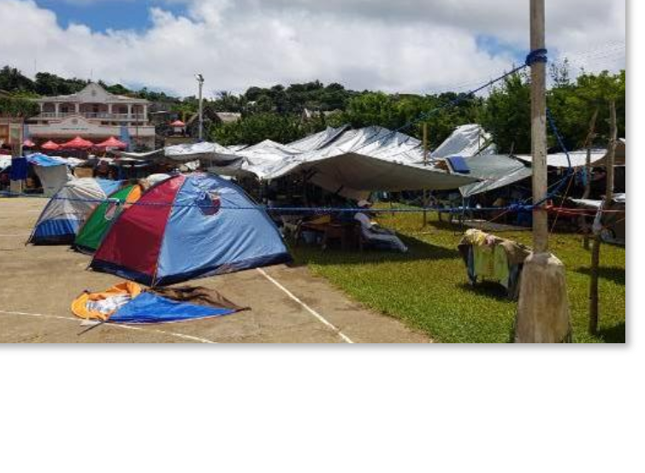
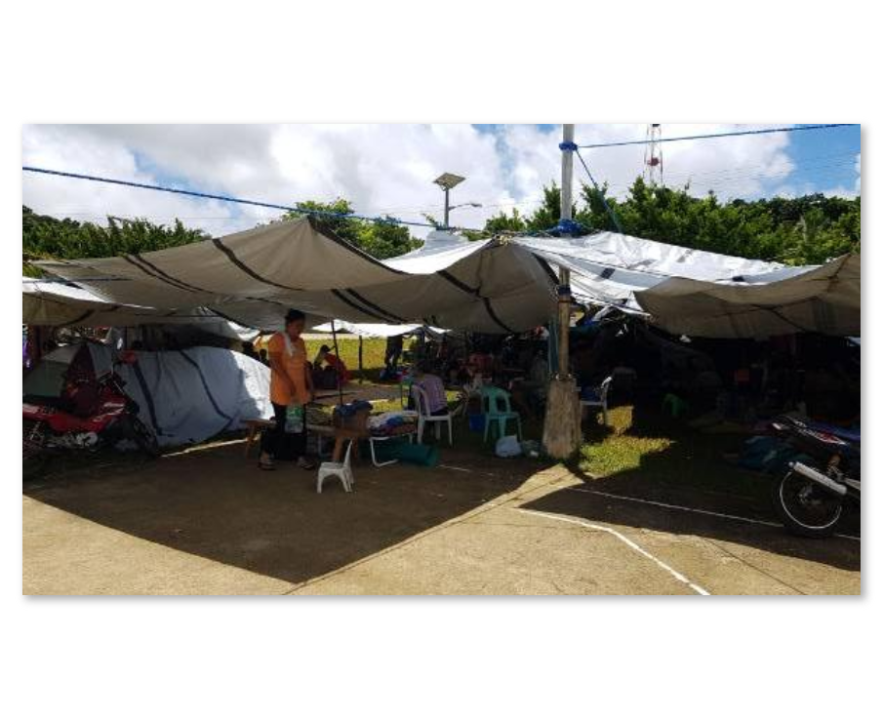
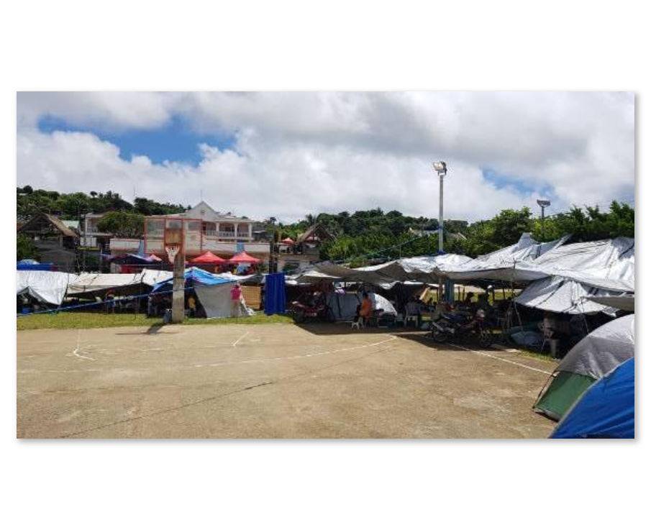
Covered Court/Municipal Plaza Open Ground Evacuation Center
Photos taken on 29 July 2019
Families are staying under makeshift tents.
As per coordination with Incident Commander (IC) Ms. Sharmaine Gato, validation of DPWH and Barangay Officials regarding damaged houses and public facilities is on 1/3 completion for assessment of damaged houses as of yesterday.
Classes will only resume until safety of buildings is ensured.

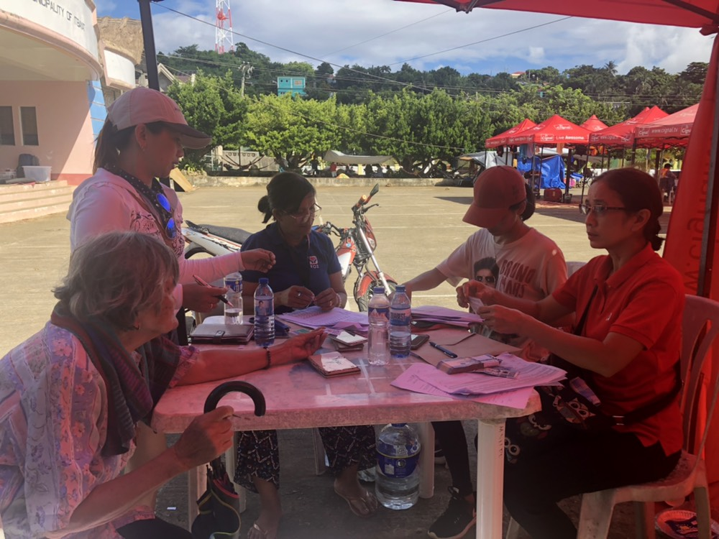

DSWD-FO II providing Social Pension to the senior citizens affected by the earthquake incident.

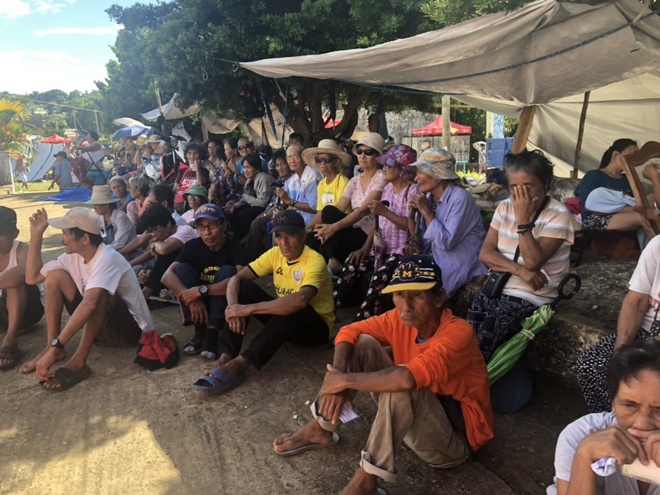

Photos taken on 29 July 2019
The senior citizens affected by the earthquake incident patiently waiting for their turn to receive financial assistance thru Social Pension.
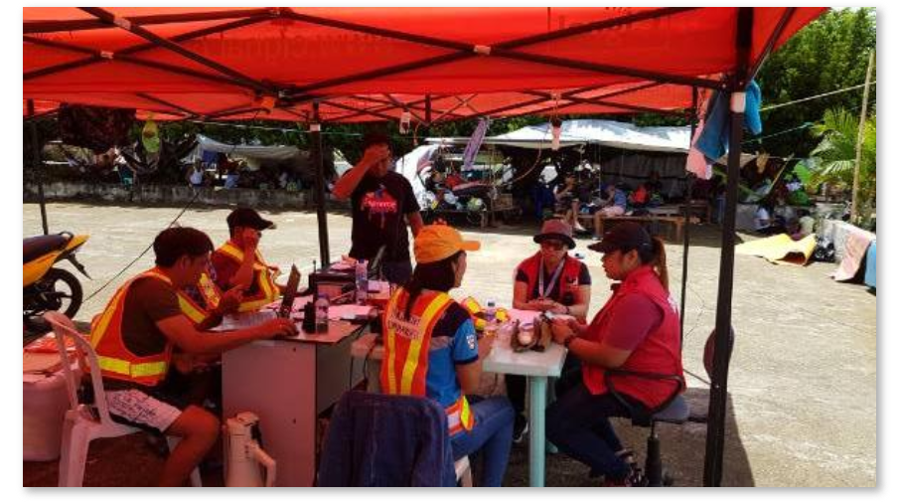
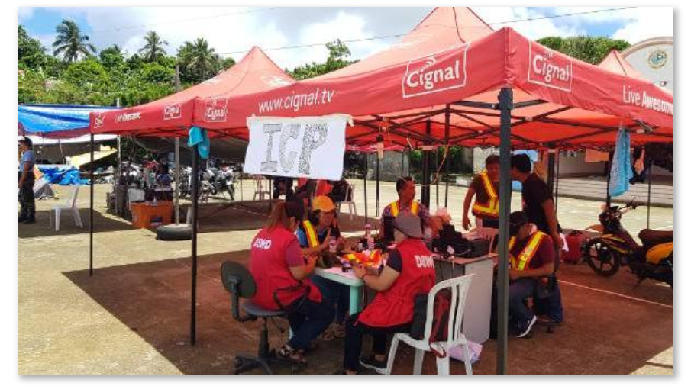
Photos taken on 29 July 2019
Incident Command Post

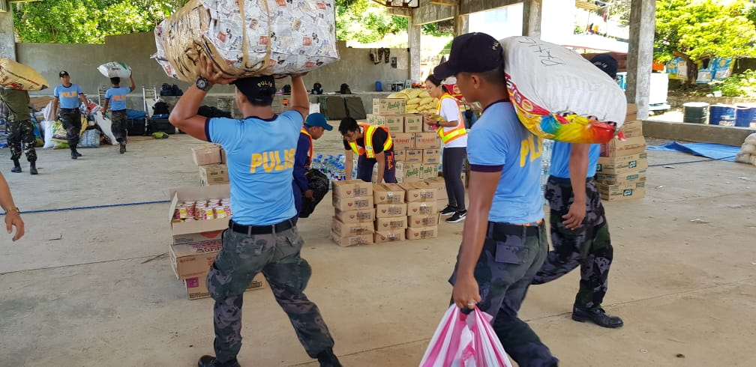
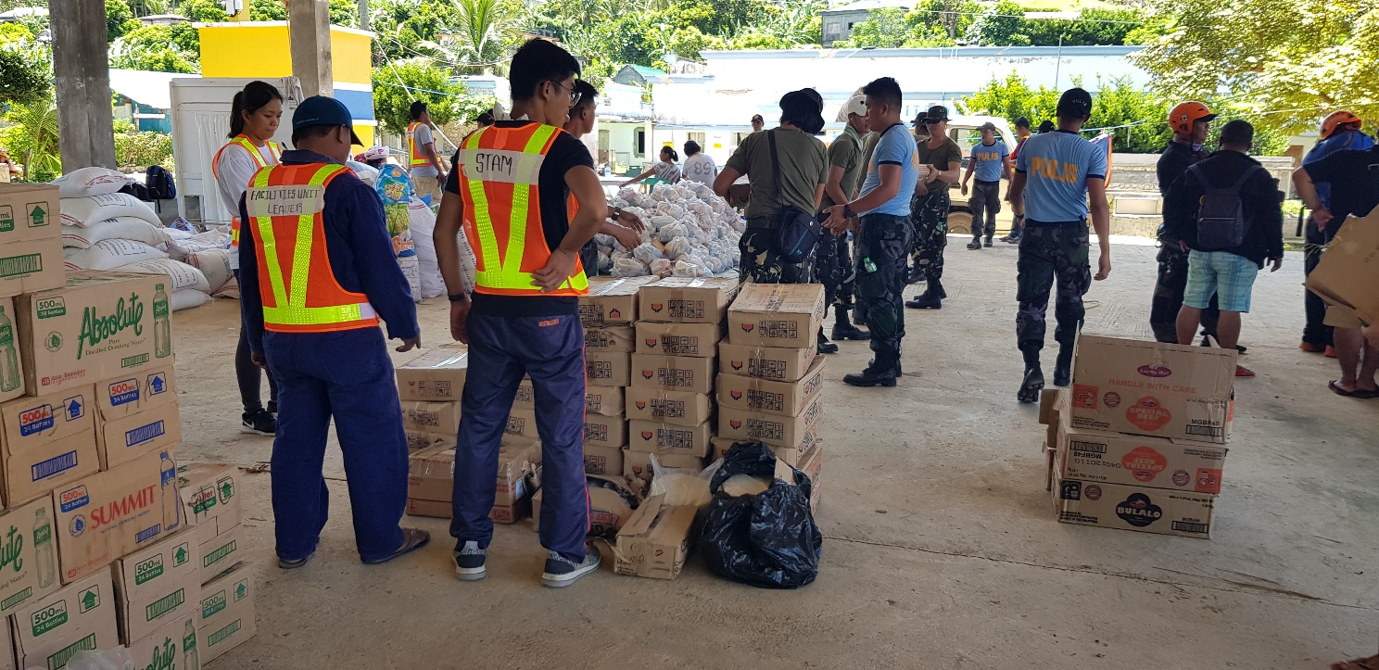
Photos taken on 29 July 2019
FNIs delivered in Itbayat, Batanes

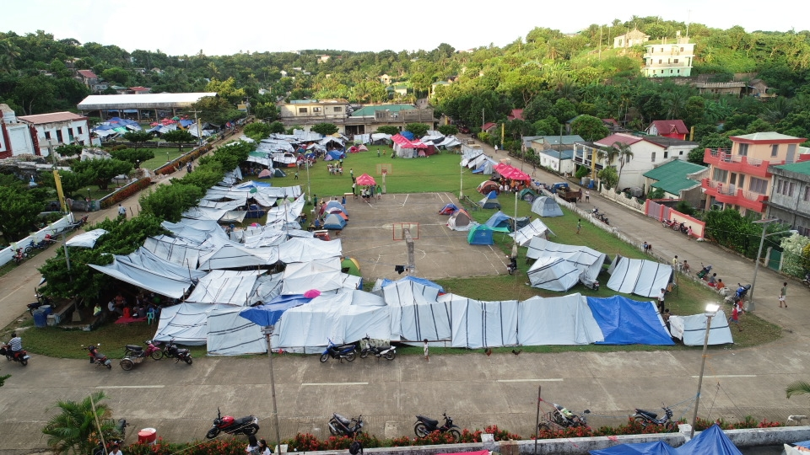
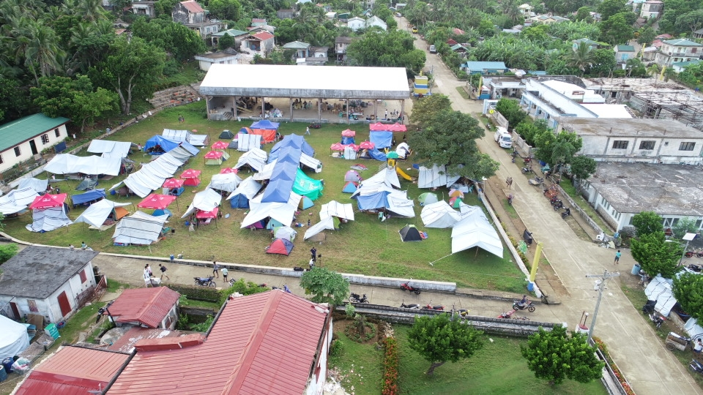
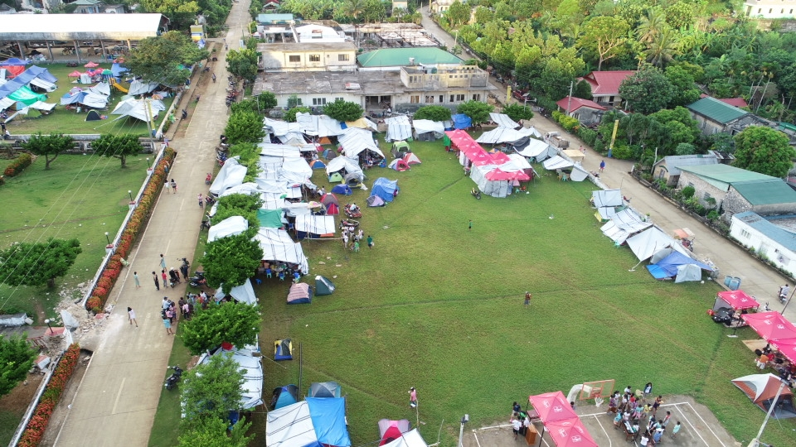
Aerial View of the Municipal Plaza as Evacuation Center

Photos taken on 30 July 2019

Photos taken on 31 July 2019
Psychosocial debriefing to children by PHIVOLCS Staff
PHIVOLCS staff explaining what happens during an earthquake

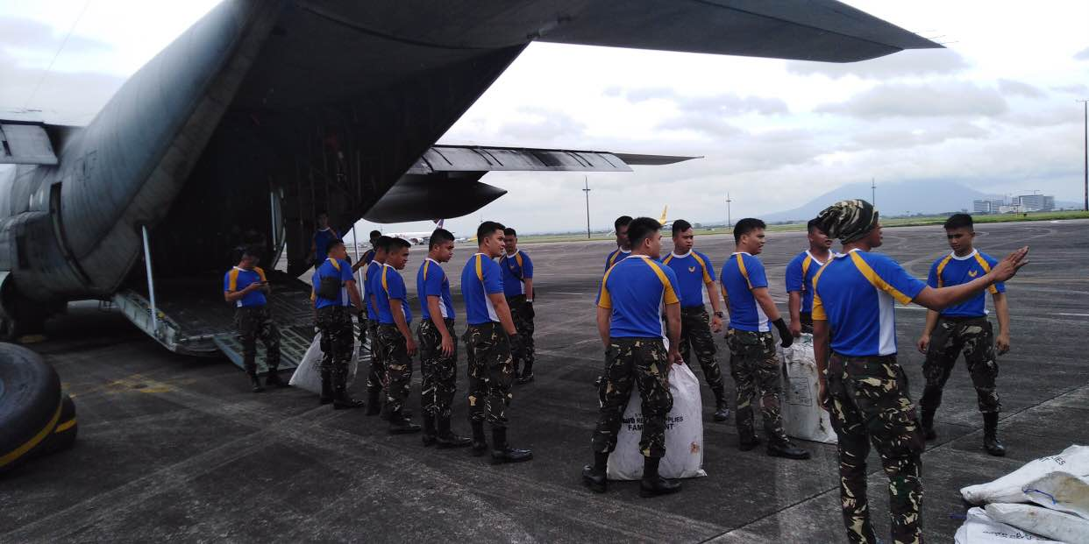
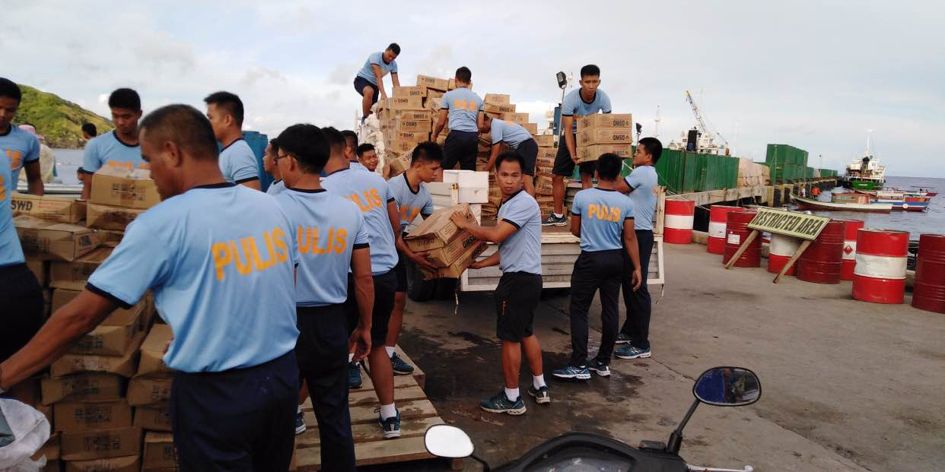
Loading of the sleeping kits and family tents at the Basco Port
Photos taken on 01 August 2019

