DSWD DROMIC Terminal Report on
the Effects of Southwest Monsoon Enhanced by TS Hanna
12 September 2019, 6PM

This is the final report on the Effects of Southwest Monsoon which started on 03 August 2019 as the Low Pressure Area east of Virac, Catanduanes has developed into a Tropical Depression and was named “Hanna” (LEKIMA). It brought moderate to heavy monsoon rains over Metro Manila, Pangasinan, Zambales, Bataan, Pampanga, Bulacan, Rizal, Cavite, Batangas, Laguna, Mindoro provinces, northern portions of Palawan (including Calamian and Cuyo islands), Romblon, Aklan, and Antique on 04 August 2019. On the same day, it has intensified and become Tropical Storm. TS “Hanna” exited the PAR on 09 August 2019. However, affected regions are expected to continuously experience cloudy skies with light to moderate rains caused by Southwest Monsoon.
Source: DOST-PAGASA

SUMMARY

- Status of Affected Families / Persons
45,676 families or 186,026 persons were affected by the Southwest Monsoon in 231 barangays in Regions I, III, MIMAROPA, VI, and CAR (see Table 1).

Table 1. Number of Affected Families / Persons
REGION / PROVINCE / MUNICIPALITY |  | NUMBER OF AFFECTED
 |  | Barangays | Families | Persons
GRAND TOTAL |  | 231 | 45,676 | 186,026
REGION I |  | 1 | 1 | 4
Ilocos Sur |  | 1 | 1 | 4
 | Cervantes | 1 | 1 | 4
REGION III |  | 57 | 18,124 | 73,926
Bataan |  | 29 | 9,717 | 40,785
 | Bagac | 1 | 10 | 36
 | City of Balanga (capital) | 2 | 242 | 841
 | Hermosa | 13 | 8,370 | 34,448
 | Morong | 7 | 1,048 | 5,272
 | Orion | 3 | 17 | 68
 | Pilar | 3 | 30 | 120
Bulacan |  | 7 | 6,412 | 25,625
 | Calumpit | 7 | 6,412 | 25,625
Pampanga |  | 4 | 398 | 1,614
 | Apalit | 2 | 390 | 1,567
 | Bacolor | 1 | 7 | 40
 | Lubao | 1 | 1 | 7
Zambales |  | 17 | 1,597 | 5,902
 | Botolan | 3 | 574 | 1,015
 | Cabangan | 1 | 52 | 187
 | Castillejos | 2 | 31 | 100
 | Masinloc | 3 | 8 | 41
 | Olongapo City | 1 | 4 | 15
 | San Antonio | 3 | 172 | 768
 | San Felipe | 1 | 3 | 9
 | San Marcelino | 1 | 750 | 3,750
 | Santa Cruz | 1 | 2 | 11
 | Subic | 1 | 1 | 6
REGION MIMAROPA |  | 57 | 8,418 | 30,004
Occidental Mindoro |  | 46 | 4,119 | 20,589
 | Abra de Ilog | 2 | 27 | 98
 | Lubang | 2 | 23 | 78
 | Magsaysay | 4 | 103 | 387
 | Mamburao (capital) | 3 | 154 | 628
 | Paluan | 3 | 58 | 247
 | Rizal | 10 | 34 | 1,901
 | Sablayan | 4 | 142 | 512
 | San Jose | 18 | 3,578 | 16,738
Palawan |  | 11 | 4,299 | 9,415
 | Busuanga | 2 | 9 | 29
 | Coron | 1 | 752 | 3,760
 | Culion | 5 | 3,446 | 5,040
 | El Nido (Bacuit) | 1 | 91 | 456
 | Magsaysay | 1 | - | 125
 | Taytay | 1 | 1 | 5
REGION VI |  | 57 | 15,337 | 66,075
Iloilo |  | 32 | 15,210 | 65,531
 | Carles | 18 | 8,955 | 40,394
 | Concepcion | 11 | 5,184 | 20,577
 | Estancia | 3 | 1,071 | 4,560
Negros Occidental |  | 25 | 127 | 544
 | Binalbagan | 1 | 1 | 6
 | Cauayan | 6 | 8 | 43
 | La Carlota City | 1 | 17 | 69
 | Pontevedra | 8 | 79 | 345
 | City of Sipalay | 9 | 22 | 81
CAR |  | 59 | 3,796 | 16,017
Abra |  | 23 | 3,377 | 14,312
 | Bangued (capital) | 1 | 4 | 15
 | Daguioman | 4 | 456 | 2,102
 | Dolores | 1 | 170 | 727
 | Lagangilang | 2 | 88 | 220
 | Lagayan | 5 | 1,301 | 5,370
 | Tubo | 10 | 1,358 | 5,878
Benguet |  | 31 | 412 | 1,667
 | Baguio City | 10 | 26 | 89
 | Bokod | 2 | 2 | 5
 | Buguias | 1 | 1 | 5
 | Itogon | 9 | 348 | 1,428
 | Kibungan | 3 | 5 | 21
 | La Trinidad (capital) | 2 | 9 | 49
 | Mankayan | 1 | 1 | 1
 | Tuba | 3 | 20 | 69
Mountain Province |  | 5 | 7 | 38
 | Bauko | 4 | 6 | 31
 | Sagada | 1 | 1 | 7
Note: The decrease in the number of affected families or persons in Region VI is based on the validated report submitted by LGU to DSWD-FO VI.
Source: DSWD-FOs I, III, MIMAROPA, VI, and CAR

- Status of Displaced Families / Persons

- Inside Evacuation Centers
A total of 19 families or 56 persons are temporarily staying in 1 evacuation center in Region III (see Table 2).

Table 2. Status of Displaced Families/ Persons Inside Evacuation Center
REGION / PROVINCE / MUNICIPALITY |  | NUMBER OF EVACUATION CENTERS (ECs) |  | INSIDE ECs
 |  |  |  | Families |  | Persons
 |  | CUM | NOW | CUM | NOW | CUM | NOW
GRAND TOTAL |  | 68 | 1 | 918 | 19 | 3,522 | 56
REGION III |  | 26 | 1 | 232 | 19 | 847 | 56
Bataan |  | 13 | - | 128 | - | 448 | -
 | Bagac | 1 | - | 10 | - | 36 | -
 | City of Balanga (capital) | 2 | - | 42 | - | 121 | -
 | Hermosa | 2 | - | 21 | - | 73 | -
 | Morong | 2 | - | 8 | - | 30 | -
 | Orion | 3 | - | 17 | - | 68 | -
 | Pilar | 3 | - | 30 | - | 120 | -
Pampanga |  | 2 | - | 8 | - | 47 | -
 | Bacolor | 1 | - | 7 | - | 40 | -
 | Lubao | 1 | - | 1 | - | 7 | -
Zambales |  | 11 | 1 | 96 | 19 | 352 | 56
 | Botolan | 1 | - | 7 | - | 28 | -
 | Cabangan | 1 | - | 52 | - | 187 | -
 | Castillejos | 1 | 1 | 19 | 19 | 56 | 56
 | Masinloc | 3 | - | 8 | - | 41 | -
 | Olongapo City | 1 | - | 4 | - | 15 | -
 | San Antonio | 2 | - | 2 | - | 10 | -
 | San Felipe | 1 | - | 3 | - | 9 | -
 | Subic | 1 | - | 1 | - | 6 | -
REGION MIMAROPA |  | 35 | - | 608 | - | 2,411 | -
Occidental Mindoro |  | 29 | - | 575 | - | 2,262 | -
 | Abra de Ilog | 2 | - | 27 | - | 98 | -
 | Lubang | 2 | - | 23 | - | 78 | -
 | Magsaysay | 5 | - | 103 | - | 387 | -
 | Mamburao (capital) | 3 | - | 154 | - | 628 | -
 | Paluan | 3 | - | 58 | - | 247 | -
 | Rizal | 2 | - | 13 | - | 69 | -
 | Sablayan | 7 | - | 142 | - | 512 | -
 | San Jose | 5 | - | 55 | - | 243 | -
Palawan |  | 6 | - | 33 | - | 149 | -
 | Busuanga | 2 | - | 9 | - | 29 | -
 | Culion | 4 | - | 24 | - | 120 | -
CAR |  | 7 | - | 78 | - | 264 | -
Benguet |  | 7 | - | 78 | - | 264 | -
 | Baguio City | 1 | - | 6 | - | 21 | -
 | Itogon | 5 | - | 62 | - | 205 | -
 | Tuba | 1 | - | 10 | - | 38 | -
Note: The LGU shall continuously monitor and provide the needs of the 19 affected families in the remaining 1 EC in Region III as per agreement with DSWD-FO III and LGU.
Source: DSWD-FOs III, MIMAROPA, and CAR

- Outside Evacuation Centers

A total of 1 family or 1 person is currently taking temporary shelter with his/her relatives and/or friends in CAR (see Table 3).

Table 3. Status of Displaced Families/ Persons Outside Evacuation Centers
REGION / PROVINCE / MUNICIPALITY |  | OUTSIDE ECs
 |  | Families |  | Persons
 |  | CUM | NOW | CUM | NOW
GRAND TOTAL |  | 9,267 | 1 | 34,309 | 1
REGION III |  | 1,289 | - | 6,154 | -
Bataan |  | 1,257 | - | 6,039 | -
 | City of Balanga (capital) | 200 | - | 720 | -
 | Hermosa | 17 | - | 77 | -
 | Morong | 1,040 | - | 5,242 | -
Zambales |  | 32 | - | 115 | -
 | Botolan | 4 | - | 20 | -
 | Castillejos | 12 | - | 44 | -
 | San Antonio | 14 | - | 40 | -
 | Santa Cruz | 2 | - | 11 | -
REGION MIMAROPA |  | 7,810 | - | 27,593 | -
Occidental Mindoro |  | 3,544 | - | 18,327 | -
 | Rizal | 21 | - | 1,832 | -
 | San Jose | 3,523 | - | 16,495 | -
Palawan |  | 4,266 | - | 9,266 | -
 | Coron | 752 | - | 3,760 | -
 | Culion | 3,422 | - | 4,920 | -
 | El Nido (Bacuit) | 91 | - | 456 | -
 | Magsaysay | - | - | 125 | -
 | Taytay | 1 | - | 5 | -
CAR |  | 168 | 1 | 562 | 1
Abra |  | 88 | - | 220 | -
 | Lagangilang | 88 | - | 220 | -
Benguet |  | 80 | 1 | 342 | 1
 | Baguio City | 20 | 1 | 68 | 1
 | Buguias | 1 | - | 5 | -
 | Itogon | 50 | - | 243 | -
 | Kibungan | 1 | - | 2 | -
 | Tuba | 8 | - | 24 | -
Note: The 1 affected family or 1 person in CAR is considered living alone based on the validated report submitted by LGU to DSWD-FO CAR.
Source: DSWD-FOs III, MIMAROPA, and CAR

- Damaged Houses
There were 216 damaged houses; of which, 74 were totally damaged and 142 were partially damaged see Table (see Table 4).

Table 4. Number of Damaged Houses
REGION / PROVINCE / MUNICIPALITY |  | NO. OF DAMAGED HOUSES
 |  | Total | Totally | Partially
GRAND TOTAL |  | 216 | 74 | 142
REGION I |  | 1 | - | 1
Ilocos Sur |  | 1 | - | 1
 | Cervantes | 1 | - | 1
REGION III |  | 49 | 46 | 3
Bataan |  | 45 | 42 | 3
 | Morong | 45 | 42 | 3
Zambales |  | 4 | 4 | -
 | Botolan | 1 | 1 | -
 | Santa Cruz | 3 | 3 | -
REGION MIMAROPA |  | 37 | 12 | 25
Occidental Mindoro |  | 23 | 3 | 20
 | Mamburao (capital) | 11 | - | 11
 | Paluan | 3 | 1 | 2
 | San Jose | 9 | 2 | 7
Palawan |  | 14 | 9 | 5
 | Culion | 10 | 5 | 5
 | Magsaysay | 1 | 1 | -
 | Taytay | 3 | 3 | -
REGION VI |  | 96 | 14 | 82
Negros Occidental |  | 96 | 14 | 82
 | Cauayan | 8 | 2 | 6
 | La Carlota City | 17 | - | 17
 | Pontevedra | 49 | 7 | 42
 | City of Sipalay | 22 | 5 | 17
CAR |  | 33 | 2 | 31
Abra |  | 1 | - | 1
 | Tubo | 1 | - | 1
Benguet |  | 26 | 2 | 24
 | Baguio City | 8 | 1 | 7
 | Bokod | 2 | - | 2
 | Buguias | 1 | - | 1
 | Itogon | 12 | - | 12
 | Kibungan | 2 | - | 2
 | Mankayan | 1 | 1 | -
Mountain Province |  | 6 | - | 6
 | Bauko | 6 | - | 6
Source: DSWD-FOs I, III, MIMAROPA, VI and CAR

- Cost of Assistance
A total of ₱9,891,810.29 worth of assistance was provided to the affected families; of which, ₱5,907,938.30 was provided by DSWD; ₱3,351,718.35 from LGUs; ₱618,253.64 from NGOs, and ₱13,900.00 from other organizations (see Table 5).

Table 5. Cost of Assistance Provided to Affected Families / Persons
REGION / PROVINCE / MUNICIPALITY |  | TOTAL COST OF ASSISTANCE
 |  | DSWD | LGUs | NGOs | OTHERS | GRAND TOTAL
GRAND TOTAL |  | 5,907,938.30 | 3,351,718.35 | 618,253.64 | 13,900.00 | 9,891,810.29
REGION I |  | - | 7,000.00 | - | - | 7,000.00
Ilocos Sur |  | - | 7,000.00 | - | - | 7,000.00
 | Cervantes | - | 7,000.00 | - | - | 7,000.00
REGION III |  | 1,047,622.00 | 1,515,509.00 | - | - | 2,563,131.00
Bataan |  | 1,047,622.00 | 1,266,400.00 | - | - | 2,314,022.00
 | City of Balanga (capital) | - | 175,000.00 | - | - | 175,000.00
 | Hermosa | 1,047,622.00 | 980,000.00 | - | - | 2,027,622.00
 | Morong | - | 100,000.00 | - | - | 100,000.00
 | Orion | - | 5,850.00 | - | - | 5,850.00
 | Pilar | - | 5,550.00 | - | - | 5,550.00
Zambales |  | - | 249,109.00 | - | - | 249,109.00
 | Botolan | - | 243,600.00 | - | - | 243,600.00
 | Castillejos | - | 5,509.00 | - | - | 5,509.00
REGION MIMAROPA |  | 344,730.00 | 1,021,809.15 | 300,960.00 | - | 1,667,499.15
Occidental Mindoro |  | 344,730.00 | 485,875.15 | 300,960.00 | - | 1,131,565.15
 | Abra de Ilog | - | 8,790.00 | - | - | 8,790.00
 | Lubang | - | 15,980.00 | - | - | 15,980.00
 | Magsaysay | 14,380.00 | 2,870.00 | 300,960.00 | - | 318,210.00
 | Mamburao (capital) | 35,440.00 | 9,480.00 | - | - | 44,920.00
 | Paluan | 32,830.00 | 15,000.00 | - | - | 47,830.00
 | Rizal | 16,510.00 | 368.00 | - | - | 16,878.00
 | Sablayan | 24,210.00 | 38,980.00 | - | - | 63,190.00
 | San Jose | 221,360.00 | 394,407.15 | - | - | 615,767.15
Palawan |  | - | 535,934.00 | - | - | 535,934.00
 | Culion | - | 469,049.00 | - | - | 469,049.00
 | El Nido (Bacuit) | - | 66,885.00 | - | - | 66,885.00
REGION VI |  | 4,191,480.00 | 679,102.20 | 317,293.64 | - | 5,187,875.84
Iloilo |  | 4,191,480.00 | 595,252.20 | 283,171.20 | - | 5,069,903.40
 | Carles | 3,186,720.00 | 317,752.20 | - | - | 3,504,472.20
 | Concepcion | 620,640.00 | 277,500.00 | 283,171.20 | - | 1,181,311.20
 | Estancia | 384,120.00 | - | - | - | 384,120.00
Negros Occidental |  | - | 83,850.00 | 34,122.44 | - | 117,972.44
 | Binalbagan | - | - | 6,365.00 | - | 6,365.00
 | Cauayan | - | 12,000.00 | - | - | 12,000.00
 | La Carlota City | - | 9,350.00 | 7,735.68 | - | 17,085.68
 | Pontevedra | - | 13,000.00 | 20,021.76 | - | 33,021.76
 | City of Sipalay | - | 49,500.00 | - | - | 49,500.00
CAR |  | 324,106.30 | 128,298.00 | - | 13,900.00 | 466,304.30
Abra |  | 194,414.00 | 85,000.00 | - | - | 279,414.00
 | Dolores | 71,978.00 | 85,000.00 | - | - | 156,978.00
 | Lagangilang | 37,259.20 | - | - | - | 37,259.20
 | Lagayan | 85,176.80 | - | - | - | 85,176.80
Benguet |  | 129,692.30 | 43,298.00 | - | 13,900.00 | 186,890.30
 | Baguio City | 33,989.50 | 9,960.00 | - | - | 43,949.50
 | Bokod | 4,845.50 | - | - | - | 4,845.50
 | Itogon | 85,741.80 | 24,838.00 | - | 11,400.00 | 121,979.80
 | Mankayan | 5,115.50 | - | - | - | 5,115.50
 | Tuba | - | 8,500.00 | - | 2,500.00 | 11,000.00
Source: DSWD-FOs I, III, MIMAROPA, VI, and CAR

Situational Reports

DSWD-FO NCR
DATE | SITUATION / PREPAREDNESS ACTIONS
12 September 2019 | - DSWD FO-NCR submitted their terminal report.
10 August 2019 | - All pre-emptive evacuation centers (ECs) which catered 143 families or 556 individuals affected by flooding brought by Habagat from 03 August 2019 were closed as of 10 August 2019.  REGION / PROVINCE / MUNICIPALITY NUMBER OF AFFECTED NUMBER OF EVACUATION CENTERS (ECs)  Barangays Families Persons  GRAND TOTAL 9 143 556 10  NCR 9 143 556 10  Las Pinas 2 31 124 2  Manila City 1 23 75 1  Paranaque City 1 15 61 1  Taguig City 4 46 184 4  Quezon City 1 28 112 2  - DSWD-FO NCR provided 40 family food packs amounting to ₱14,834.40, through the request of Manila City Social Welfare and Development for the families at Delpan Evacuation Center who were affected by the flooding.
DSWD-FO I
DATE | SITUATION / PREPAREDNESS ACTIONS
05 September 2019 | - DSWD-FO I submitted their terminal report.

DSWD-FO III
DATE | SITUATION / PREPAREDNESS ACTIONS
- August 2019 | - DSWD-FO III submitted their terminal report.

DSWD-FO MIMAROPA
DATE | SITUATION / PREPAREDNESS ACTIONS
05 September 2019 | - DSWD-FO I submitted their terminal report.
07 August 2019 | - There were 23 families or 78 individuals who were pre-emptively evacuated in 2 evacuation centers in Lubang, Occidental Mindoro.  REGION / PROVINCE / MUNICIPALITY NUMBER OF AFFECTED NUMBER OF EVACUATION CENTERS (ECs)  Barangays Families Persons  GRAND TOTAL 2 23 78 2  REGION MIMAROPA 2 23 78 2  Occidental Mindoro 2 23 78 2  Lubang 2 23 78 2

DSWD-FO VI
DATE | SITUATION / PREPAREDNESS ACTIONS
12 September 2019 | - DSWD FO-VI submitted their terminal report.

DSWD-FO CAR
DATE | SITUATION / PREPAREDNESS ACTIONS
10 September 2019 | - DSWD FO-CAR submitted their terminal report.
***
The Disaster Response Operations Monitoring and Information Center (DROMIC) of the DSWD-DRMB continues to closely coordinate with DSWD Field Offices for any request of Technical Assistance and Resource Augmentation (TARA).

Prepared by:

MARIE JOYCE G. RAFANAN

JAN ERWIN ANDREW I. ONTANILLAS
Releasing Officer

PHOTO DOCUMENTATION

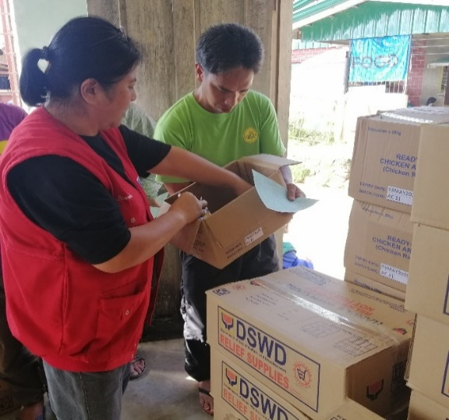
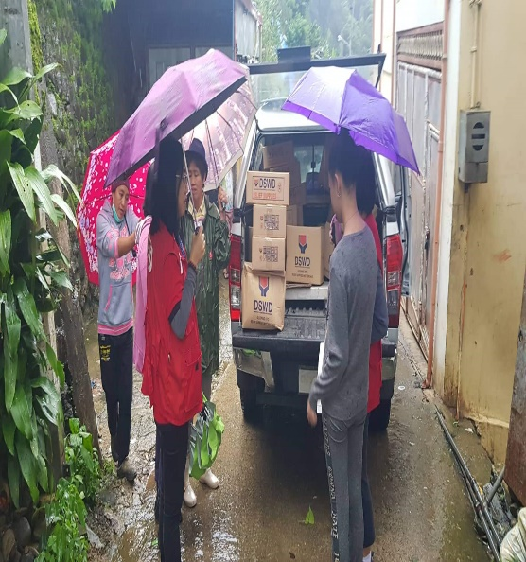
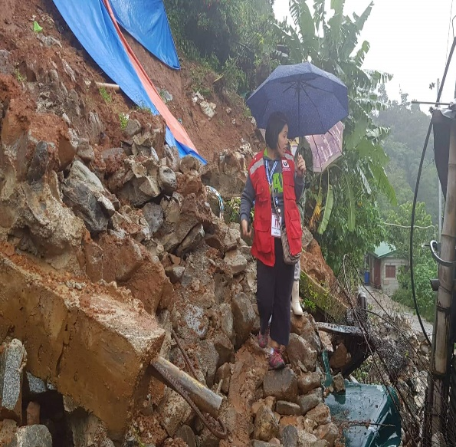
DSWD FO-CAR
Ms. Brenda Consolacion facilitated the distribution of relief goods in Itogon, Benguet
The beneficiary received family food packs for their consumption.
Ms. Mary Ann G. Buclao,OIC-DC, DRMD facilitated the distribution of goods to the affected families.
DRMD personnel (Ms. Gie and Ms. Mary Ann) visited the area.

