DSWD DROMIC Terminal Report on the Fire Incident
in Tabaan Norte, Tuba, Benguet
12 October 2020, 6PM

This is the final report on the fire incident occurred in Sitio Jana, Tabaan Norte, Tuba, Benguet on 22 June 2019.
Source: DSWD-FO CAR

SUMMARY

- Status of Affected Families / Persons
A total of 1 family or 4 persons were affected by the fire incident in Sitio Jana, Tabaan Norte, Tuba, Benguet (see Table 1).

Table 1. Number of Affected Families / Persons
REGION / PROVINCE / MUNICIPALITY | NUMBER OF AFFECTED
 | Barangays | Families | Persons
GRAND TOTAL | 1 | 1 | 4
REGION CAR | 1 | 1 | 4
Benguet | 1 | 1 | 4
Tuba | 1 | 1 | 4
Source: DSWD-FO CAR

- Status of Displaced Families / Persons
A total of 1 family or 4 persons are temporarily staying with their relatives and/or friends (see Table 2).

Table 2. Number of Displaced Families / Persons Inside Evacuation Center
REGION / PROVINCE / MUNICIPALITY | OUTSIDE ECs
 | Families |  | Persons
 | CUM | NOW | CUM | NOW
GRAND TOTAL | 1 | 1 | 4 | 4
REGION CAR | 1 | 1 | 4 | 4
Benguet | 1 | 1 | 4 | 4
Tuba | 1 | 1 | 4 | 4
Source: DSWD-FO CAR

- Damaged Houses
One (1) house was totally damaged by the fire (see table 3).

Table 3. Number of Damaged Houses
REGION / PROVINCE / MUNICIPALITY | NO. OF DAMAGED HOUSES
 | Total | Totally | Partially
GRAND TOTAL | 1 | 1 | -
REGION CAR | 1 | 1 | -
Benguet | 1 | 1 | -
Tuba | 1 | 1 | -
Source: DSWD-FO CAR

- Assistance Provided
A total of ₱8,957.75 worth of assistance was provided to the affected family; of which, ₱3,957.75 was provided by DSWD and ₱5,000.00 from the LGU (see table 4).

Table 4. Cost of Assistance Provided to the Affected Families
REGION / PROVINCE / MUNICIPALITY | TOTAL COST OF ASSISTANCE
 | DSWD | LGU | NGOs | OTHERS | GRAND TOTAL
GRAND TOTAL | 3,957.75 | 5,000.00 | - | - | 8,957.75
REGION CAR | 3,957.75 | 5,000.00 | - | - | 8,957.75
Benguet | 3,957.75 | 5,000.00 | - | - | 8,957.75
Tuba | 3,957.75 | 5,000.00 | - | - | 8,957.75
Source: DSWD-FO CAR

SITUATIONAL REPORT

DSWD-FO CAR
DATE | SITUATIONS / ACTIONS UNDERTAKEN
10 July 2020 | - DSWD-FO CAR submitted their terminal report.  - DSWD-FO CAR provided 1 family kit and 1 hygiene kit to the affected families.  - The LGU of Tuba provided ₱5,000.00 cash assistance to the affected family.

*****
The Disaster Response Operations Monitoring and Information Center (DROMIC) of the DSWD-DRMB is closely coordinating with DSWD-FO CAR for any request of Technical Assistance and Resource Augmentation (TARA).

Prepared by:

MARIE JOYCE G. RAFANAN

MARC LEO L. BUTAC
Releasing Officer

PHOTO DOCUMENTATION

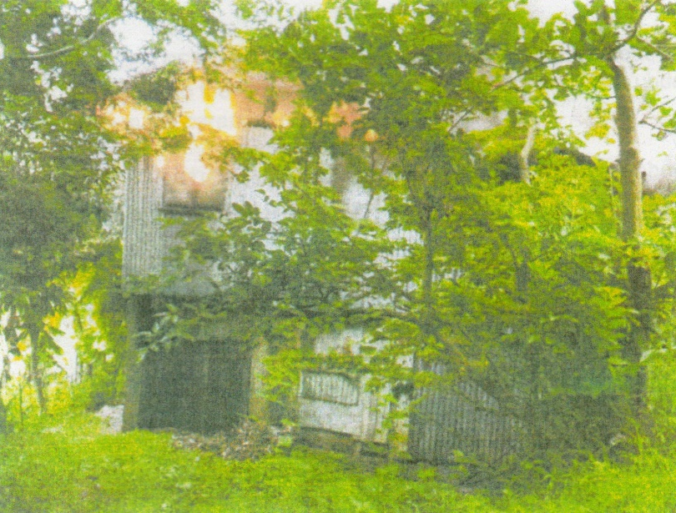
A picture of the house being razed by fire in the morning of 22 June 2019.

