DSWD DROMIC Terminal Report
on the Fire Incident in Naujan, Oriental Mindoro
07 March 2019, 4PM

SUMMARY

On 18 February 2019, a fire incident occurred in Sitio Acacia, Brgy. Sta. Maria, Naujan, Oriental Mindoro at around 4:10 PM and declared fire out at exactly 5:00 PM.
Source: DSWD-MIMAROPA

Status of Affected Families / Persons
A total of 16 families or 74 persons are affected in Brgy. Sta. Maria, Naujan, Oriental Mindoro (see Table 1).

Table 1. Affected Families / Persons
REGION / PROVINCE / MUNICIPALITY |  | NUMBER OF AFFECTED
 |  | Barangays | Families | Persons
GRAND TOTAL |  | 1 | 16 | 74
REGION MIMAROPA |  | 1 | 16 | 74
Oriental Mindoro |  | 1 | 16 | 74
 | Naujan | 1 | 16 | 74

Source: DSWD-MIMAROPA

- Status of Displaced Families / Persons

Chuksan Protestant Church served as evacuation center to the affected families is already closed.

Table 2. Displaced Families / Persons Inside Evacuation Center
REGION / PROVINCE / MUNICIPALITY |  | NUMBER OF EVACUATION CENTERS (ECs) |  | INSIDE ECs
 |  |  |  | Families |  | Persons
 |  | CUM | NOW | CUM | NOW | CUM | NOW
GRAND TOTAL |  | 1 | - | 16 | - | 74 | -
REGION MIMAROPA |  | 1 | - | 16 | - | 74 | -
Oriental Mindoro |  | 1 | - | 16 | - | 74 | -
 | Naujan | 1 | - | 16 | - | 74 | -

Source: DSWD-MIMAROPA

- Damaged Houses
13 houses were totally damaged by the fire (see Table 3).

Table 3. Damaged Houses
REGION / PROVINCE / MUNICIPALITY |  | NO. OF DAMAGED HOUSES
 |  | Total | Totally | Partially
GRAND TOTAL |  | 13 | 13 | -
REGION MIMAROPA |  | 13 | 13 | -
Oriental Mindoro |  | 13 | 13 | -
 | Naujan | 13 | 13 | -

Source: DSWD-MIMAROPA

- Summary of Assistance Provided (see Table 4)
A total of ₱98,648.00 worth of assistance was provided to the affected families; of which, ₱48,352.00 was provided by DSWD, ₱13,600.00 from the LGU and ₱36,696.00 was provided by the NGOs (see Table 4).

Table 4. Cost of Assistance Provided to Affected Families / Persons
REGION / PROVINCE / MUNICIPALITY |  | TOTAL COST OF ASSISTANCE
 |  | DSWD | LGU | NGOs | OTHERS | GRAND TOTAL
GRAND TOTAL |  | 48,352.00 | 13,600.00 | 36,696.00 | - | 98,648.00
REGION MIMAROPA |  | 48,352.00 | 13,600.00 | 36,696.00 | - | 98,648.00
Oriental Mindoro |  | 48,352.00 | 13,600.00 | 36,696.00 | - | 98,648.00
 | Naujan | 48,352.00 | 13,600.00 | 36,696.00 | - | 98,648.00

Source: DSWD-MIMAROPA

SITUATIONAL REPORTS

DSWD-MIMAROPA
DATE | SITUATIONS / ACTIONS UNDERTAKEN
- March 2019 | - DSWD-MIMAROPA submitted their Terminal Report.  - Owner of the Chuksan Protestant Church is donating a part of the land for the Mangyan families where they can reconstruct their new houses. Deed of donation is now on process and in coordination with the LGU of Naujan.  - LGU of Naujan will provide Emergency Shelter Assistance (ESA) in the form of construction materials to the affected families with damaged houses. Provision of assistance will be based on the assessment of the MSWDO Naujan.  - LGU Naujan is now facilitating, monitoring and supplying the immediate needs of families/individuals affected by the fire incident.

*****

The Disaster Response Operations Monitoring and Information Center (DROMIC) of the DSWD-DRMB is closely coordinating with the concerned DSWD-MIMAROPA for any request of Technical Assistance and Resource Augmentation (RATA).

JAN ERWIN ANDREW I. ONTANILLAS
Releasing Officer

PHOTO DOCUMENTATION

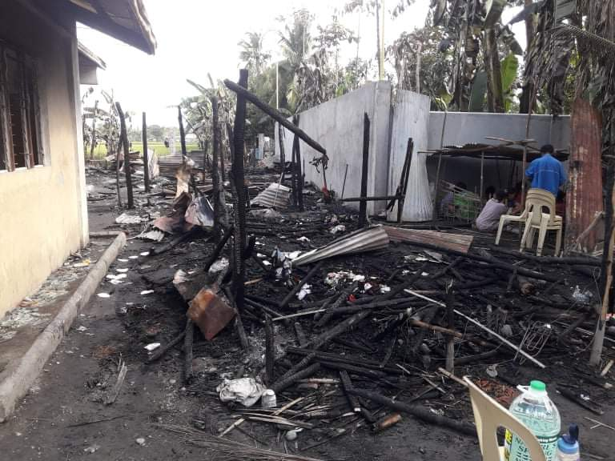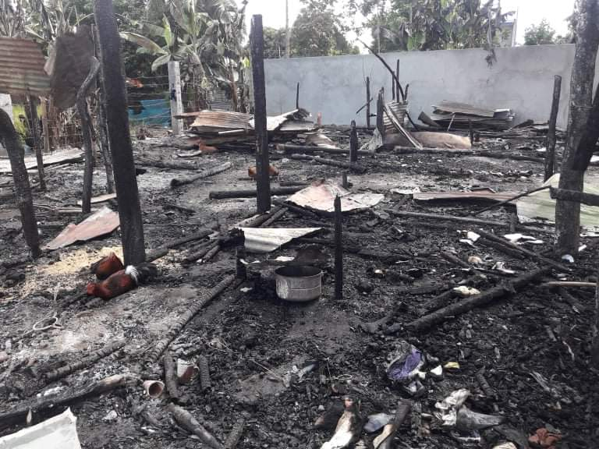

Fire incident report of BFP Naujan.

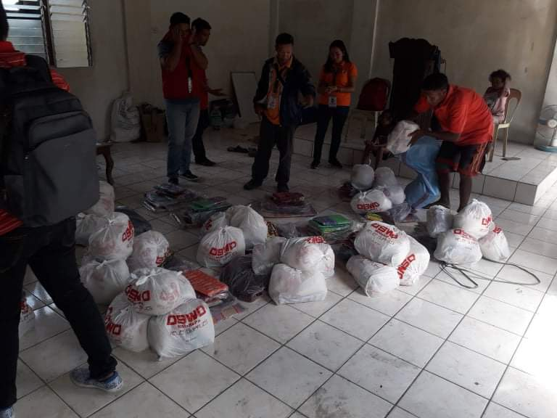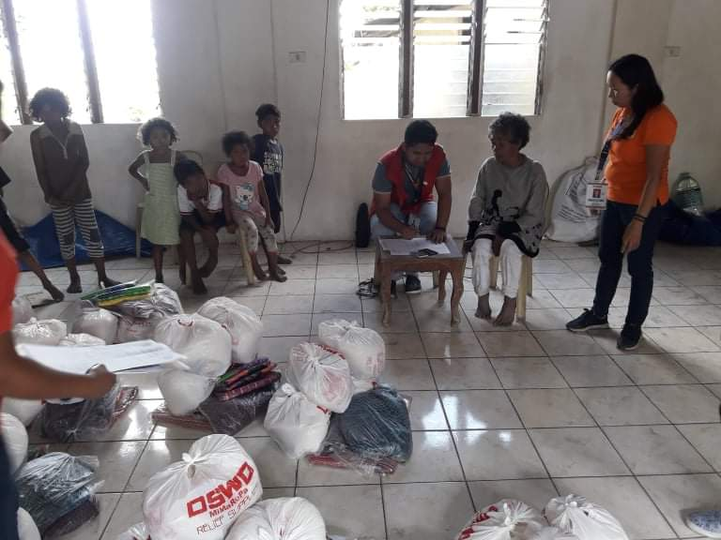

Relief distribution to the affected families/individuals in Sitio Acacia, Brgy. Sta. Maria, Naujan, Oriental Mindoro

