DSWD DROMIC Preparedness for Response Report
#1 on Tropical Depression “MARILYN”
as of 13 September 2019, 6PM

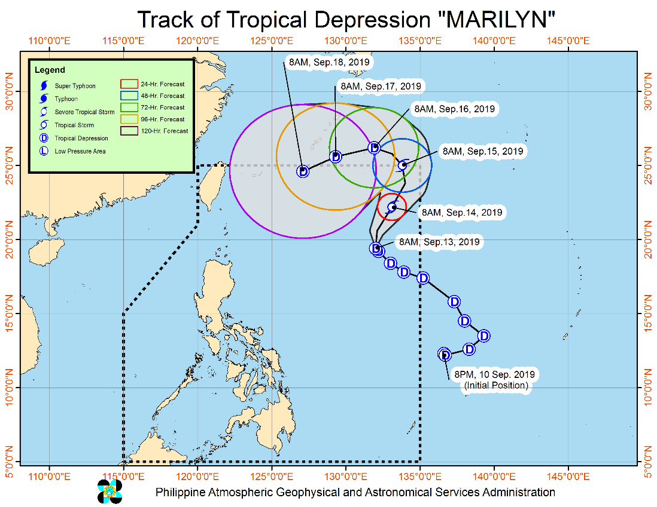
Situation Overview

TROPICAL DEPRESSION "MARILYN" SLOWS DOWN WHILE MOVING NORTHWESTWARD.
- Today until tomorrow morning, frequent light to moderate with occasional heavy rains will experienced over Palawan, Western Visayas, Zamboanga Peninsula and Bangsamoro. Occasional light to moderate rains with at times heavy rain showers during thunderstorms will be experienced over Metro Manila, CALABARZON, Bicol Region, Northern Mindanao, SOCCSKSARGEN, and the rest of MIMAROPA and Visayas.
- Residents of the aforementioned areas, especially those living in areas identified to be highly or very highly susceptible to floods and rain-induced landslides, are advised to take precautionary measures, coordinate with local disaster risk reduction and management offices, and continue monitoring for updates, especially the Thunderstorm or Rainfall Advisories and Heavy Rainfall Warnings to be issued by PAGASA Regional Services Divisions.
- Sea travel is risky, especially for small seacrafts, over the central and eastern seaboards of Visayas and the seaboards of Mindanao due to potentially rough sea condition.
- "MARILYN" remains less likely to make landfall in the country throughout the forecast period.
At 10:00 AM today, the center of Tropical Depression "MARILYN" was estimated based on all available data at 1,045 km East of Basco, Batanes (19.4 °N, 131.9 °E )
Source: DOST-PAGASA Severe Weather Bulletin
PREDICTIVE ANALYTICS FOR HUMANITARIAN RESPONSE

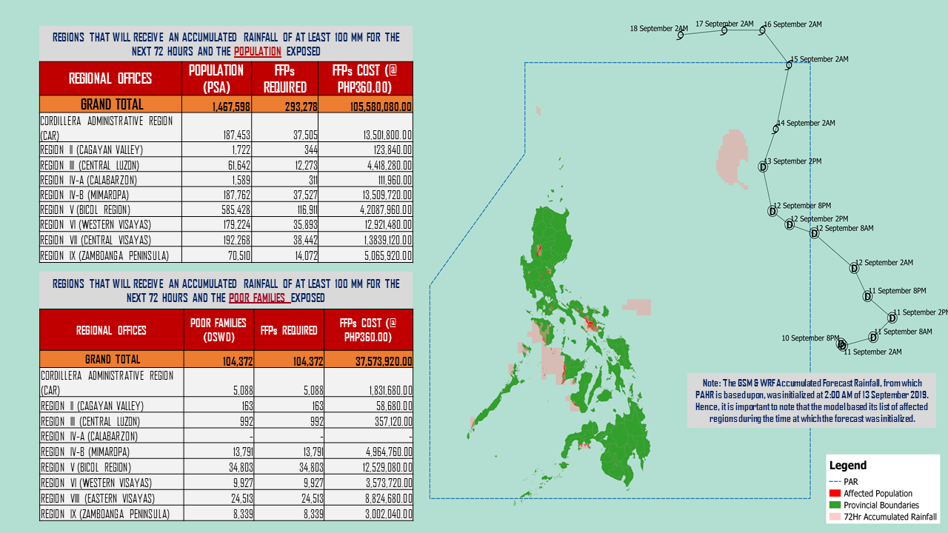

Source: DRMB-DROMIC GIS Specialists
Status of Prepositioned Resources: Stockpile and Standby Funds

The DSWD Central Office (CO), Field Offices (FOs), and National Resource Operations Center (NROC) have stockpiles and standby funds amounting to ₱1,871,796,339.98 with breakdown as follows (see Table 1):

- Standby Funds
A total of ₱1,119,839,304.24 standby funds in the CO and FOs. Of the said amount, ₱1,076,221,717.34 is the available Quick Response Fund (QRF) in the CO.

- Stockpiles
A total of 340,697 Family Food Packs (FFPs) amounting to ₱129,963,029.76 and available Food and Non-food Items (FNIs) amounting to ₱621,994,005.98.

FIELD OFFICE | STANDBY FUNDS | STOCKPILES |  |  |  |  | Total STANDBY FUNDS & STOCKPILE
 |  | Family Food Packs |  | Other Food Items | Non Food Items | SUB-TOTAL (Food and NFIs)
 |  | Quantity | Total Cost | Total Cost | Total Cost
TOTAL | 1,119,839,304.24 | 340,697 | 129,963,029.76 | 137,155,617.74 | 484,838,388.24 | 621,994,005.98 | 1,871,796,339.98
Central Office* | 1,076,221,717.34 |  |  |  |  |  | 1,076,221,717.34
NRLMB - NROC | - | 102,649 | 41,166,501.86 | 72,358,598.06 | 328,321,461.83 | 400,680,059.89 | 441,846,561.75
NRLMB - VDRC | - | 11,700 | 4,212,000.00 | 1,203,200.00 | 5,224,562.31 | 6,427,762.31 | 10,639,762.31
I | 2,379,275.00 | 13,096 | 4,753,296.40 | 299,455.20 | 34,081,356.31 | 34,380,811.51 | 41,513,382.91
II | 3,638,241.66 | 28,662 | 9,214,300.12 | 84,672.00 | 349,602.75 | 434,274.75 | 13,286,816.53
III | 3,068,057.00 | 23,611 | 9,284,808.50 | 979,469.70 | 241,406.00 | 1,220,875.70 | 13,573,741.20
CALABARZON | 2,584,325.00 | 3,775 | 1,347,537.20 | 3,787,294.00 | 3,175,812.37 | 6,963,106.37 | 10,894,968.57
MIMAROPA | 1,777,188.26 | 30,835 | 12,889,030.00 | 880,561.74 | 859,605.00 | 1,740,166.74 | 16,406,385.00
V | 1,464,000.00 | 18,706 | 7,295,340.00 | 8,958,033.52 | 40,451,448.22 | 49,409,481.74 | 58,168,821.74
VI | 3,000,000.00 | 5,691 | 2,057,295.72 | 8,594,920.49 | 3,711,406.00 | 12,306,326.49 | 17,363,622.21
VII | 3,001,150.00 | 13,169 | 4,740,840.00 | 17,429,517.64 | 17,077,542.18 | 34,507,059.82 | 42,249,049.82
VIII | 3,202,960.00 | 12,018 | 4,343,545.56 | 1,304,119.84 | 896,387.00 | 2,200,506.84 | 9,747,012.40
IX | 1,488,588.85 | 11,446 | 4,120,560.00 | 1,005,900.00 | 3,793,242.35 | 4,799,142.35 | 10,408,291.20
X | 3,000,000.00 | 12,832 | 4,619,520.00 | 7,814,676.00 | 28,187,391.56 | 36,002,067.56 | 43,621,587.56
XI | 3,028,750.00 | 12,566 | 4,541,352.40 | 2,763,200.00 | 8,150,042.00 | 10,913,242.00 | 18,483,344.40
XII | 3,000,701.68 | 4,724 | 1,894,324.00 | 3,484,211.10 | 866,517.26 | 4,350,728.36 | 9,245,754.04
CARAGA | 3,000,000.00 | 13,832 | 5,440,182.24 | 227,028.56 | 3,505,436.70 | 3,732,465.26 | 12,172,647.50
NCR | 3,292,543.50 | 5,484 | 2,052,190.36 | 1,162,526.29 | 1,038,066.00 | 2,200,592.29 | 7,545,326.15
CAR | 2,691,805.95 | 15,901 | 5,990,405.40 | 4,818,233.60 | 4,907,102.40 | 9,725,336.00 | 18,407,547.35
*Quick Response Fund (QRF) as of 12 September 2019

Situational Reports

DSWD-DRMB
DATE | SITUATIONS / ACTIONS UNDERTAKEN
13 September 2019 | - The Disaster Response Management Bureau (DRMB) is closely coordinating with the concerned DSWD-Field Offices for significant disaster preparedness for response updates.  - All QRT members and emergency equipment are on standby and ready for deployment.  - Based on the concluded Pre-Disaster Risk Assessment (PDRA) Meeting, no raising of alert level is advised.

DSWD-FO I
DATE | SITUATIONS / ACTIONS UNDERTAKEN
- September 2019 | - DSWD-FO I through the Disaster Response Management Division (DRMD) staff are monitoring the possible effects of TD “Marilyn” in close coordination with the Office of Civil Defense (OCD) of Region I.  - Provincial Operations Offices (POOs) is in close coordination with the different Provincial/City/Municipal Disaster Risk Reduction and Management Councils (P/C/MDRRMCs) who are currently monitoring the adverse effects that might be brought by the weather disturbance.

DSWD-FO II
DATE | SITUATIONS / ACTIONS UNDERTAKEN
13 September 2019 | - DSWD-FO II through the Disaster Response Management Division (DRMD) ensures an on-call and standby duty of the Disaster Management Response Team (DMRT) for possible activation in the event that the TD “Marilyn” will accelerate its strength.  - Continuous sharing of weather advisories to Social Welfare and Development Teams (SWADTs) and City/Municipal Action Teams (C/MATS) for their information and reference.  - DSWD-FO II is in close coordination with the SWAD Teams, the Provincial/City/Municipal Disaster Risk Reduction and Management.

DSWD-FO MIMAROPA
DATE | SITUATIONS / ACTIONS UNDERTAKEN
- September 2019 | - DSWD-FO MIMAROPA through the Disaster Response Management Division and Provincial Project Development Officers are alerted to monitor daily local weather condition.  - 24/7 on-call status of the R/P/C/M Quick Response Team together with special projects for the possible activation of Operations Center.  - Alerted all Provincial/City/Municipal Quick Response Team (P/C/M/ QRT) in five provinces of MIMAROPA to monitor the possible effects of the current weather condition.  - Standby logistical equipment and workforce through coordination with SWADT Offices and concerned LGUs on the management of stranded passengers if there will be reported strandees in ports and terminals.  - Advised our P/C/M QRTs to coordinate with concerned LGUs to report any unusual eventualities in their respective areas and take appropriate actions.  - Information and Communication Technology Management Unit (ICTMU) is on standby status to ensure robust communication system.  - All members of Rapid Emergency Telecommunications Team are on standby status ready for deployment if needed.  - Ensured that the Rapid Emergency Telecommunications Equipment (GX Terminal, BGAN Terminals and Satellite Phones) are in good condition and ready for deployment to areas that will experience potential emergencies.  - Ensured that there is an on-call truck available for delivery of goods and equipment to areas that will be affected.  - Ensured that Relief Goods both Food and Non-Food Item (F/NFI) are also ready and available at any given time.  - DSWD-FO MIMAROPA is in close coordination with the Office of Civil Defense (OCD) and RDRRMC MIMAROPA for any warning signal updates for monitoring purposes and response mechanisms.

*****
The Disaster Response Operations Monitoring and Information Center (DROMIC) of the DSWD-DRMB is closely monitoring the effects of TD Marilyn and is coordinating with the concerned DSWD-Field Offices for any significant updates.

PREPARED BY:

MARIE JOYCE G. RAFANAN

RODEL V. CABADDU
Releasing Officer

