DSWD DROMIC Report #1 on the Effects of Southwest Monsoon
Enhanced by Tropical Depression "NIMFA"
as of 19 September 2019, 6PM

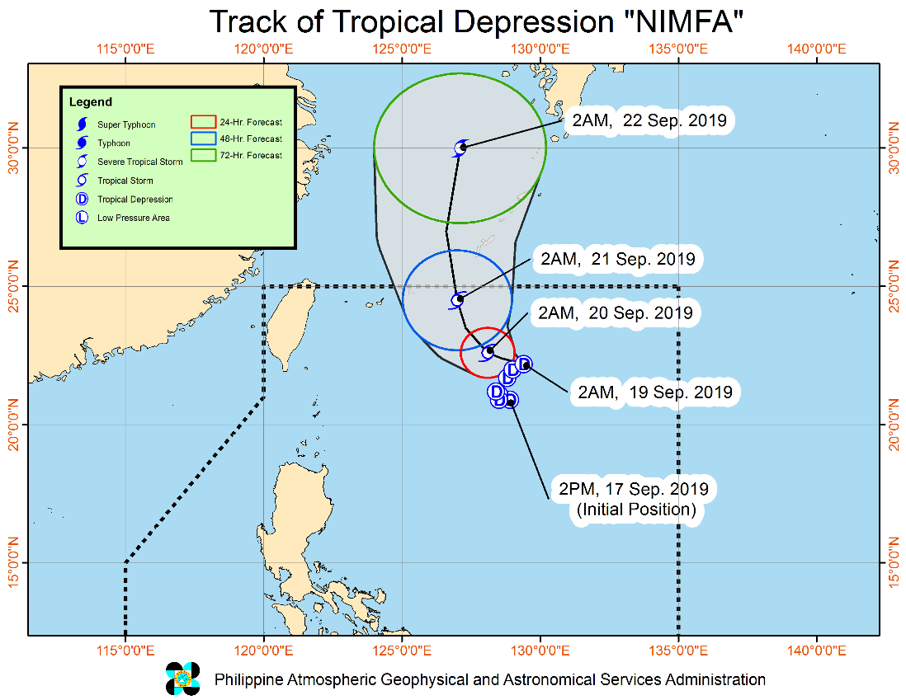
Situation Overview

TROPICAL DEPRESSION "NIMFA" IS NOW MOVING WEST NORTHWESTWARD SLOWLY OVER THE NORTHERN PORTION OF THE PHILIPPINE SEA.
- Between today and tomorrow (20 September) morning, frequent light to moderate with occasional heavy rains will be experienced over Ilocos Region, Cordillera Administrative Region, and the provinces of Cagayan, Zambales, Bataan, and Occidental Mindoro. Occasional light to moderate rains with at times heavy rain showers during thunderstorms will affect Metro Manila and the rest of Luzon.
- Residents of the aforementioned areas, especially those living in areas identified to be highly or very highly susceptible to floods and rain-induced landslides, are advised to take precautionary measures, coordinate with local disaster risk reduction and management offices, and continue monitoring for updates, especially the Thunderstorm or Rainfall Advisories and Heavy Rainfall Warnings to be issued by PAGASA Regional Services Divisions.
- Sea travel is risky, especially for small seacrafts, over the seaboards of Northern Luzon and the western seaboard of Central Luzon due to potentially rough to very rough sea conditions. Most of the other seaboards of the country will remain moderate to rough.
At 10:00 AM today, the center of Tropical Depression "NIMFA" was estimated based on all available data at 715 km East Northeast of Basco, Batanes (22.3 °N, 128.6 °E)
Source: DOST-PAGASA Severe Weather Bulletin

- Status of Affected Families / Persons
A total of 69 families or 251 persons were affected by the effects of Tropical Depression Nimfa in 3 barangays in Region III (see Table 1).

Table 1. Number of Affected Families / Persons
REGION / PROVINCE / MUNICIPALITY |  | NUMBER OF AFFECTED
 |  | Barangays | Families | Persons
GRAND TOTAL |  | 3 | 69 | 251
REGION III |  | 3 | 69 | 251
Pampanga |  | 3 | 69 | 251
 | Apalit | 1 | 54 | 192
 | City of San Fernando (capital) | 2 | 15 | 59
Note: Ongoing assessment and validation being conducted.
Source: DSWD-FO III
- Status of Displaced Families / Persons
- Inside Evacuation Centers
A total of 69 families or 339 persons are currently taking shelter in 3 evacuation centers in Region III (see Table 2).

Table 2. Number of Displaced Families / Persons Outside Evacuation Center
REGION / PROVINCE / MUNICIPALITY |  | NUMBER OF EVACUATION CENTERS (ECs) |  | INSIDE ECs
 |  |  |  | Families |  | Persons
 |  | CUM | NOW | CUM | NOW | CUM | NOW
GRAND TOTAL |  | 3 | 3 | 69 | 69 | 339 | 339
REGION III |  | 3 | 3 | 69 | 69 | 339 | 339
Pampanga |  | 3 | 3 | 69 | 69 | 339 | 339
 | Apalit | 1 | 1 | 54 | 54 | 280 | 280
 | City of San Fernando (capital) | 2 | 2 | 15 | 15 | 59 | 59
Note: Ongoing assessment and validation being conducted.
Source: DSWD-FO III

Situational Reports

DSWD-DRMB
DATE | SITUATIONS / ACTIONS UNDERTAKEN
19 September 2019 | - The Disaster Response Management Bureau (DRMB) is closely coordinating with the concerned DSWD-Field Offices for significant disaster preparedness for response updates.  - All QRT members and emergency equipment are on standby and ready for deployment.

DSWD-FO III
DATE | SITUATIONS / ACTIONS UNDERTAKEN
- September 2019 | - The DSWD-FO III is continuously monitoring of weather updates with the concerned LGUs

*****
The Disaster Response Operations Monitoring and Information Center (DROMIC) of the DSWD-DRMB is closely monitoring the effects of TD Nimfa and is coordinating with the concerned DSWD-Field Offices for any significant updates.

PREPARED BY:

MARIEL B. FERRARIZ

RODEL V. CABADDU
Releasing Officer

