DSWD DROMIC Report #1 on Trough of
Tropical Depression “NIMFA”
as of 19 September 2019, 6PM
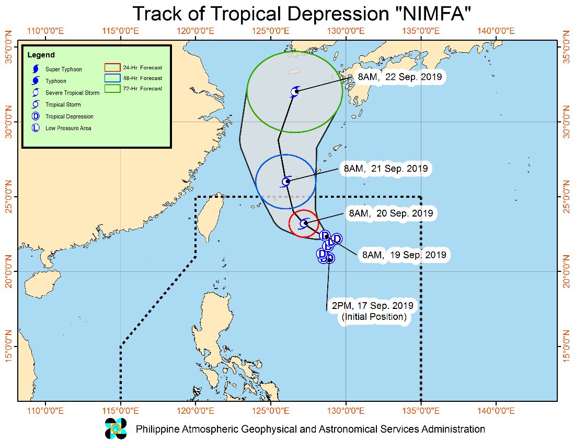
Situation Overview

TROPICAL DEPRESSION "NIMFA" IS NOW MOVING WEST NORTHWESTWARD SLOWLY OVER THE NORTHERN PORTION OF THE PHILIPPINE SEA.
- Between today and tomorrow (20 September) morning, frequent light to moderate with occasional heavy rains will be experienced over Ilocos Region, Cordillera Administrative Region, and the provinces of Cagayan, Zambales, Bataan, and Occidental Mindoro. Occasional light to moderate rains with at times heavy rain showers during thunderstorms will affect Metro Manila and the rest of Luzon.
- Residents of the aforementioned areas, especially those living in areas identified to be highly or very highly susceptible to floods and rain-induced landslides, are advised to take precautionary measures, coordinate with local disaster risk reduction and management offices, and continue monitoring for updates, especially the Thunderstorm or Rainfall Advisories and Heavy Rainfall Warnings to be issued by PAGASA Regional Services Divisions.
- Sea travel is risky, especially for small seacrafts, over the seaboards of Northern Luzon and the western seaboard of Central Luzon due to potentially rough to very rough sea conditions. Most of the other seaboards of the country will remain moderate to rough.
At 10:00 AM today, the center of Tropical Depression "NIMFA" was estimated based on all available data at 715 km East Northeast of Basco, Batanes (22.3 °N, 128.6 °E)
Source: DOST-PAGASA Severe Weather Bulletin

- Status of Affected Families / Persons
A total of 3 families or 20 persons were affected in 2 barangays, and 3 cities/municipalities in Region CAR (see Table 1).

Table 1. Affected Areas and Number of Affected Families / Persons
REGION / PROVINCE / MUNICIPALITY |  | NUMBER OF AFFECTED
 |  | Barangays | Families | Persons
GRAND TOTAL |  | 2 | 3 | 20
CAR |  | 2 | 3 | 20
Ifugao |  | 2 | 3 | 20
 | Hingyon | 1 | 2 | 15
 | Lagawe (capital) | 1 | 1 | 5
Note: Ongoing assessment and validation.
Source: DSWD FO-CAR

- Status of Displaced Families / Persons Outside EC
A total of 1 family or 10 persons who took temporary shelter with their relatives and/or friends in Regions CAR (see Table 2).

Table 2. Number of Families / Persons Outside ECs
REGION / PROVINCE / MUNICIPALITY |  | OUTSIDE ECs
 |  | Families |  | Persons
 |  | CUM | NOW | CUM | NOW
GRAND TOTAL |  | 1 | - | 10 | -
CAR |  | 1 | - | 10 | -
Ifugao |  | 1 | - | 10 | -
 | Hingyon | 1 | - | 10 | -
 | Lagawe (capital) | - | - | - | -
Note: Ongoing assessment and validation.
Source: DSWD FO-CAR

- Damaged Houses
There are 3 damaged houses; of which 1 is totally damaged and 2 are partially damaged (see Table 3).

Table 3. Number of Damaged Houses
REGION / PROVINCE / MUNICIPALITY |  | NO. OF DAMAGED HOUSES
 |  | Total | Totally | Partially
GRAND TOTAL |  | 3 | 1 | 2
CAR |  | 3 | 1 | 2
Ifugao |  | 3 | 1 | 2
 | Hingyon | 2 | 1 | 1
 | Lagawe (capital) | 1 | - | 1
Note: Ongoing assessment and validation.
Source: DSWD FO-CAR

Situational Reports

DSWD-DRMB
DATE | SITUATIONS / ACTIONS UNDERTAKEN
19 September 2019 | - The Disaster Response Management Bureau (DRMB) is closely coordinating with the concerned DSWD-Field Offices for significant disaster preparedness for response updates.

DSWD-FO CAR
DATE | SITUATION / PREPAREDNESS ACTIONS
19 September 2019 | - The Provincial Social Welfare and Development Teams (PSWADT) DRMD PDO IIs are alerted, members are on standby for the possible effects of the weather disturbances.  - The DRMD is continuously monitoring the situation on ground.  - Rapid Emergency Telecommunications Team (RETT) including the International Maritime/Marine Satellite (INMARSAT) equipment are on standby.

The Disaster Response Operations Monitoring and Information Center (DROMIC) of the DSWD-DRMB is closely monitoring the effects of Trough of Tropical Depression “NIMFA” and is coordinating with the concerned DSWD-Field Offices for any significant updates.

Prepared by:

MARIEL B. FERRARIZ

RODEL V. CABADDU
Releasing Officer

