DSWD DROMIC Report #1 on the
Tornado Incident in Rizal, Occidental Mindoro
as of 22 September 2019, 4PM

SUMMARY

On 18 September 2019, a tornado ripped through Barangays Adela, San Pedro and Sto. Niño, Rizal in Occidental Mindoro. It rendered some of the families homeless due to damage it caused to their houses.
Source: DSWD-FO MIMAROPA

- Status of Affected Families / Persons
A total of 12 families or 51 persons were affected by the tornado incident in Rizal, Occidental Mindoro (see Table 1).

Table 1. Number of Affected Families / Persons
REGION / PROVINCE / MUNICIPALITY |  | NUMBER OF AFFECTED
 |  | Barangays | Families | Persons
GRAND TOTAL |  | 3 | 12 | 51
MIMAROPA |  | 3 | 12 | 51
Occidental Mindoro |  | 3 | 12 | 51
 | Rizal | 3 | 12 | 51
Note: Ongoing assessment and validation
Source: DSWD-FO MIMAROPA

- Status of Displaced Families / Persons
There are 12 families or 51 persons who are currently staying with their relatives (see Table 2).

Table 2. Number of Displaced Families / Persons Outside Evacuation Center
REGION / PROVINCE / MUNICIPALITY |  | OUTSIDE ECs
 |  | Families |  | Persons
 |  | CUM | NOW | CUM | NOW
GRAND TOTAL |  | 12 | 12 | 51 | 51
MIMAROPA |  | 12 | 12 | 51 | 51
Occidental Mindoro |  | 12 | 12 | 51 | 51
 | Rizal | 12 | 12 | 51 | 51
Note: Ongoing assessment and validation
Source: DSWD-FO MIMAROPA

- Damaged Houses
There are 12 damaged houses; of which, 3 are totally damaged and 9 are partially damaged (see Table 3).

Table 3. Number of Damaged Houses
REGION / PROVINCE / MUNICIPALITY |  | NO. OF DAMAGED HOUSES
 |  | Total | Totally | Partially
GRAND TOTAL |  | 12 | 3 | 9
MIMAROPA |  | 12 | 3 | 9
Occidental Mindoro |  | 12 | 3 | 9
 | Rizal | 12 | 3 | 9
Note: Ongoing assessment and validation
Source: DSWD-FO MIMAROPA

- Assistance Provided
A total of ₱6,750.00 worth of assistance was provided by DSWD to the affected families (see Table 4).

Table 4. Cost of Assistance Provided to Affected Families / Persons
REGION / PROVINCE / MUNICIPALITY |  | TOTAL COST OF ASSISTANCE
 |  | DSWD | LGU | NGOs | OTHERS | GRAND TOTAL
GRAND TOTAL |  | 6,750.00 | - | - | - | 6,750.00
MIMAROPA |  | 6,750.00 | - | - | - | 6,750.00
Occidental Mindoro |  | 6,750.00 | - | - | - | 6,750.00
 | Rizal | 6,750.00 | - | - | - | 6,750.00
Note: Ongoing assessment and validation.
Source: DSWD-FO MIMAROPA

SITUATIONAL REPORT

DSWD-DRMB
DATE | SITUATIONS / ACTIONS UNDERTAKEN
22 September 2019 | - The Disaster Response Operations Monitoring and Information Center (DROMIC) of the DSWD-DRMB is closely coordinating with DSWD-FO MIMAROPA for any significant disaster response updates.

DSWD-FO MIMAROPA
DATE | SITUATIONS / ACTIONS UNDERTAKEN
22 September 2019 | - The Disaster Response Management Division of DSWD-FO MIMAROPA through SWADT Occidental Mindoro is continuously coordinating with the concerned LGU and MSWDO/MDRRMO to further assess the condition/situation of the affected families/individuals.

*****
The Disaster Response Operations Monitoring and Information Center (DROMIC) of the DSWD-DRMB continues to closely coordinate with DSWD-MIMAROPA for significant disaster response updates and assistance provided.

Prepared by:

MACON J. DEL PRADO

JAN ERWIN ANDREW I. ONTANILLAS
Releasing Officer

PHOTO DOCUMENTATION

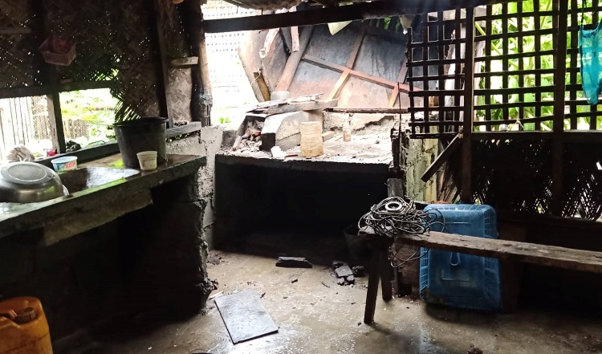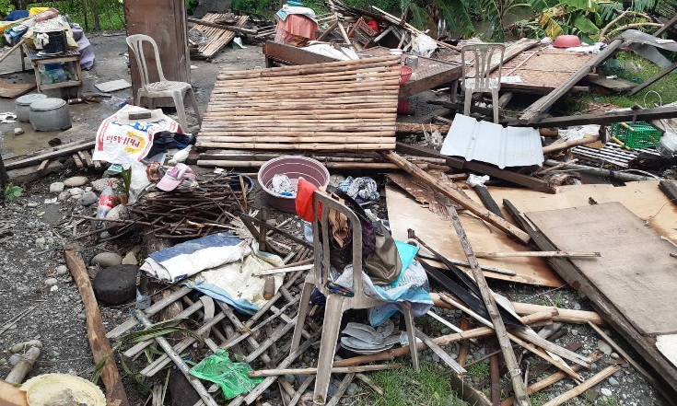
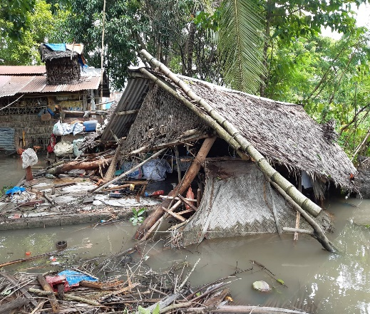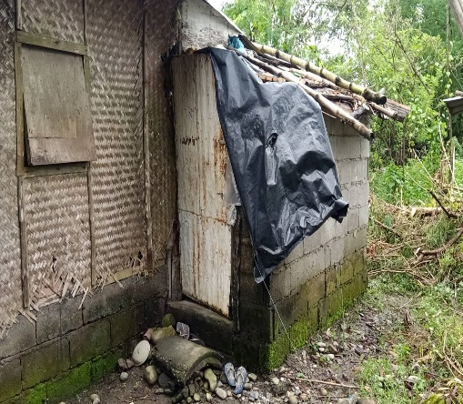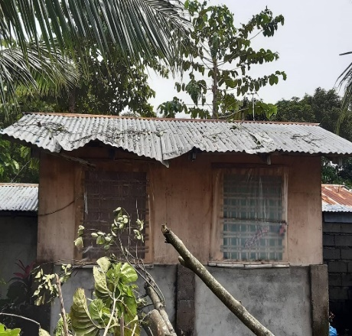
Damaged houses in Brgy. Adela, Rizal, Occidental Mindoro.

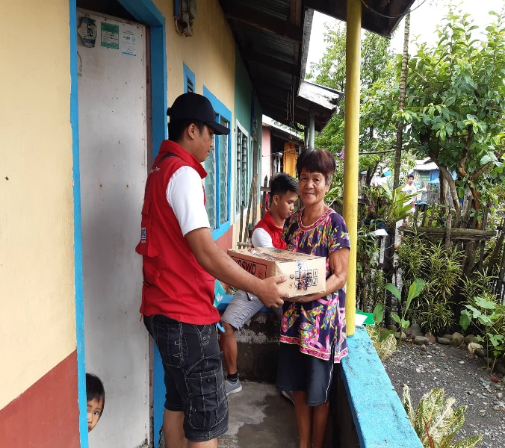
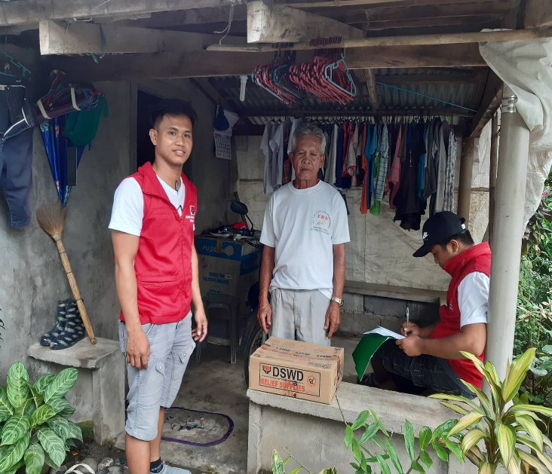
Distribution of Family Food Packs (FFPs) to the affected families.

