DSWD DROMIC Report #2 on
Trough of Tropical Storm “NIMFA”
as of 20 September 2019, 6PM
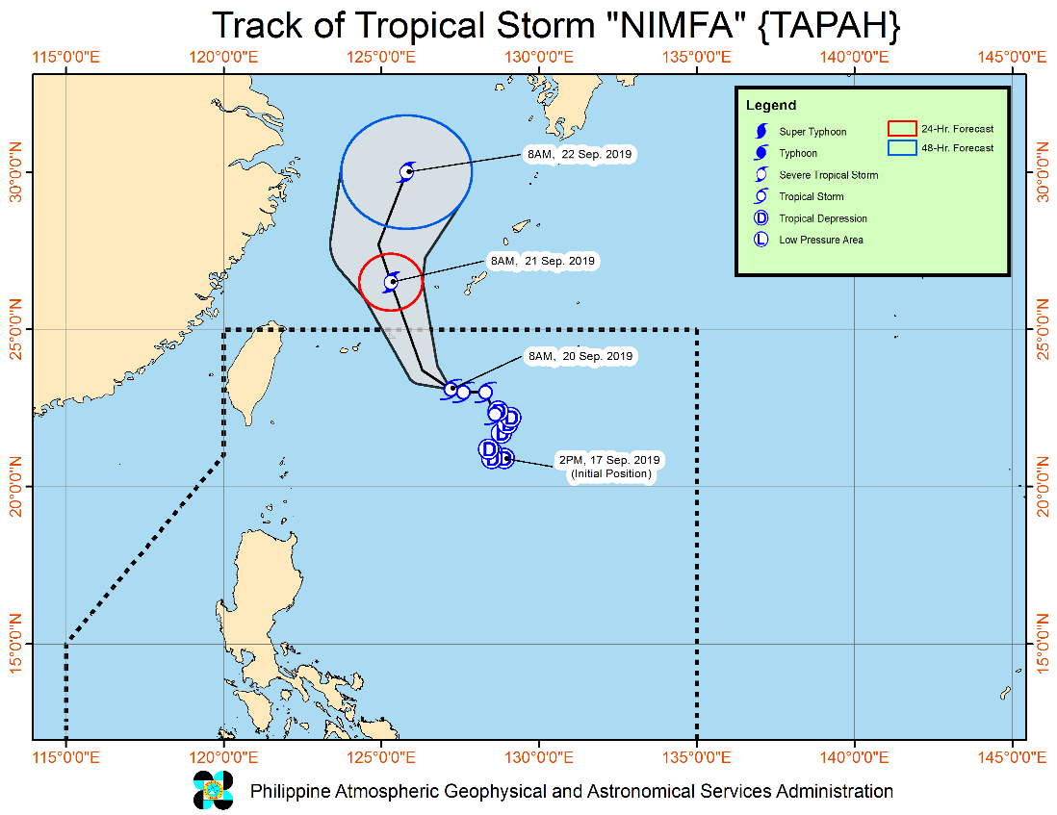
Situation Overview

“NIMFA” HAS SLOWED DOWN WHILE OVER THE NORTHERN PORTION OF THE PHILIPPINE SEA.
- Between today and tomorrow (21 September) morning, the Southwest Monsoon will bring occasional light to moderate with intermittent heavy rains over Bataan, Cavite, Batangas and Occidental Mindoro. Intermittent light to moderate rains with at times heavy rainshowers during thunderstorms may affect Metro Manila, Oriental Mindoro, Marinduque, northern portion of Palawan including Calamian Islands and the rest of Central Luzon and CALABARZON.
- Residents of the aforementioned areas, especially those living in areas identified to be highly or very highly susceptible to floods and rain-induced landslides, are advised to take precautionary measures, coordinate with local disaster risk reduction and management offices, and continue monitoring for updates, especially the Thunderstorm or Rainfall Advisories and Heavy Rainfall Warnings to be issued by PAGASA Regional Services Divisions.
- Sea travel is risky, especially for small seacrafts, over the seaboards of Northern and Central Luzon and the eastern seaboard of Southern Luzon due to potentially rough to very rough sea conditions. The other seaboards of the country will remain moderate to rough.
- “NIMFA” is forecast to exit the Philippine Area of Responsibility tomorrow morning.
At 10:00 AM today, the center of Tropical Storm "NIMFA" was estimated based on all available data at 620 km East Northeast of Basco, Batanes (23.2 °N, 127.2 °E )
Source: DOST-PAGASA Severe Weather Bulletin

- Status of Affected Families / Persons
A total of 575 families or 2,880 persons were affected in 8 barangays, and in Region I and CAR (see Table 1).

Table 1. Affected Areas and Number of Affected Families / Persons
REGION / PROVINCE / MUNICIPALITY |  | NUMBER OF AFFECTED
 |  | Barangays | Families | Persons
GRAND TOTAL |  | 8 | 575 | 2,880
REGION I |  | 6 | 572 | 2,860
Pangasinan |  | 6 | 572 | 2,860
 | Balungao | 6 | 572 | 2,860
CAR |  | 2 | 3 | 20
Ifugao |  | 2 | 3 | 20
 | Hingyon | 1 | 2 | 15
 | Lagawe (capital) | 1 | 1 | 5
Note: Ongoing assessment and validation being conducted.
Source: DSWD-FOs I and CAR

- Status of Displaced Families / Persons Outside Evacuation Center
A total of 1 family or 10 persons have temporarily stayed with their relatives and/or friends in CAR (see Table 2).

Table 2. Number of Families / Persons Outside ECs
REGION / PROVINCE / MUNICIPALITY |  | OUTSIDE ECs
 |  | Families |  | Persons
 |  | CUM | NOW | CUM | NOW
GRAND TOTAL |  | 1 | - | 10 | -
CAR |  | 1 | - | 10 | -
Ifugao |  | 1 | - | 10 | -
 | Hingyon | 1 | - | 10 | -
Note: Ongoing assessment and validation being conducted.
Source: DSWD FO-CAR

- Damaged Houses
There are 3 damaged houses; of which 1 is totally damaged and 2 are partially damaged (see Table 3).

Table 3. Number of Damaged Houses
REGION / PROVINCE / MUNICIPALITY |  | NO. OF DAMAGED HOUSES
 |  | Total | Totally | Partially
GRAND TOTAL |  | 3 | 1 | 2
CAR |  | 3 | 1 | 2
Ifugao |  | 3 | 1 | 2
 | Hingyon | 2 | 1 | 1
 | Lagawe (capital) | 1 | - | 1
Note: Ongoing assessment and validation being conducted.
Source: DSWD FO-CAR

Situational Reports

DSWD-DRMB
DATE | SITUATIONS / ACTIONS UNDERTAKEN
20 September 2019 | - The Disaster Response Management Bureau (DRMB) is closely coordinating with the concerned DSWD-Field Offices for significant disaster preparedness for response updates.

DSWD-FO CAR
DATE | SITUATION / PREPAREDNESS ACTIONS
19 September 2019 | - The Provincial Social Welfare and Development Teams (PSWADT) DRMD PDO IIs were alerted and members were on standby for possible effects of the weather disturbances.  - DSWD-FO CAR through the Disaster Response Management Division (DRMD) was continuously monitoring the situation on the ground.  - Rapid Emergency Telecommunications Team (RETT) including the International Maritime/Marine Satellite (INMARSAT) equipment were on standby.

DSWD-FO I
DATE | SITUATION / PREPAREDNESS ACTIONS
- September 2019 | - DSWD-FO I is closely monitoring the effects brought by the trough of TD “Nimfa” and is coordinating with the Social Welfare and Development (SWAD) Team Leaders, the Provincial/City/Municipal Disaster Risk Reduction and Management Councils (P/C/MDRRMCs) and Provincial/City/Municipal Social Welfare and Development Offices (P/C/MSWDOs) for any significant updates.

DSWD-FO II
DATE | SITUATION / PREPAREDNESS ACTIONS
20 September 2019 | - DSWD-FO II through the Disaster Response Management Division (DRMD) ensures an on-call and standby duty of the DMRT for possible activation in the event that the Tropical Depression “Nimfa” will accelerate its strength.  - Ensured that the relief goods on both Food and Non-Food Items are ready and available at any given time.  - DSWD-FO II alerted all Regional DRMT, PC/M Quick Response Team (P/C/M QRT) in five provinces of the region to monitor the possible effects of the current weather condition.  - Standby logistical equipment and workforce through coordination with SWADT Offices and concerned LGUs on the management of stranded passengers if there will be reported strandees in ports and terminals.  - Continuous sharing of weather advisories to SWADTs and C/MATS for their information and reference.  - DSWD-FO II is in close coordination with the Social Welfare and Development (SWAD) Teams, the Provincial/City/Municipal Disaster Risk Reduction and Management Council (P/C/MDRRMC).

*****

The Disaster Response Operations Monitoring and Information Center (DROMIC) of the DSWD-DRMB is closely monitoring the Trough of Tropical Storm “NIMFA” and is coordinating with the concerned DSWD-Field Offices for any significant updates.

Prepared by:

MARIE JOYCE G. RAFANAN

RODEL V. CABADDU
Releasing Officer

