DSWD DROMIC Report #2 on the Armed Conflict
in Brgy. Paitan, Escalante, Negros Occidental
as of 03 September 2019, 12NN

SUMMARY

On 31 August 2019 at 6:45 AM, an encounter transpired between more or less 30 terrorist NPAs and troops of 79th Infantry Battalion while conducting combat operations at Sitio Morino, Brgy. Paitan, Escalante City, Negros Occidental. The soldiers fought in a 45-minute running gun battle against the NPAs who used an anti-personnel mine in the process and eventually withdrew towards the forested portion of Sitio Sampinit of same barangay.

Source: DSWD-FO VI

- Status of Affected Families / Persons
There are 206 families or 644 persons who were affected by the armed conflict in 2 Barangays in Escalante, Negros Occidental (see Table 1).

Table 1. Number of Affected Families / Persons
REGION / PROVINCE / MUNICIPALITY |  | NUMBER OF AFFECTED
 |  | Barangays | Families | Persons
GRAND TOTAL |  | 2 | 206 | 644
REGION VI |  | 2 | 206 | 644
Negros Occidental |  | 2 | 206 | 644
 | City of Escalante | 2 | 206 | 644
Note: Ongoing assessment and validation being conducted.
Source: DSWD-FO VI
- Status of Affected Families / Persons
A total of 206 families or 644 persons are temporarily staying in 2 Evacuation Centers in Brgy. Paitan and Brgy. Libertad (see Table 2).

Table 2. Number of Displaced Families / Persons Inside Evacuation Center
REGION / PROVINCE / MUNICIPALITY |  | NUMBER OF EVACUATION CENTERS (ECs) |  | INSIDE ECs
 |  |  |  | Families |  | Persons
 |  | CUM | NOW | CUM | NOW | CUM | NOW
GRAND TOTAL |  | 2 | 2 | 206 | 206 | 644 | 644
REGION VI |  | 2 | 2 | 206 | 206 | 644 | 644
Negros Occidental |  | 2 | 2 | 206 | 206 | 644 | 644
 | City of Escalante | 2 | 2 | 206 | 206 | 644 | 644
Note: Ongoing assessment and validation.
Source: DSWD-FO VI
- Assistance Provided
A total of ₱104,383.00 worth of assistance was provided by LGU to the affected families (see Table 3).
REGION / PROVINCE / MUNICIPALITY | TOTAL COST OF ASSISTANCE
 | DSWD | LGU | NGOs | OTHERS | GRAND TOTAL
GRAND TOTAL | - | 104,383.00 | - | - | 104,383.00
REGION VI | - | 104,383.00 | - | - | 104,383.00
Negros Occidental | - | 104,383.00 | - | - | 104,383.00
City of Escalante | - | 104,383.00 | - | - | 104,383.00
Note: Ongoing assessment and validation being conducted.
Source: DSWD-FO VI
SITUATIONAL REPORT

DSWD-DRMB
DATE | SITUATIONS / ACTIONS UNDERTAKEN
03 September 2019 | - The Disaster Response Operations Monitoring and Information Center (DROMIC) of the DSWD-DRMB continues to closely coordinate with DSWD-FO VI for significant reports on the status of affected families, assistance, and relief efforts.

DSWD-FO VI
DATE | SITUATIONS / ACTIONS UNDERTAKEN
- September 2019 | - DSWD-FO VI is in close coordination with SWAD Negros for the provision of technical assistance on CCCM.  - The Local Government of Escalante City provided 20 sacks of rice, 10 boxes of sardines, 520 pieces of coffee, 42 dozens of milo, 2 boxes of mineral water (500 ml) and 3 boxes of biscuits.  - LGU Escalante also provided 1 FFP per affected family consisting of 3 kilos of rice and 4 cans of sardines.  - DSWD-FO VI is in close coordination with PSWDO Negros Occidental and LGU for further updates and possible augmentation support.

*****
The Disaster Response Operations Monitoring and Information Center (DROMIC) of the DSWD-DRMB continues to closely coordinate with DSWD-FO VI for significant disaster response updates and assistance provided.

Prepared by:

MARIEL B. FERRARIZ

RODEL V. CABADDU
Releasing Officer

PHOTO DOCUMENTATION
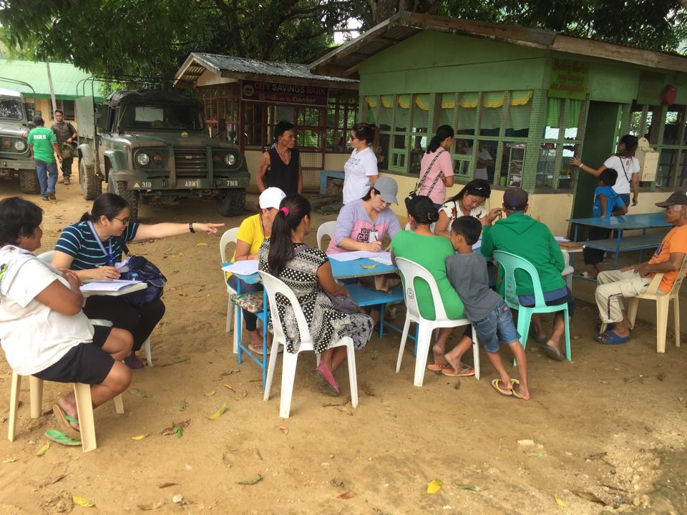
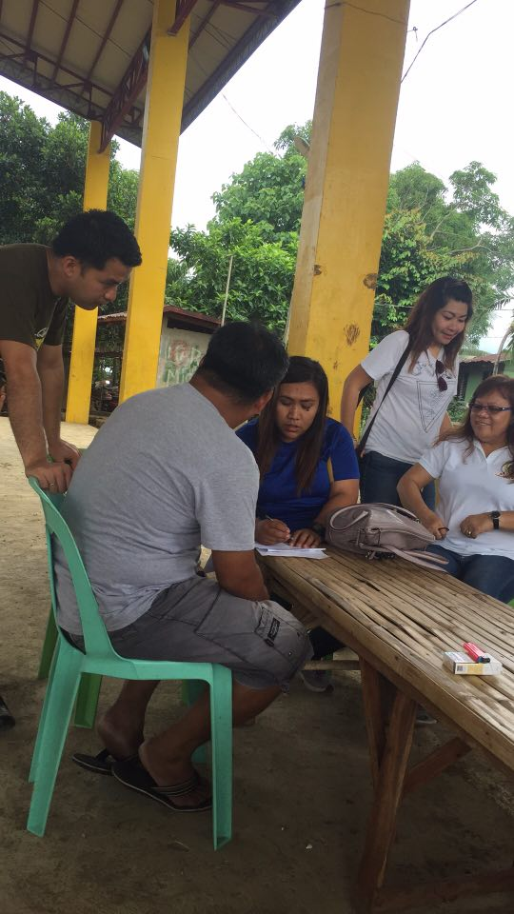

Registration of IDPs using Disaster Assistance Family Access Card

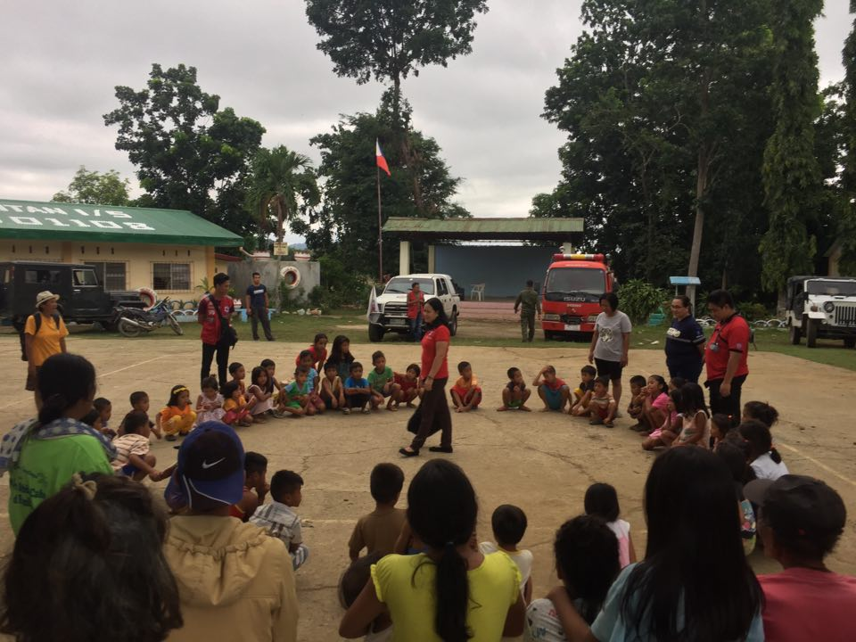

Conduct of MHPSS to affected children (PNRC)

