DSWD DROMIC Report #2 on the Effects of Southwest Monsoon
Enhanced by Tropical Storm “NIMFA”
as of 20 September 2019, 6PM

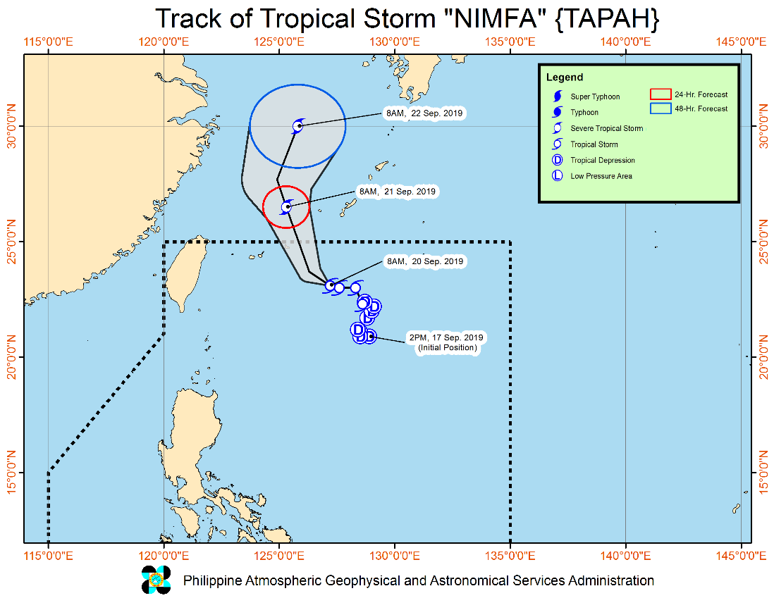
Situation Overview

“NIMFA” HAS SLOWED DOWN WHILE OVER THE NORTHERN PORTION OF THE PHILIPPINE SEA.
- Between today and tomorrow (21 September) morning, the Southwest Monsoon will bring occasional light to moderate with intermittent heavy rains over Bataan, Cavite, Batangas and Occidental Mindoro. Intermittent light to moderate rains with at times heavy rainshowers during thunderstorms may affect Metro Manila, Oriental Mindoro, Marinduque, northern portion of Palawan including Calamian Islands and the rest of Central Luzon and CALABARZON.
- Residents of the aforementioned areas, especially those living in areas identified to be highly or very highly susceptible to floods and rain-induced landslides, are advised to take precautionary measures, coordinate with local disaster risk reduction and management offices, and continue monitoring for updates, especially the Thunderstorm or Rainfall Advisories and Heavy Rainfall Warnings to be issued by PAGASA Regional Services Divisions.
- Sea travel is risky, especially for small seacrafts, over the seaboards of Northern and Central Luzon and the eastern seaboard of Southern Luzon due to potentially rough to very rough sea conditions. The other seaboards of the country will remain moderate to rough.
- “NIMFA” is forecast to exit the Philippine Area of Responsibility tomorrow morning.
At 10:00 AM today, the center of Tropical Storm "NIMFA" was estimated based on all available data at 620 km East Northeast of Basco, Batanes (23.2 °N, 127.2 °E )
Source: DOST-PAGASA Severe Weather Bulletin

- Status of Affected Families / Persons
A total of 77 families or 371 persons were affected by the effects of Southwest Monsoon enhanced by Tropical Storm “Nimfa” in 3 barangays in Region III (see Table 1).

Table 1. Number of Affected Families / Persons
REGION / PROVINCE / MUNICIPALITY |  | NUMBER OF AFFECTED
 |  | Barangays | Families | Persons
GRAND TOTAL |  | 3 | 77 | 371
REGION III |  | 3 | 77 | 371
Pampanga |  | 3 | 77 | 371
 | Apalit | 1 | 54 | 280
 | City of San Fernando (capital) | 2 | 23 | 91
Note: Ongoing assessment and validation being conducted.
Source: DSWD-FO III

- Status of Displaced Families / Persons Inside Evacuation Centers
A total of 73 families or 350 persons are currently taking shelter in 2 evacuation centers in Region III (see Table 2).

Table 2. Number of Displaced Families / Persons Inside Evacuation Centers
REGION / PROVINCE / MUNICIPALITY |  | NUMBER OF EVACUATION CENTERS (ECs) |  | INSIDE ECs
 |  |  |  | Families |  | Persons
 |  | CUM | NOW | CUM | NOW | CUM | NOW
GRAND TOTAL |  | 3 | 2 | 77 | 73 | 371 | 350
REGION III |  | 3 | 2 | 77 | 73 | 371 | 350
Pampanga |  | 3 | 2 | 77 | 73 | 371 | 350
 | Apalit | 1 | 1 | 54 | 54 | 280 | 280
 | City of San Fernando (capital) | 2 | 1 | 23 | 19 | 91 | 70
Note: The increase in the number of affected families or persons is based on the ongoing assessment and validation being conducted.
Source: DSWD-FO III

Situational Reports

DSWD-DRMB
DATE | SITUATIONS / ACTIONS UNDERTAKEN
20 September 2019 | - The Disaster Response Management Bureau (DRMB) is closely coordinating with the concerned DSWD-Field Offices for significant disaster preparedness for response updates.

DSWD-FO III
DATE | SITUATIONS / ACTIONS UNDERTAKEN
- September 2019 | - DSWD-FO III is continuously coordinating with the affected Local Government Units relative to the status of their respective areas.

*****
The Disaster Response Operations Monitoring and Information Center (DROMIC) of the DSWD-DRMB is closely monitoring the effects of Southwest Monsoon enhanced by TS “Nimfa” and is coordinating with the concerned DSWD-Field Offices for any significant updates.

PREPARED BY:

MARIE JOYCE G. RAFANAN

RODEL V. CABADDU
Releasing Officer

