DSWD DROMIC Report #2 on the
Fire in Incident in Brgy. Dumagoc, Pagadian City
as of 18 September 2019, 6PM

SUMMARY

On 30 August 2019 at 11:11 AM, a fire incident occurred in Purok Kahayag & Sweet Love in Barangay Dumagoc, Pagadian City. The cause of fire is still under investigation.
Source: DSWD-FO IX

- Status of Affected Families / Persons
A total of 131 families or 560 persons were affected in Brgy. Dumagoc, Pagadian City (see Table 1).

Table 1. Number of Affected Families / Persons
REGION / PROVINCE / MUNICIPALITY |  | NUMBER OF AFFECTED
 |  | Barangays | Families | Persons
GRAND TOTAL |  | 1 | 131 | 560
REGION IX |  | 1 | 131 | 560
Zamboanga del Sur |  | 1 | 131 | 560
 | Pagadian City (capital) | 1 | 131 | 560
Note: The decrease of the number of affected persons in Brgy. Dumagoc, Pagadian City is upon validation of CSWDO.
Ongoing assessment and validation being conducted.
Source: DSWD-FO IX

- Status of Displaced Families / Persons
  - Inside Evacuation Center
46 families or 175 persons are currently staying inside at Balangasan Gymnasium (see Table 2).

Table 2. Number of Displaced Families / Persons Inside Evacuation Center
REGION / PROVINCE / MUNICIPALITY |  | NUMBER OF EVACUATION CENTERS (ECs) |  | INSIDE ECs
 |  |  |  | Families |  | Persons
 |  | CUM | NOW | CUM | NOW | CUM | NOW
GRAND TOTAL |  | 1 | 1 | 56 | 46 | 280 | 175
REGION IX |  | 1 | 1 | 56 | 46 | 280 | 175
Zamboanga del Sur |  | 1 | 1 | 56 | 46 | 280 | 175
 | Pagadian City (capital) | 1 | 1 | 56 | 46 | 280 | 175
Note: Ongoing assessment and validation being conducted.
Source: DSWD-FO IX
b. Outside Evacuation Center
There are 75 families or 280 persons who are temporarily staying with their friends and/or relatives (see Table 3).

Table 3. Number of Displaced Families / Persons Outside Evacuation Center
REGION / PROVINCE / MUNICIPALITY |  | OUTSIDE ECs
 |  | Families |  | Persons
 |  | CUM | NOW | CUM | NOW
GRAND TOTAL |  | 75 | 75 | 280 | 280
REGION IX |  | 75 | 75 | 280 | 280
Zamboanga del Sur |  | 75 | 75 | 280 | 280
 | Pagadian City (capital) | 75 | 75 | 280 | 280
Note: The decrease of the number of persons outside evacuation center in Brgy. Dumagoc, Pagadian City is upon validation of CSWDO. Ongoing assessment and validation being conducted.
Source: DSWD-FO IX

- Damaged Houses
There are 119 totally damaged houses (see Table 4).

Table 4. Number of Damaged Houses
REGION / PROVINCE / MUNICIPALITY |  | NO. OF DAMAGED HOUSES
 |  | Total | Totally | Partially
GRAND TOTAL |  | 119 | 119 | -
REGION IX |  | 119 | 119 | -
Zamboanga del Sur |  | 119 | 119 | -
 | Pagadian City (capital) | 119 | 119 | -
Note: Ongoing assessment and validation being conducted.
Source: DSWD-FO IX

- Assistance Provided
A total of ₱346,412.50 worth of assistance was provided to the affected families; of which, ₱146,412.50 was provided by DSWD and ₱200,000.00 from LGU. (see Table 5).
Table 5. Cost of Assistance Provided to Affected Families / Persons
REGION / PROVINCE / MUNICIPALITY |  | TOTAL COST OF ASSISTANCE
 |  | DSWD | LGU | NGOs | OTHERS | GRAND TOTAL
GRAND TOTAL |  | 146,412.50 | 200,000.00 | - | - | 346,412.50
REGION IX |  | 146,412.50 | 200,000.00 | - | - | 346,412.50
Zamboanga del Sur |  | 146,412.50 | 200,000.00 | - | - | 346,412.50
 | Pagadian City (capital) | 146,412.50 | 200,000.00 | - | - | 346,412.50
Note: Ongoing assessment and validation being conducted.
Source: DSWD-FO IX
SITUATIONAL REPORT

DSWD-DRMB
DATE | SITUATIONS / ACTIONS UNDERTAKEN
18 September 2019 | - The Disaster Response Operations Monitoring and Information Center (DROMIC) of the DSWD-DRMB continues to closely coordinate with DSWD-FO IX for significant reports on the status of affected families, assistance, and relief efforts.

DSWD-FO IX
DATE | SITUATIONS / ACTIONS UNDERTAKEN
18 September 2019 | - The Disaster Response Management Division of the DSWD FO IX is continuously coordinating with the concerned LGU and SWADT-Leader of Pagadian for any updates and assistance needed.

*****
The Disaster Response Operations Monitoring and Information Center (DROMIC) of the DSWD-DRMB is closely coordinating with DSWD-FO IX for any significant disaster response updates.

Prepared by:

MARIJOY V. SAN BUENAVENTURA

RODEL V. CABADDU
Releasing Officer

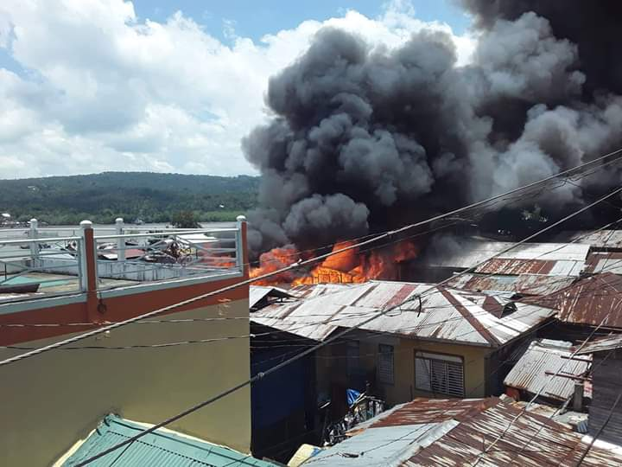
PHOTO DOCUMENTATION

