DSWD DROMIC Report #3 on the Effects of Southwest Monsoon
Enhanced by Tropical Storm “NIMFA”
as of 21 September 2019, 4PM

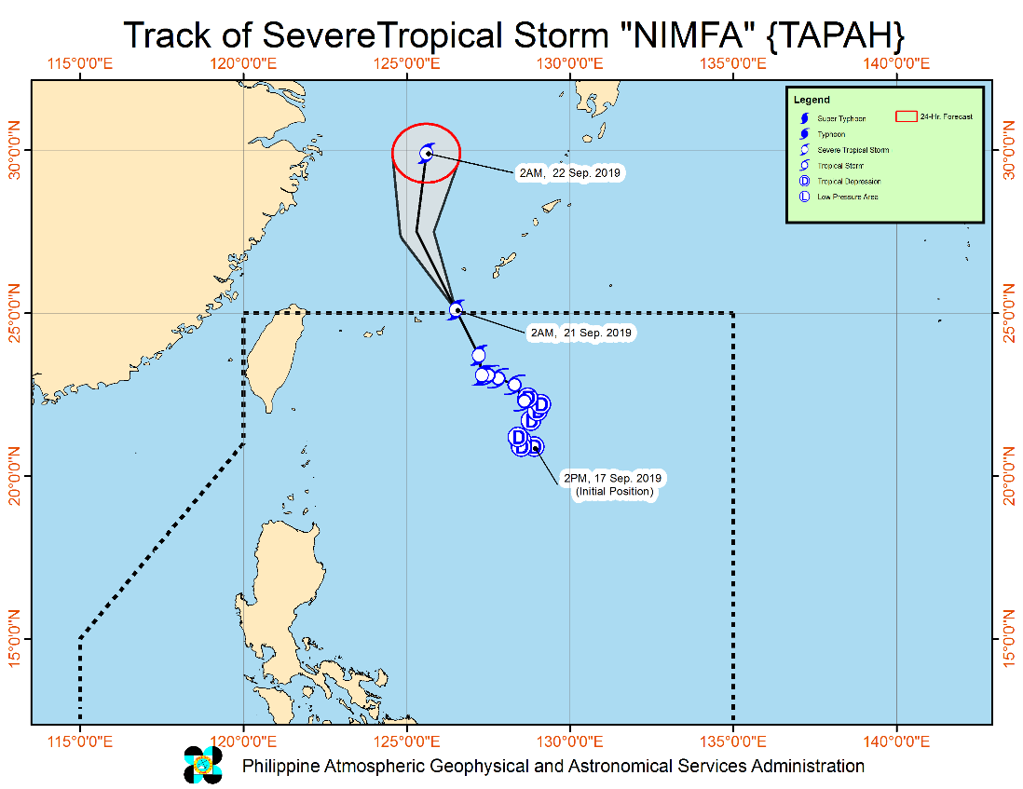
Situation Overview

"NIMFA" HAS SLIGHTLY INTENSIFIED AND IS NOW OUTSIDE THE PHILIPPINE AREA OF RESPONSIBILITY (PAR).
- "NIMFA" exited the PAR at 2:00 AM today.
- Between today and tomorrow (21 September) morning, the Southwest Monsoon will bring scattered rain showers and thunderstorms over Metro Manila and the rest of Luzon.
- Residents of the aforementioned areas, especially those living in areas identified to be highly or very highly susceptible to floods and rain-induced landslides, are advised to take precautionary measures, coordinate with local disaster risk reduction and management offices, and continue monitoring for updates, especially the Thunderstorm or Rainfall Advisories and Heavy Rainfall Warnings to be issued by PAGASA Regional Services Divisions.
- Sea travel is risky, especially for small seacrafts, over the seaboards of Northern Luzon and the eastern seaboards of Central and Southern Luzon due to potentially rough to very rough sea conditions. The other seaboards of the country will remain moderate to rough.
At 4:00 AM today, the center of Severe Tropical Storm "NIMFA" was estimated based on all available data at 705 km Northeast of Basco, Batanes (OUTSIDE PAR) (25.4 °N, 126.3 °E )
Source: DOST-PAGASA Severe Weather Bulletin

- Status of Affected Families / Persons
A total of 146 families or 578 persons were affected by the effects of Southwest Monsoon enhanced by Tropical Storm “Nimfa” in 4 barangays in Region III (see Table 1).

Table 1. Number of Affected Families / Persons
REGION / PROVINCE / MUNICIPALITY |  | NUMBER OF AFFECTED
 |  | Barangays | Families | Persons
GRAND TOTAL |  | 4 | 146 | 578
REGION III |  | 4 | 146 | 578
Nueva Ecija |  | 1 | 69 | 207
 | Zaragoza | 1 | 69 | 207
Pampanga |  | 3 | 77 | 371
 | Apalit | 1 | 54 | 280
 | City of San Fernando (capital) | 2 | 23 | 91
Note: Ongoing assessment and validation being conducted.
Source: DSWD-FO III

- Status of Displaced Families / Persons Inside Evacuation Centers
a. Inside Evacuation Centers
A total of 73 families or 350 persons are currently taking shelter in 2 evacuation centers in Region III (see Table 2).

Table 2. Number of Displaced Families / Persons Inside Evacuation Centers
REGION / PROVINCE / MUNICIPALITY |  | NUMBER OF EVACUATION CENTERS (ECs) |  | INSIDE ECs
 |  |  |  | Families |  | Persons
 |  | CUM | NOW | CUM | NOW | CUM | NOW
GRAND TOTAL |  | 3 | 2 | 77 | 73 | 371 | 350
REGION III |  | 3 | 2 | 77 | 73 | 371 | 350
Pampanga |  | 3 | 2 | 77 | 73 | 371 | 350
 | Apalit | 1 | 1 | 54 | 54 | 280 | 280
 | City of San Fernando (capital) | 2 | 1 | 23 | 19 | 91 | 70
Note: Ongoing assessment and validation being conducted.
Source: DSWD-FO III

b. Outside Evacuation Centers
There are 69 families or 207 persons who have temporarily stayed with their relatives and/or friends. (see Table 3)

Table 3. Displaced Families / Persons Outside Evacuation Center
REGION / PROVINCE / MUNICIPALITY |  | OUTSIDE ECs
 |  | Families |  | Persons
 |  | CUM | NOW | CUM | NOW
GRAND TOTAL |  | 69 | 69 | 207 | 207
REGION III |  | 69 | 69 | 207 | 207
Nueva Ecija |  | 69 | 69 | 207 | 207
 | Zaragoza | 69 | 69 | 207 | 207
Note: Ongoing assessment and validation being conducted.
Source: DSWD-FO III

Situational Reports

DSWD-DRMB
DATE | SITUATIONS / ACTIONS UNDERTAKEN
21 September 2019 | - The Disaster Response Management Bureau (DRMB) is closely coordinating with the concerned DSWD-Field Offices for significant disaster preparedness for response updates.

DSWD-FO III
DATE | SITUATIONS / ACTIONS UNDERTAKEN
21 September 2019 | - DSWD-FO III is continuously coordinating with the affected Local Government Units relative to the status of their respective areas.

*****
The Disaster Response Operations Monitoring and Information Center (DROMIC) of the DSWD-DRMB is closely monitoring the effects of Southwest Monsoon enhanced by TS “Nimfa” and is coordinating with the concerned DSWD-Field Offices for any significant updates.

PREPARED BY:

MARIJOY V. SAN BUENAVENTURA

JAN ERWIN ANDREW I. ONTANILLAS
Releasing Officer

