DSWD DROMIC Report#1 on
the Armed Conflict in Bauko, Mountain Province
as of 08 April 2019, 4PM

SUMMARY

On 29 March 2019 at around 9:45 AM, an encounter transpired between the Cordillera Police Regional Public Safety Battalion (RPSB) and the members of New People’s Army in the vicinity of Mt. Kapuwaw, Sitio Mabalagan, Bagnen Proper, Bauko. Mt. Province. The incident was followed by another encounter on 02 April 2019 at around 3 PM in Cabunagan, Tadian, Mt. Province and Sitio Malupa, Abatan, Bauko, Mt. Province.
Source: DSWD-FO CAR

- Status of Affected Families / Persons
A total of 67 families or 306 persons were affected by the armed conflict in Bauko, Mountain Province (see Table 1).

Table 1. Number of Affected Families / Persons
REGION / PROVINCE / MUNICIPALITY |  | NUMBER OF AFFECTED
 |  | Barangays | Families | Persons
GRAND TOTAL |  | 4 | 67 | 306
CAR |  | 4 | 67 | 306
Mountain Province |  | 4 | 67 | 306
 | Bauko | 4 | 67 | 306
Note: Ongoing assessment and validation being conducted.
Source: DSWD-FO CAR
- Status of Displaced Families / Persons

  - Inside Evacuation Center
There are 13 families or 65 persons who are currently taking temporary shelter in 3 Evacuation Centers in Bauko, Mountain Province (see Table 2).

Table 2. Number of Displaced Families / Persons Inside Evacuation Center
REGION / PROVINCE / MUNICIPALITY |  | NUMBER OF EVACUATION CENTERS (ECs) |  | INSIDE ECs
 |  |  |  | Families |  | Persons
 |  | CUM | NOW | CUM | NOW | CUM | NOW
GRAND TOTAL |  | 3 | 3 | 13 | 13 | 65 | 65
CAR |  | 3 | 3 | 13 | 13 | 65 | 65
Mountain Province |  | 3 | 3 | 13 | 13 | 65 | 65
 | Bauko | 3 | 3 | 13 | 13 | 65 | 65
Note: Ongoing assessment and validation being conducted.
Source: DSWD-FO CAR
  - Outside Evacuation Center
There are 5 families or 25 persons who are temporarily staying with their friends and/or relatives (see Table 3).

Table 3. Number of Displaced Families / Persons Outside Evacuation Center
REGION / PROVINCE / MUNICIPALITY |  | OUTSIDE ECs
 |  | Families |  | Persons
 |  | CUM | NOW | CUM | NOW
GRAND TOTAL |  | 43 | 5 | 208 | 25
CAR |  | 43 | 5 | 208 | 25
Mountain Province |  | 43 | 5 | 208 | 25
 | Bauko | 43 | 5 | 208 | 25
Note: Ongoing assessment and validation being conducted.
Source: DSWD-FO CAR

- Assistance Provided
A total of ₱131,118.00 worth of assistance was provided by DSWD to the affected families (see Table 4).

Table 4. Cost of Assistance Provided to Affected Families / Persons
REGION / PROVINCE / MUNICIPALITY | TOTAL COST OF ASSISTANCE
 | DSWD | LGU | NGOs | OTHERS | GRAND TOTAL
GRAND TOTAL | 131,118.00 | - | - | - | 131,118.00
CAR | 131,118.00 | - | - | - | 131,118.00
Mountain Province | 131,118.00 | - | - | - | 131,118.00
Bauko | 131,118.00 | - | - | - | 131,118.00
Note: Ongoing assessment and validation being conducted.

Source: DSWD-FO CAR
SITUATIONAL REPORT

DSWD-DRMB
DATE | SITUATIONS / ACTIONS UNDERTAKEN
08 April 2019 | - The Disaster Response Operations Monitoring and Information Center (DROMIC) of the DSWD-DRMB continues to closely coordinate with DSWD-FO CAR for significant reports on the status of affected families, assistance, and relief efforts.

DSWD-FO CAR
DATE | SITUATIONS / ACTIONS UNDERTAKEN
- April 2019 | - DSWD-FO CAR provided 328 family food packs amounting to ₱131,118.00 to the affected families.  - DSWD-FO CAR through the Disaster Response and Management Division through is continuously coordinating with Mt. Province P/MSWDOs, SWAD Office for the status of affected families.

*****
The Disaster Response Operations Monitoring and Information Center (DROMIC) of the DSWD-DRMB continues to closely coordinate with DSWD-FO CAR for significant disaster response updates and assistance
provided.

Prepared by:

MARIE JOYCE G. RAFANAN

RODEL V. CABADDU
Releasing Officer

PHOTO DOCUMENTATION:

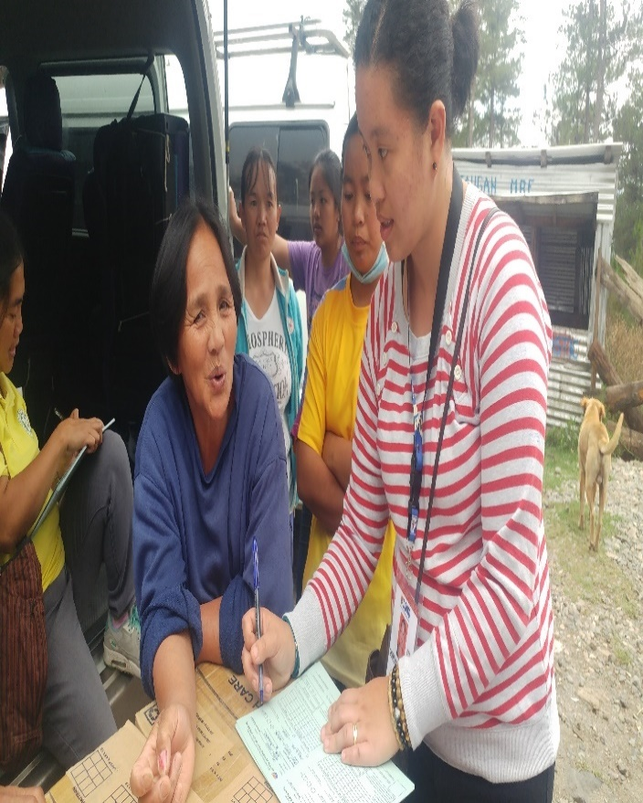
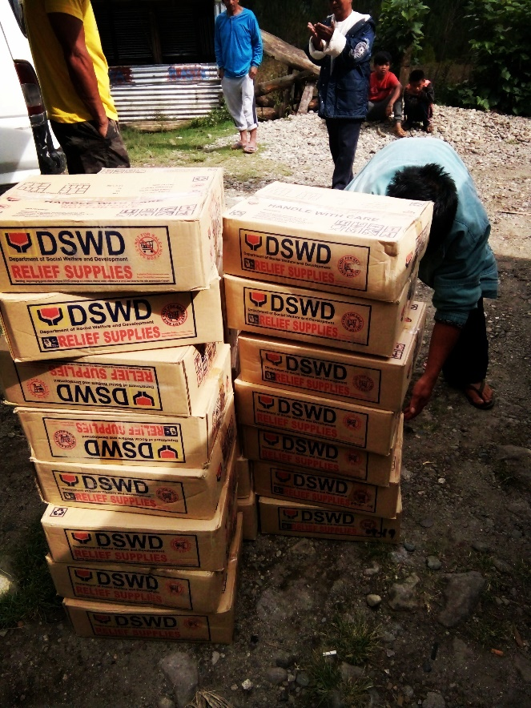
April 4, 2019:
Municipal Link Ms. Cristine Rayco conducted interview to the beneficiary using the DAFAC form.
April 4, 2019:
36 FFPs distributed in Balintaugan, Bauko for the affected families.

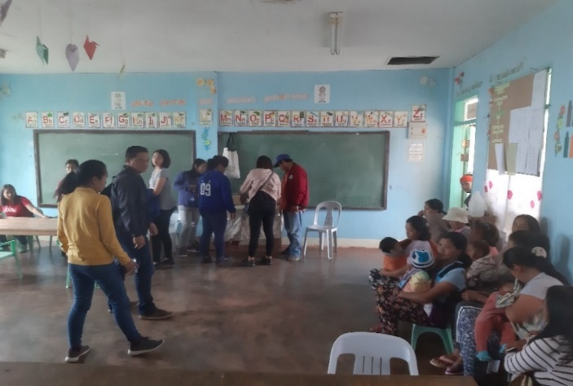
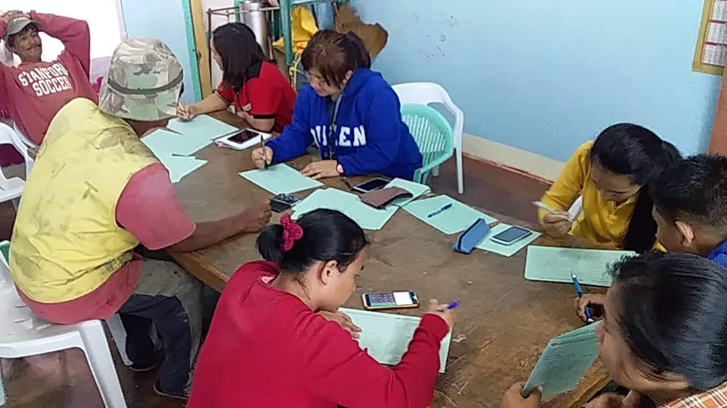
Distribution of FFPs by the DSWD staff in SWAD Mountain Province and Office of the PPPP in Bauko/ Municipal Action Team with the assistance of MSWDO Bauko staff.
Staff of Municipal Action Team of Bauko together with the MSWDO staff conducted DAFAC interview before the distribution of FFPs to beneficiaries.

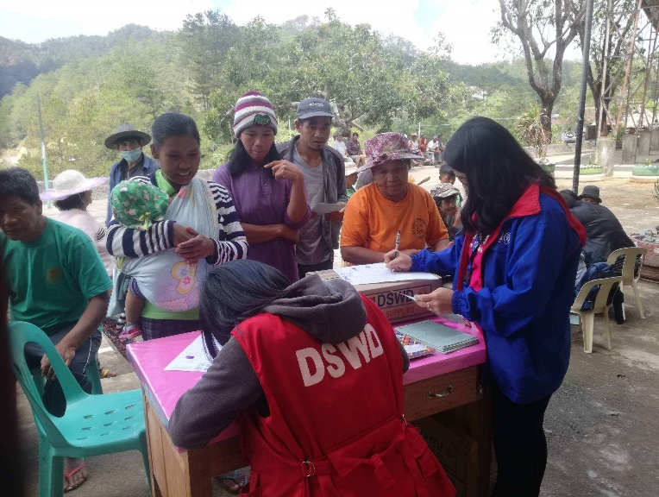
A total of 175 FFPs were distributed to affected families at Bagnen Proper.

Convergence and Pantawid staff during the distribution of family food packs in Bagnen Proper.

Ms. Tricia Bondad, SWO II of Convergence facilitated the utilization of DAFAC before releasing of FFPs to beneficiary in Bagnen Proper last April 5, 2019.
DSWD staff Municipal Action Team of Bauko and staff of MSWDO Bauko conducted interviews (DAFAC) to beneficiaries before distribution of FFPs in Bagnen Oriente.
