DSWD DROMIC Terminal Report on
the Armed Conflict in Bauko, Mountain Province
August 22, 2019, 8PM

This is the final report on the armed conflict that occurred in Bauko, Mountain Province, along the boundary of Bauko and Tadian, Mountain Province. The incident first occurred on 29 March 2019 followed by another incident on 02 April 2019 which caused the displacement of families and individuals in the area.

SUMMARY

- Status of Affected Families / Persons
A total of 656 families or 1,683 persons were affected by the armed conflict in Bauko, Mountain Province (see Table 1).

Table 1. Number of Affected Families / Persons
REGION / PROVINCE / MUNICIPALITY |  | NUMBER OF AFFECTED
 |  | Barangays | Families | Persons
GRAND TOTAL |  | 6 | 656 | 1,683
CAR |  | 6 | 656 | 1,683
Mountain Province |  | 6 | 656 | 1,683
 | Bauko | 6 | 656 | 1,683
Source: DSWD-FO CAR
- Status of Displaced Families / Persons
  - Inside Evacuation Center
A total of 16 families or 78 persons took temporary shelter in 3 Evacuation Centers in Bauko, Mountain Province wherein all of the affected families have already returned to their respective houses (see Table 2).

Table 2. Number of Displaced Families / Persons Inside Evacuation Center
REGION / PROVINCE / MUNICIPALITY |  | NUMBER OF EVACUATION CENTERS (ECs) |  | INSIDE ECs
 |  |  |  | Families |  | Persons
 |  | CUM | NOW | CUM | NOW | CUM | NOW
GRAND TOTAL |  | 3 | - | 16 | - | 78 | -
CAR |  | 3 | - | 16 | - | 78 | -
Mountain Province |  | 3 | - | 16 | - | 78 | -
 | Bauko | 3 | - | 16 | - | 78 | -
Source: DSWD-FO CAR
  - Outside Evacuation Center
A total of 66 families or 289 persons have temporarily stayed with their friends and/or relatives (see Table 3).

Table 3. Number of Displaced Families / Persons Inside Evacuation Center
REGION / PROVINCE / MUNICIPALITY |  | OUTSIDE ECs
 |  | Families |  | Persons
 |  | CUM | NOW | CUM | NOW
GRAND TOTAL |  | 66 | - | 289 | -
CAR |  | 66 | - | 289 | -
Mountain Province |  | 66 | - | 289 | -
 | Bauko | 66 | - | 289 | -
Source: DSWD-FO CAR
- Assistance Provided
A total of ₱306,935.60 worth of assistance was provided to the affected families: of which, ₱289,335.60 was provided by DSWD and ₱17,600.00 was provided by LGU (see Table 4).

Table 4. Cost of Assistance Provided to Affected Families / Persons
REGION / PROVINCE / MUNICIPALITY |  | TOTAL COST OF ASSISTANCE
 |  | DSWD | LGU | NGOs | OTHERS | GRAND TOTAL
GRAND TOTAL |  | 289,335.60 | 17,600.00 | - | - | 306,935.60
CAR |  | 289,335.60 | 17,600.00 | - | - | 306,935.60
Mountain Province |  | 289,335.60 | 17,600.00 | - | - | 306,935.60
 | Bauko | 289,335.60 | 17,600.00 | - | - | 306,935.60
Source: DSWD-FO CAR

SITUATIONAL REPORT

DSWD-FO CAR
DATE | SITUATIONS / ACTIONS UNDERTAKEN
02 September 2019 | - DSWD-FO CAR submitted terminal report.

*****
The Disaster Response Operations Monitoring and Information Center (DROMIC) of the DSWD-DRMB continues to closely coordinate with DSWD-FO CAR for any request of Technical Assistance and Resource Augmentation (TARA).

Prepared by:

DIANE C. PELEGRINO

RODEL V. CABADDU
Releasing Officer

PHOTO DOCUMENTATION:

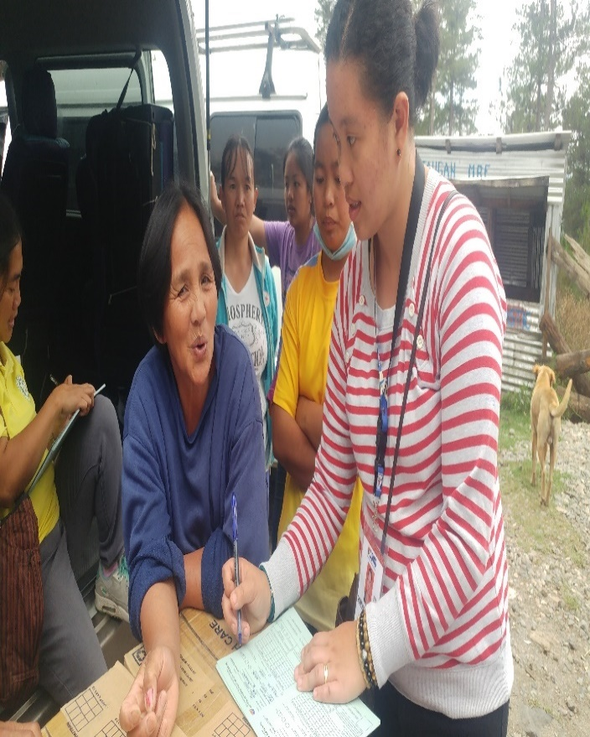
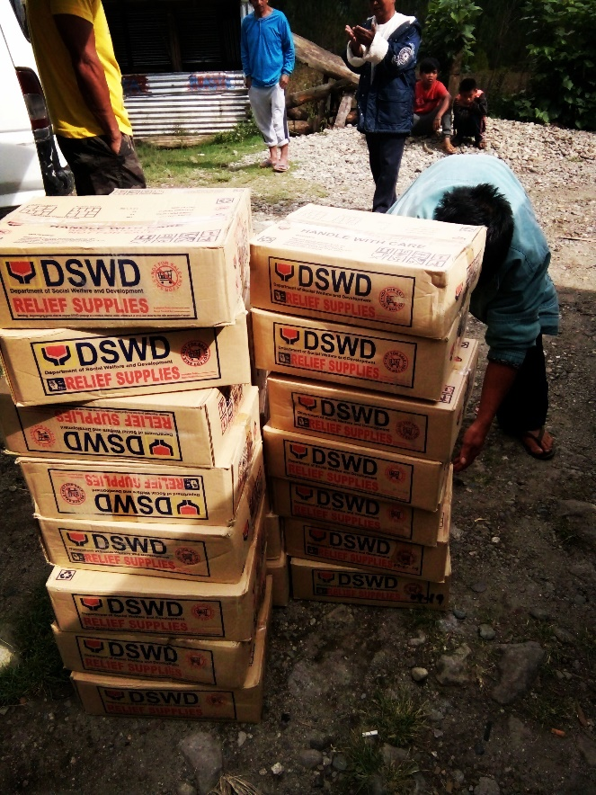
April 4, 2019:
Municipal Link Ms. Cristine Rayco conducted interview to the beneficiary using the DAFAC form.
April 4, 2019:
36 FFPs distributed in Balintaugan, Bauko for the affected families.

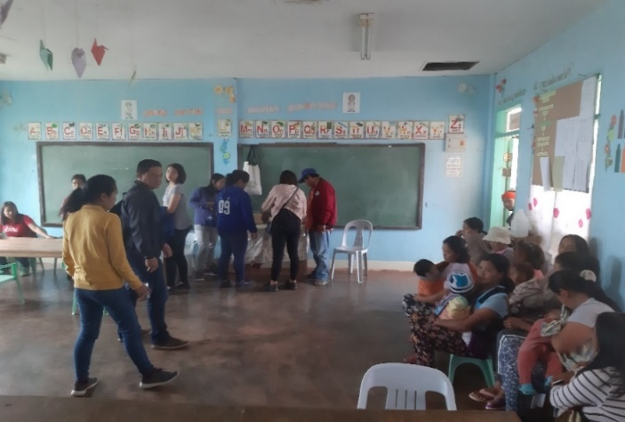
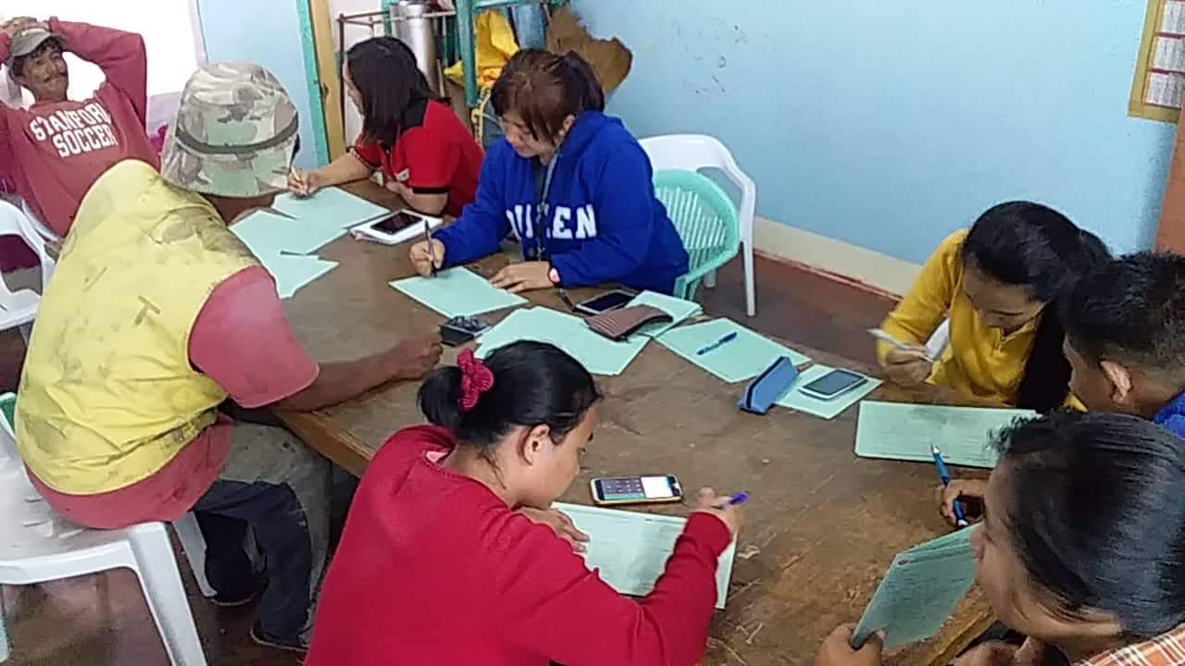
Distribution of FFPs by the DSWD staff in SWAD Mountain Province and Office of the PPPP in Bauko/ Municipal Action Team with the assistance of MSWDO Bauko staff.
Staff of Municipal Action Team of Bauko together with the MSWDO staff conducted DAFAC interview before the distribution of FFPs to beneficiaries.

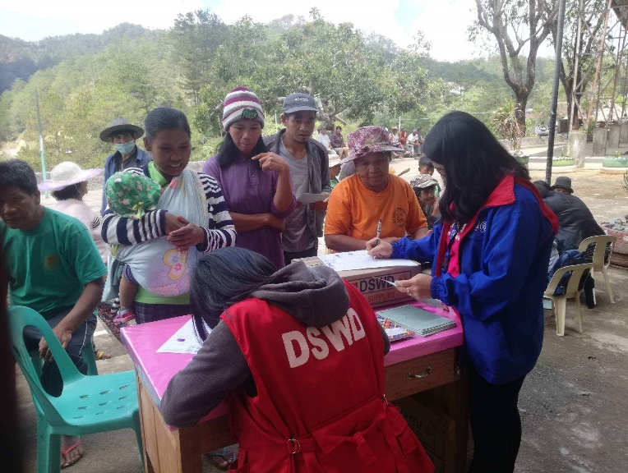
A total of 175 FFPs were distributed to affected families at Bagnen Proper.

Convergence and Pantawid staff during the distribution of family food packs in Bagnen Proper.

Ms. Tricia Bondad, SWO II of Convergence facilitated the utilization of DAFAC before releasing of FFPs to beneficiary in Bagnen Proper last April 5, 2019.
DSWD staff Municipal Action Team of Bauko and staff of MSWDO Bauko conducted interviews (DAFAC) to beneficiaries before distribution of FFPs in Bagnen Oriente.
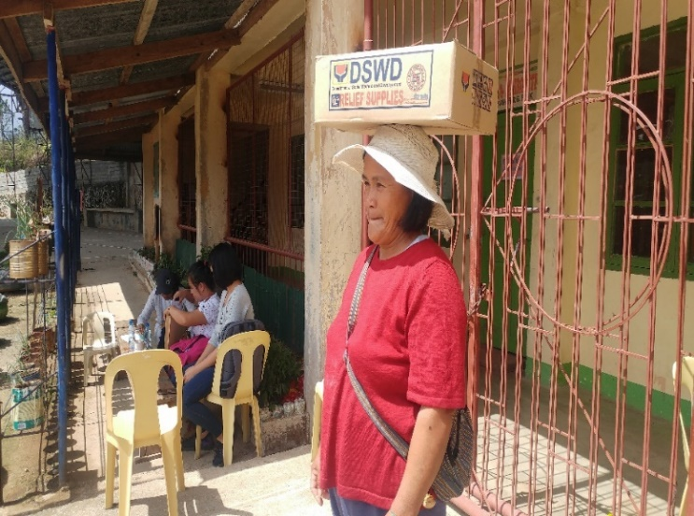
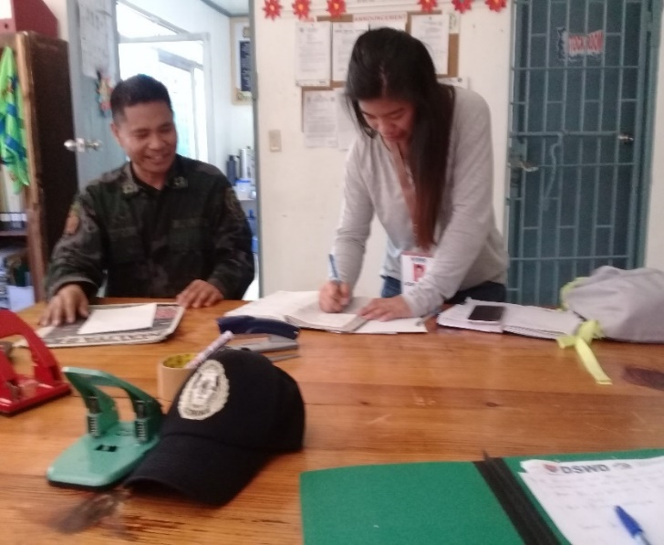
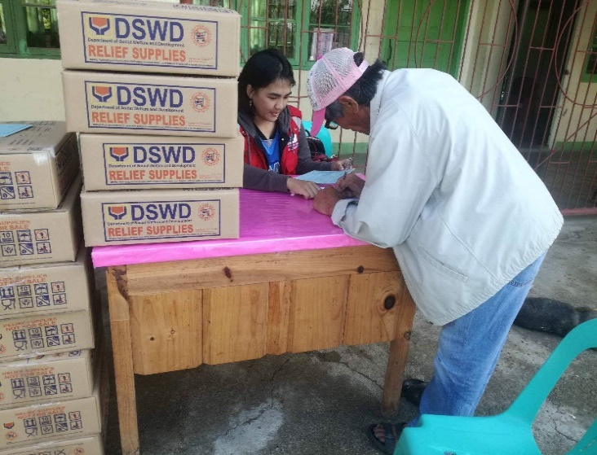
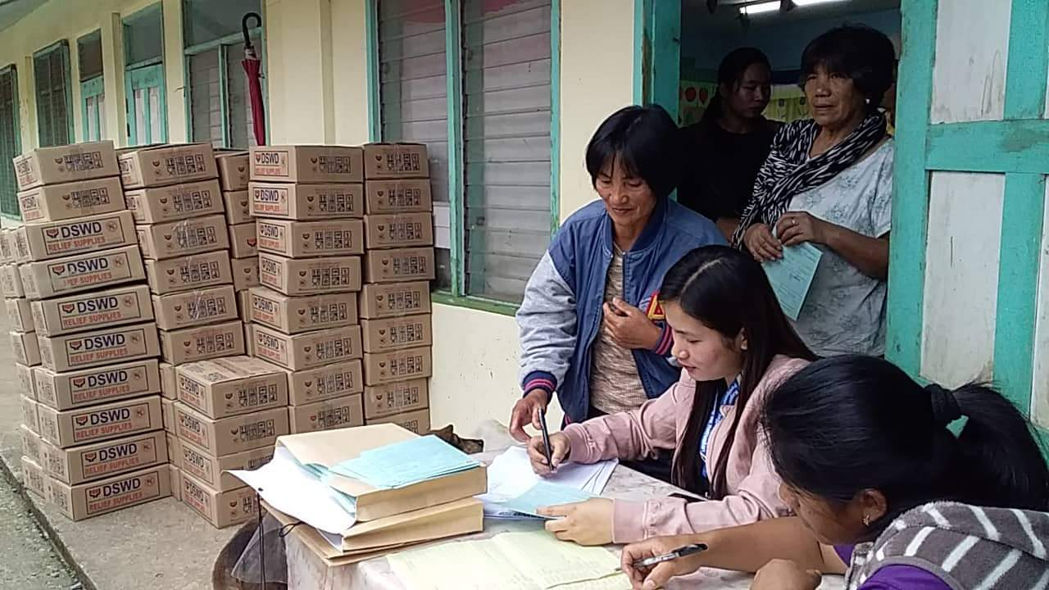
A beneficiary in Bagnen Proper receiving her FFP on April 11, 2019.
April 9, 2019:
The DRR focal of SWAD Mountain Province went to do courtesy call together with Ms. Julina Malianas, SWO I (disaster focal of MSWDO Bauko) to the Bauko Municipal Police Station to PLT Peter B. Apangcay, Deputy Chief of Police
MPOC, Bauko, Mountain Province regarding the incident report happening in Bauko, Mountain Province and for further clarification of the news from the different social media.

