DSWD DROMIC Terminal Report on the Armed Conflict
in Brgy. Paitan, Escalante, Negros Occidental
26 November 2020, 6PM

This is the final report on the armed conflict on 31 August 2019 at 6:45 AM in Brgy. Paitan, Escalante, Negros Occidental. Based on the report, an encounter transpired between more or less 30 terrorist NPAs and troops of 79th Infantry Battalion while conducting combat operations at Sitio Morino, Brgy. Paitan, Escalante City. The soldiers fought in a 45-minute running gun battle against the NPAs who used an anti-personnel mine in the process and eventually withdrew towards the forested portion of Sitio Sampinit of same barangay.
Source: DSWD-FO VI

SUMMARY

- Status of Affected Families / Persons
A total of 206 families or 644 persons were affected by the armed conflict in two (2) Barangays in Escalante, Negros Occidental (see Table 1).

Table 1. Number of Affected Families / Persons
REGION / PROVINCE / MUNICIPALITY |  | NUMBER OF AFFECTED
 |  | Barangays | Families | Persons
GRAND TOTAL |  | 2 | 206 | 644
REGION VI |  | 2 | 206 | 644
Negros Occidental |  | 2 | 206 | 644
 | City of Escalante | 2 | 206 | 644
Source: DSWD-FO VI

- Status of Affected Families / Persons
A total of 206 families or 644 persons took temporary shelter in two (2) evacuation centers in Brgy. Paitan and Brgy. Libertad (see Table 2). All of these families have returned home.

Table 2. Number of Displaced Families / Persons Inside Evacuation Center
REGION / PROVINCE / MUNICIPALITY |  | NUMBER OF EVACUATION CENTERS (ECs) |  | INSIDE ECs
 |  |  |  | Families |  | Persons
 |  | CUM | NOW | CUM | NOW | CUM | NOW
GRAND TOTAL |  | 2 | - | 206 | - | 644 | -
REGION VI |  | 2 | - | 206 | - | 644 | -
Negros Occidental |  | 2 | - | 206 | - | 644 | -
 | City of Escalante | 2 | - | 206 | - | 644 | -
Source: DSWD-FO VI

- Assistance Provided
A total of ₱104,383.00 worth of assistance was provided by LGU to the affected families (see Table 3).

Table 3. Cost of Assistance Provided to Affected Families / Persons
REGION / PROVINCE / MUNICIPALITY | TOTAL COST OF ASSISTANCE
 | DSWD | LGU | NGOs | OTHERS | GRAND TOTAL
GRAND TOTAL | - | 104,383.00 | - | - | 104,383.00
REGION VI | - | 104,383.00 | - | - | 104,383.00
Negros Occidental | - | 104,383.00 | - | - | 104,383.00
City of Escalante | - | 104,383.00 | - | - | 104,383.00
Source: DSWD-FO VI
SITUATIONAL REPORT

DSWD-FO VI
DATE | SITUATIONS / ACTIONS UNDERTAKEN
22 October 2020 | - DSWD-FO VI submitted their terminal report.  - The Local Government Unit (LGU) of Escalante City provided 20 sacks of rice, 10 boxes of sardines, 520 pieces of coffee, 42 dozens of milo, two (2) boxes of mineral water (500 ml) and three (3) boxes of biscuits.  - The LGU Escalante also provided 1 FFP per affected family consisting of three (3) kilos of rice and four (4) cans of sardines.

*****
The Disaster Response Operations Monitoring and Information Center (DROMIC) of the DSWD-DRMB continues to closely coordinate with DSWD-FO VI for any request of Technical Assistance and Resource Augmentation (TARA).

Prepared by:

MARIE JOYCE G. RAFANAN

LESLIE R. JAWILI
Releasing Officer

PHOTO DOCUMENTATION
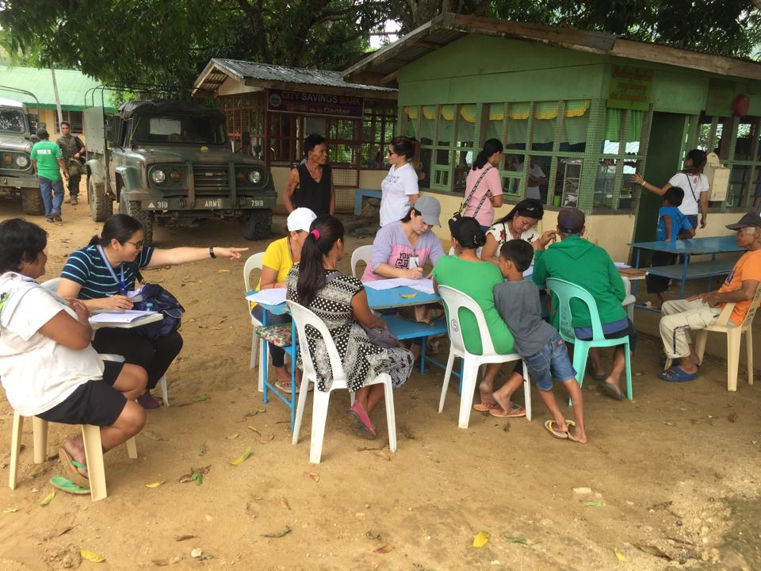
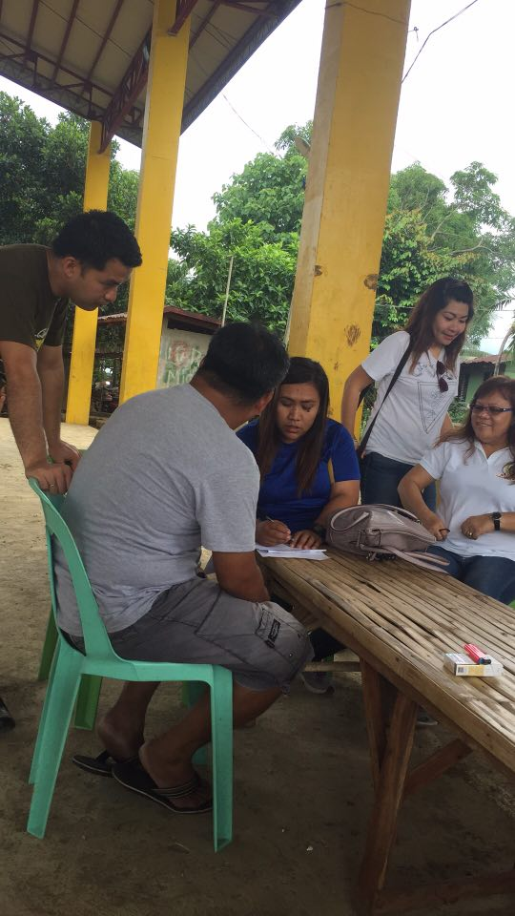

Registration of IDPs using Disaster Assistance Family Access Card

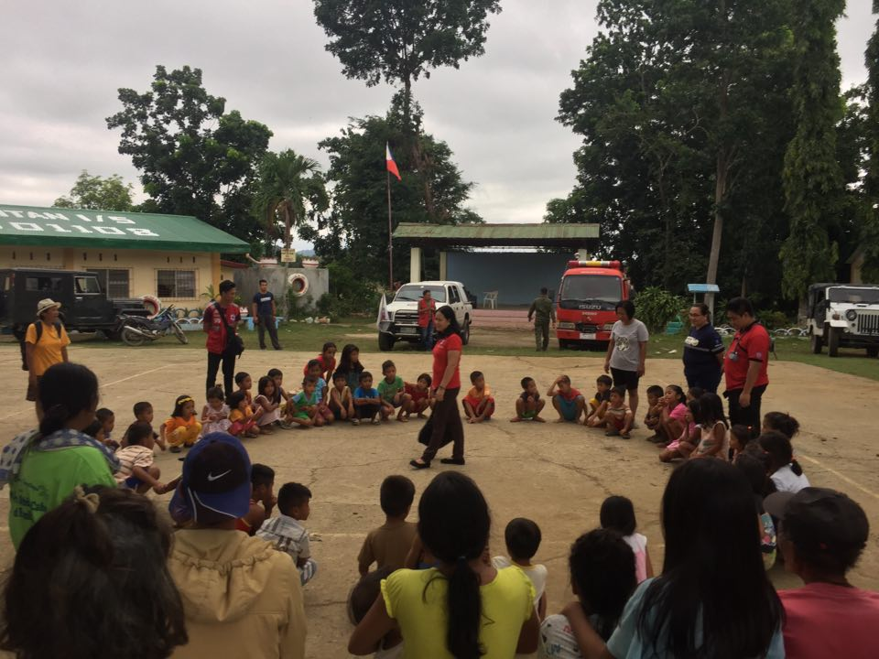

Conduct of MHPSS to affected children (PNRC)

