DSWD DROMIC Terminal Report on the Fire Incident
in Brgy. Duljo Fatima, Cebu City
07 July 2020, 6PM

This is the final report on the fire incident occurred in a residential area at Sitio Second Street, Brgy. Duljo, Cebu City on 14 September 2019. The fire started at 10:49 AM and was put under control at 11:52 AM.
Source: DSWD-FO VII

SUMMARY

- Status of Affected Families / Persons
A total of 43 families or 129 persons were affected in Brgy. Duljo, Cebu City (see Table 1).

Table 1. Number of Affected Families / Persons
REGION / PROVINCE / MUNICIPALITY |  | NUMBER OF AFFECTED
 |  | Barangays | Families | Persons
GRAND TOTAL |  | 1 | 43 | 129
REGION VII |  | 1 | 43 | 129
Cebu |  | 1 | 43 | 129
 | Cebu City (capital) | 1 | 43 | 129
Source: DSWD-FO VII

- Status of Displaced Families / Persons Inside Evacuation Center
8 families or 40 persons took temporary shelter at Barangay’s Old Convent (see Table 2).

Table 2. Number of Displaced Families / Persons Inside Evacuation Center
REGION / PROVINCE / MUNICIPALITY |  | NUMBER OF EVACUATION CENTERS (ECs) |  | NUMBER OF DISPLACED
 |  |  |  | INSIDE ECs
 |  |  |  | Families |  | Persons
 |  | CUM | NOW | CUM | NOW | CUM | NOW
GRAND TOTAL |  | 1 | - | 8 | - | 40 | -
REGION VII |  | 1 | - | 8 | - | 40 | -
Cebu |  | 1 | - | 8 | - | 40 | -
 | Cebu City (capital) | 1 | - | 8 | - | 40 | -
Source: DSWD-FO VII

- Damaged Houses
There were 6 damaged houses; of which, 4 were totally damaged and 2 were partially damaged (see Table 3).

Table 3. Number of Damaged Houses
REGION / PROVINCE / MUNICIPALITY |  | NO. OF DAMAGED HOUSES
 |  | Total | Totally | Partially
GRAND TOTAL |  | 6 | 4 | 2
REGION VII |  | 6 | 4 | 2
Cebu |  | 6 | 4 | 2
 | Cebu City (capital) | 6 | 4 | 2
Source: DSWD-FO VII

- Assistance Provided
A total of ₱71,160.70 worth of assistance was provided by DSWD to the affected families (see Table 4).

Table 4. Cost of Assistance Provided to Affected Families / Persons
REGION / PROVINCE / MUNICIPALITY |  | TOTAL COST OF ASSISTANCE
 |  | DSWD | LGU | NGOs | OTHERS | GRAND TOTAL
GRAND TOTAL |  | 71,160.70 | - | - | - | 71,160.70
REGION VII |  | 71,160.70 | - | - | - | 71,160.70
Cebu |  | 71,160.70 | - | - | - | 71,160.70
 | Cebu City (capital) | 71,160.70 | - | - | - | 71,160.70
Note: Ongoing assessment and validation being conducted.
Source: DSWD-FO VII

SITUATIONAL REPORT

DSWD-FO VII
DATE | SITUATIONS / ACTIONS UNDERTAKEN
01 July 2020 | - DSWD-FO VII submitted their terminal report.  - DSWD-FO VII provided family food packs, malongs and hygiene kits to the affected families amounting to ₱71,160.70.

*****
The Disaster Response Operations Monitoring and Information Center (DROMIC) of the DSWD-DRMB continues to closely coordinate with DSWD-FO VII for any request of Technical Assistance and Resource Augmentation (TARA).

Prepared by:

MARIE JOYCE G. RAFANAN

MARC LEO L. BUTAC
Releasing Officer

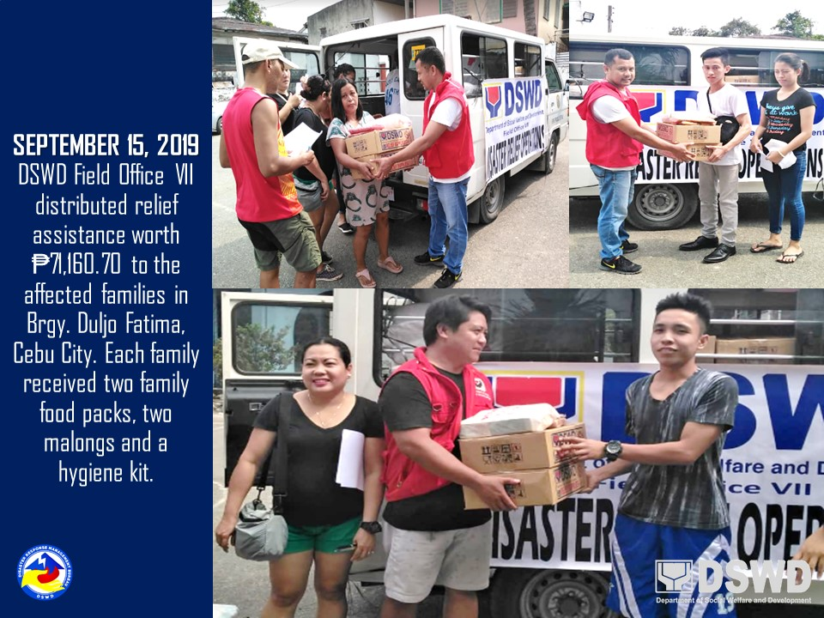
PHOTO DOCUMENTATION

